Independent University, Bangladesh
School of Engineering Technology and Science
Department of Computer Science and Engineering

PROJECT PROPOSAL FORM
SEMESTER: Summer 2023

PROJECT TITLE: IoT-Based-Plant-Detection-and-Finding-Ayurvedic-Plants-Through-Image-Processing.
Survey to develop a process for complex engineering problems considering cultural and societal factors:
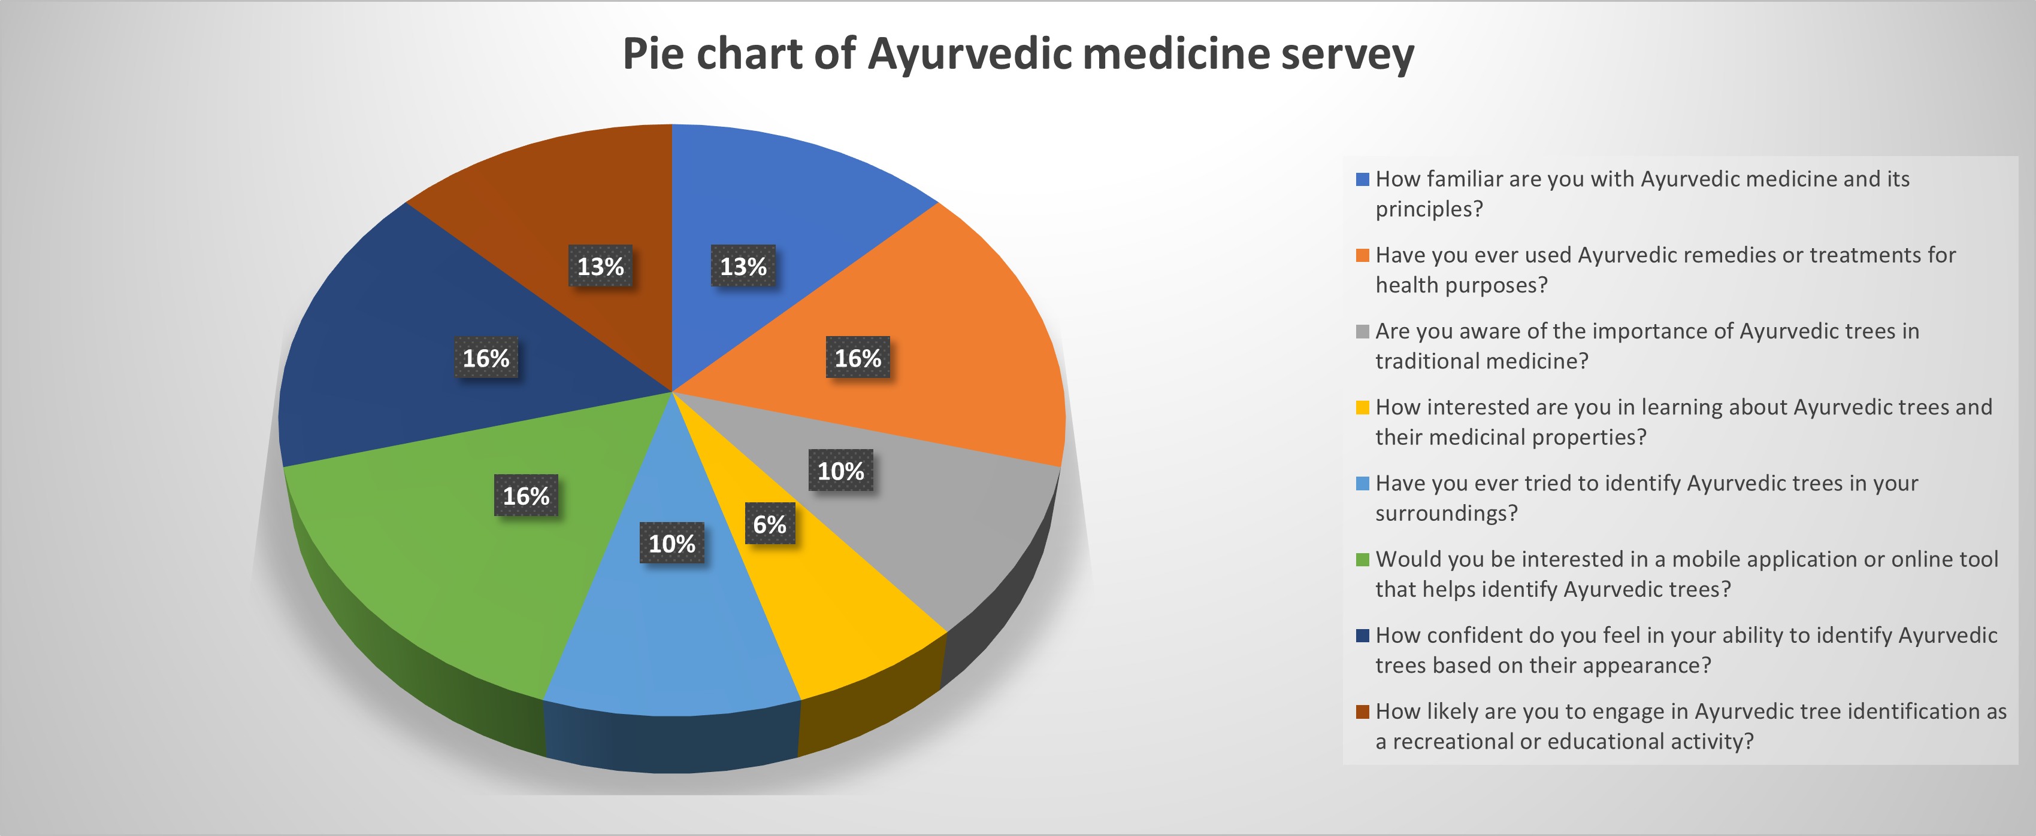

GOALS AND BENEFITS OF THE PROJECT:

Preservation of Traditional Knowledge: The project of creating an Ayurvedic tree identification system aims to preserve and promote traditional knowledge related to Ayurvedic medicine. By accurately identifying and documenting medicinal trees, the project helps in the conservation of traditional healing practices.

Enhanced Medicinal Plant Conservation: Identifying Ayurvedic trees contributes to the conservation and sustainable use of medicinal plants. By recognizing and cataloging these trees, the project helps raise awareness about their importance and encourages their preservation in natural habitats.

Access to Medicinal Resources: The project facilitates easy access to medicinal resources by providing a reliable means of identifying Ayurvedic trees. This information can be valuable for Ayurvedic practitioners, researchers, and herbalists who rely on specific plants for the preparation of medicines, remedies, and formulations.

Medicinal Plant Diversity: The project contributes to the understanding and appreciation of the rich diversity of medicinal plants used in Ayurveda. By documenting various tree species and their medicinal properties, it expands the knowledge base and promotes exploration of new therapeutic possibilities.

Promoting Sustainable Practices: With the identification of Ayurvedic trees, the project encourages the sustainable and responsible harvesting of medicinal plants. It helps prevent the overexploitation of certain species and promotes the cultivation of endangered plants, thus ensuring their long-term availability.

Educational and Research Purposes: The project provides a valuable resource for educational institutions, researchers, and students interested in Ayurvedic medicine. It serves as a reference tool for studying medicinal plants, their characteristics, and their applications, fostering further research and innovation.

Integration of Traditional and Modern Medicine: By creating an Ayurvedic tree identification system, the project supports the integration of traditional and modern medicine. It encourages collaborations between Ayurvedic practitioners and scientific researchers, leading to the development of evidence-based approaches to healthcare.

Empowering Local Communities: The project empowers local communities by promoting the utilization of their traditional knowledge and expertise in Ayurvedic medicine. It recognizes the value of indigenous wisdom and encourages community involvement in the preservation and sustainable use of medicinal plants.

Overall, the project of Medicine Alternative System combines the preservation of traditional knowledge, the conservation of medicinal plant resources, and the promotion of sustainable practices. It aims to enhance access to medicinal resources, foster research and education, and contribute to the integration of traditional and modern healthcare systems.

EXPERIMENTAL BLOCK DIAGRAM:

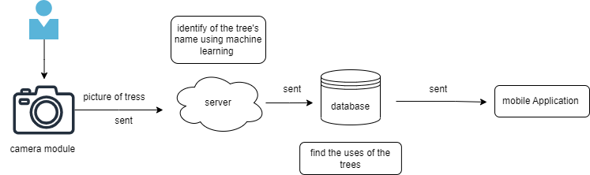

PROJECT TIMELINE (GANTT CHART):

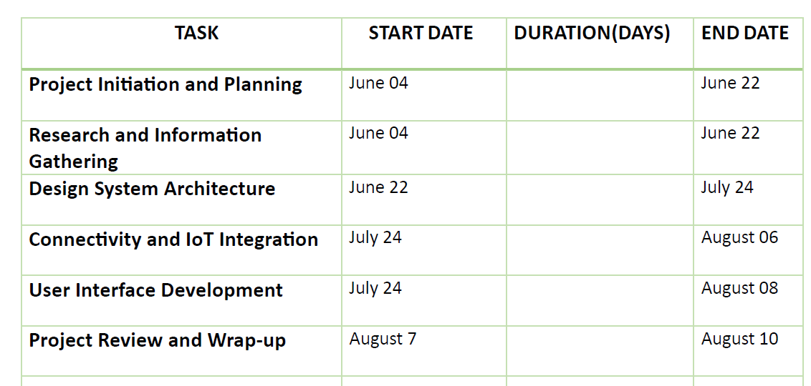

REFERENCES:
- https://d1wqtxts1xzle7.cloudfront.net/58241633/IRJET-V5I567-libre.pdf?1548247773=&response-content-disposition=inline%3B+filename%3DIRJET_Identification_of_Ayurvedic_Medici.pdf&Expires=1688155094&Signature=N35J3jkKz6sySLYfreC4ya4011D8gYIYRXiPvGx1G0CYizDhzx~HC5oNtn9Kf8~y7fDAXC3pbaNyEsMZoFm0b~WtLUSNp7i~~AlZ119BJBMK6p7~eL74P0jOis6rd-vKBqpF7nTtUEZWQuhEwORTn0Ba21CoZ7OXsohG3Xor~ed~x~lNyvYfKILdswv-S-gvFnf~KAYO1tLXr8xMWcHme7j9K2sWyEJYcRNyvIt4t3cFwZ1hgVz8D~WA3v2SqUkhIJYVpUrfaH1P9yLPMfrzaN6iygYBaAung3oxT3L3YSE8hRul2ol0ncqOCXUTlxUHuzfc7sKLLkSIUokoc5CGYA__&Key-Pair-Id=APKAJLOHF5GGSLRBV4ZA
- https://www.hindawi.com/journals/cin/2017/7361042/

FOR FACULTY USE ONLY
COMMENTS BY COURSE TEACHER:

COURSE TEACHER’S NAME COURSE TEACHER’S SIGNATURE DAT
GROUP MEMBERS

NAME: Toufikul Islam Eyasin  ID…2031254……………  PROGRAM: CSE  EMAIL: 2031254@iub.edu.bd | NAME: Zaber Al Mamun  ID…2022676  PROGRAM: CSE  EMAIL:Zaber00007@gmail.com  EMAIL:2022676@iub.edu.bd
NAME: Sejuti Rahman Fammi  ID…2010543………………  PROGRAM: CSE  EMAIL:2010543@iub.edu.bd | NAME: MD Abdullah Bin Asad Siam  ID : 1911120………………  PROGRAM: CSE  EMAIL: 1911120@iub.edu.bd
REMARKS (for OFFICE use only)

