ENEL469: Analog Electronic Circuits

Department of Electrical and Software Engineering
University of Calgary

Lab #1: Circuit Simulation Using Multisim

Do not change the formatting of this Word document

Student’s Name | Reinhardt Zabrocki

Objectives
- Circuit Constructions in Multisim:
Develop proficiency in building electronic circuits using the Multisim simulator.

- Connect and Customize Probes:
Learn how to correctly connect probes and adjust their settings to capture and measure key parameters.

- Run Simulations and Analyze Outputs:
Gain experience in running circuit simulations, including performing sweeps and generating output plots for analysis.

Instructions
- Group Work and Submission: While collaboration is encouraged, this is not a group project. You may work with peers, but each student must submit their own completed lab manual individually through D2L.
- Multisim Screenshot Requirements: All Multisim screenshots must display gridlines to verify the originality of your work.
- Editing Guidelines: Do not modify this document except in the designated blue boxes and tables where you are required to insert images or text.

Part-A: Study a Zener Diode Circuit

Construct the Zener diode circuit shown below in a Multisim design window, then complete the following tasks. Be sure to insert screenshots of your circuit and relevant graphs in the designated boxes with blue boundaries.
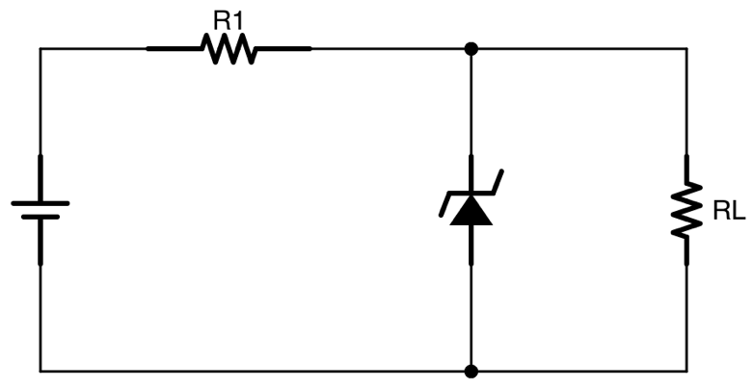
V_{S}
I_{S}
I_{L}
I_{D}

Figure 1. The Zener diode circuit is to be constructed and analyzed in Multisim.

- Circuit construction: Set V_{S} = 20 V, R₁ = 800 Ω, and R_{L} = 2 kΩ. You may choose any Zener diode, but ensure the reverse breakdown voltage V_{B} is no more than 10 V and not less than 6 V. If needed, you can edit the breakdown voltage of the inserted Zener diode. Run the interactive simulation. Neatly insert suitable voltage and current probes to display the required DC currents and voltages across all elements. Customize the probes to display only the necessary currents and voltages.
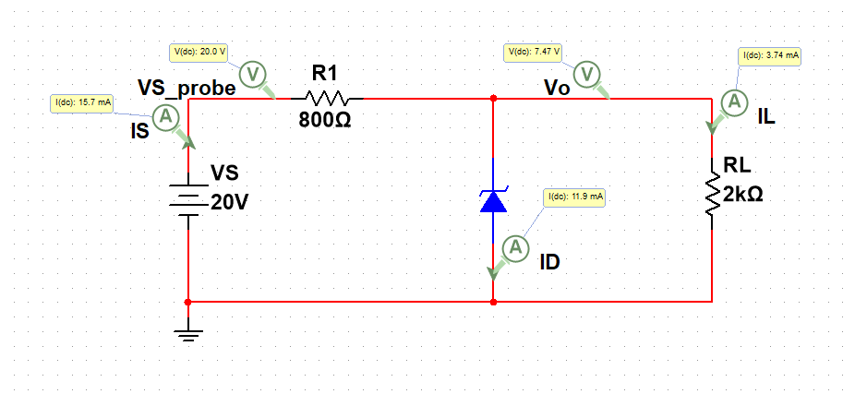
V_{B} = 7.47V
I_{S} = 15.7mA

Figure 2. (Insert) A screenshot of the Zener diode circuit constructed in Multisim with all the simulated currents and voltages is displayed in neatly formatted probes.
- DC Sweep: In this section, you will observe the dependency of the input voltage V_{S} on the voltage across the load R_{L}. Use the same circuit you constructed for the previous section with the same elements. Run a DC sweep simulation with 6 V ≤ V_{S} ≤ 24 V and an increment of 0.05 V. You will observe that the load voltage remains stabilized for a specific range of V_{S}. Create a graph showing this phenomenon, where V_{S} is plotted against the x-axis, and the voltage across R_{L} is along the y-axis. Meaningfully select the axis ranges, labels, formatting, etc., and neatly present the graph in the following space.

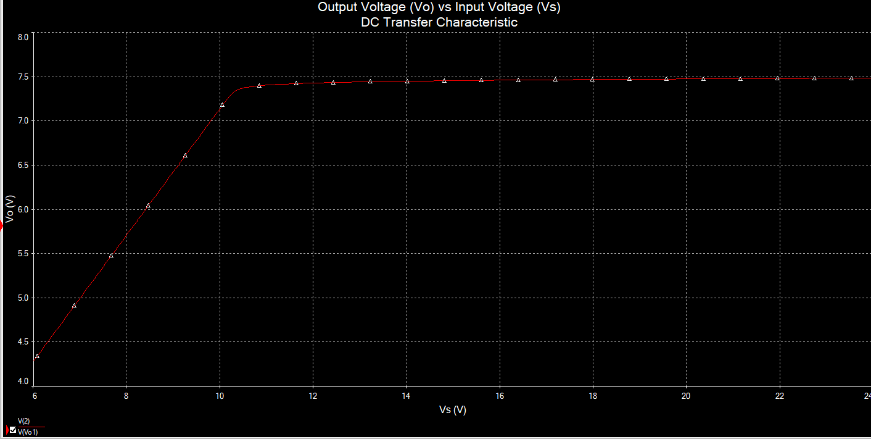

Figure 3. (Insert) A screenshot of the graph demonstrating the effect of V_{S} on stabilization.

Observations: (No submission is required for these observations)
- Determine the input voltage V_{S} at which the load voltage becomes stabilized. Compare this value to the Zener diode's breakdown voltage. If there is a discrepancy, investigate and understand the cause.
- Run the same voltage sweep and observe how the diode current and load current change with variations in the input voltage. Generate similar graphs for your own study purpose, but do not insert them anywhere in this document.

- Parameter sweep: In this section, you will observe the dependency of the limiting resistor R₁ on voltage stabilization, i.e., the voltage across the load R_{L}. Use the same circuit configuration from the previous section, maintaining the same components, but set V_{S} = 18 V. Run a parameter sweep simulation with R1 ranging from 100 Ω to 4 kΩ, with increments of 5 Ω. You will observe that the load voltage remains stabilized within a specific range of R₁. Generate a graph where R₁ is on the x-axis and the voltage across R_{L} is on the y-axis. Ensure the axes are meaningfully scaled, appropriately labelled, and formatted for clarity. Present your graph neatly in the space provided below.
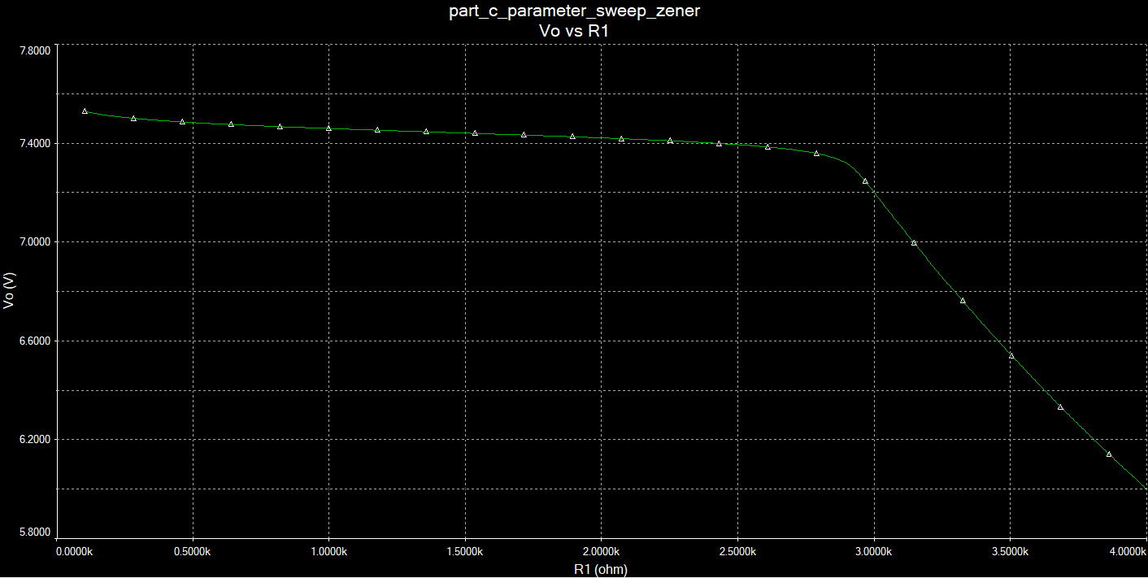

Figure 4. (Insert) A screenshot of the graph demonstrating the effect of R₁ on stabilization.

Observations: (No submission is required for these observations)
- For what range of R₁ does the load voltage stabilize?
- Run the same parameter sweep simulation and observe how the diode and load currents change with R₁. Generate similar graphs for your own study purpose, but do not insert them anywhere in this document.

Part-B: BJT Output Characteristic Curve Analyzer

Using Multisim, generate the output characteristics curve for a 2N3904 NPN transistor. For reference, Part 3 of the tutorial video demonstrates a similar analyzer operation. Apply the following parameters.
Start V_{CE} = 0 V Start I_{B} = 20 μA
Stop V_{CE} = 22 V Stop I_{B} = 80 μA
Increment = 10 mV Increment = 20 μA

Ensure that you appropriately choose the axis ranges, labels, and formatting to clearly present the graph. Neatly insert the final graph in the space provided below.

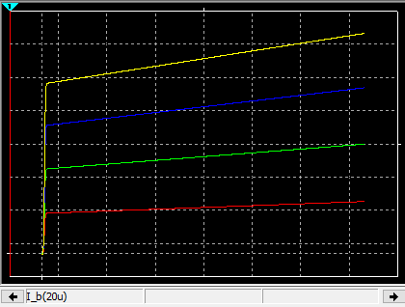

Figure 5. (Insert) A screenshot of the output characteristic curves of the 2N3904 transistor.

Observations: (Enter the values in the provided spaces below)
- Determine the value of the common-emitter current gain β from the obtained characteristic curves.
β = 156.3

- Does the value remain constant?
Yes or No: No

- How does it vary with I_{B} at a constant V_{CE}?
β_{(min)} = 149.8 & β_{(max)} = 159.3

- How does it vary with V_{CE} at a constant I_{B}?
β_{(min)} = 158.7 & β_{(max)} = 203.1

Part-C: Two-stage CE Amplifier Biasing and Output Signal Analysis

The circuit in Figure 6 is a two-stage common-emitter (CE) amplifier, which has not yet been covered in this course. While you may not be familier with its theoretical analysis, our focus in this lab will be on other relevant aspects of its operation. The input signal v₂ in the far left is a sinusoidal waveform, which gets amplified and appears as the output (v_{o}) in the far right of the circuit. It is important to note that the DC biasing voltages and currents do not reach the output terminal v_{o}. As a result, the load only receives the amplified AC signal applied to the input.

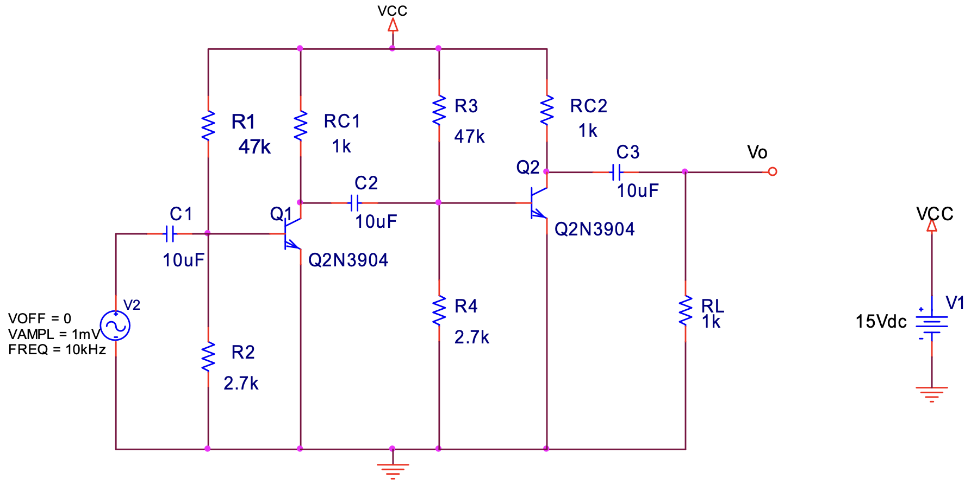

Figure 6. A two-stage CE amplifier circuit

- Circuit construction: Construct the circuit shown in Figure 6 in a Multisim design window. Use the same elements shown in the given circuit.
Apply the input signal as shown in the circuit. Use a multimeter to determine the following biasing (DC) voltages and currents and write them in the spaces provided below. Ensure that your readings do not contain any AC component, i.e. the signal.

Transistor Q1 |  | Transistor Q2
V_{BE1} | 715mV | V_{BE2} | 672mV
I_{B1} | 39.1uA | I_{B2} | 55.9uA
V_{CE1} | 8.21V | V_{CE2} | 6.81V
I_{C1} | 6.79mA | I_{C2} | 8.19mA

Neatly insert a screenshot of your circuit in the space below. All element names and values must be displayed.
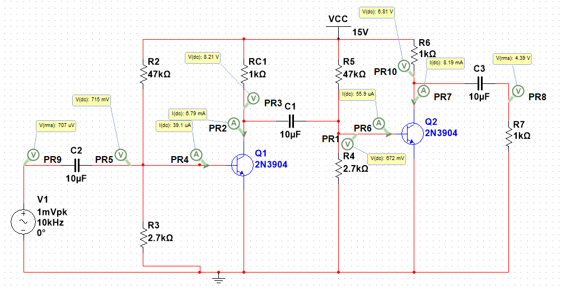

Figure 7. (Insert) A screenshot of the two-stage CE amplifier.

- Voltage gain: Set the input voltage to V_{2,rms} = 2 mV at 100 kHz. Connect an oscilloscope to the output terminal, i.e., across the load resistor R_{L}. Determine the overall voltage gain as defined below.

$Voltage gain=\frac{v_{o,rms}}{v_{2,rms}}=$ 2460

