Project Report for Web Design & Development
Contents
1 Introduction 1
2 Link to Github Repo 1
3 Installation/Usage 1
4 Use of GenAI 1
5 Design Decisions Made 2
5.1 Look and Feel 2
5.2 Breakpoints 2
6 Performance 2
7 SEO 2
8 Accessibility 2
9 Wireframes 2
10 Reflection on your work 2

Introduction
[Briefly describe what you have designed the site for and what it does]
I have designed a bit of a tongue and cheek crypto store. It allows the user to login to a preexisting account or create a new one (making use of Local Storage). My site also allows users to simulate browsing the shop page and adding token(s) to their cart, they are then lead to payment and finally confirmation (also using Local Storage).
I am proud of my website, it uses a Nav Bar that literally pops out at the user when prompted and overall I am very happy of the design choices I have made.

Link to public Github Repo
[link to your public repo]
Link: https://github.com/Zac-Herrity/Year2Project

Installation/Usage
[Add in here any specific details that will allow the lecturer to test your work – e.g. Username/password combo to “allow” login of the prototype. Also add in any missing elements, functionality not working, etc]
When logging in rather than creating an account, you can use the following login details:
email: "MrMoneybags@Money.com",
name: "Walter",
password: "LoveMoney123"

Use of GenAI
[outline how you use GenAI for the project in terms of debugging, code review, etc. Include prompts used for product images if relevant]
AI was not used to generate code or CSS styling. I wanted to create a project that is my own work and also something I could be proud of.
ChatGPT (OpenAI) was used for aid when debugging JavaScript; however, none of the code it provided was used, and most of the bugs were very simple errors anyway.
Gemini AI was used to create most of the images for this site. For complete transparency, I will provide the prompts below:
- Create me a fun and simple logo for a cryptocurrency called "Whimsy Cash"
- Now make one called Div Coin
- Now make OOP Bucks
- SQL Coin
- Create me a logo for GitPushPay
- now finally create BinaryBling
These prompts were used to create the images for the products of the same name.
Some other prompts for images:
- Create me a stock image for a crypto graph, please keep it very simple and use this colour for a background: rgb(21, 19, 19)
Which provided this image:
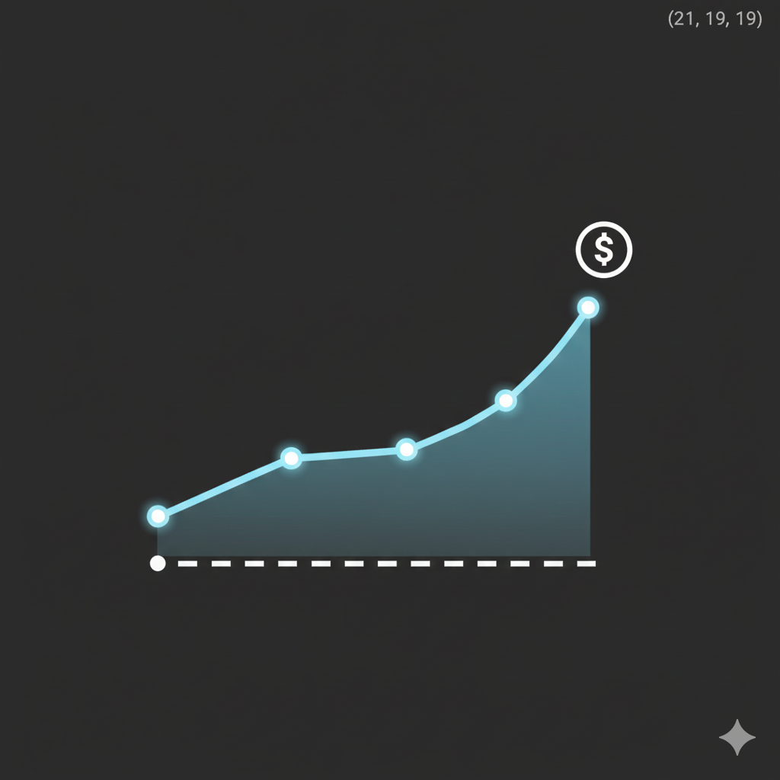
- Hi, can you generate a simple contact us logo? nothing fancy please

- Create me an image titled “About Us”, I’d like it to be a winky face please
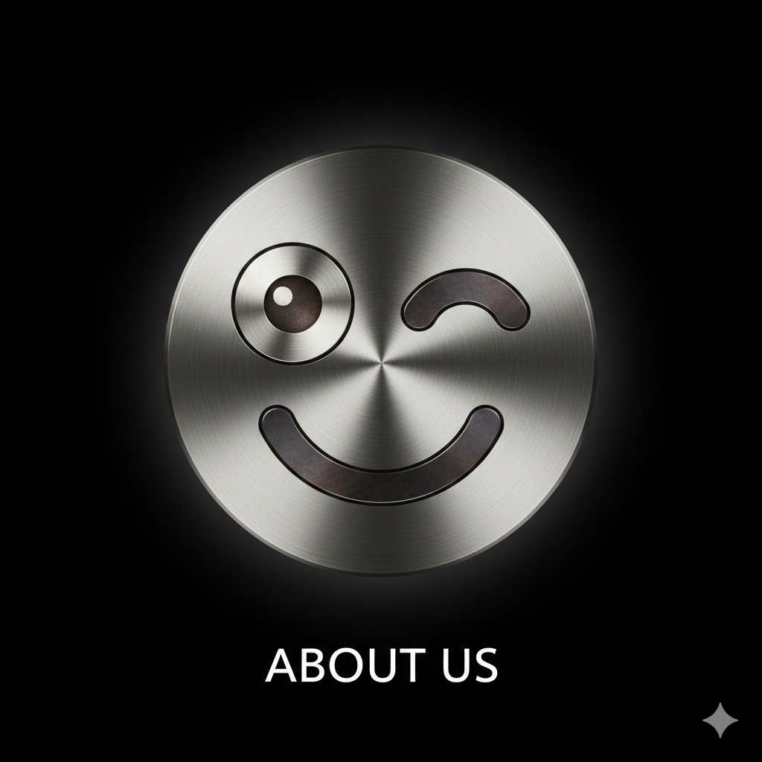

Image Attribution
[if images used from commercial site, give website locations. State if images have creative commons licence etc. allowing them to be used].
The only image that Gen Ai wasn’t used for was my Bitcoin image on the index page
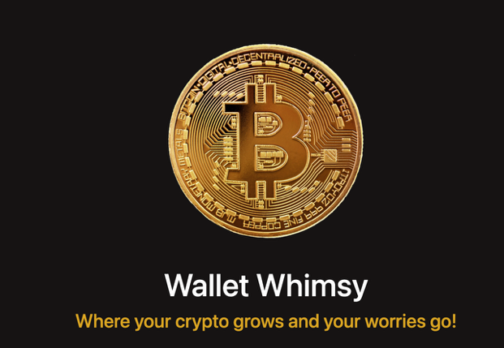
This was an image I used in the past for a presentation in my Personal Devlopment module. I got it from PNG Tree and it is fair use to use.

Design Decisions Made
[For each of the following state briefly what you did and why you did it]

Look and Feel
[Describe what how you have applied Bootstrap to your site or any customisations you have made toward the end of the project]
- Bootstrap was applied to most of my pages, mostly for convenience.
- I found myself using Bootstrap Containers, Rows / Columns, and certain classes like “text-centre” a lot as well.
I like using these classes because they are easy to use, lightweight and tidy. These classes helped centre or layout my content in a very organised way.
- I altered the sizing and colouring of some of these classes as I wanted to stray away from the Bootstrap look of them.

Breakpoints
[Briefly list what changes at each breakpoint. Did you implement any minor tweaks at these breakpoints using media query techniques? e.g. font size changes, hiding of content, responsive images using srcset, etc?]
<picture class="home-coin">
<source srcset="/images/BitcoinLarge.png" media="(min-width: 901px)">
<source srcset="/images/Bitcoin.png" media="(min-width: 601px)">
<img src="/images/BitcoinSmall.png" alt="Crytpo Image">
</picture>

- The first change I made for breakpoints was for the Bitcoin image on my index page.
I wanted the size to change for the breakpoints above.
- This image is removed when hitting the mobile breakpoint by using the “img-fluid” class.
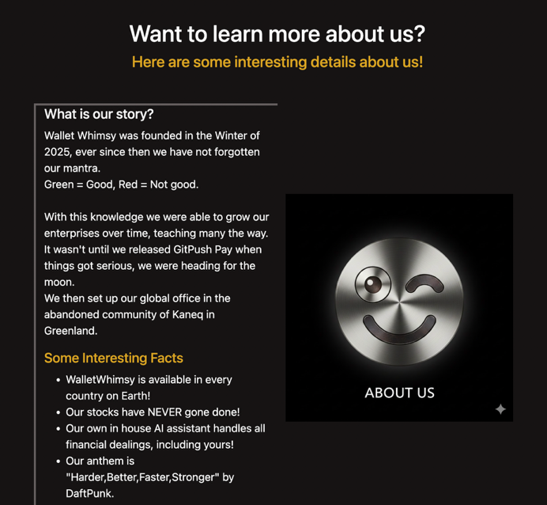
- For the shop page, I have it where a row of 3 cards becomes only 1 single column when hitting the mobile breakpoint.

Performance
[Explain what you have done to improve the performance of your site (minification, image optimisation, etc) , and suggest any changes you could make for a production site.
- Using SCSS I minified my CSS file which boosts site performance.
- If this were to be a production site, I would probably take greater care for all my images on the site.
- I would like to streamline my Javascript files (where possible).
- I would like to add greater validation to my inputs on the site.

SEO
[Explain what you have done to improve the SEO of your site. Illustrate with brief screenshot examples from your code]
I had a general list of meta data like keywords in my head partial (see below)
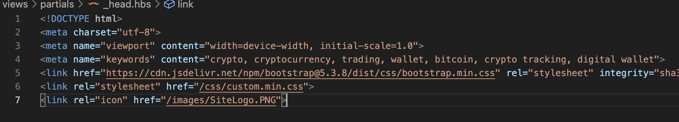
And tried to include different keywords for different routes, also see below:
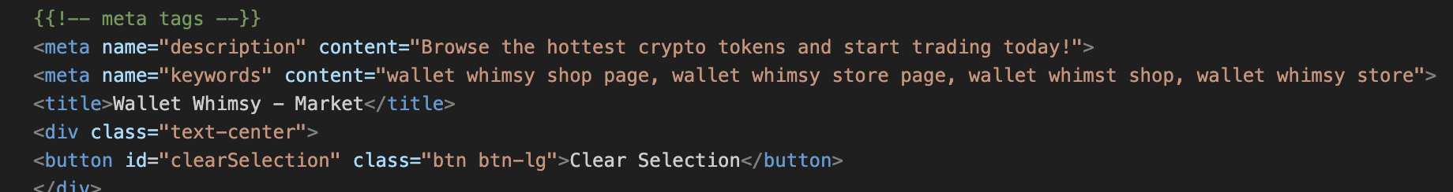
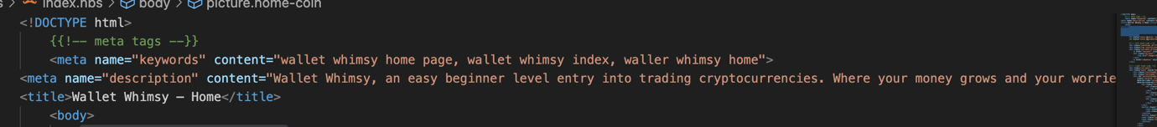
As you can see I also added a description tag to my pages too.

Accessibility
[Explain briefly what you have done to make your site accessible. Illustrate with screenshot examples from your code]
I attempted to place buttons near the bottom centre of the screen to make it easier for mobile use.

Wireframes
[If the paper wireframes that you presented in early November are different to the finished website – explain briefly why this is so? What could you have done differently?]
I believe I stuck to my Wireframes well.

Reflection on your work

Write briefly under the following headings:
- What went well?
- What did not go well and if so what would you differently?
- Did you do anything in this project that was not covered in this module, maybe it was covered in another module? Maybe you applied something you learning from your own research?
- Creating the structure of the website, I think it went well. Once I got the styling I wanted it felt more like filling in the blanks when I added new content to my page.
- Debugging the Javascript was a nightmare at times (usually because it was a missing ; or the id’s did not match), however I know that this will only improve with time.
If I were to recreate this site again, I would plan ahead how I wanted my JS to work to make it less messy.
- A lot of the Javascript I used was previously covered in another module (Client Side Scripting), adding things like Event Listeners or appending data to empty divs was light work.
Some of the Javascript used was also just basic programming knowledge, adding to a quanity when a button was clicked etc.
Local Storage however was completely new to me, we have touched on it slightly in another module when using API’s however never in detail. I’m very happy with the progress I made with it.

