PARTICIPANT PROFILE
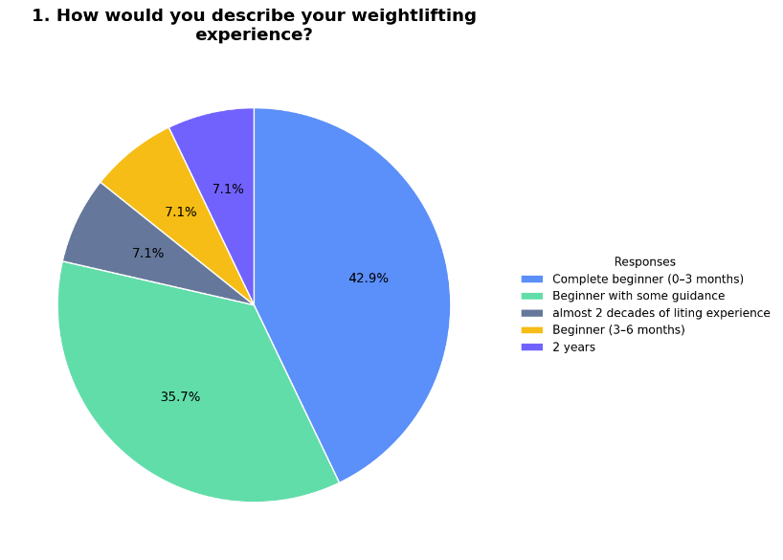
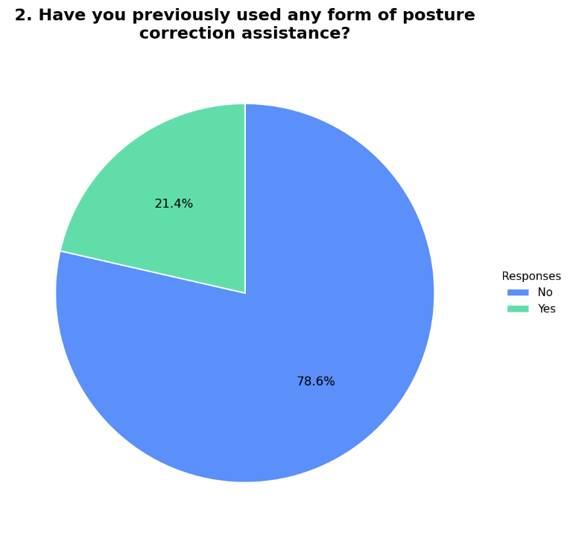
The participant profile shows that the majority of respondents are beginners, with most having little to no prior weightlifting experience, while a smaller portion reported having some guidance or more extensive experience. Additionally, most participants indicated that they have not previously used any form of posture correction assistance, which means that the system was evaluated primarily by first-time or inexperienced users. This is important because it suggests that the system’s usability and effectiveness are being assessed by individuals who are most likely to benefit from guided feedback.

BICEP CURL EVALUATION
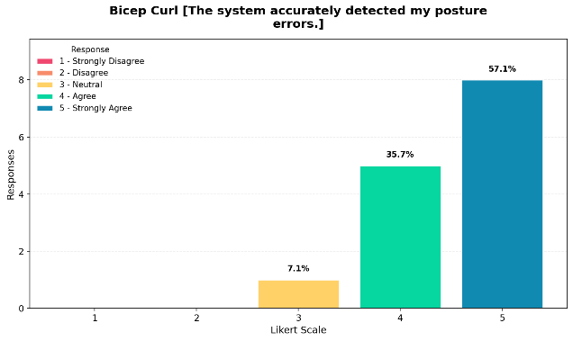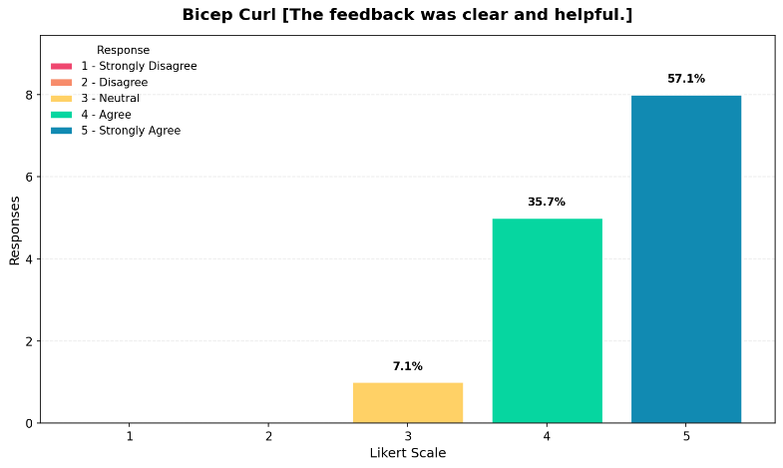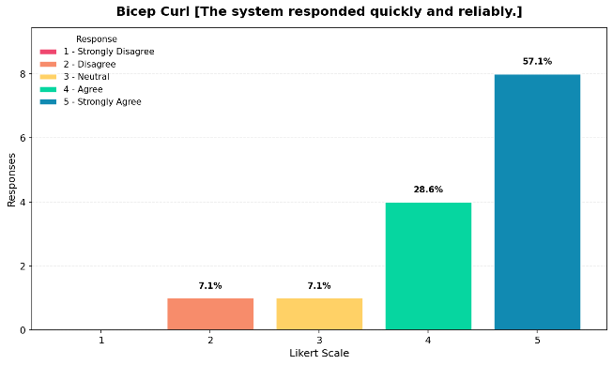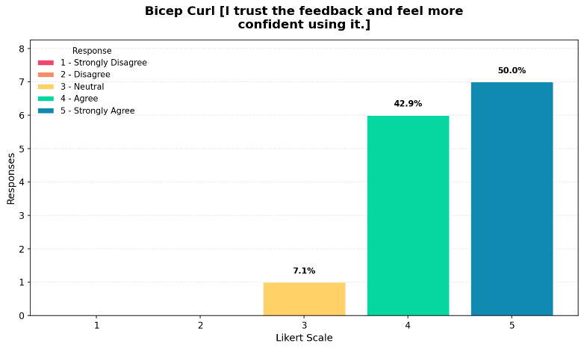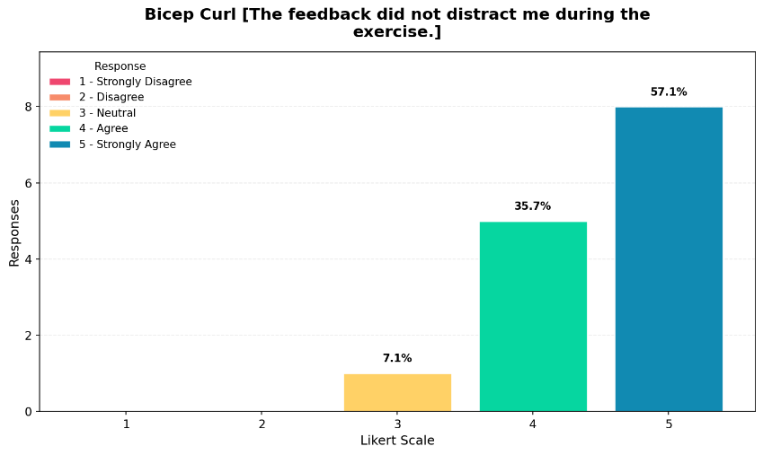The results for the bicep curl exercise show that the majority of responses fall within values 4 and 5 across all evaluated aspects, which indicates that users generally agree that the system performs effectively during the exercise. Most participants strongly agreed that the system accurately detects posture errors and provides clear and helpful feedback, which suggests that the feedback mechanism is understandable and useful for beginners. The system was also perceived as responsive and reliable, although a small number of neutral and lower responses indicate that there may be occasional delays or inconsistencies experienced by some users. In terms of user confidence, most respondents reported that they trust the feedback and feel more confident when using the system, which highlights its effectiveness in guiding performance. Additionally, the feedback was generally not distracting during the exercise, indicating that the system integrates well into the workout without interrupting user focus. Overall, these results suggest that the system performs well in assisting users during bicep curl exercises, particularly for beginner-level users.

SHOULDER PRESS EVALUATION
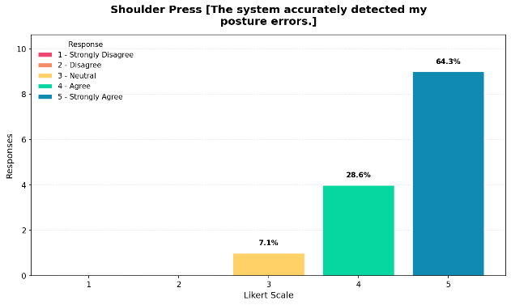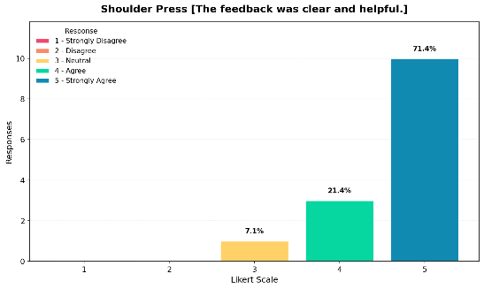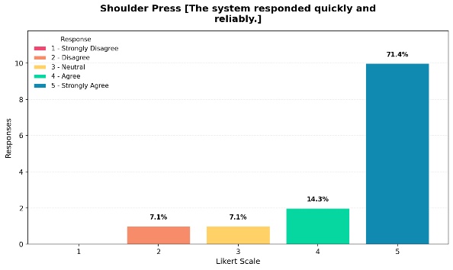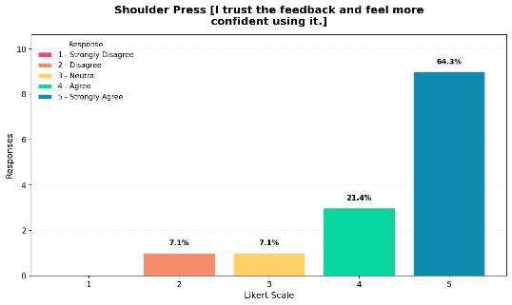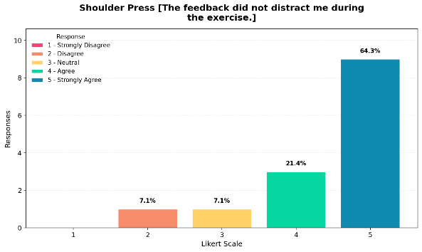
The results for the shoulder press exercise indicate that most responses are concentrated at value 5, which means that participants strongly agree that the system performs effectively across all evaluated aspects. The system was perceived as highly accurate in detecting posture errors, while the feedback provided was considered clear and helpful. The responsiveness of the system was also rated highly, although a few lower responses suggest that minor inconsistencies may still occur. Participants reported high levels of trust and confidence when using the system, indicating that the feedback is reliable and contributes positively to their performance. Furthermore, the feedback was generally not distracting during the exercise, which shows that the system can provide guidance without interfering with user focus. Overall, the results suggest that the system performs very well during shoulder press exercises, with strong user satisfaction across all criteria.

LATERAL RAISE EVALUATION

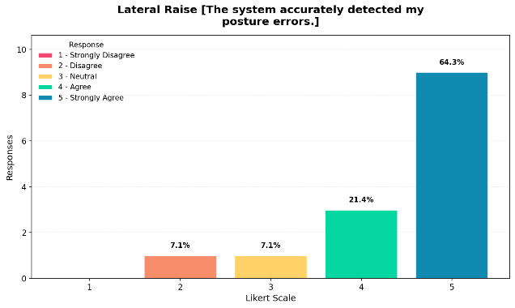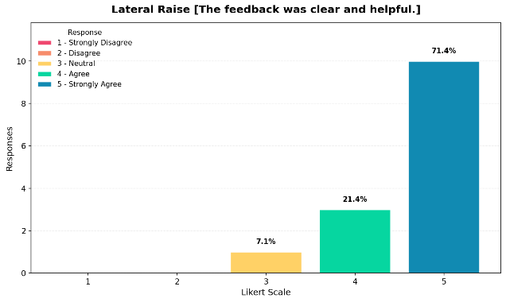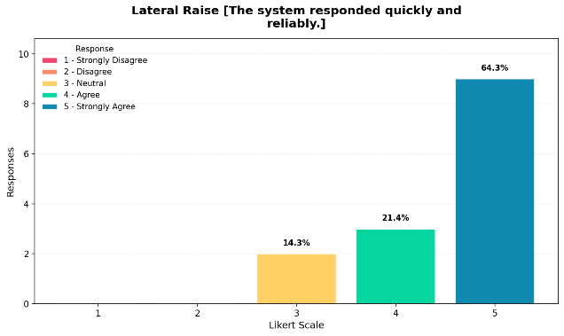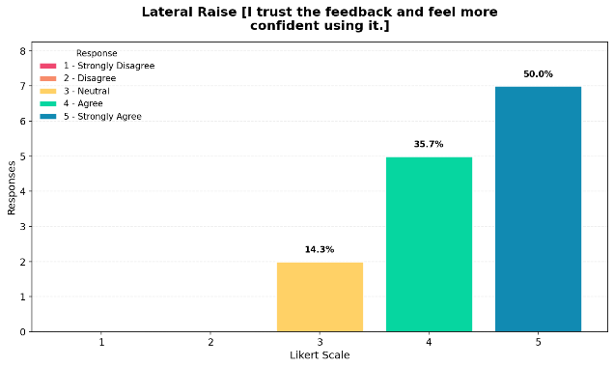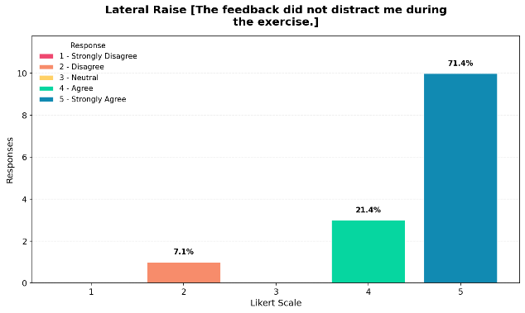
The results for the lateral raise exercise show that most responses fall within values 4 and 5, indicating that participants generally agree that the system performs effectively during this exercise. The system was rated highly in terms of posture detection accuracy and feedback clarity, which suggests that users are able to understand and apply the feedback provided. While most responses indicate strong agreement, the presence of some neutral responses suggests that certain aspects of the system may be less consistent during this exercise compared to others. Participants also reported that they trust the feedback and feel more confident when using the system, although this is slightly less pronounced than in other exercises. Additionally, the feedback was generally not distracting, indicating that it does not interfere with user performance. Overall, the system demonstrates good performance in lateral raise exercises, although there may be slightly more variability in user experience compared to other movements.
FATIGUE ADAPTATION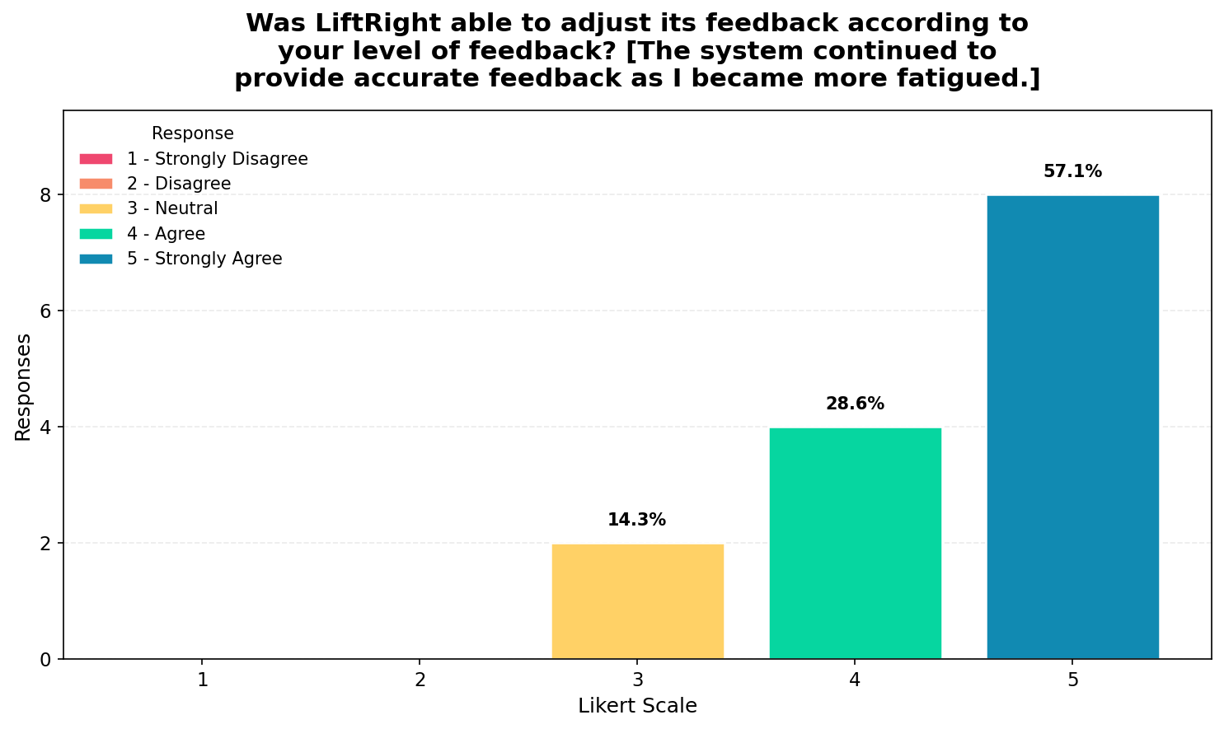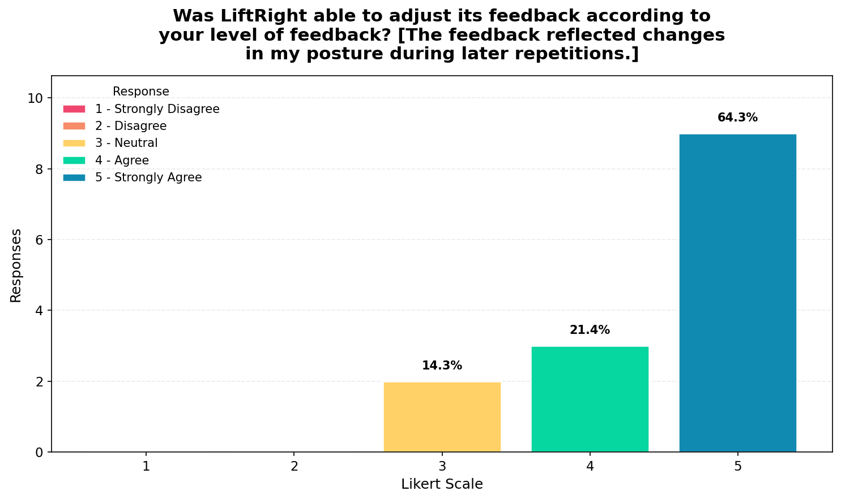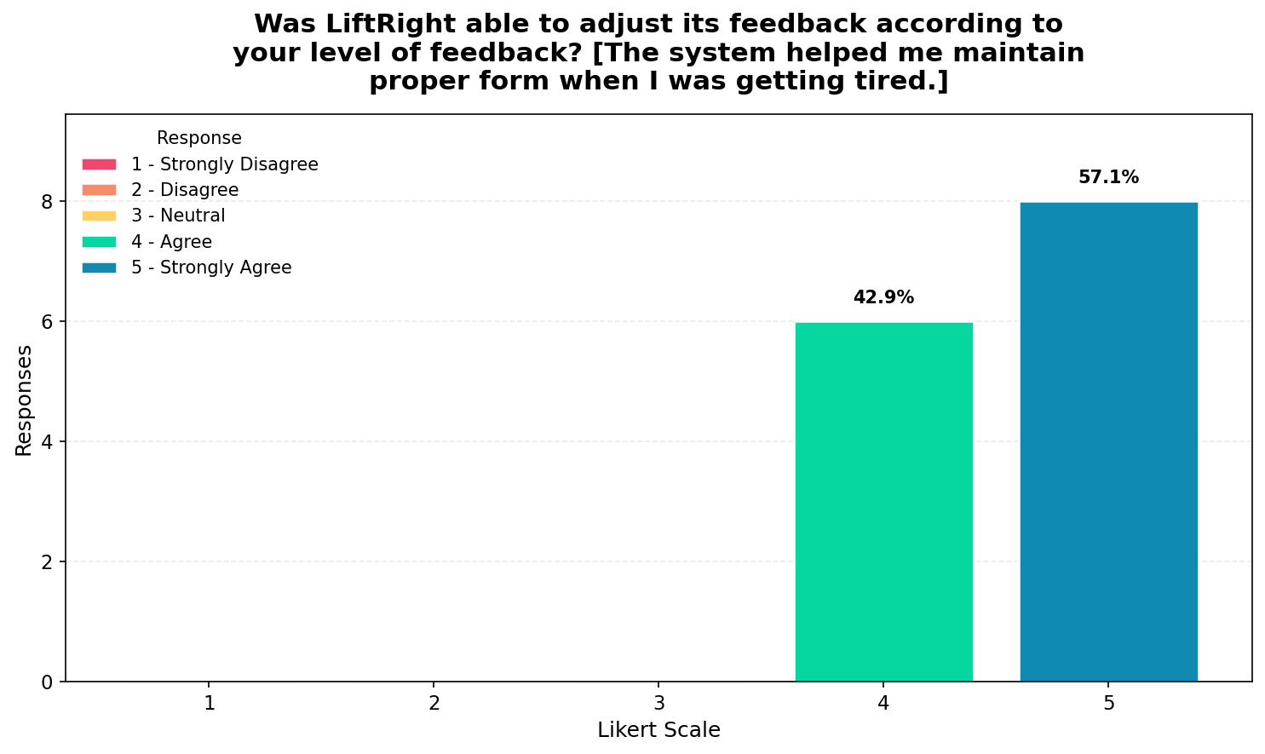The results for fatigue adaptation indicate that most responses fall within values 4 and 5, which means that participants generally agree that the system is capable of adjusting its feedback based on their level of fatigue. Respondents indicated that the feedback reflected changes in their posture during later repetitions and helped them maintain proper form even when they were getting tired. The presence of some neutral responses suggests that this behavior may not be consistently perceived across all users, which indicates that while the fatigue recognition component is effective, further refinement may be needed to ensure more consistent performance across different users.

USABILITY
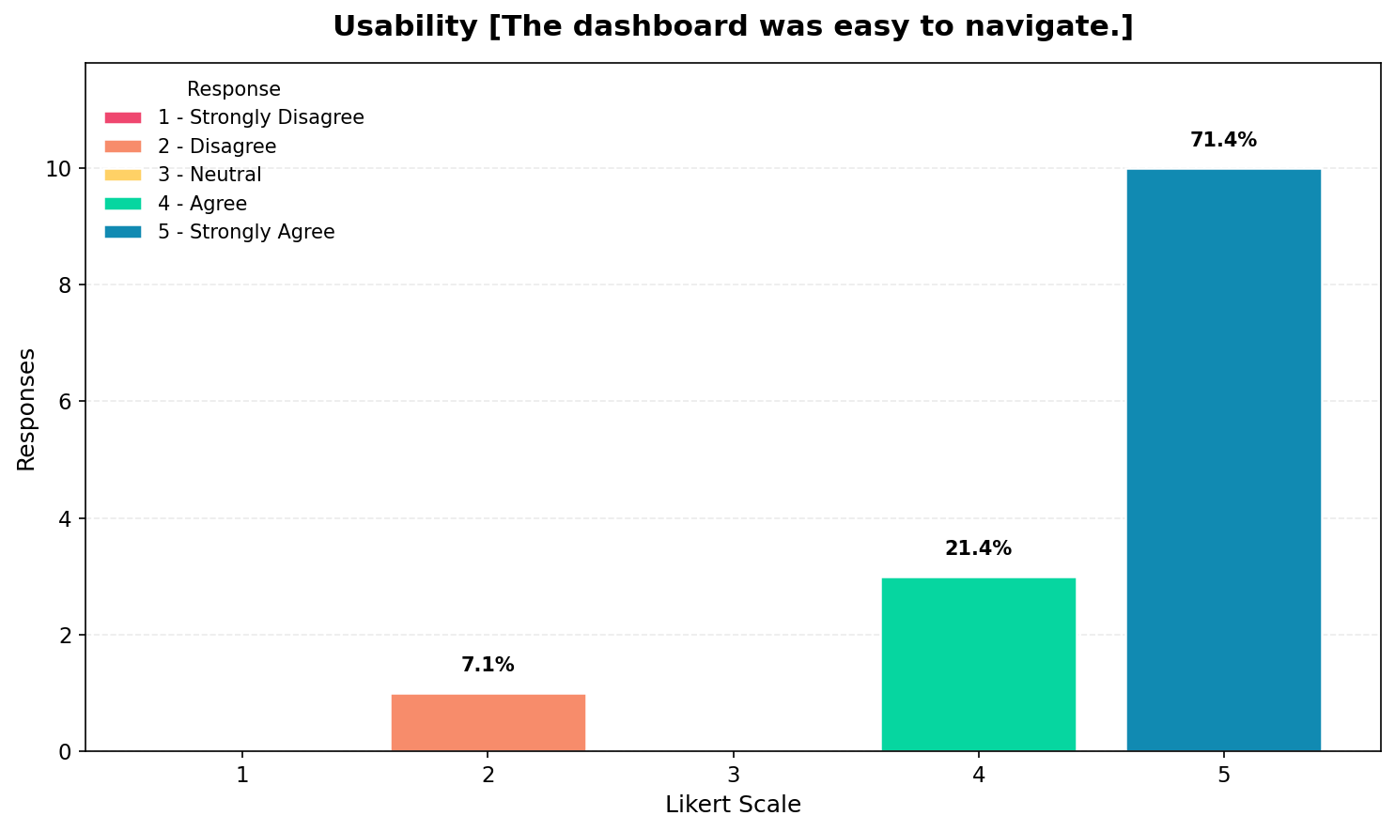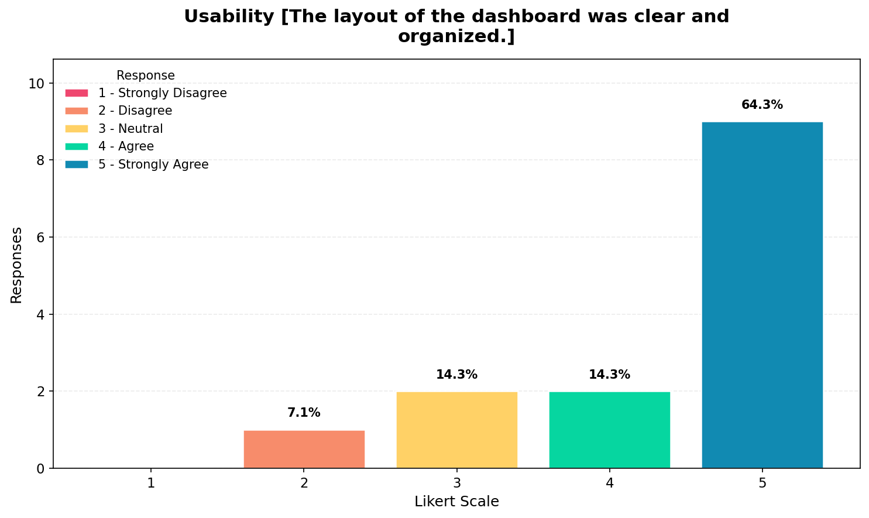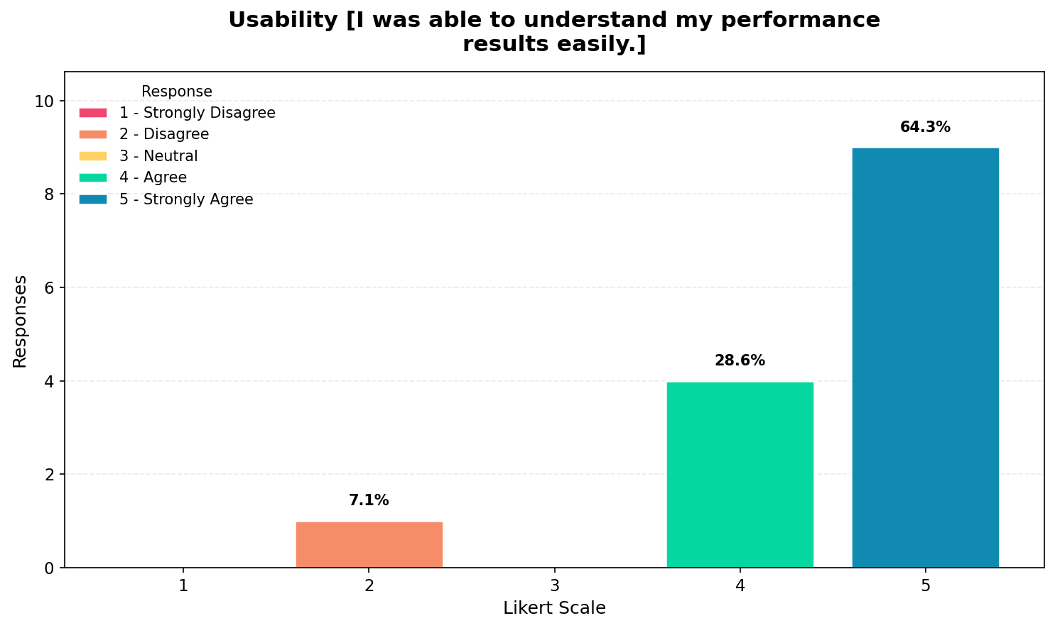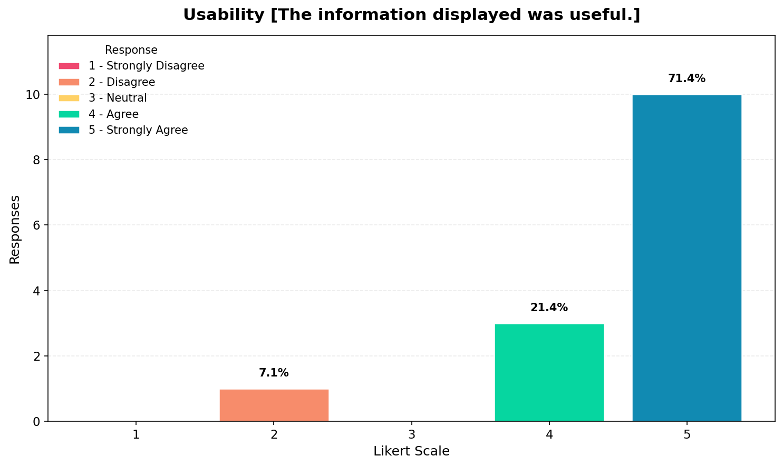
The usability results show that the majority of responses are concentrated at values 4 and 5, which indicates that participants generally find the system easy to use and understand. The dashboard was perceived as easy to navigate, and the layout was considered clear and organized, which helps users interact with the system effectively. Additionally, most respondents agreed that they were able to understand their performance results easily and that the information displayed by the system was useful. However, the presence of some neutral and lower responses suggests that certain aspects of the interface may still require minor improvements in clarity or presentation. Overall, the results indicate that the system provides a usable and accessible interface for beginner users.

LEARNABILITY & USEFULNESS
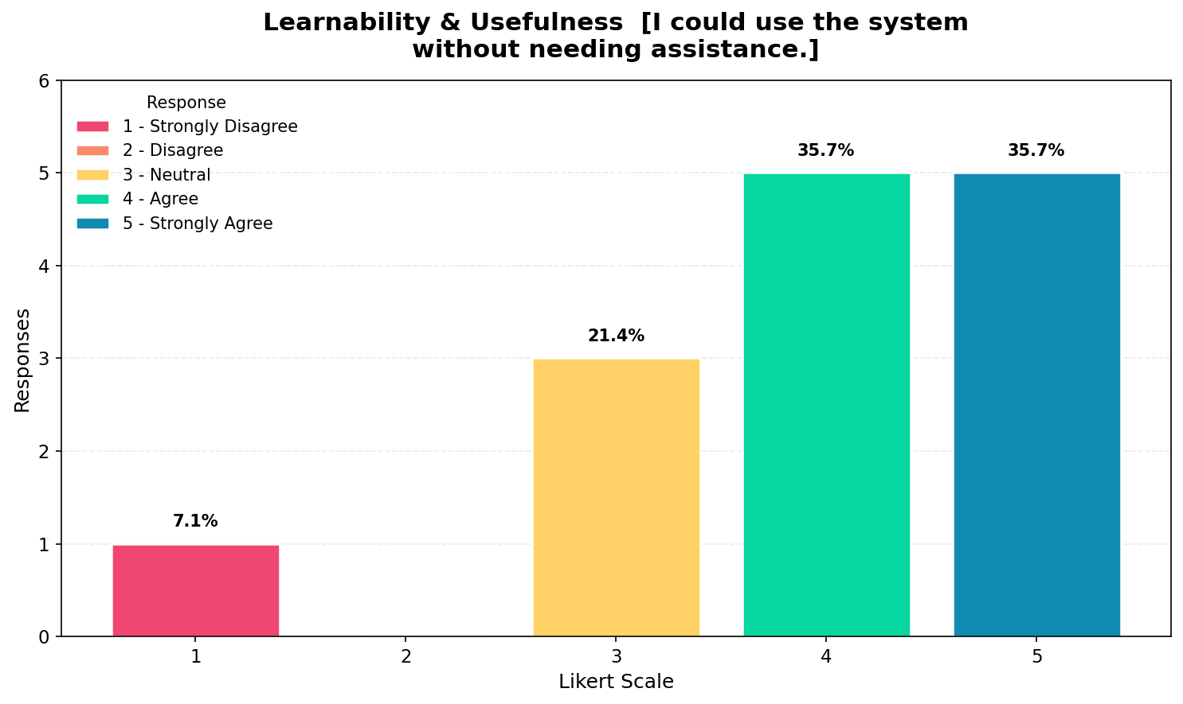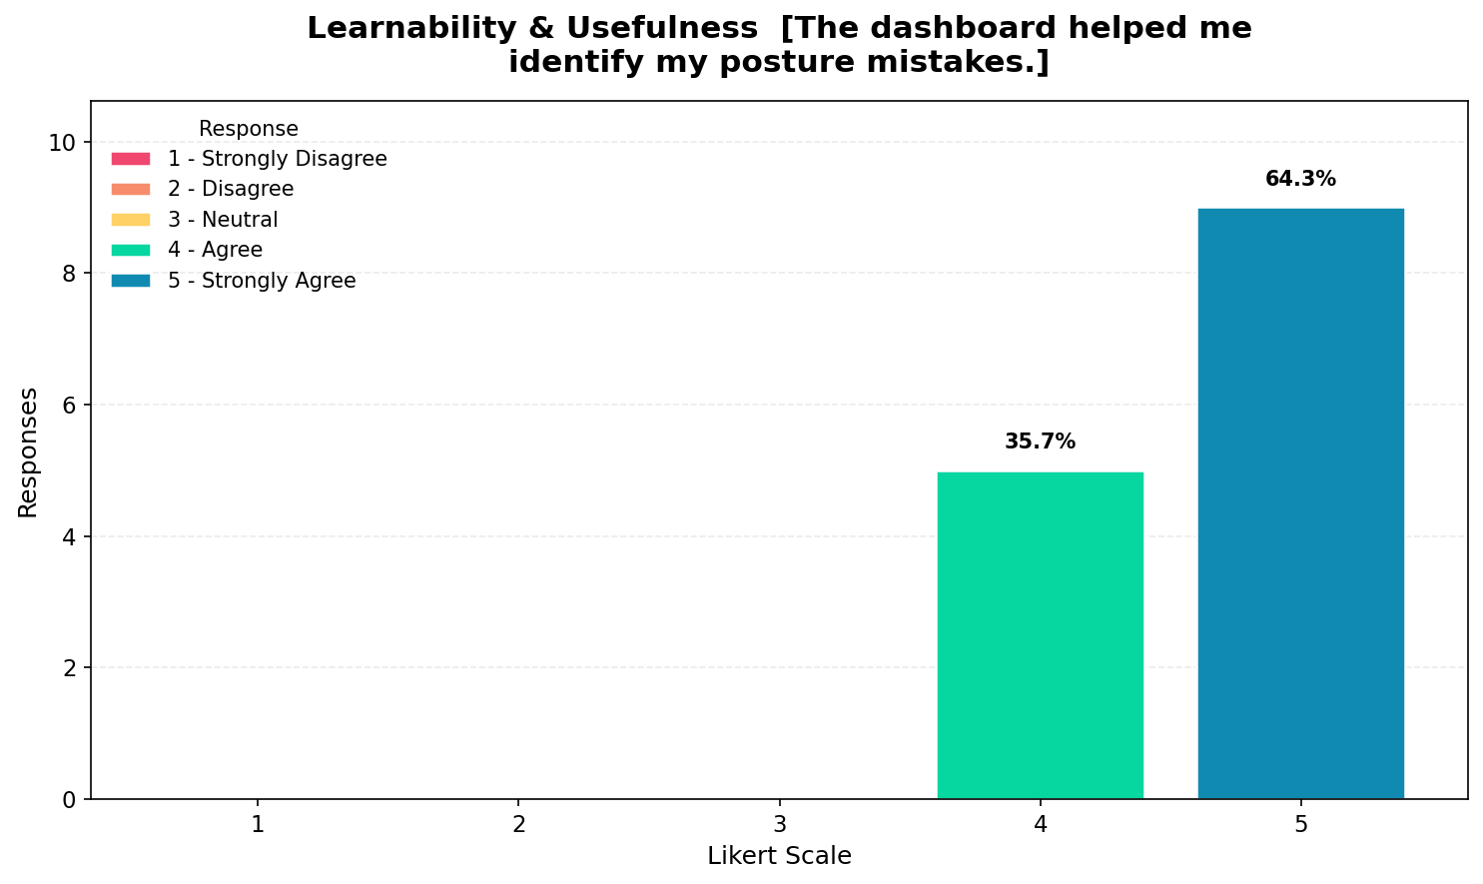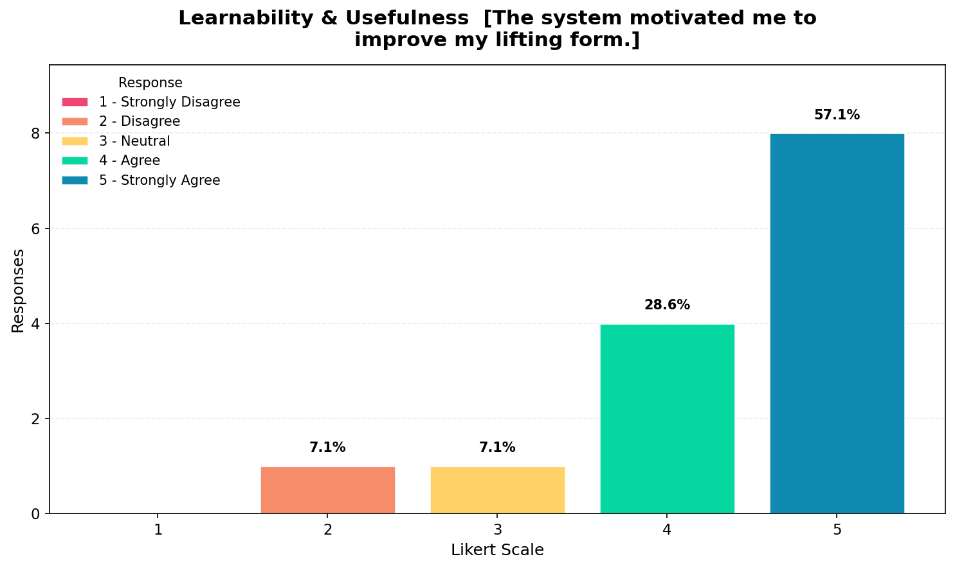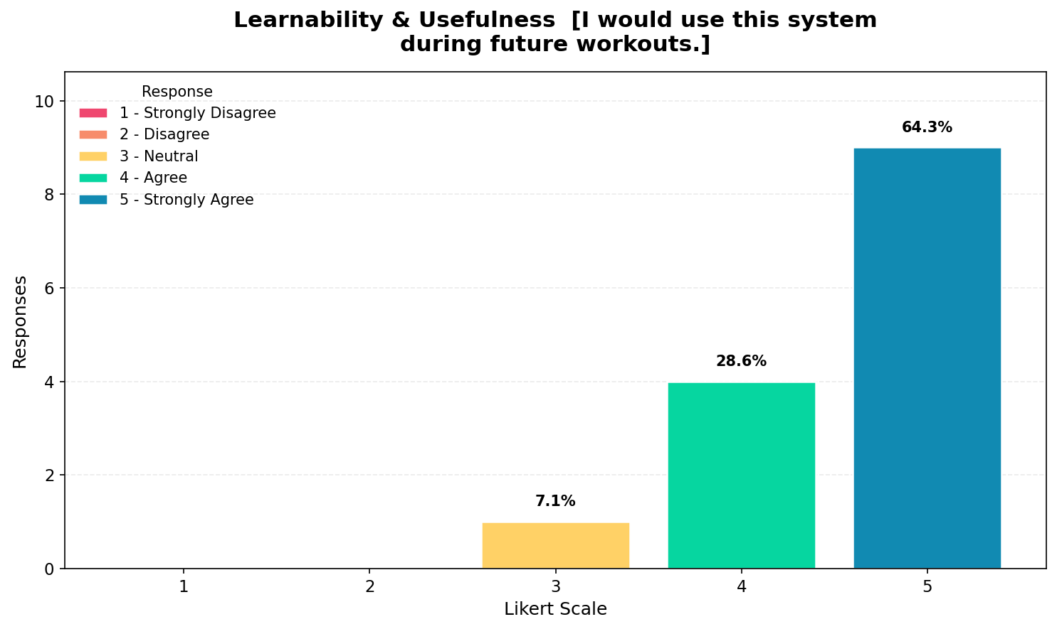The results for learnability and usefulness indicate that most participants selected values between 4 and 5, which suggests that the system is generally easy to learn and beneficial for improving exercise performance. Respondents indicated that they are able to use the system without assistance, although some neutral responses suggest that not all users feel fully independent when interacting with it. The system was also perceived as helpful in identifying posture mistakes and motivating users to improve their lifting form, which highlights its effectiveness as a training aid. Furthermore, most participants expressed willingness to use the system during future workouts, indicating a positive perception of its usefulness. Overall, these results suggest that the system supports learning and skill development, particularly for beginner users.

USER SATISFACTION / INTENT
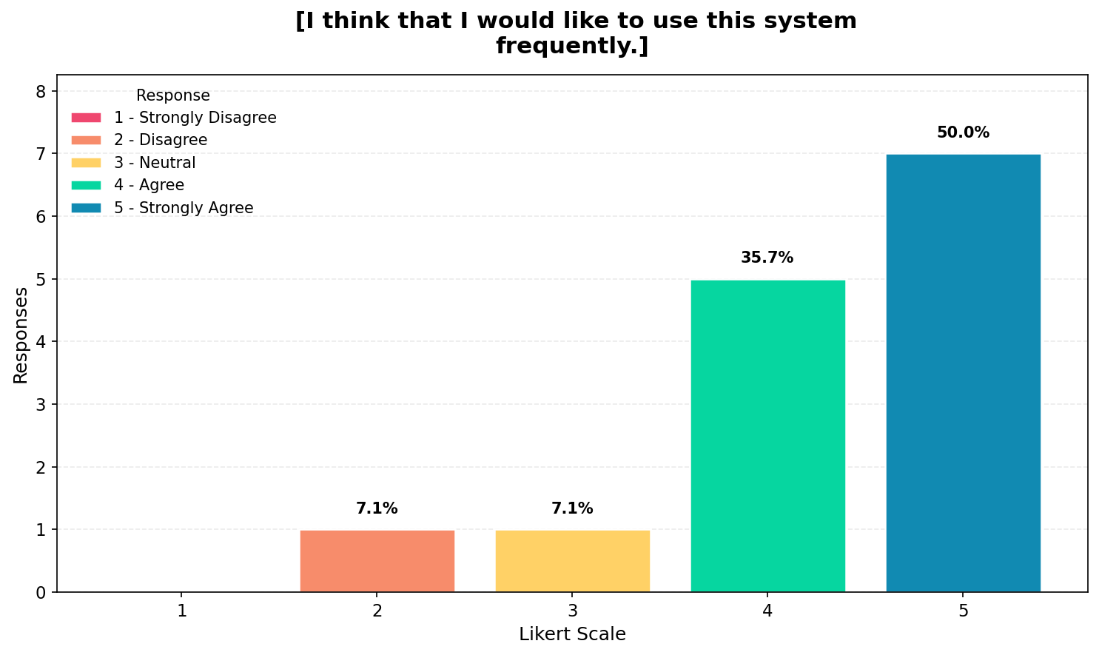The responses for this item show that most participants selected values 4 and 5, which indicates that users are generally willing to use the system frequently. This suggests that the system is engaging and provides sufficient value for continued use, although the presence of some lower responses indicates that not all users are fully committed to frequent usage. This reflects a generally positive but not absolute level of user satisfaction.

NEGATIVE USABILITY PERCEPTION
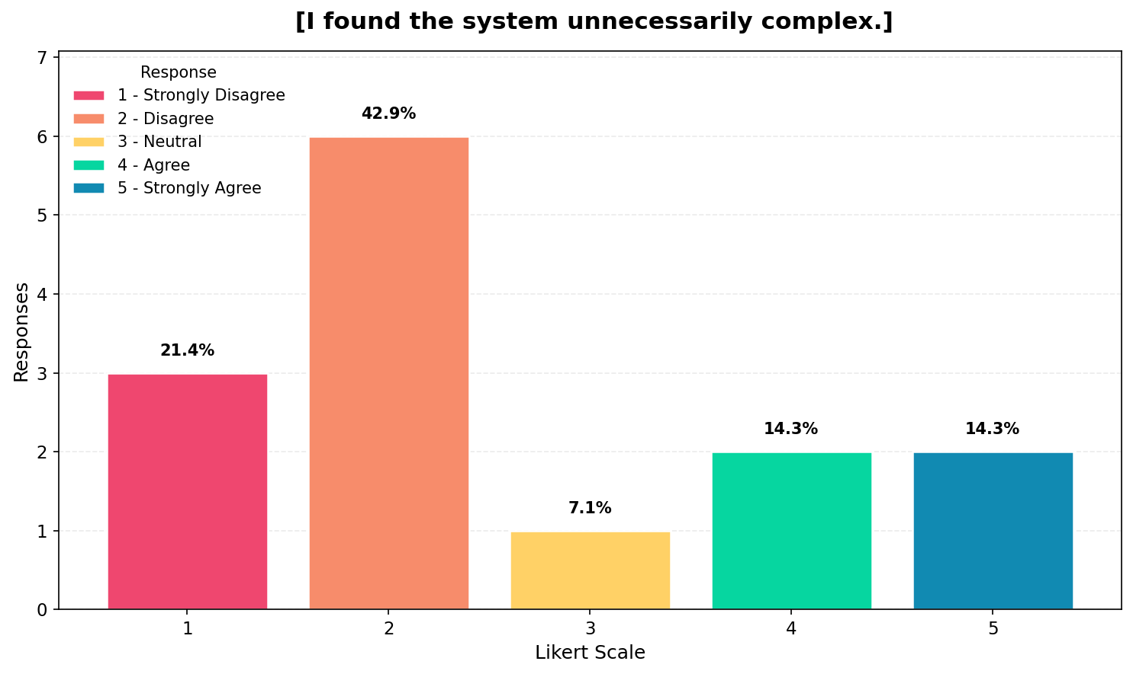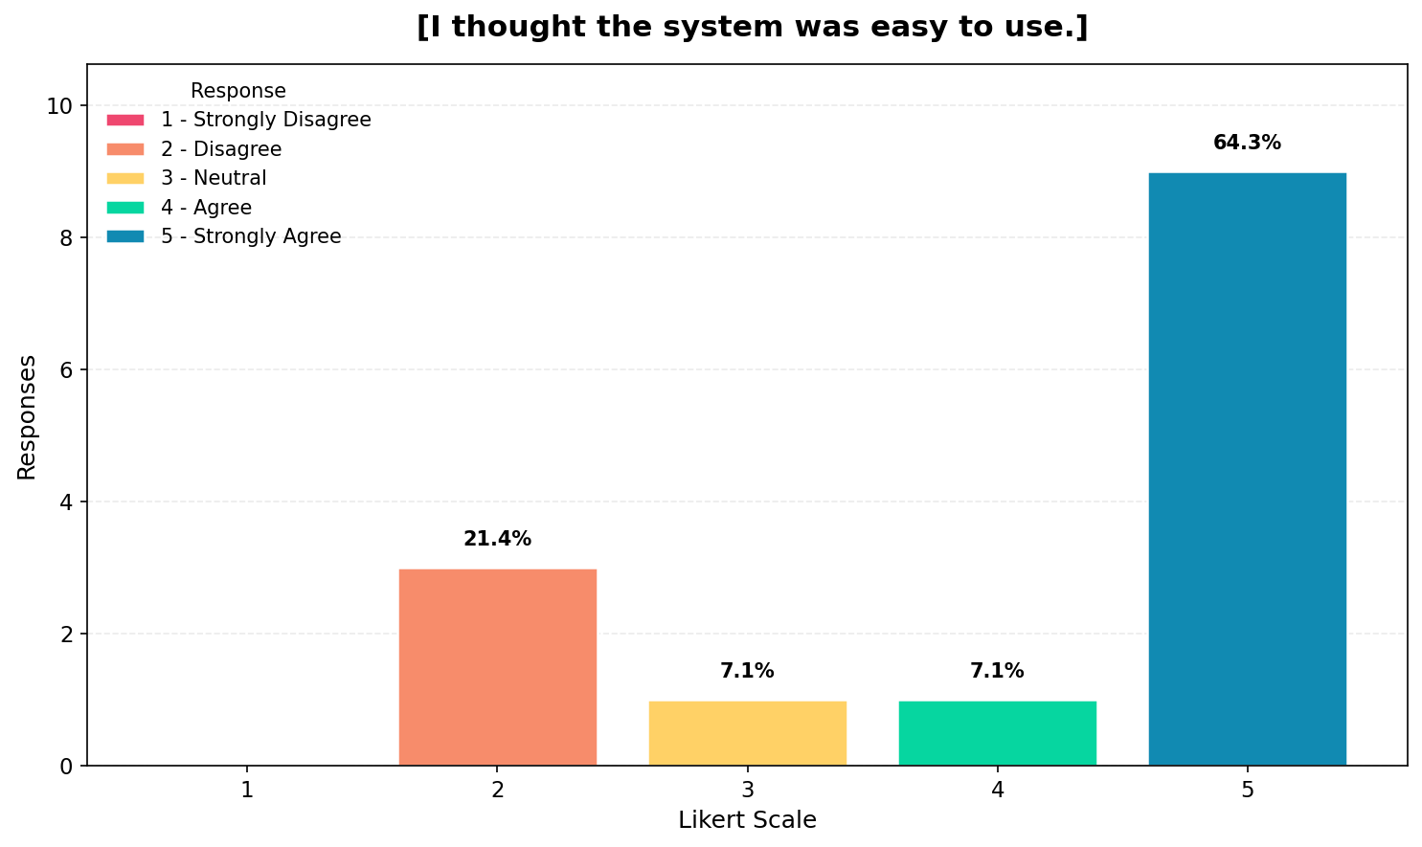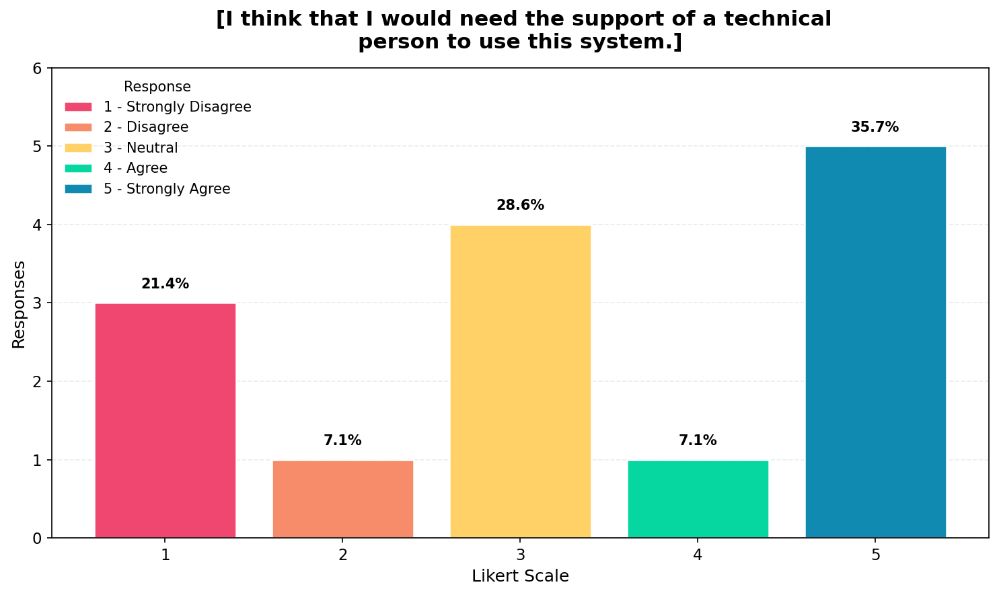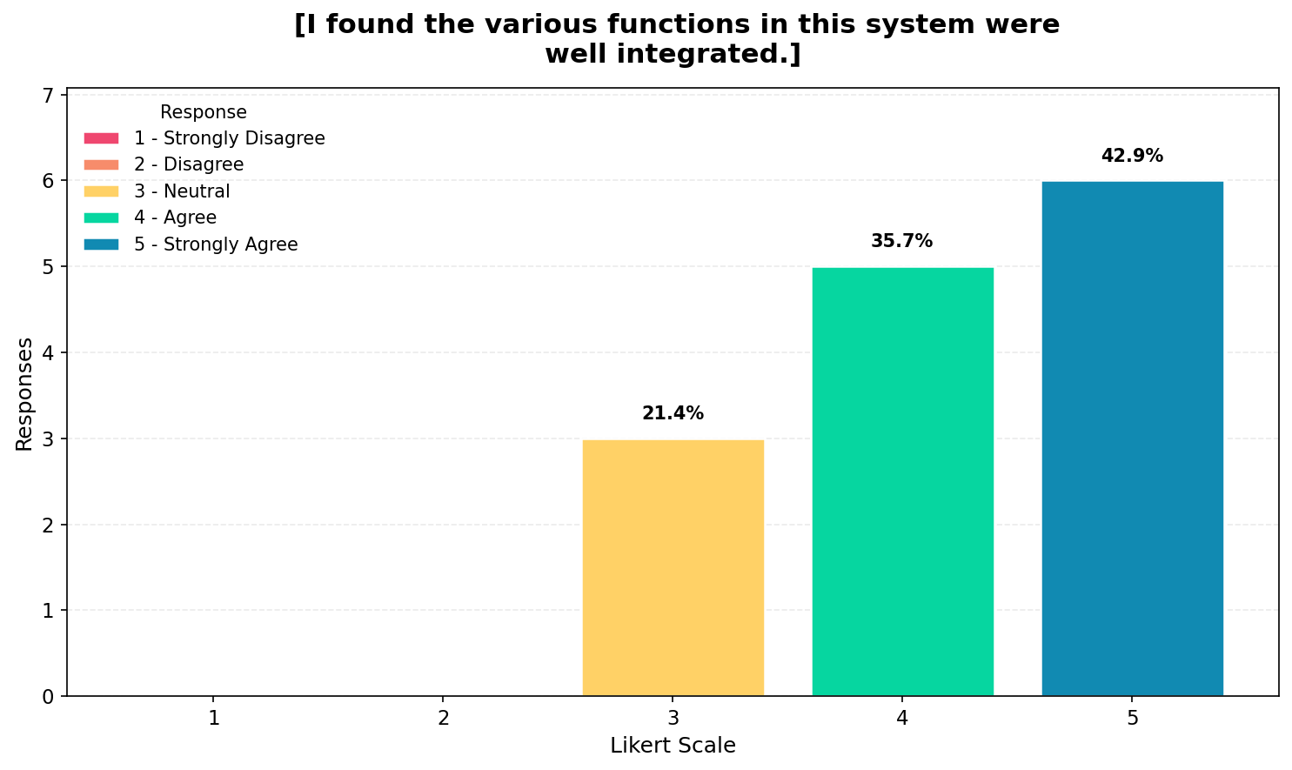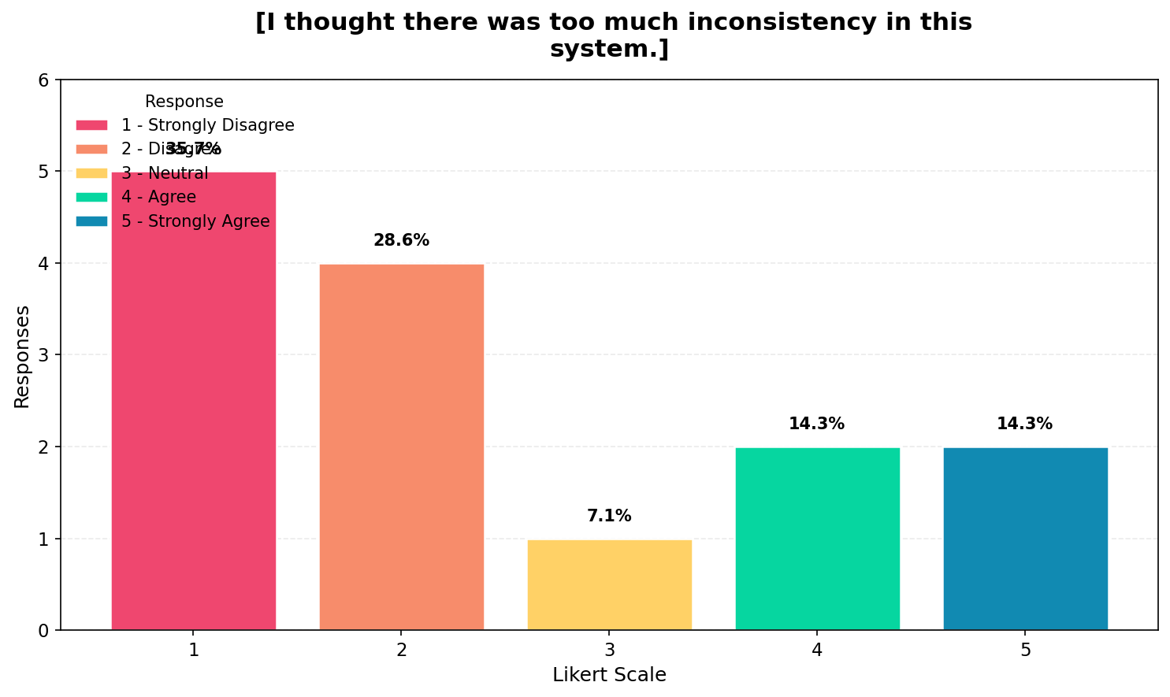The results for negative usability perception show a more varied distribution of responses compared to previous sections, which indicates that participants experienced some challenges while using the system. While a portion of respondents disagreed with statements suggesting that the system is complex, a notable number of participants still expressed agreement, which suggests that some users perceive the system as difficult to use. Similarly, responses regarding the need for technical support show that several users believe assistance may be required, indicating that the system may not be entirely intuitive for all beginners. Despite this, many respondents agreed that the system is easy to use and that its functions are well integrated, which suggests that usability issues are not universal but may depend on individual user experience. Additionally, responses related to system inconsistency indicate that some users encountered variability in performance, which aligns with earlier observations regarding occasional inconsistencies. Overall, this section highlights areas where the system can be improved, particularly in simplifying the user experience and ensuring consistent performance.

LEARNING CURVE & EFFICIENCY
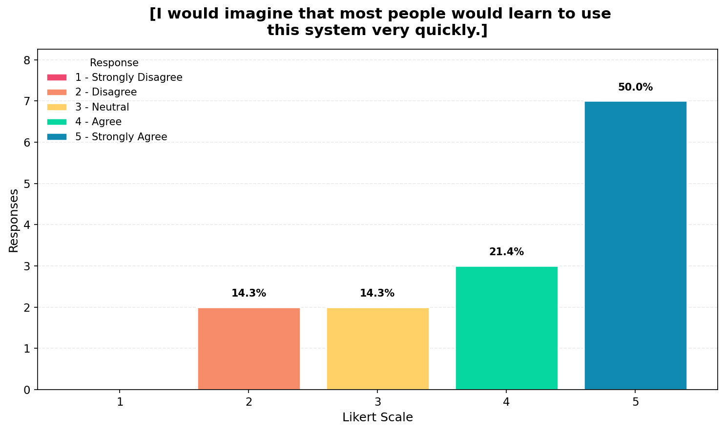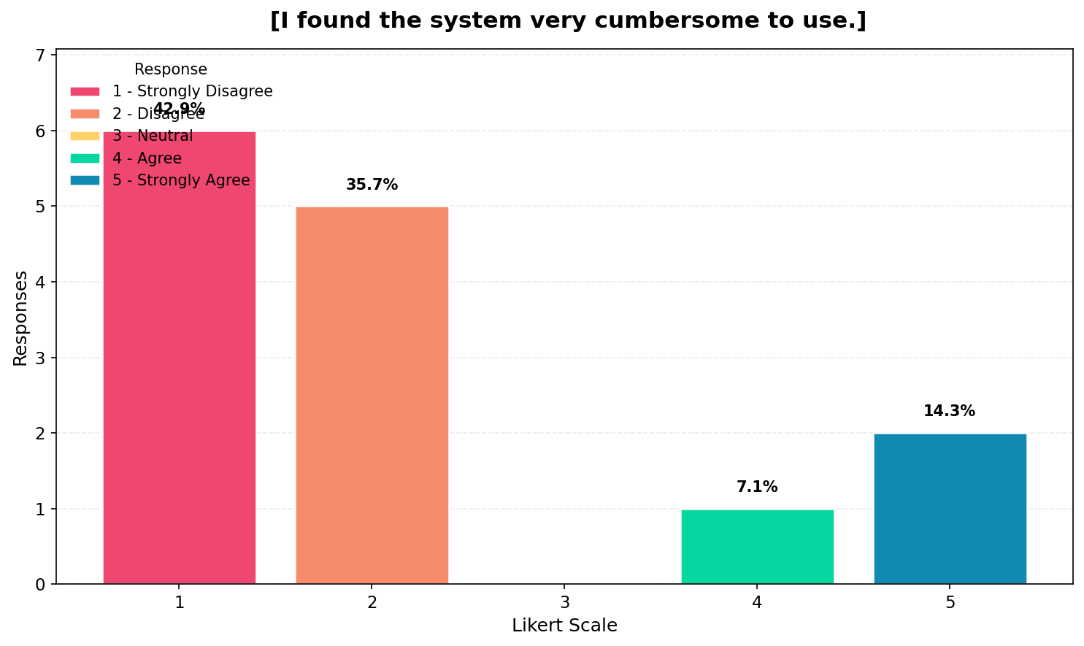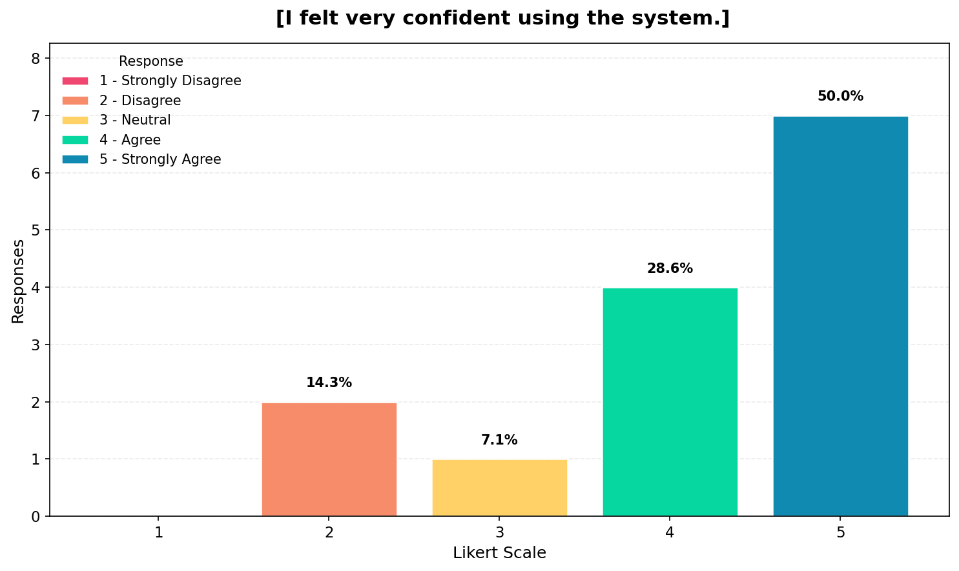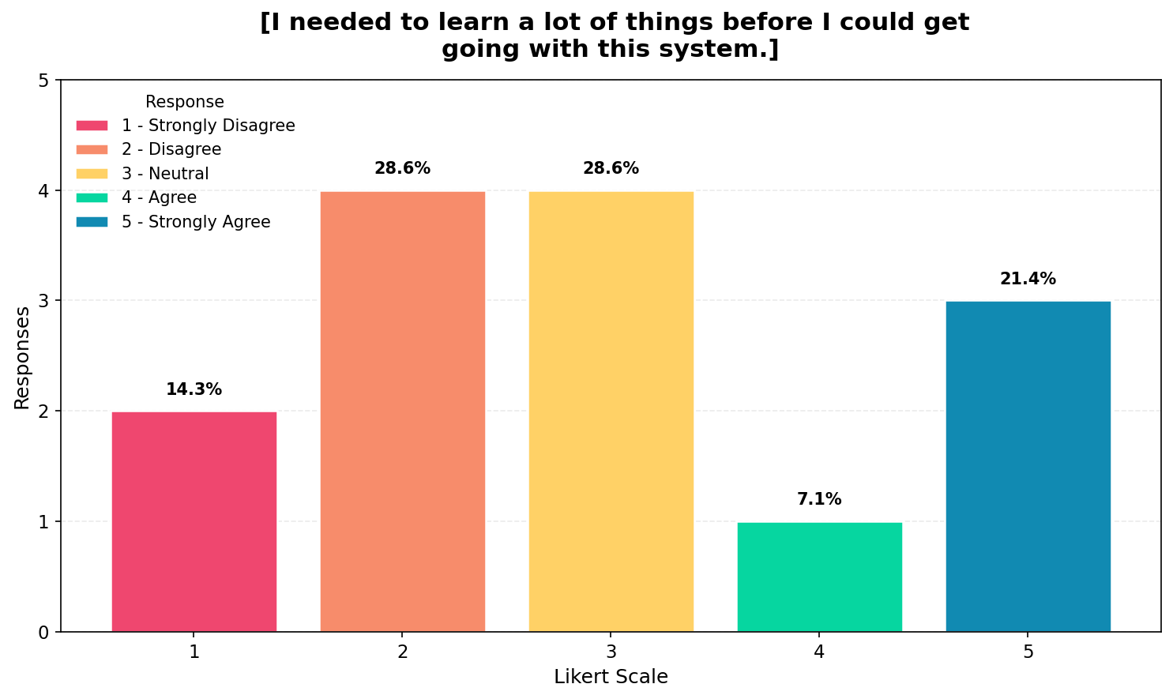
The results for learning curve and efficiency show that most participants generally agree that the system can be learned quickly, which indicates that it is accessible to beginner users. However, responses regarding the system being cumbersome reveal that some users still find it difficult or inconvenient to use, suggesting that the interface or workflow may require simplification. Participants also reported moderate to high levels of confidence when using the system, which indicates that despite some usability challenges, users are still able to interact with the system effectively. Additionally, responses regarding the amount of learning required show a mixed distribution, which suggests that while some users find the system easy to adopt, others perceive a steeper learning curve. Overall, this indicates that the system is generally usable but may require improvements to reduce complexity and enhance ease of learning.

