PARTICIPANT PROFILE
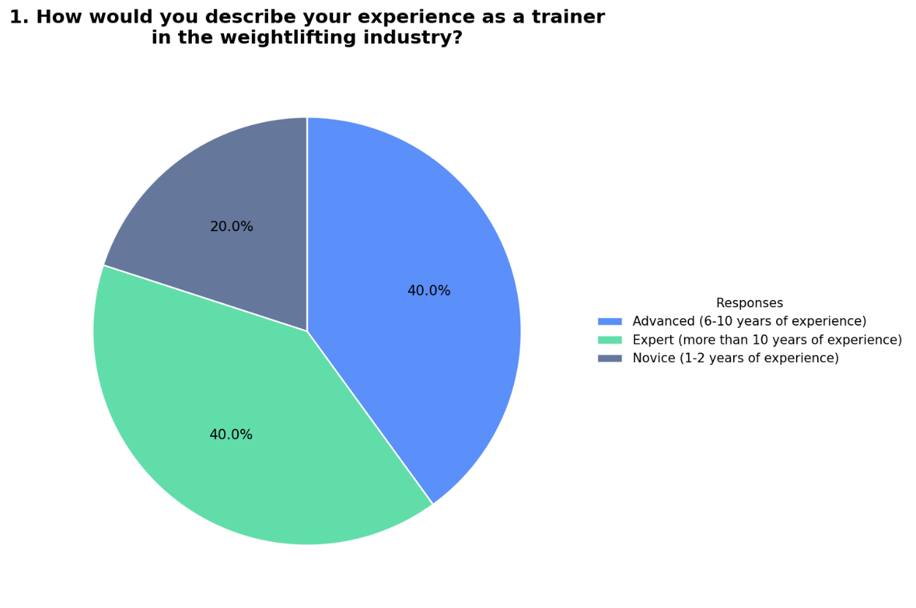
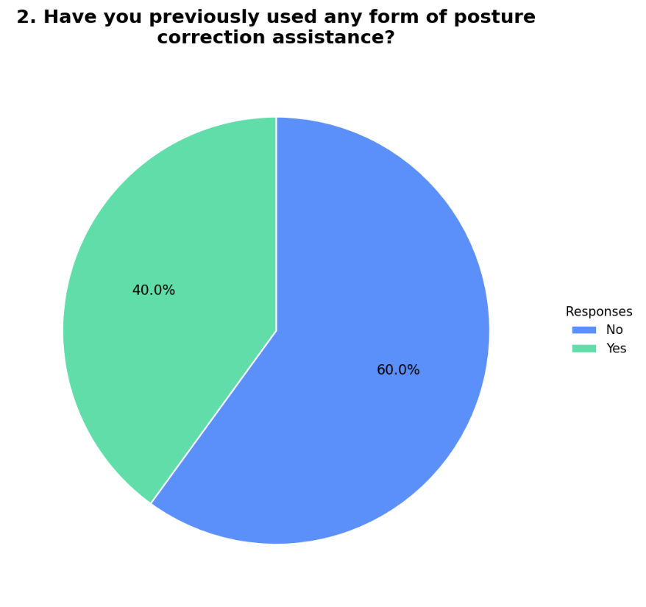
The participant profile indicates that the respondents consist primarily of experienced trainers, with the majority categorized as advanced and expert-level practitioners, while a smaller portion are novice trainers. This reflects a group with strong practical knowledge in weightlifting and exercise instruction. Additionally, most respondents indicated that they have not previously used posture correction systems, although a notable portion have prior experience, which suggests that the evaluation includes both first-time users and those familiar with similar tools. This provides a balanced perspective on the system’s effectiveness from a trainer’s point of view.

BICEP CURL EVALUATION

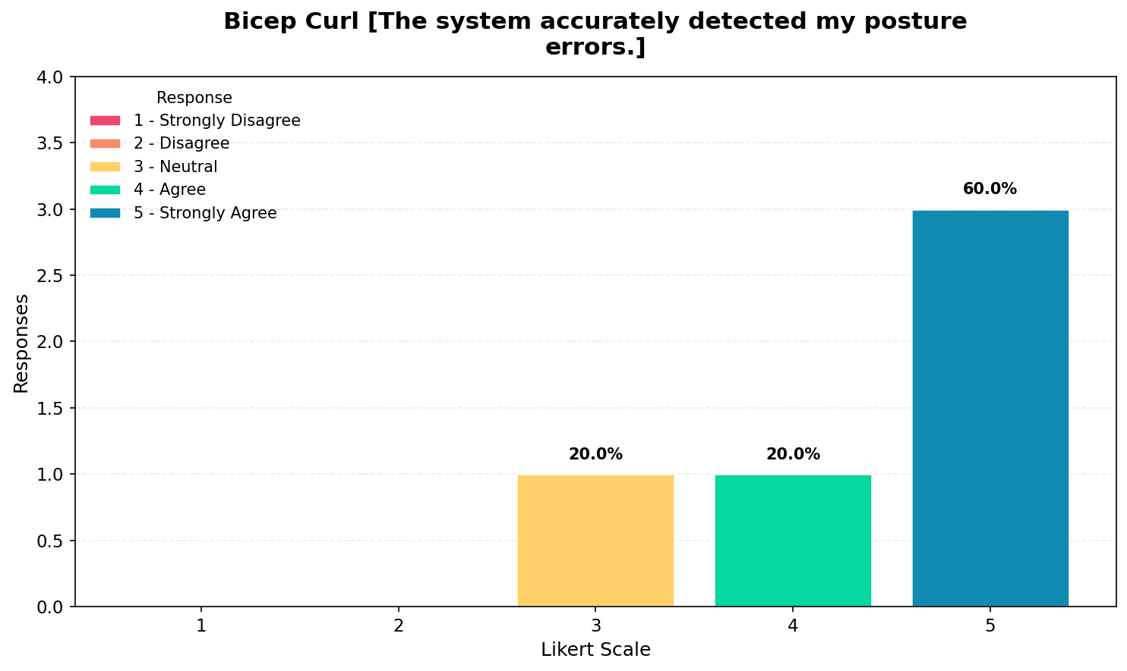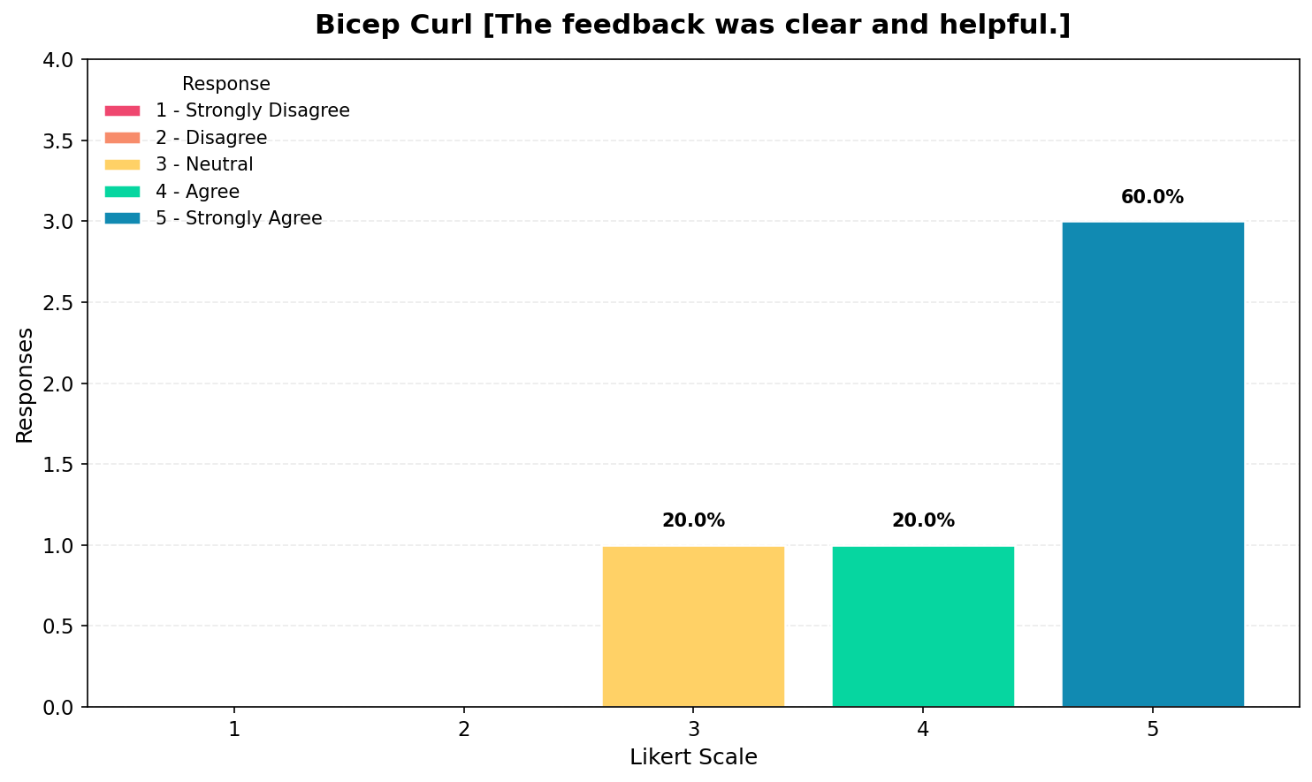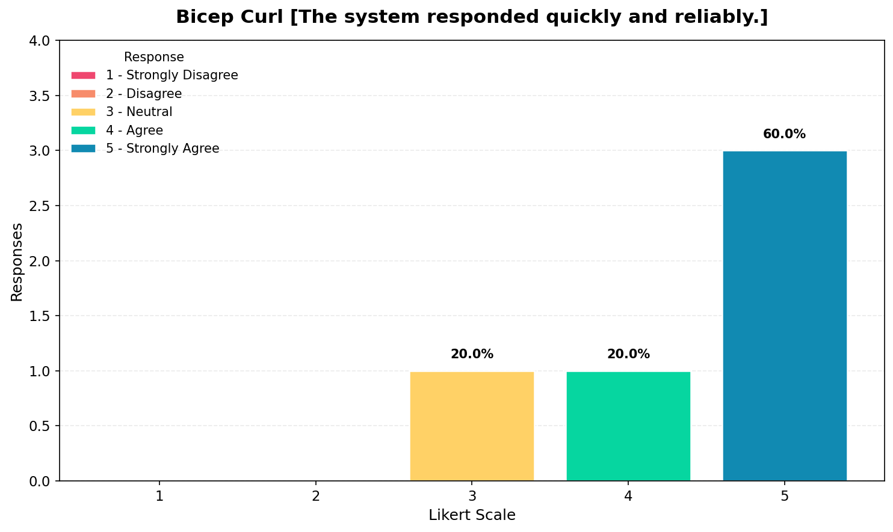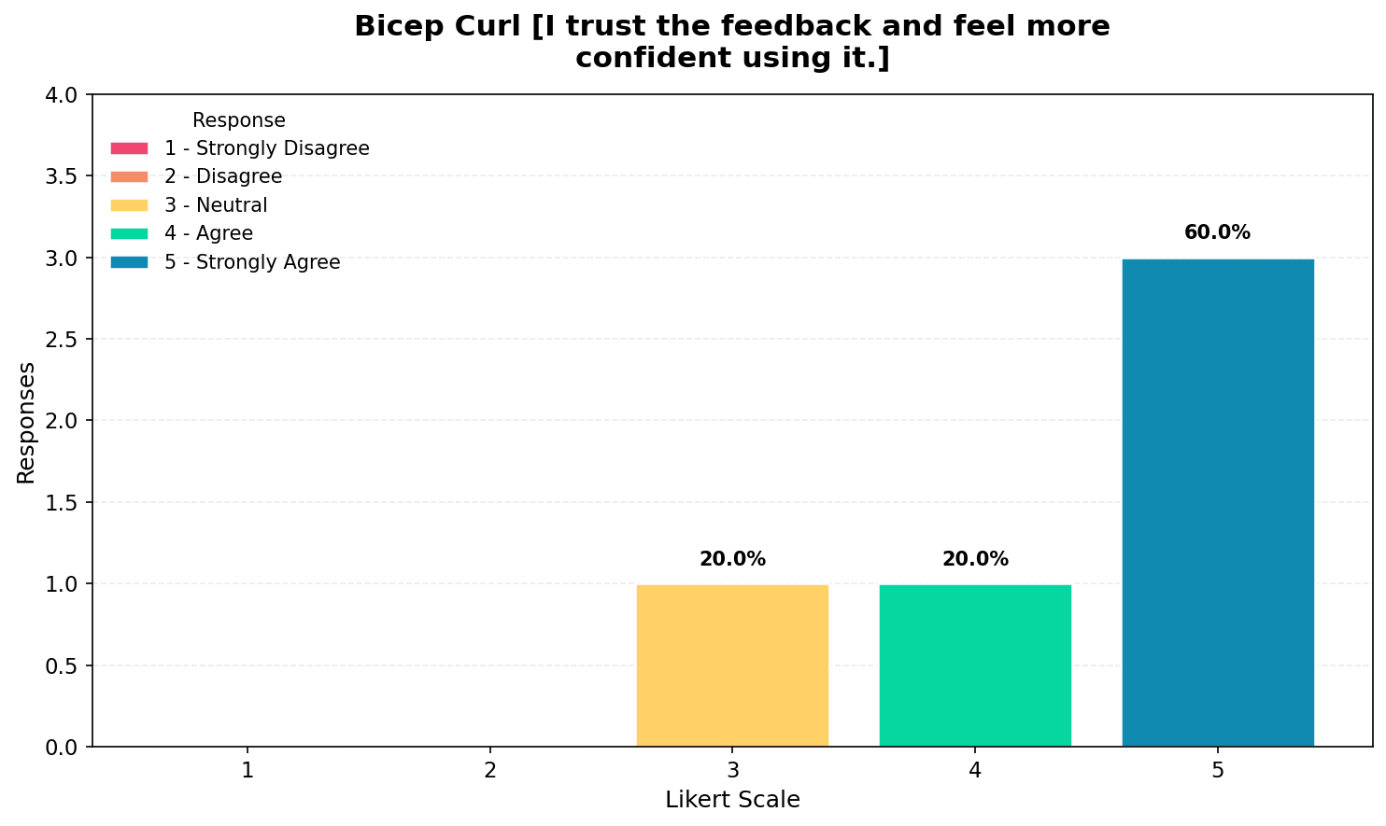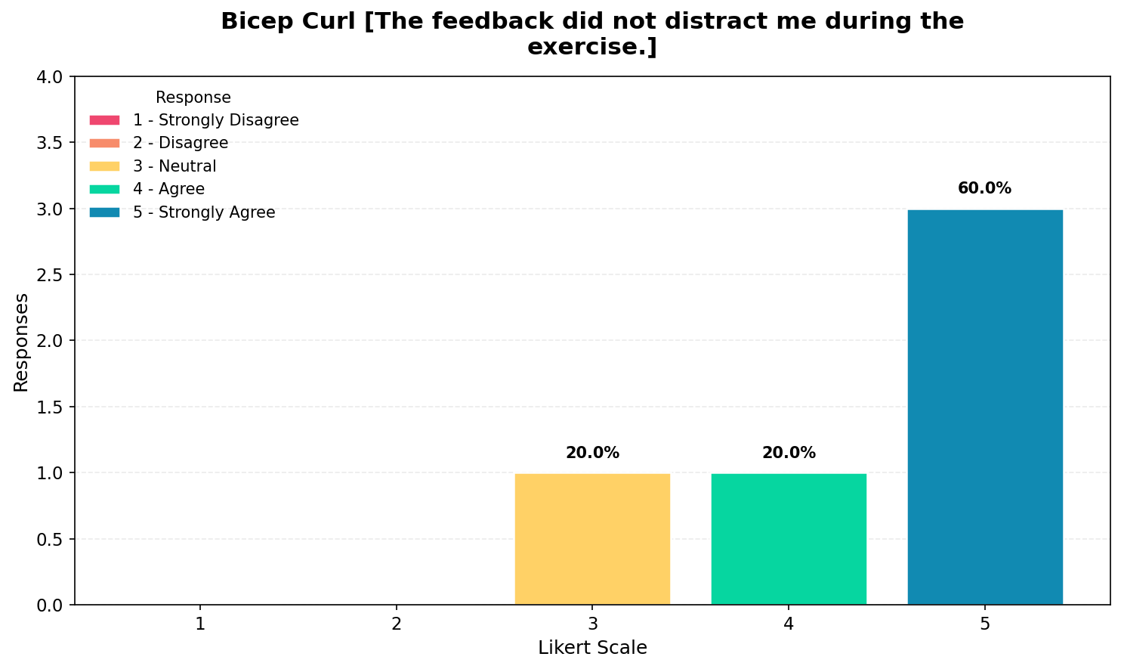The results for the bicep curl exercise show that the majority of responses are concentrated at value 5, with remaining responses at values 3 and 4, which indicates that trainers generally strongly agree that the system performs effectively during the exercise. The system was perceived as accurate in detecting posture errors, while the feedback was considered clear and helpful. Additionally, the system was rated highly in terms of responsiveness and reliability, and respondents reported that they trust the feedback and feel more confident when using it. The feedback was also not considered distracting during the exercise, which suggests that the system integrates smoothly into training sessions. Overall, these results indicate that the system performs very well in assisting bicep curl exercises from a trainer’s perspective.

SHOULDER PRESS EVALUATION
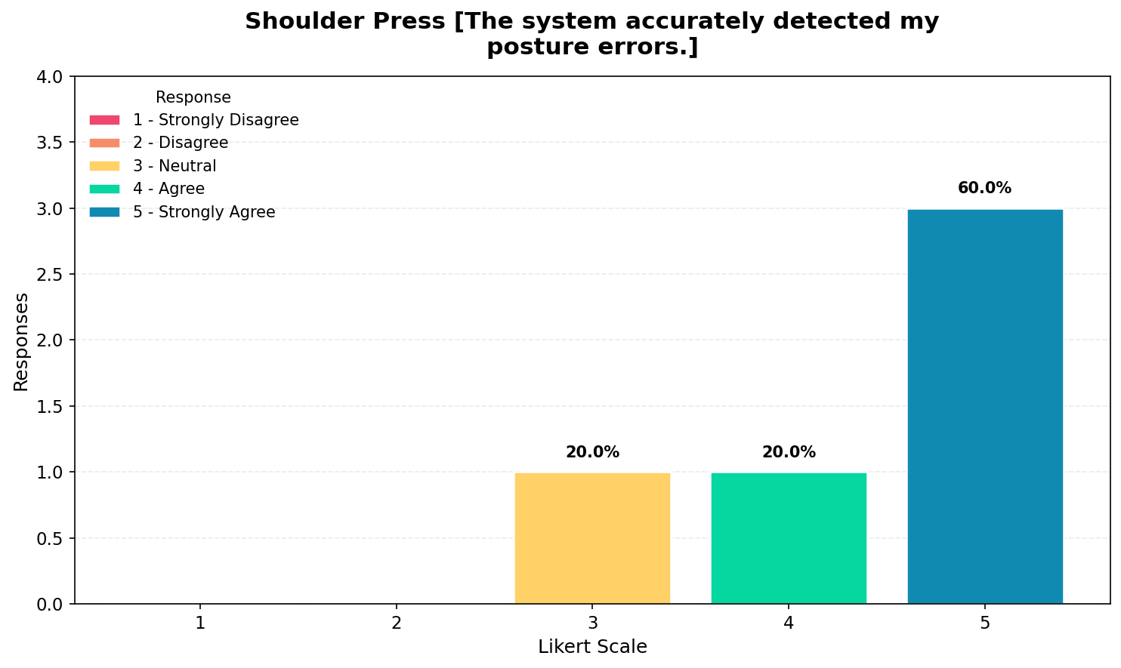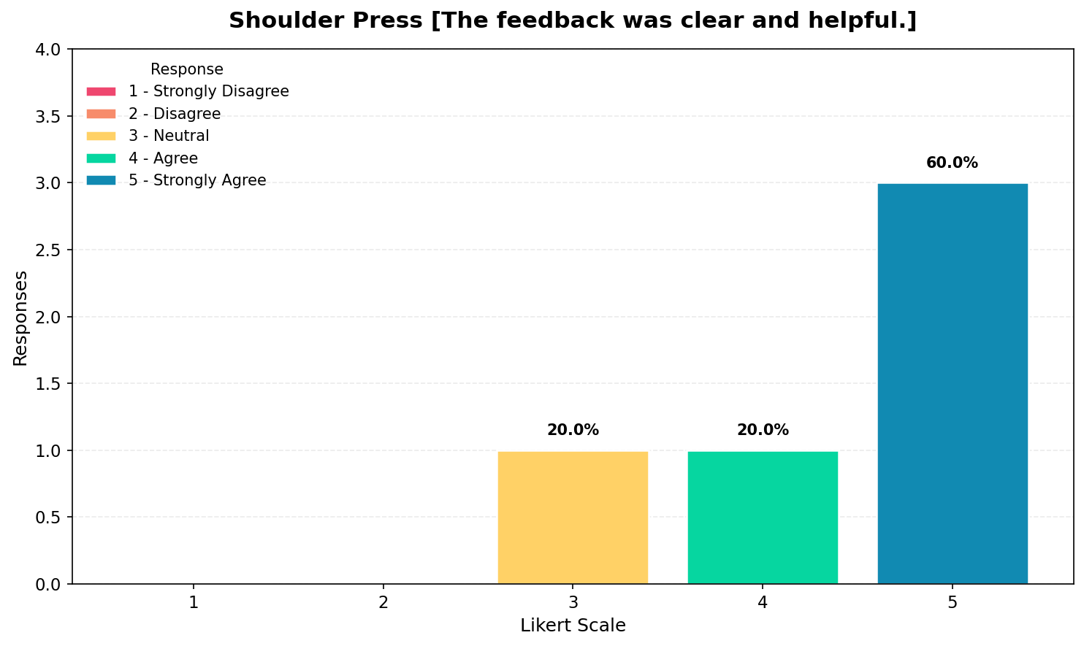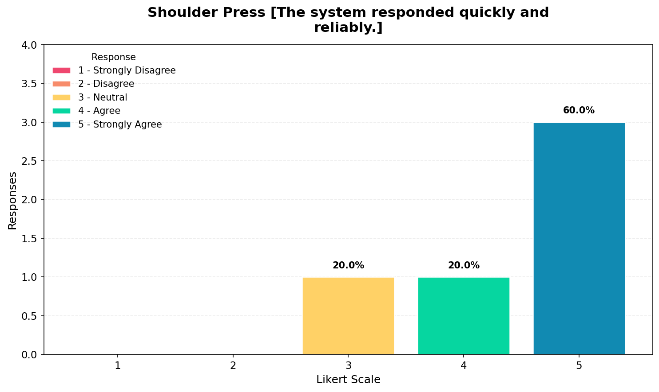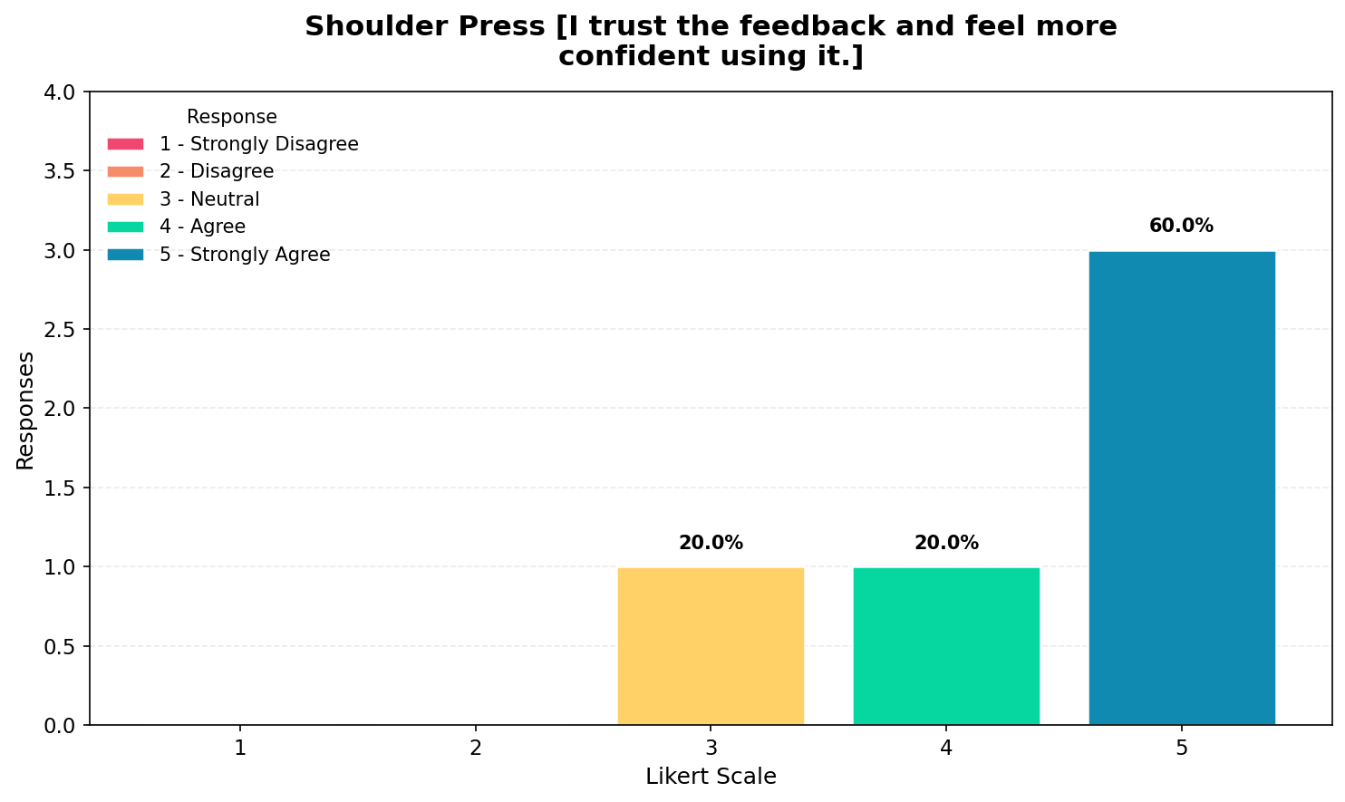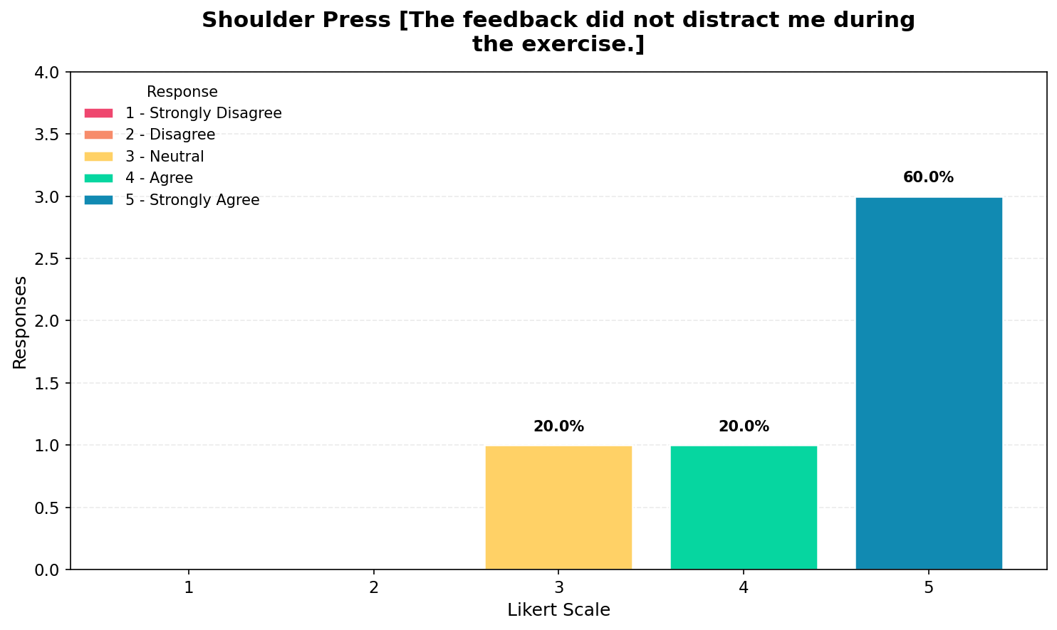

The results for the shoulder press exercise show a similar pattern, with most responses concentrated at value 5 and some at values 3 and 4, which indicates strong agreement among trainers regarding system performance. The system was perceived as accurate in detecting posture errors, and the feedback provided was considered clear and useful. The responsiveness and reliability of the system were also rated highly, indicating consistent performance during use. Trainers also reported a high level of trust in the system and increased confidence when using it, while the feedback was not considered distracting. Overall, these results suggest that the system performs effectively during shoulder press exercises, with strong positive evaluations across all criteria.

LATERAL RAISE EVALUATION
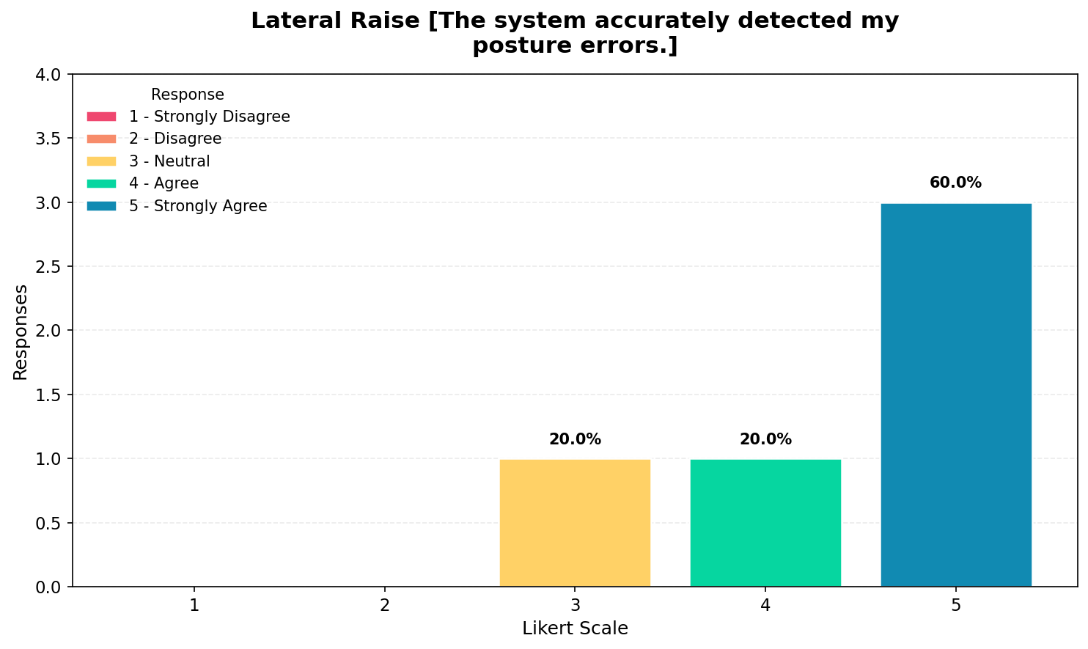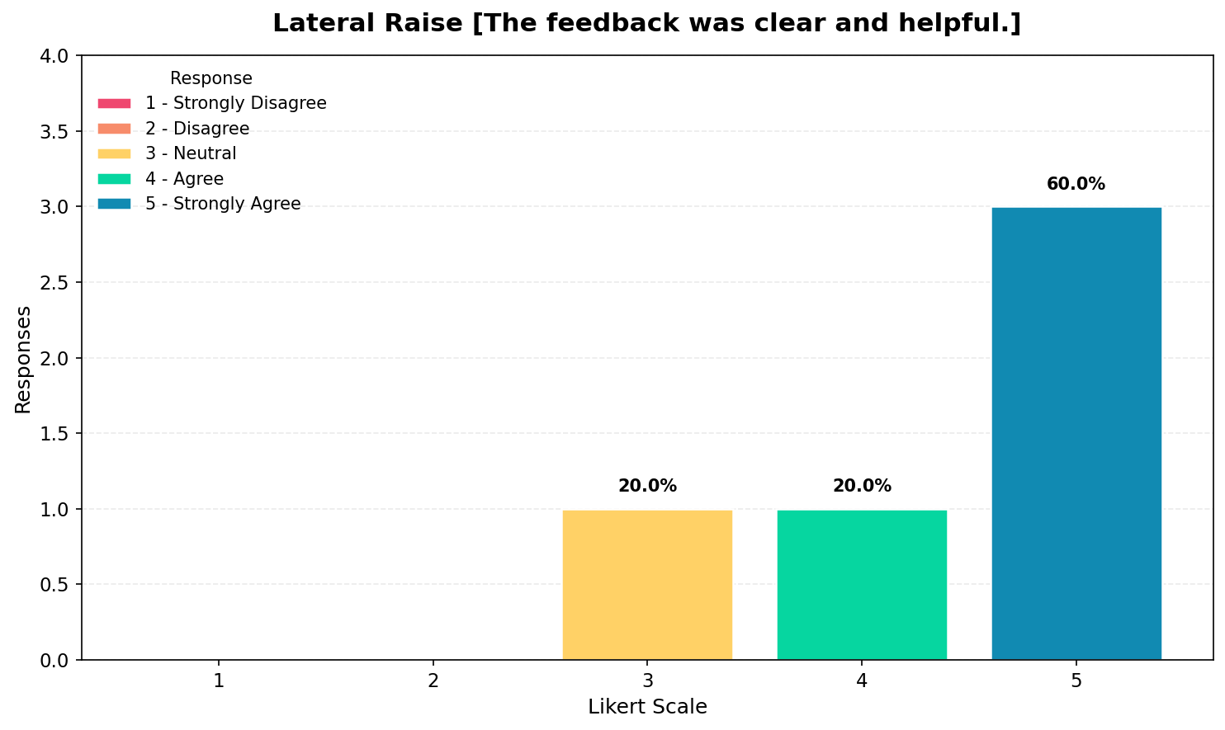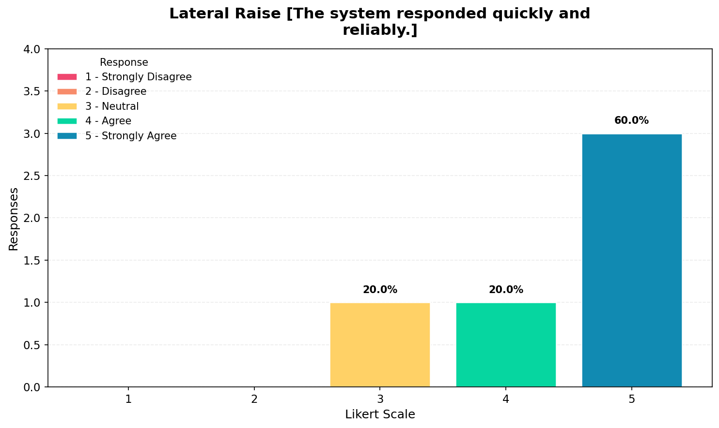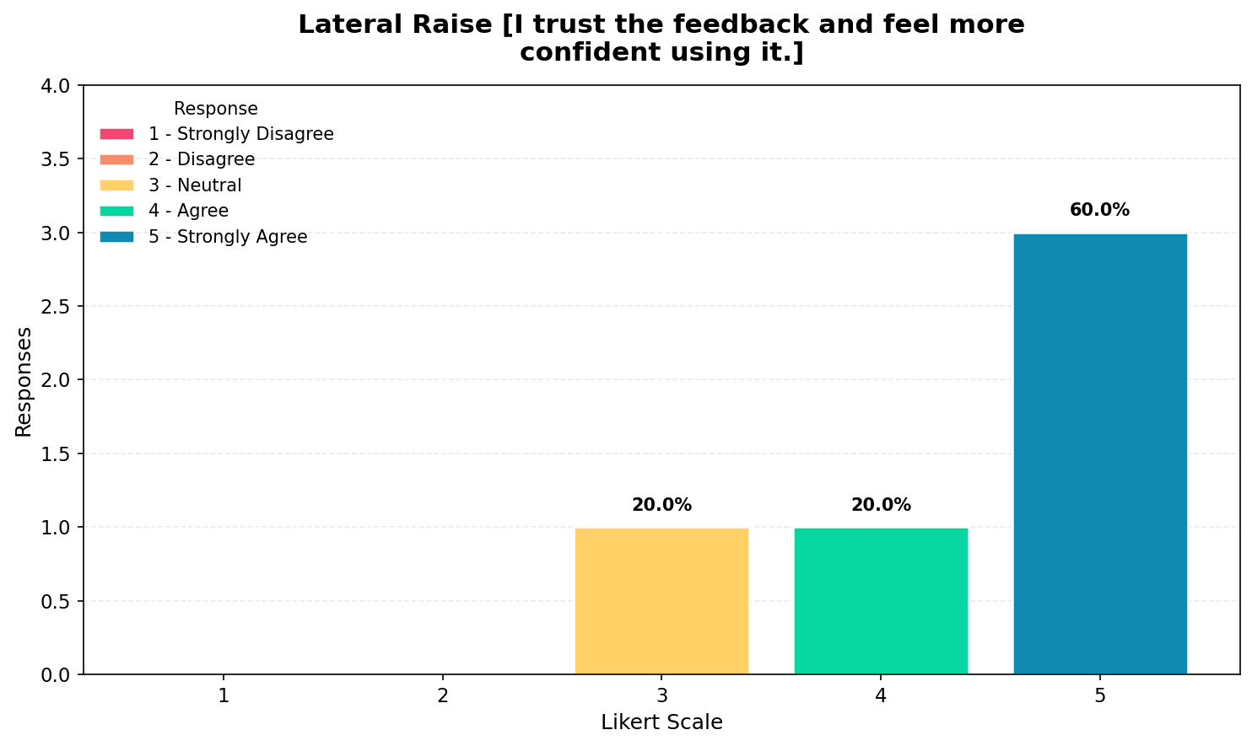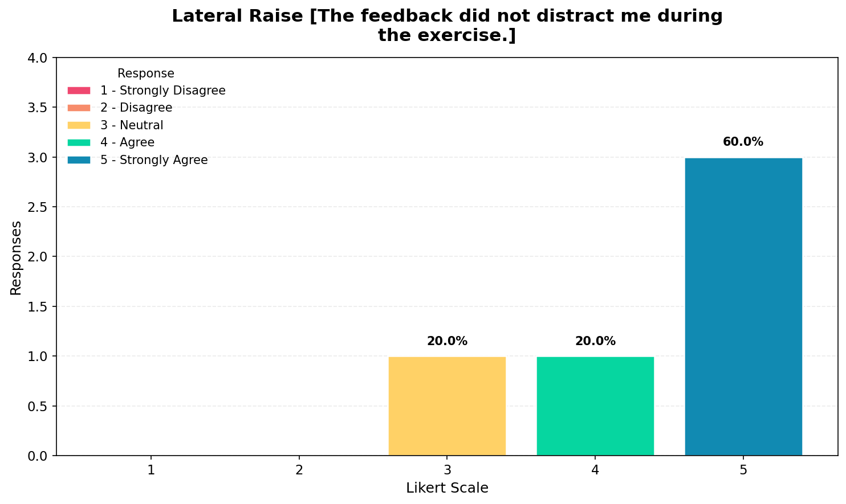
The results for the lateral raise exercise also show that the majority of responses are at value 5, with some responses at values 3 and 4, indicating strong agreement among trainers regarding system effectiveness. The system was rated highly in terms of posture detection accuracy and feedback clarity, while responsiveness and reliability were also positively evaluated. Trainers reported that they trust the feedback and feel more confident when using the system, and the feedback was generally not distracting during the exercise. Overall, the system demonstrates consistent performance across lateral raise exercises, reinforcing its reliability across different movement types.

FATIGUE ADAPTATION
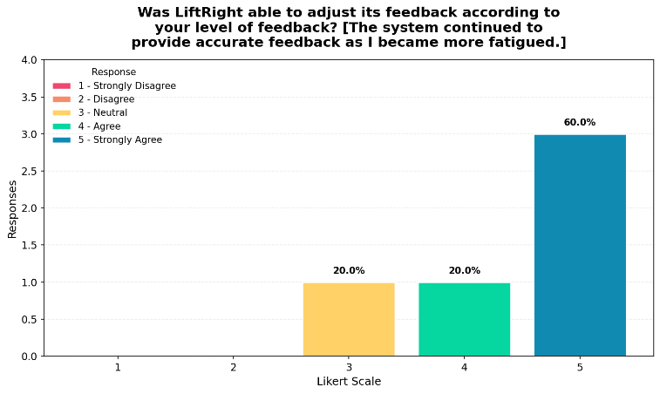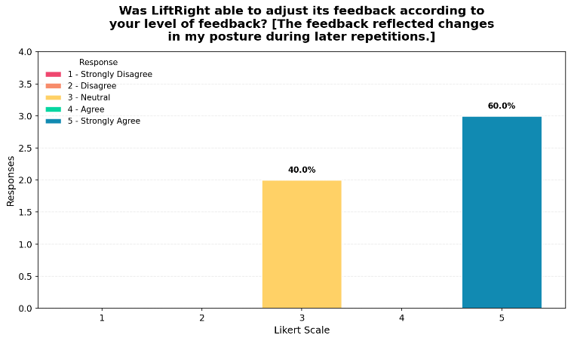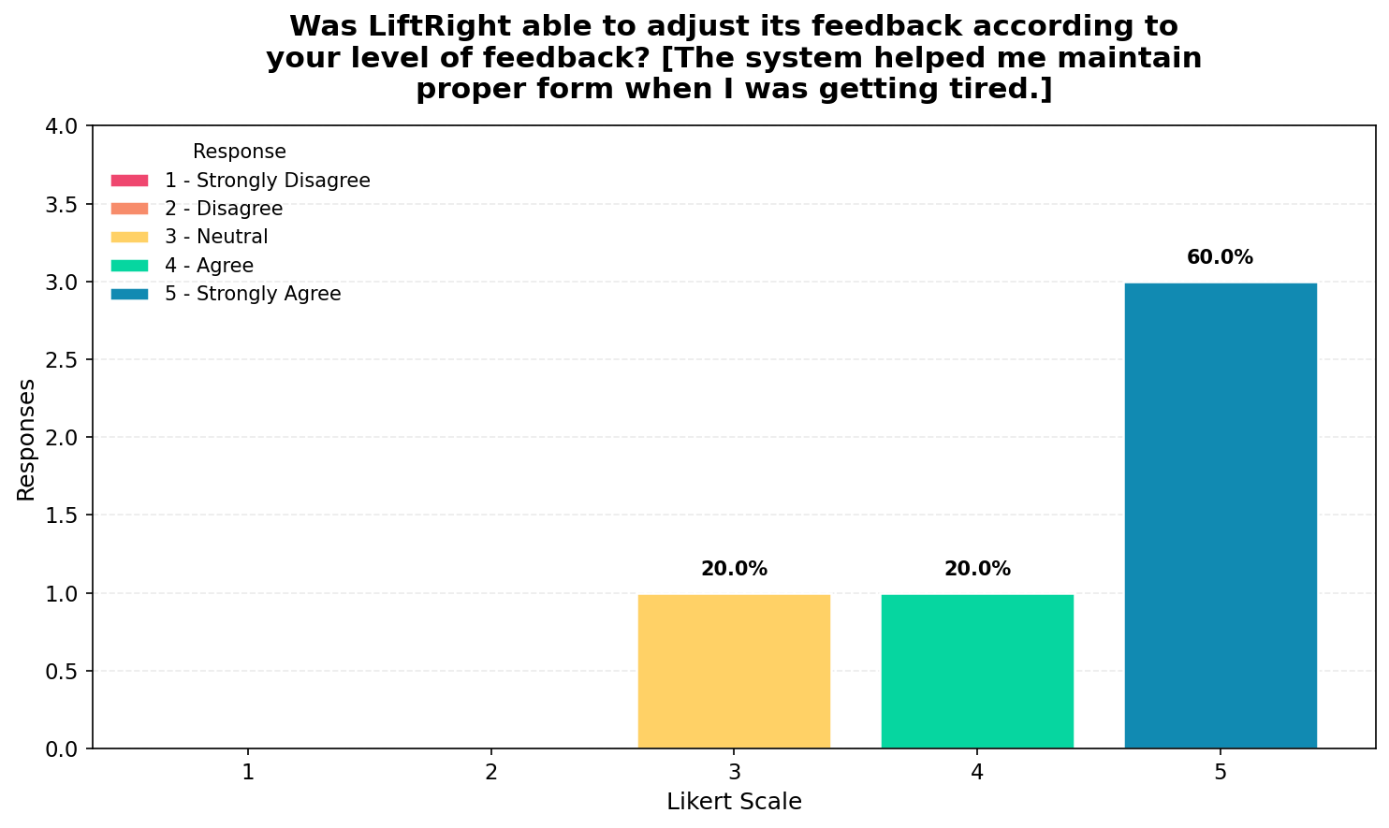
The results for fatigue adaptation indicate that most responses are concentrated at value 5, with some responses at value 3 and 4, which means that trainers generally agree that the system is capable of adjusting its feedback according to the user’s level of fatigue. Respondents indicated that the feedback reflects changes in posture during later repetitions and helps maintain proper form even when users become tired. However, the presence of neutral responses suggests that this capability may not be consistently perceived across all situations, indicating that while the fatigue recognition component is effective, further refinement may improve consistency.

USABILITY
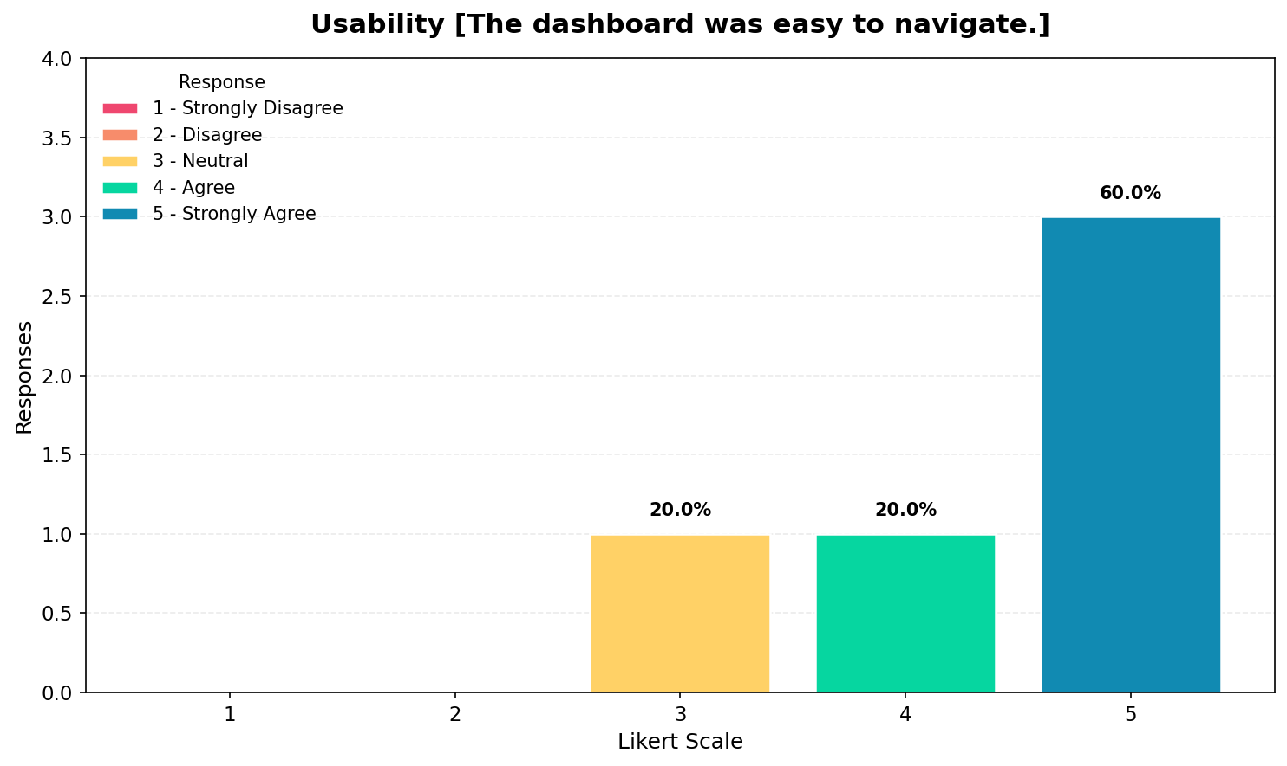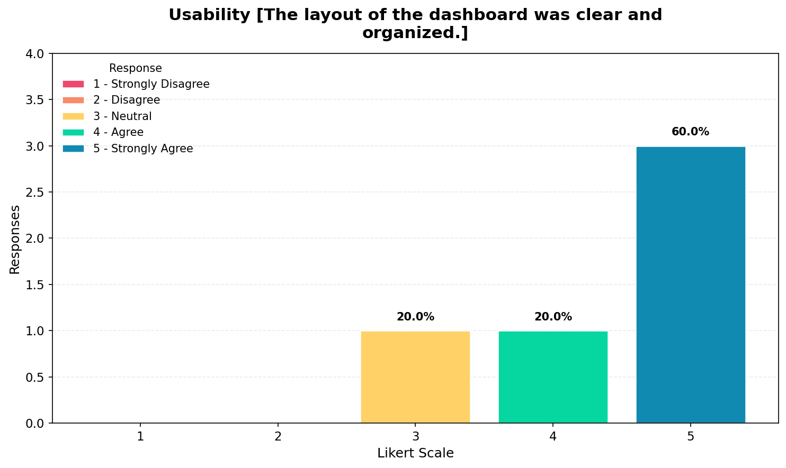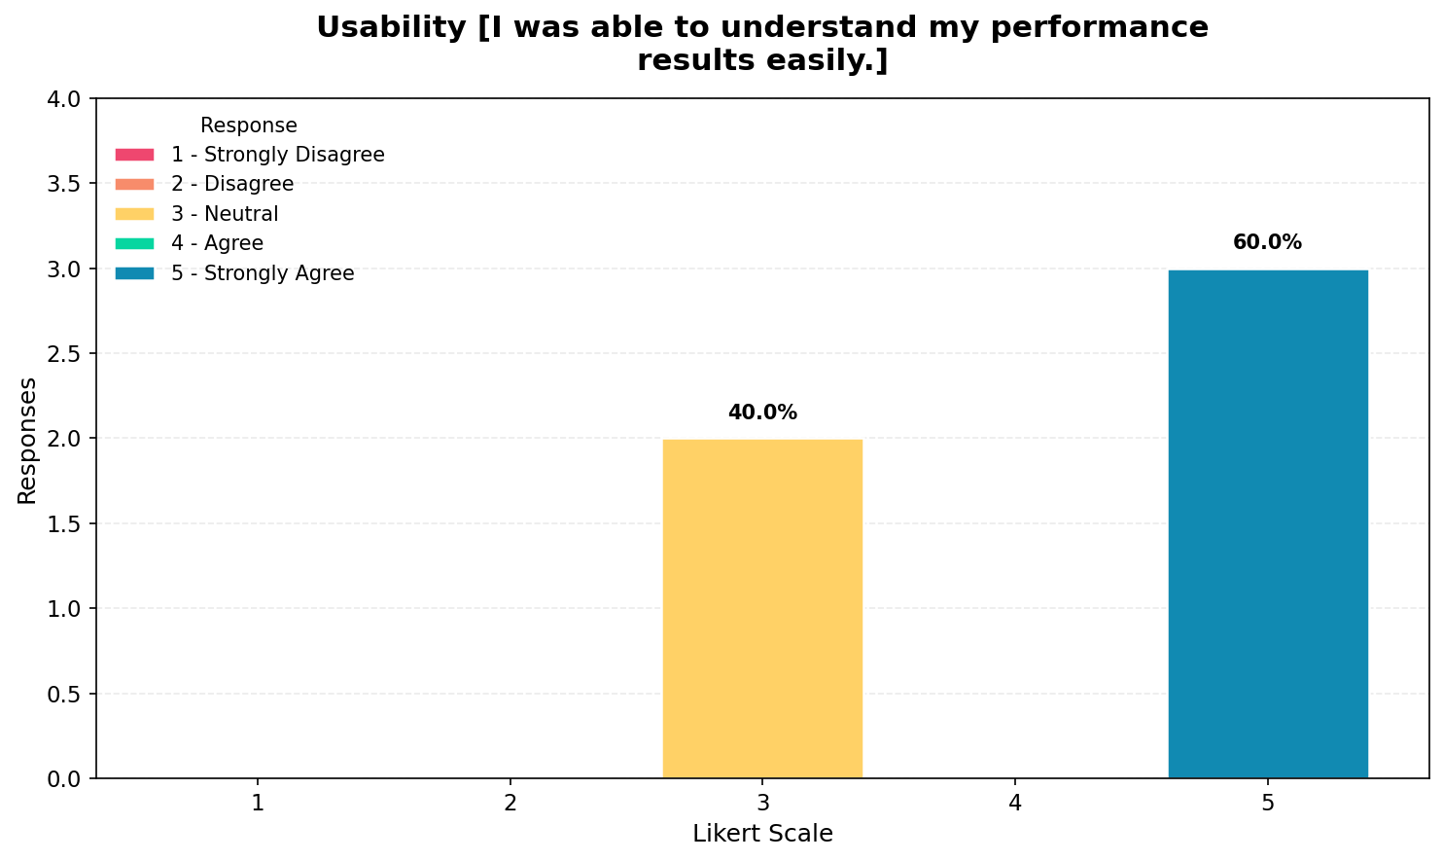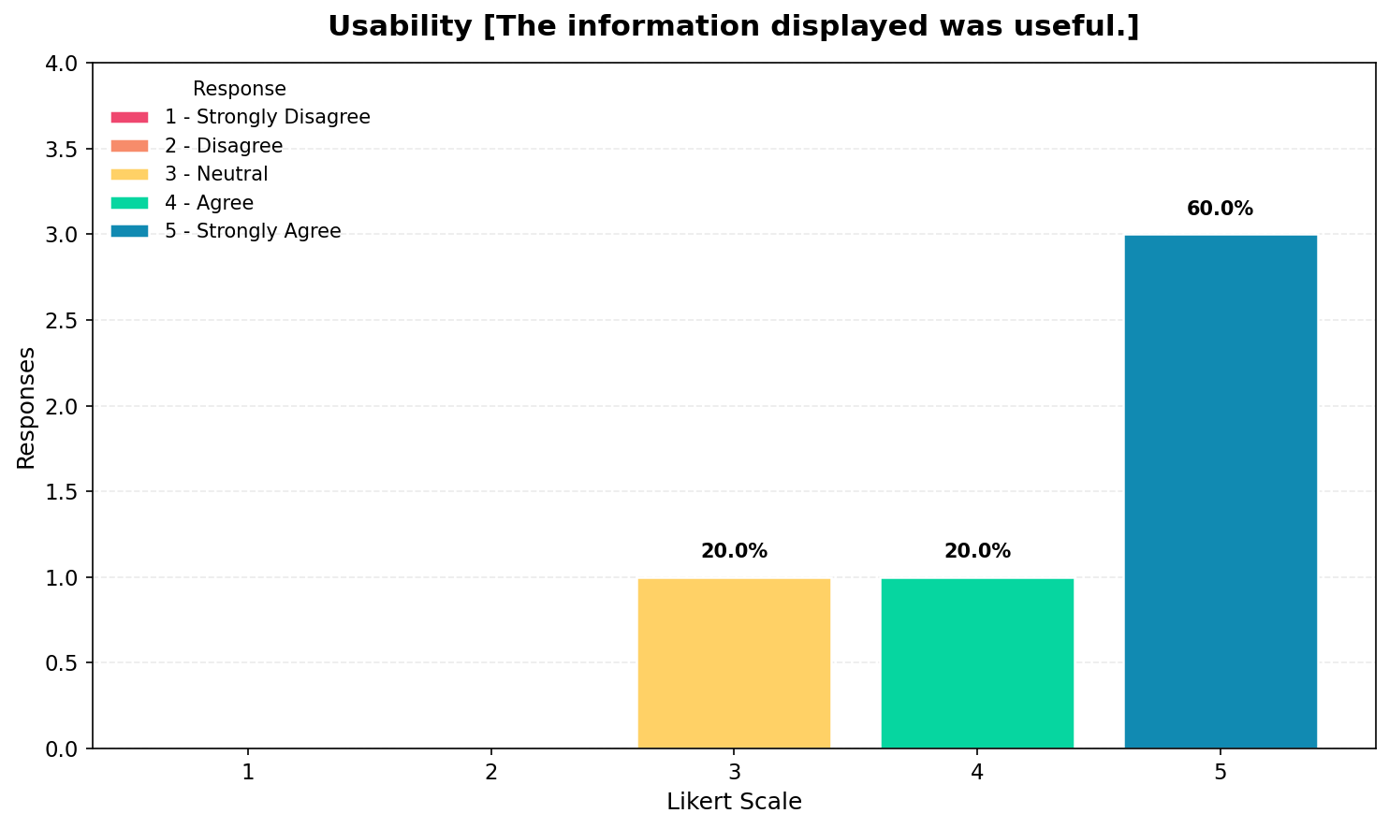
The usability results show that the majority of responses are concentrated at value 5, which indicates that trainers generally find the system easy to use and understand. The dashboard was perceived as easy to navigate, while the layout was considered clear and organized. Additionally, respondents agreed that they were able to understand performance results easily and that the information displayed was useful. However, the presence of some neutral responses suggests that while usability is strong overall, certain aspects of the interface may still benefit from minor improvements in clarity or presentation.

LEARNABILITY & USEFULNESS
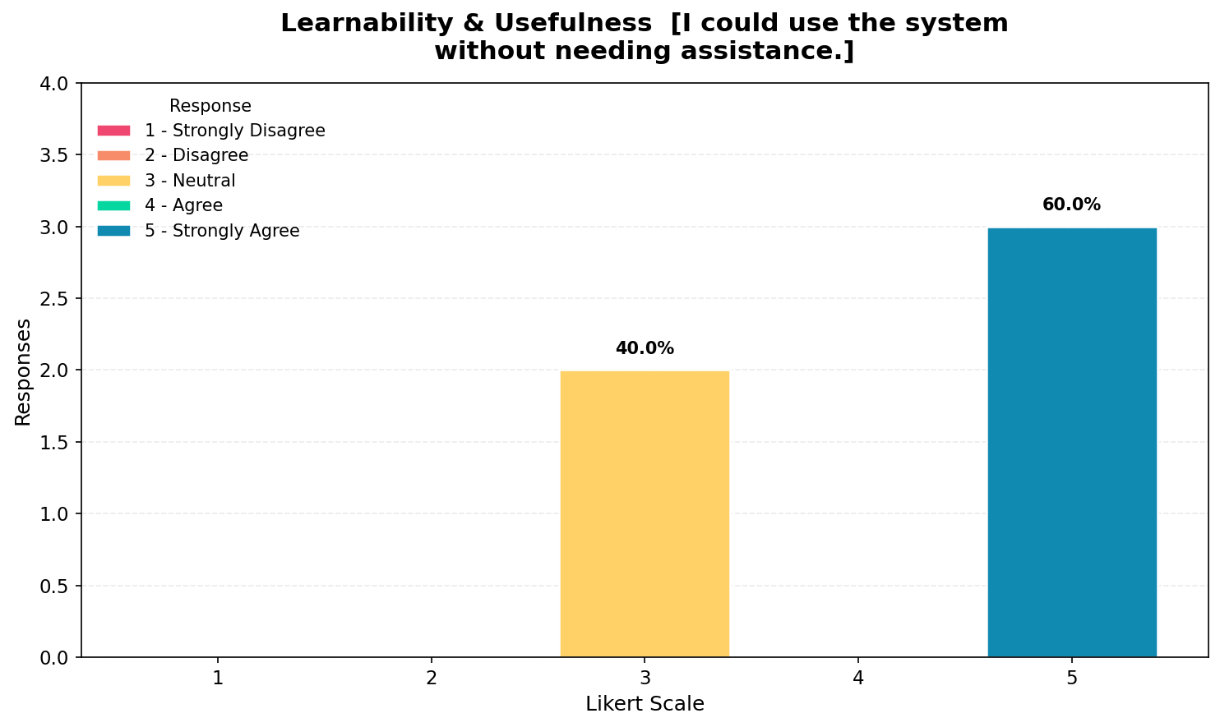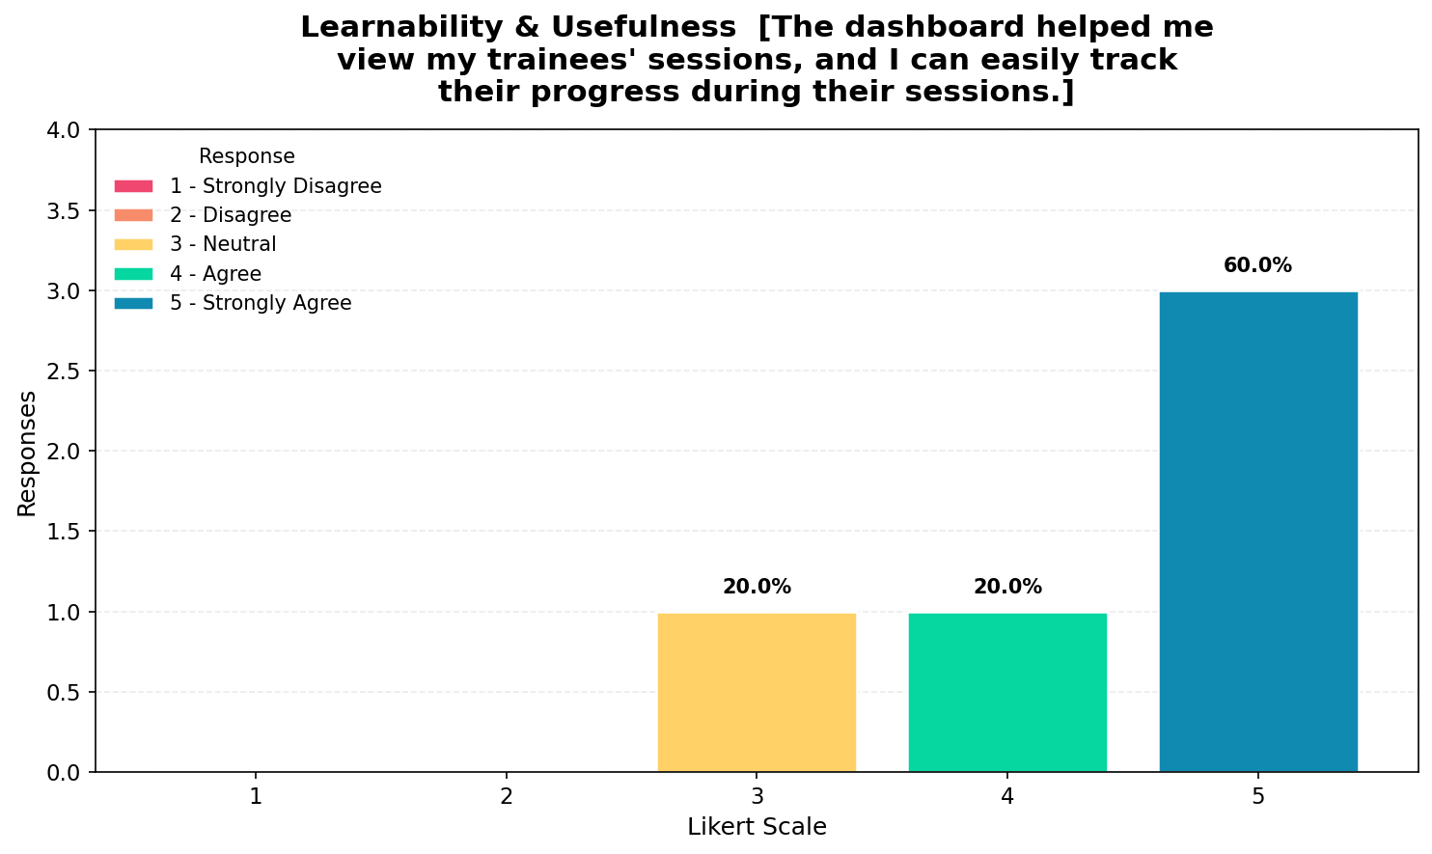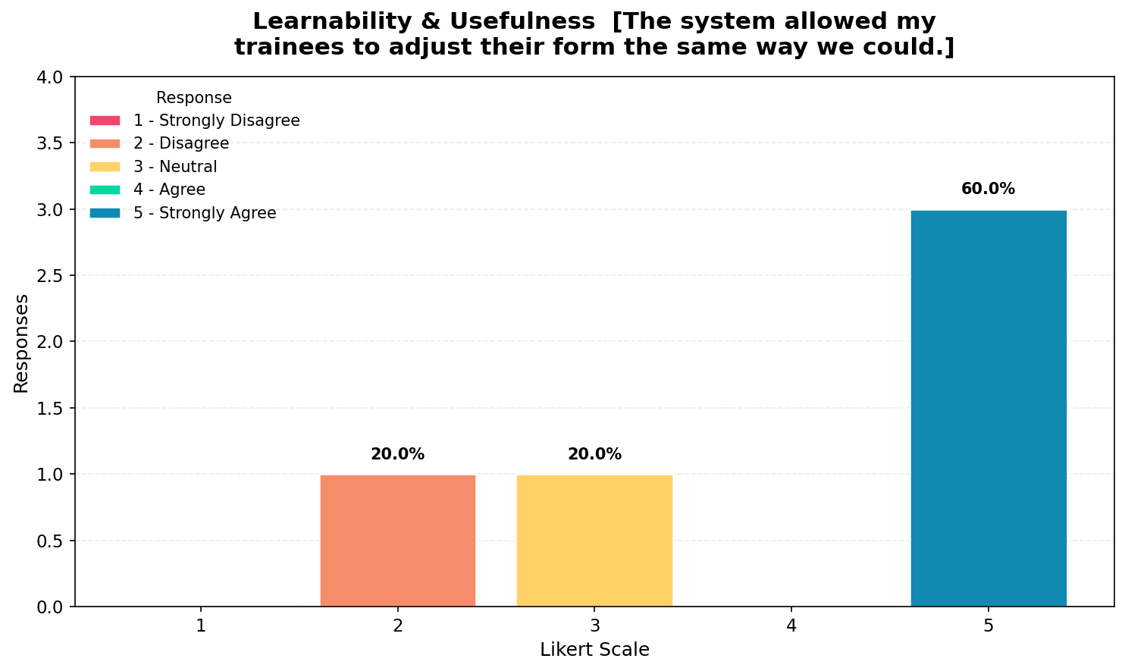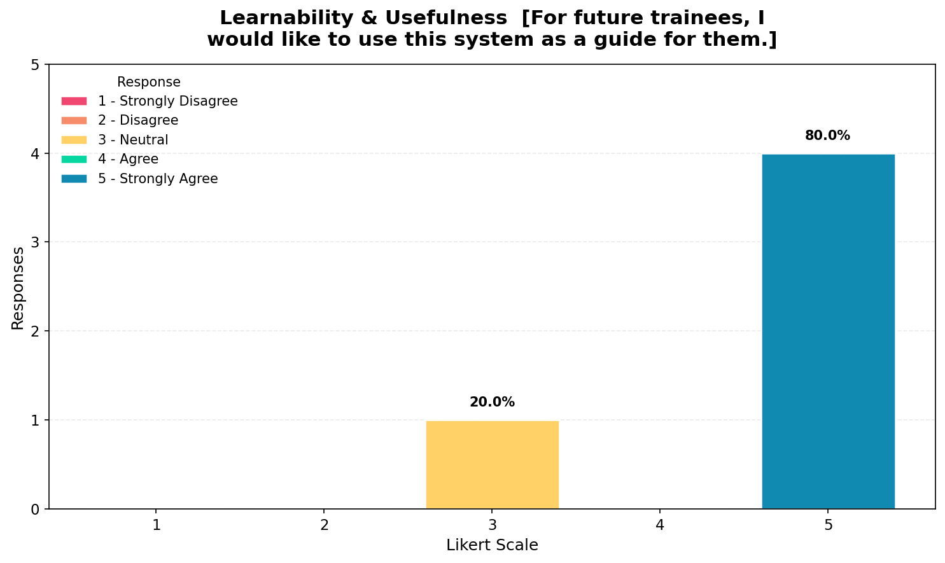
The results for learnability and usefulness indicate that most responses are concentrated at value 5, which suggests that the system is generally easy to learn and highly useful in a training context. Trainers indicated that they are able to use the system without assistance, although some neutral responses suggest that not all users feel completely independent. The system was also perceived as helpful in monitoring trainees and tracking their progress, which highlights its practical application in real training environments. Additionally, respondents agreed that the system allows trainees to adjust their form in a manner similar to guidance provided by trainers, which reinforces its effectiveness as a support tool. Most participants also expressed willingness to use the system for future trainees, indicating strong acceptance of its usefulness.

USER INTENT
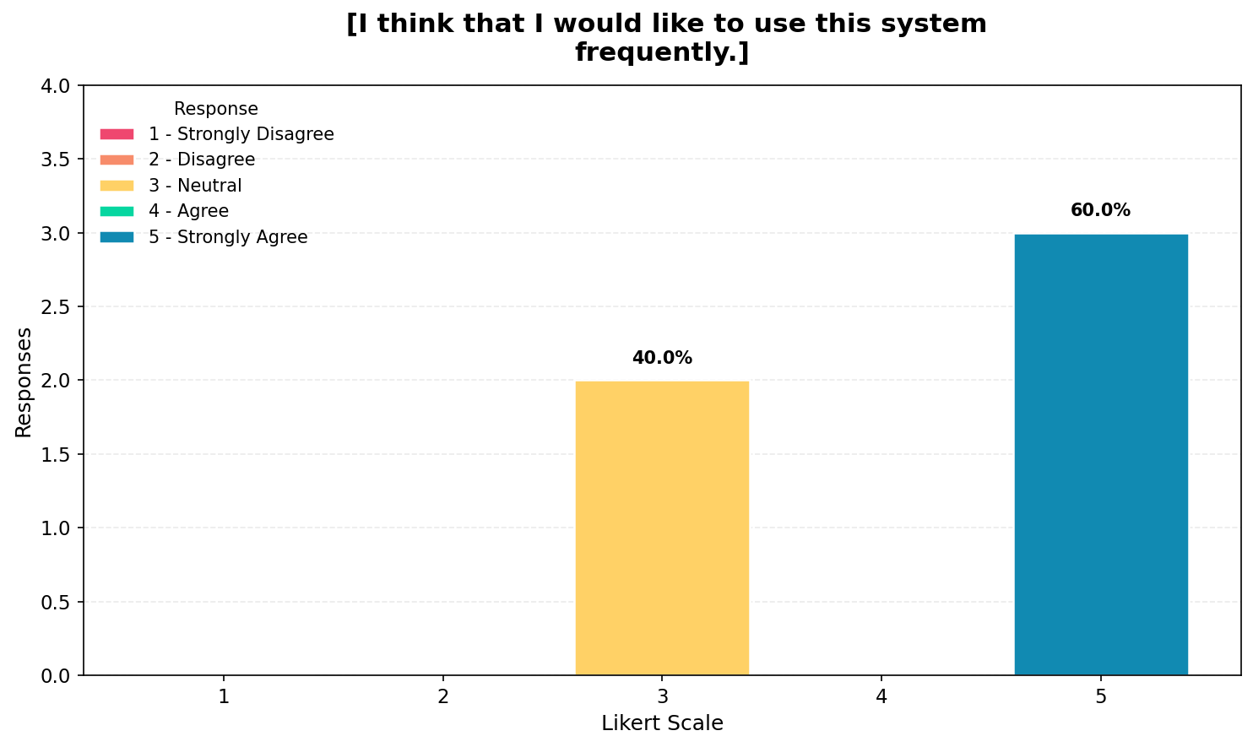
The results for negative usability perception show a more varied distribution of responses, which indicates that trainers have mixed opinions regarding certain aspects of system usability. While a portion of respondents disagreed with the statement that the system is unnecessarily complex, some neutral responses suggest that certain features may still be perceived as moderately difficult to use. Similarly, responses regarding the need for technical support indicate that while some trainers feel confident using the system independently, others believe assistance may still be required. Despite this, respondents generally agreed that the system is easy to use and that its functions are well integrated, indicating that usability concerns are present but not dominant. Additionally, responses related to system inconsistency suggest that while most trainers do not perceive significant issues, some variability in performance may still exist. Overall, this section highlights that while the system is functionally strong, there are still areas where usability and consistency can be improved.

NEGATIVE USABILITY PERCEPTION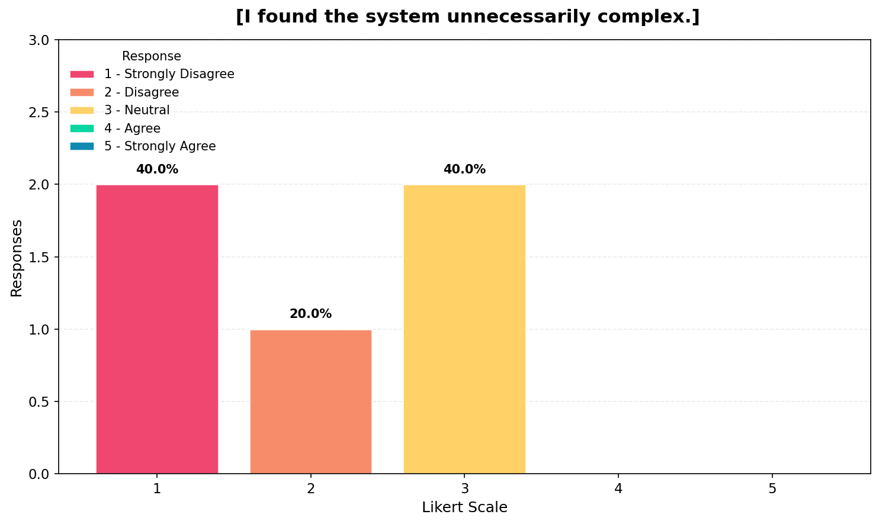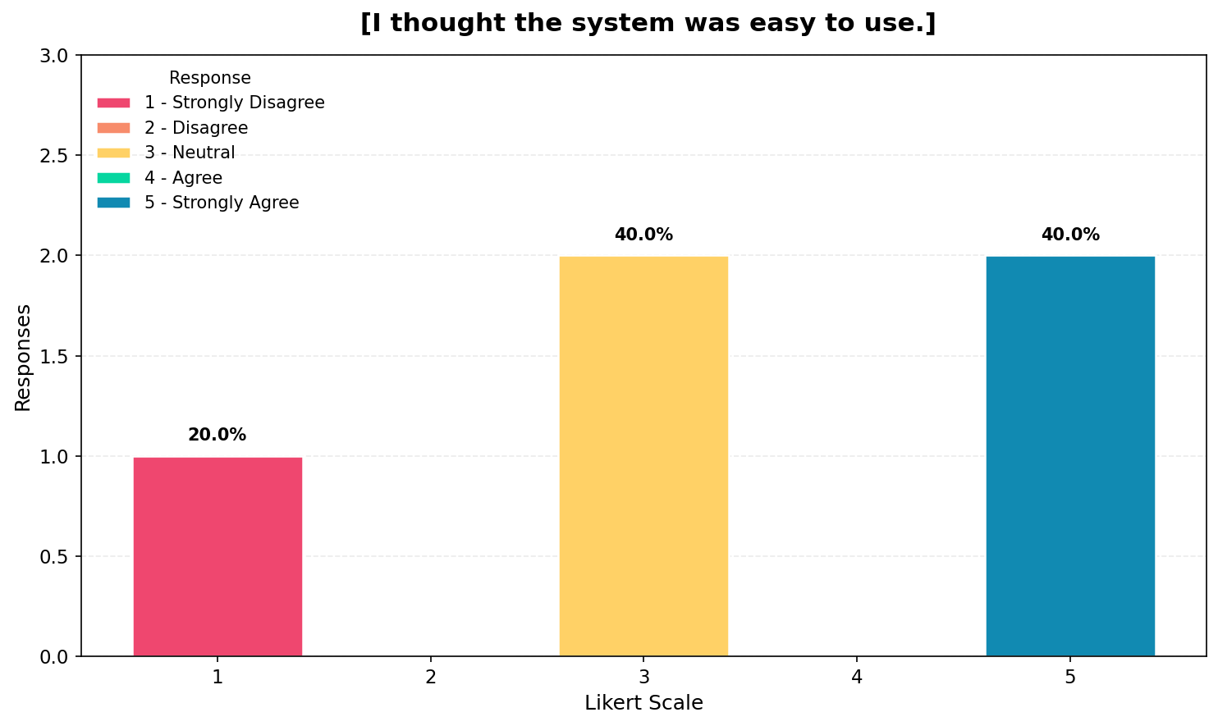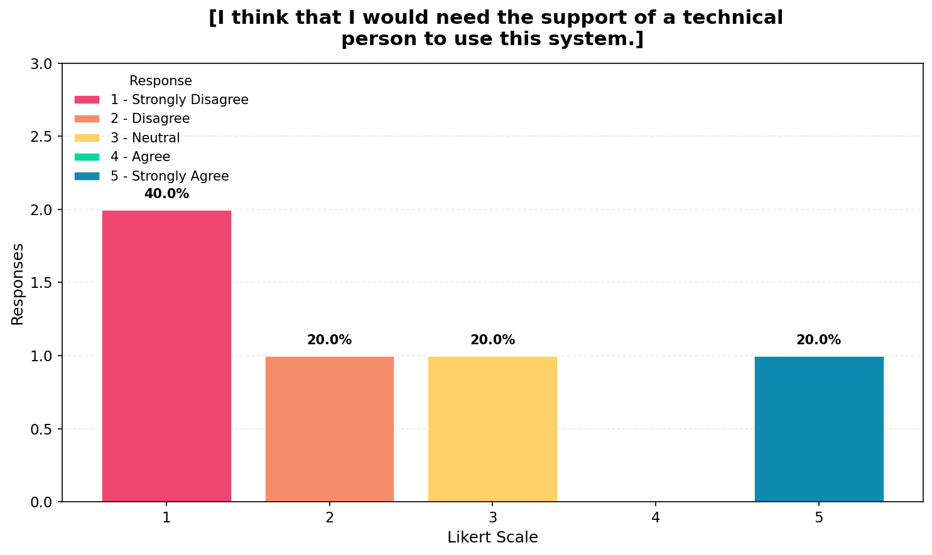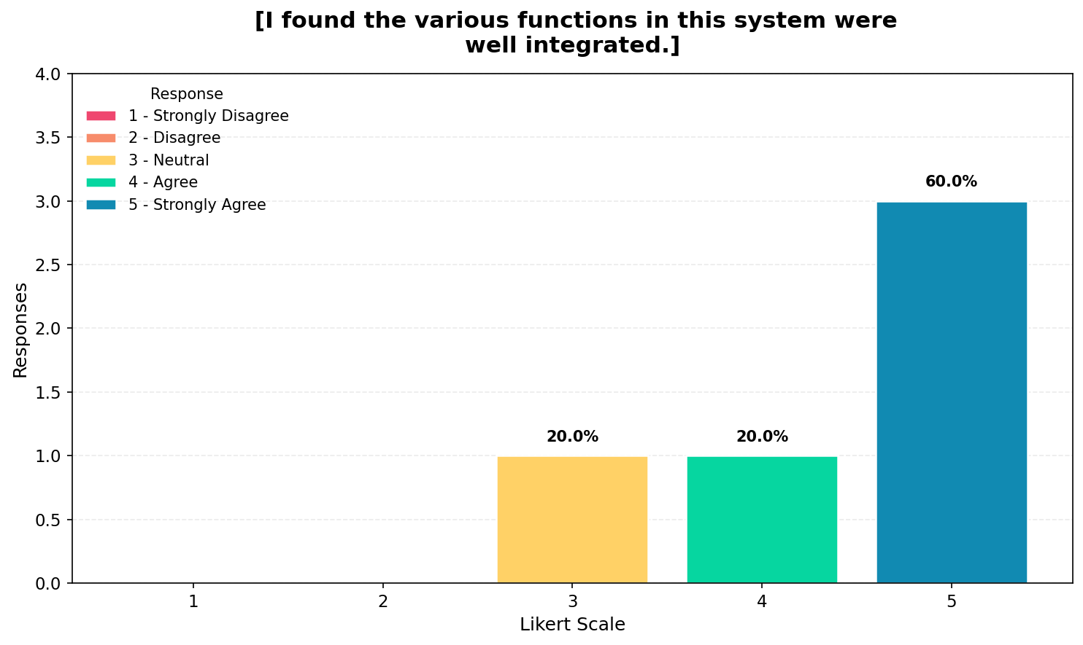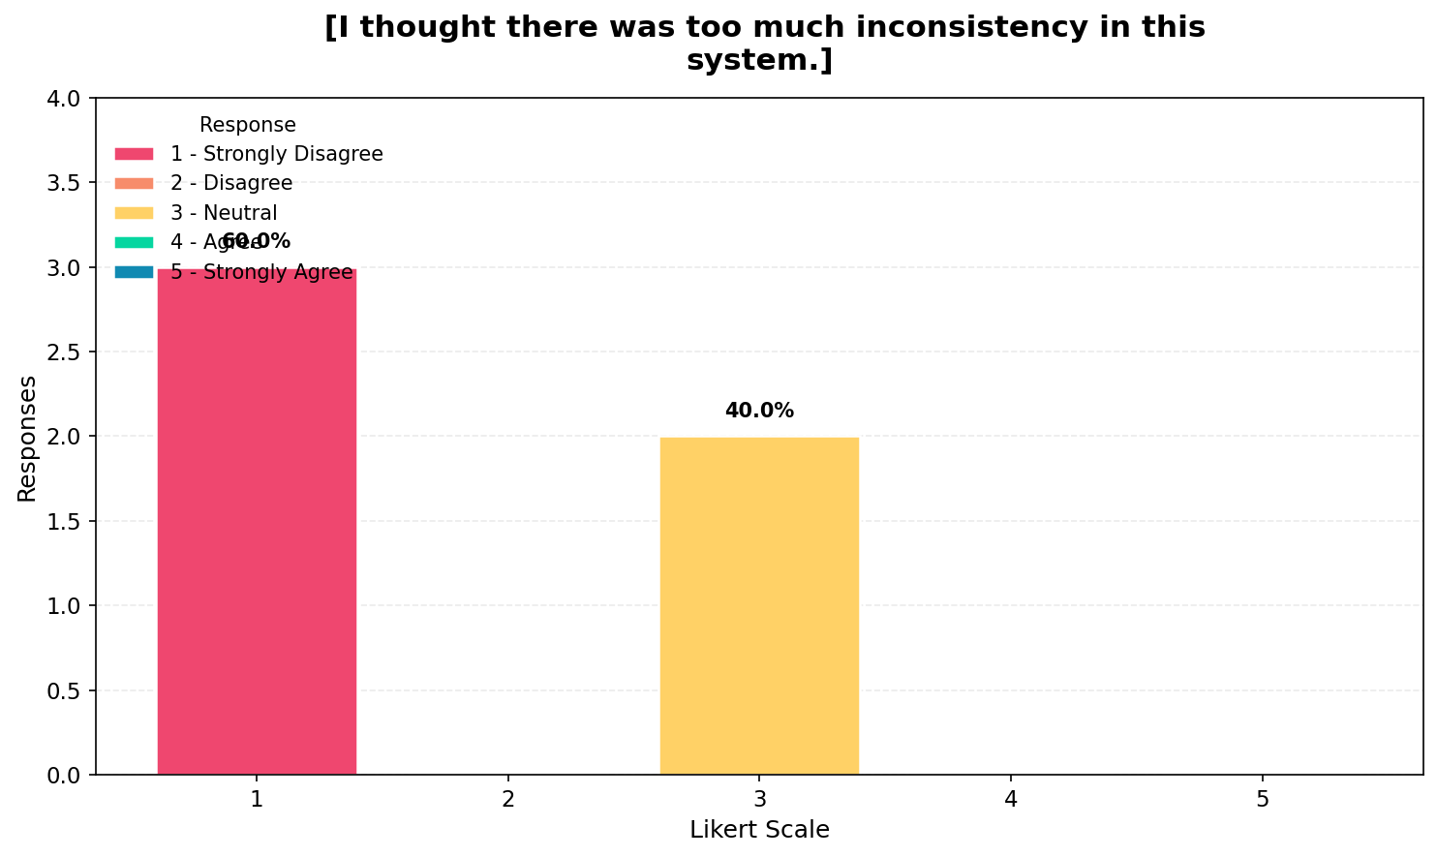
The results for negative usability perception show a more varied distribution of responses, which indicates that trainers have mixed opinions regarding certain aspects of system usability. While a portion of respondents disagreed with the statement that the system is unnecessarily complex, some neutral responses suggest that certain features may still be perceived as moderately difficult to use. Similarly, responses regarding the need for technical support indicate that while some trainers feel confident using the system independently, others believe assistance may still be required. Despite this, respondents generally agreed that the system is easy to use and that its functions are well integrated, indicating that usability concerns are present but not dominant. Additionally, responses related to system inconsistency suggest that while most trainers do not perceive significant issues, some variability in performance may still exist. Overall, this section highlights that while the system is functionally strong, there are still areas where usability and consistency can be improved.

LEARNING CURVE & EFFICIENCY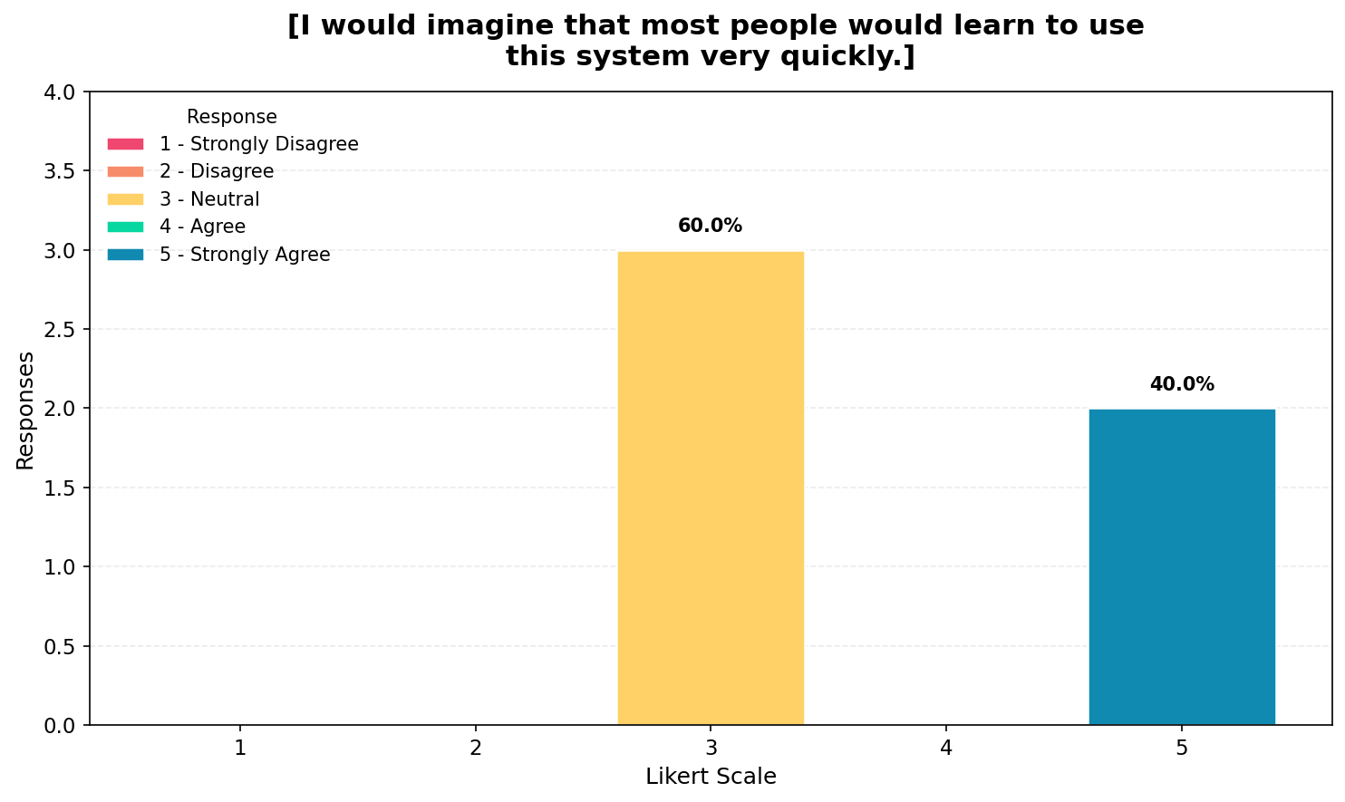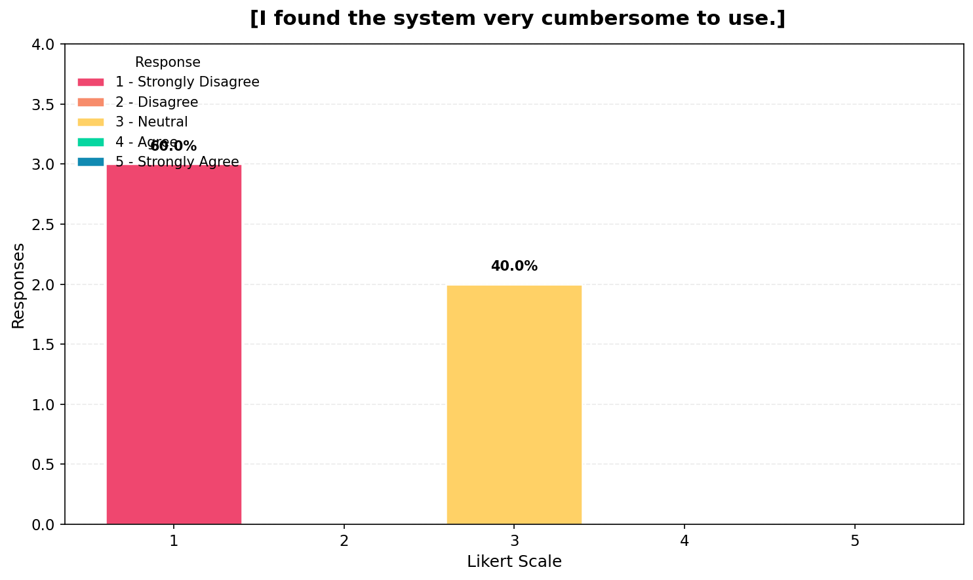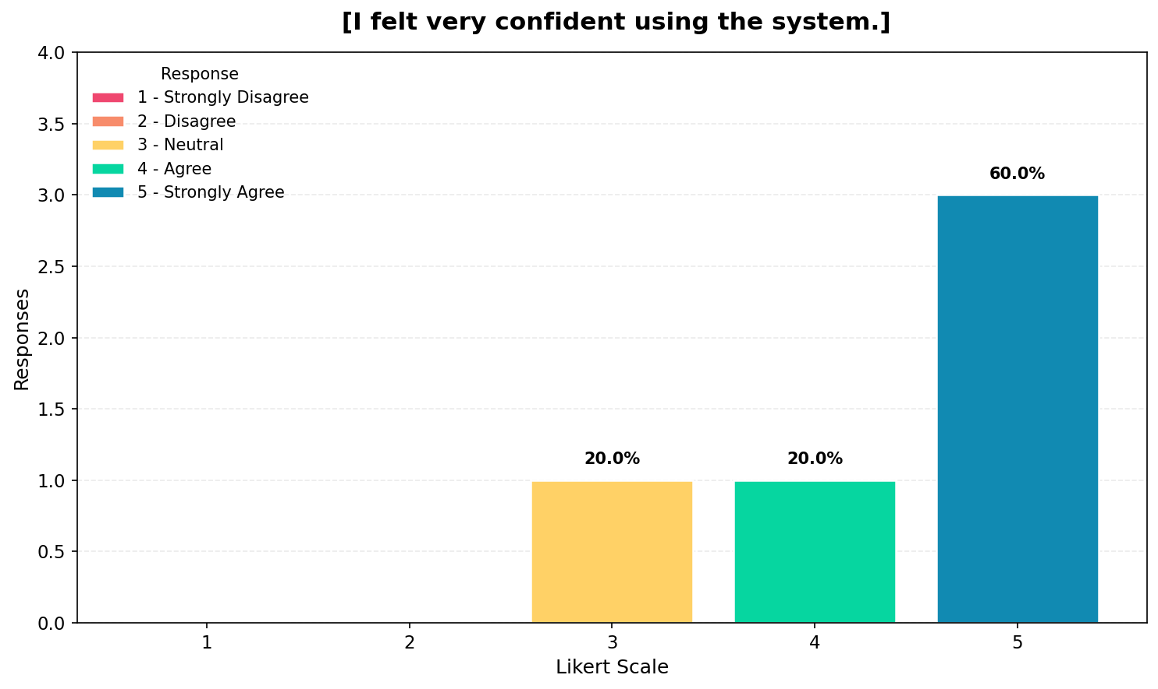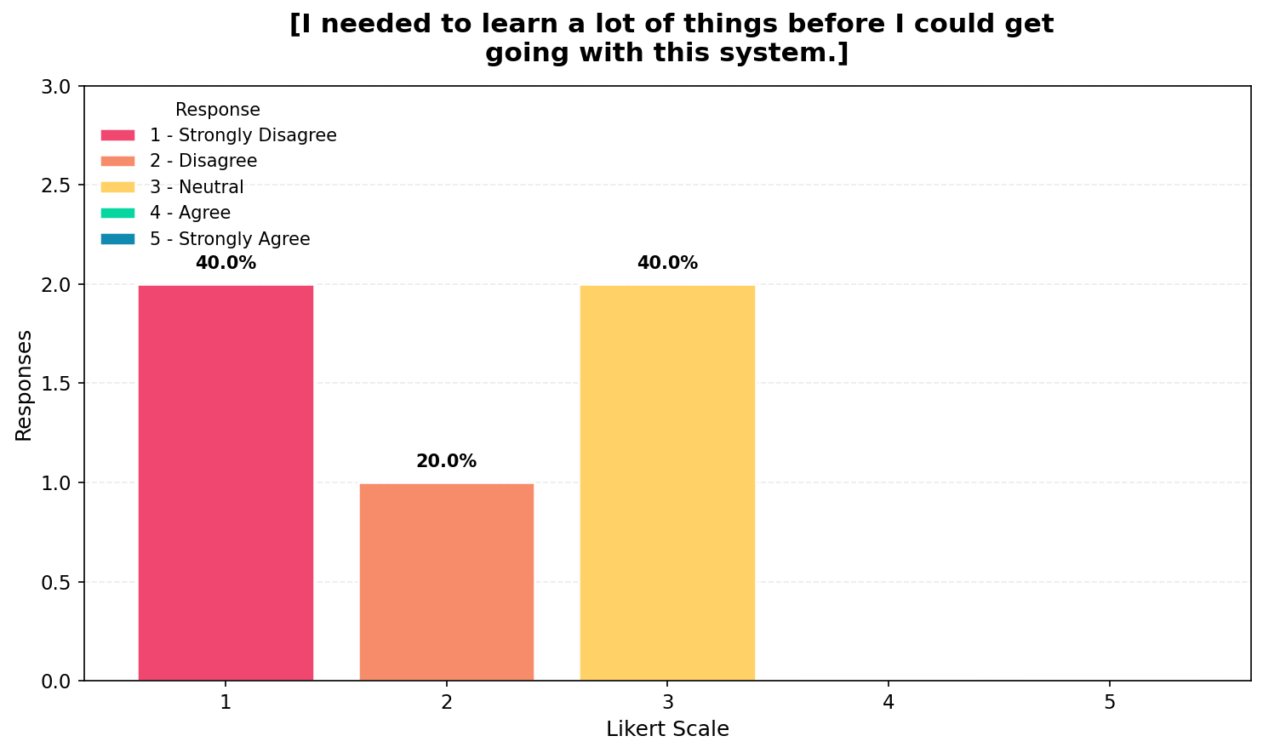
The results for learning curve and efficiency indicate that trainers generally agree that the system can be learned quickly, which suggests that it is accessible even to experienced users. However, responses regarding the system being cumbersome reveal that some trainers still perceive certain aspects of the system as inconvenient or inefficient. Despite this, participants reported high levels of confidence when using the system, indicating that they are able to interact with it effectively once familiar with its functionality. Additionally, responses regarding the amount of learning required show a mixed distribution, which suggests that while some users find the system easy to adopt, others perceive a need for additional learning. Overall, the system demonstrates good usability but may benefit from further refinement to reduce complexity and improve efficiency.

