Project: <Joel Atkinson Assignment 4.2>
Course: <CSD380 DevOps >
Description: <Creating 5 test cases for the functional requirements from the ToDo Business Requirements>
Date: <February 6, 2026>
To complete the test case plan, fill out the information for Project, Course, Description and Date in the header below.
.
TABLE OF CONTENTS
<Test Access To ToDo Application via URL> 2
<Create a New ToDo Task Item> 3
<Delete a ToDo Task Item from List> 3
<Prevent Submitting Blank ToDo Item> 4
<Edit a ToDo Task Item> 5

For each test, the developer should: provide a test description, a test objective, the developer name and date tested. For each step, fill out the actions to be taken and describe the expected results, and indicate yes or no for each step depending upon the result. The peer tester should provide their name, date tested, indicate yes or no for each step depending upon the result, and a screenshot (thumbnail) of the result.

Test 1 | <Test Access To ToDo Application via URL>
 | Test Objective: Verify that users can access the ToDo application through the standard URL and that it load correctly | Developer: Joel Atkinson  Date tested: <2026/02/06> | Peer tester: Zac Baker  Date tested: 2026/02/07
Step | Action | Expected results: | Developer pass/fail | Tester pass/fail  + Screenshot
1 | <Open browser and navigate to https://buwebdev.github.io/todo/> | <ToDo application loads successfully with no errors> | <yes> | Yes  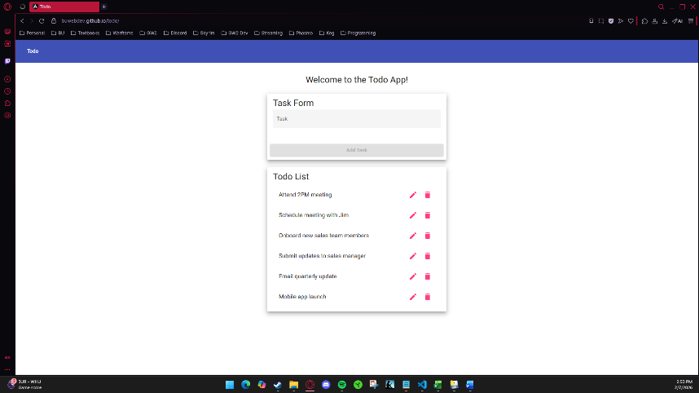
2 | <Verify page content is visible> | <Todo input field and task list area are visible> | <yes> | Yes  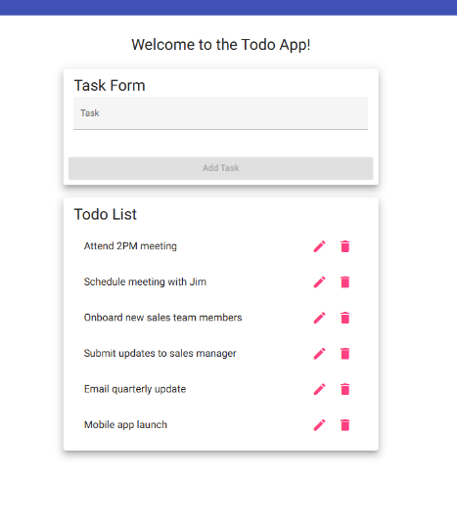
3 | <Refresh the browser page> | <Page reloads successfully without errors> | <yes> | Yes  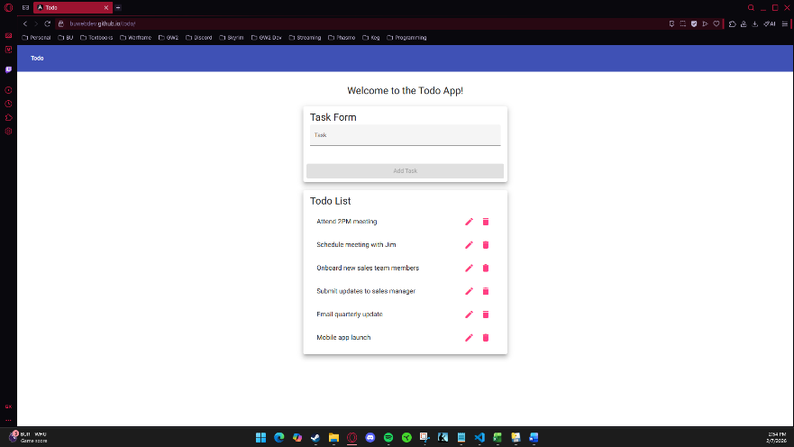
4 | <Open URL in a different browser> | <Application loads in new browser successfully with no errors> | <yes> | Yes  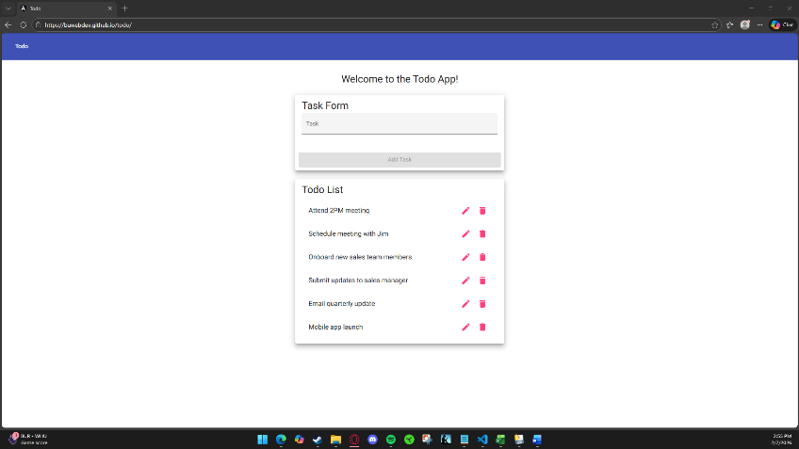
5 | <Confirm that no error messages appear> | <No console or UI errors are shown> | <yes> | Yes  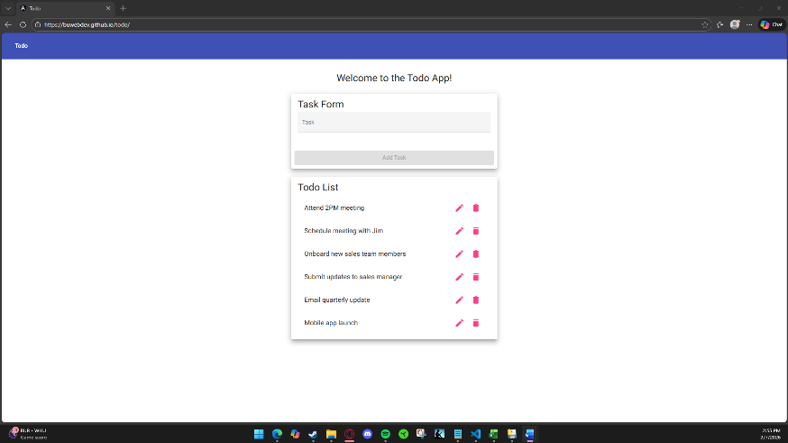
Comments | Entering the URL provided allowed me to access the Todo application. I started off in my Opera GX browser which loaded as expected with no visible errors. I then reloaded the page with no issues. I then chose to use Microsoft Edge as my secondary browser for testing purposes. The page loaded with no errors or difficulty.

Test 2 | <Create a New ToDo Task Item>
 | Test Objective: Confirm that users can successfully create a new todo task item by entering text and submitting the form | Developer: Joel Atkinson  Date tested: <2026/02/06> | Peer tester: Zac Baker  Date tested: 2026/02/07
Step | Action | Expected results: | Developer pass/fail | Tester pass/fail
1 | <Navigate to the ToDo application> | <Application loads successfully> | <yes> | Yes  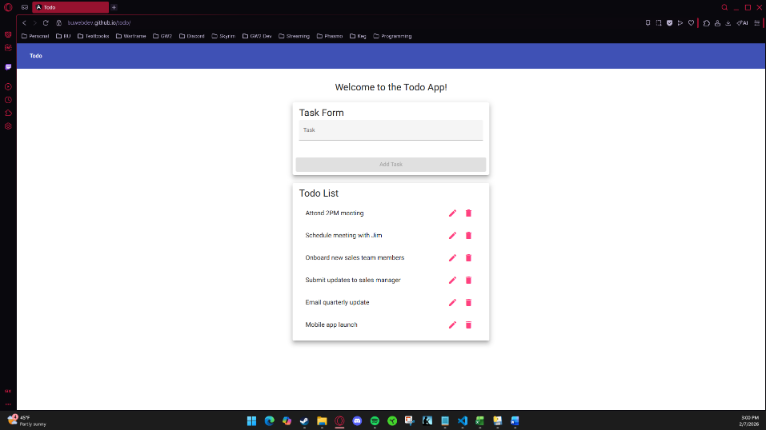
2 | <Click inside the todo input field> | <Cursor appears in the input field> | <yes> | Yes  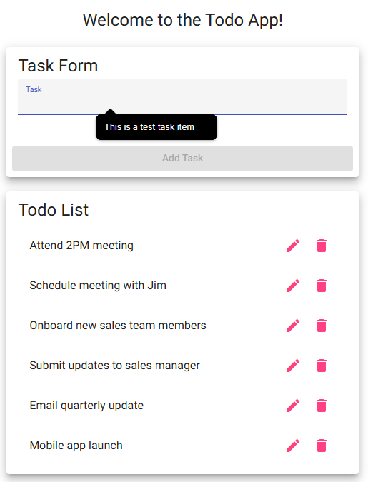
3 | <Enter a valid todo item into the input field> | <Text appears in the input field> | <yes> | Yes  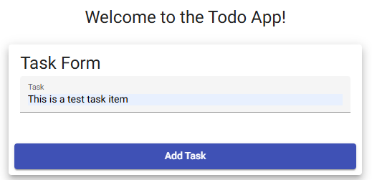
4 | <Click the “add task” button> | <Todo item is added to the list when button is pushed> | <yes> | Yes  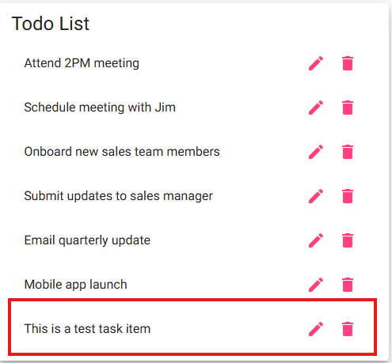
5 | <Verify that the new item has been added to the todo list> | <Todo item is on the list and is readable> | <yes> | Yes
Comments | This test was to ensure that users can successfully create and add task items to the Todo List section. I started off by ensuring that the page was loaded successfully. Afterwards I ensured that the cursor was visible in the input field and that it could be selected. I then ensured that text could be entered by typing the phrase “This is a test task item”. I then added it successfully to the List and ensured that it was visible and readable.

Test 3 | <Delete a ToDo Task Item from List>
 | Test Objective: Verify that users can delete an existing todo task item from the list | Developer: Joel Atkinson  Date tested: <2026/02/06> | Peer tester: Zac Baker  Date tested: 2026/02/07
Step | Action | Expected results: | Developer pass/fail | Tester pass/fail
1 | <Create a new todo item, call it “delete me” and add it to the todo list> | <”delete me” todo item is created and added to the list without error> | <yes> | Yes  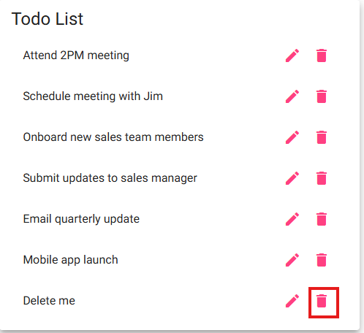
2 | <Locate the delete button (trash can) on the “delete me” item in the list> | <The delete icon (trashcan) is visible> | <yes> | Yes  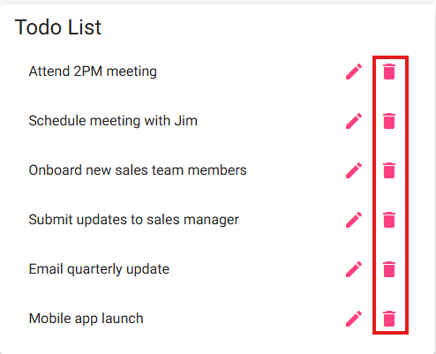
3 | <Click the delete button/icon> | <The “delete me” item is removed from the todo list> | <yes> | Yes  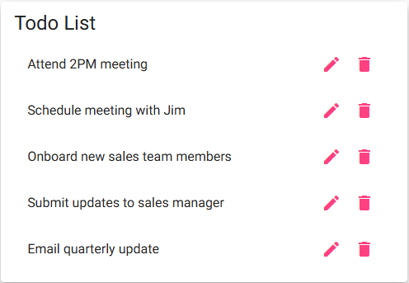
4 | <Verify that the item no longer appears on the todo list> | <Deleted item no longer appears on the todo list> | <yes> | Yes  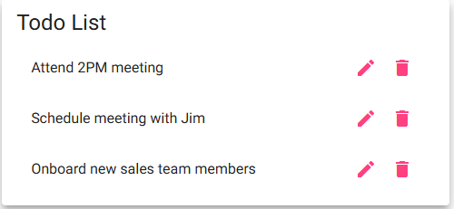
5 | <Refresh the page> | <The page refreshes and the deleted item does not reappear> | <yes> | Yes  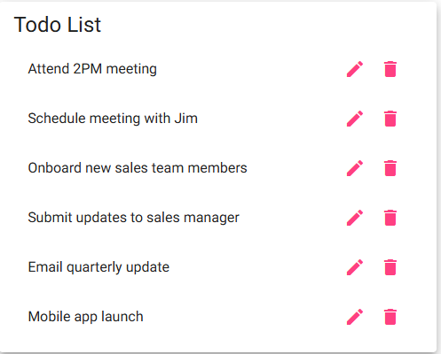
Comments | This test was to ensure that the delete service is functional. I started off by creating and adding a task item named “Delete me”. I then ensured that the trash icons were visible and deleted the item successfully. After ensuring that the item was no longer visible, I deleted a few more items. I reloaded the web page to ensure that the added task item did not appear again, to which it remained deleted. However, the default task items were visible again.

Test 4 | <Prevent Submitting Blank ToDo Item>
 | Test Objective: Verify that the application prevents users from submitting a task form without entering text into the input field for new todo item | Developer: Joel Atkinson  Date tested: <2026/02/06> | Peer tester: Zac Baker  Date tested: 2026/02/07
Step | Action | Expected results: | Developer pass/fail | Tester pass/fail
1 | <Navigate to the todo application> | <Application loads successfully without error> | <yes> | Yes  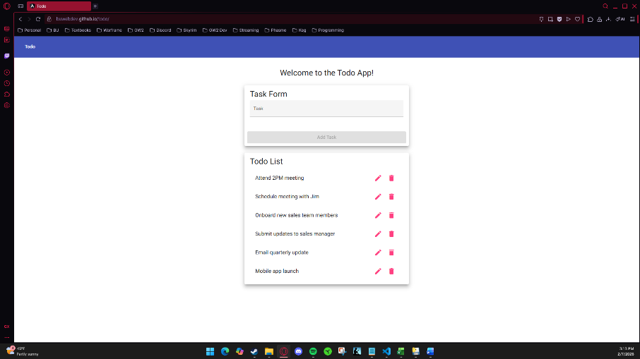
2 | <Ensure the todo input field for new list item is empty> | <The input field contains no text or characters of any kind> | <yes> | Yes  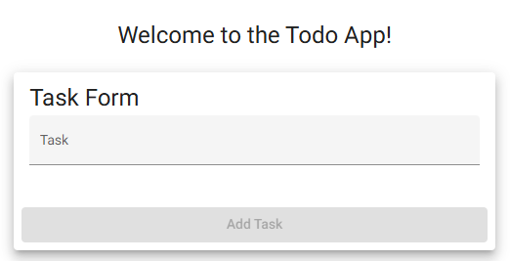
3 | <Observe the add button with an empty input field > | <”Add Task” button is grayed out and unclickable when no input has been entered into the input field> | <yes> | Yes  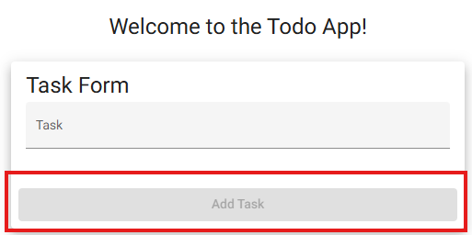
4 | < Attempt to click the “Add Task” button > | < The button remains grayed out and unclickable and no new item is added to the list> | <yes> | Yes
5 | <Enter valid input text into the input field> | <The “Add Task” button becomes enabled and clickable> | <yes> | Yes  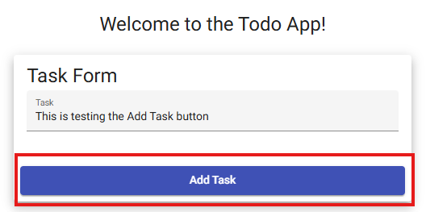
Comments | This test was to ensure that users are prevented and unable to add blank task items to the Todo List. I started off by ensuring the web page was loaded correctly. Afterwards, I ensured that no text was present in the input field and that the “Add Task” button remained greyed out. I attempted to click it to which no task item was added to do List. I then entered text into the input field “This is testing the Add Task button” and the button turned blue and became clickable.

Test 5 | <Edit a ToDo Task Item>
 | Test Objective: Verify that users can edit an existing todo task item and save the updated value | Developer: Joel Atkinson  Date tested: <2026/02/06> | Peer tester: Zac Baker  Date tested: 2026/02/07
Step | Action | Expected results: | Developer pass/fail | Tester pass/fail
1 | <Create a todo item named “original task”> | <New todo item appears on list titled “original task”> | <yes> | Yes  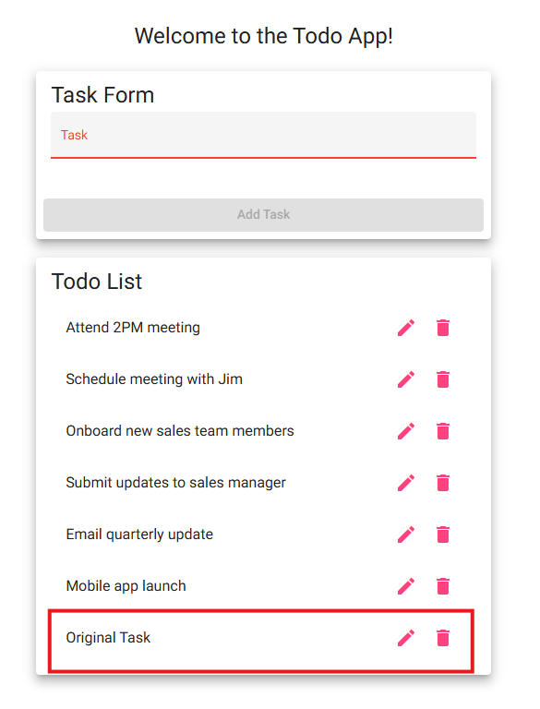
2 | <Click the edit (pencil) icon> | <Edit form window pop up window opens with input field> | <yes> | Yes  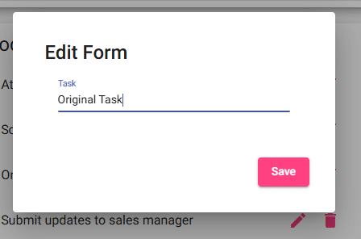
3 | <Change the text to “updated task”> | <The input field responds and the updated text appears without error> | <yes> | Yes  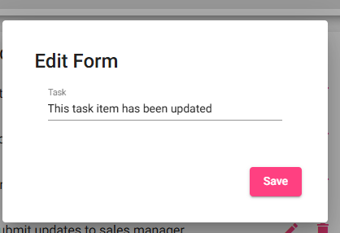
4 | <Hit the save button and save the changes> | <Todo item updates in the list> | <yes> | Yes  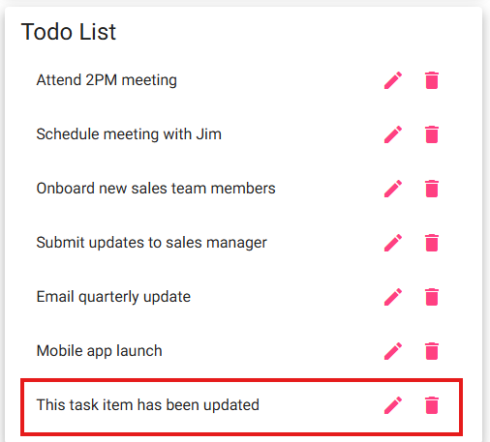
5 | <Verify that updated task is displayed in list> | <”updated task” is visible in the todo list> | <yes> | Yes
Comments | This test is to ensure that task items can be edited and updated. I started by creating a new task item called “Original Task” and ensured that it was successfully added to the Todo List. Afterwards, I clicked on the edit icon, and the popup window appeared. I then entered “This task item has been updated” and clicked the Save button. I then ensured that the edited item appeared in the updated List.

