Project: <Enter a project name> | Project: Todo Web Application
Course: <Enter the course number and name> | Course: CSD 380 – Software Testing
Description: <Enter a description> | Description: Functional test cases based on Todo Business Requirements document
Date: <Enter a date (yyyy/mm/dd)> | Date: 2026/02/06
To complete the test case plan, fill out the information for Project, Course, Description and Date in the header below.

TABLE OF CONTENTS
Access Todo Application via Standard URL 2
Create a New Todo Item 3
Prevent Empty Todo Submission 4
Edit One of the Existing Todo Item 5
Delete Todo Item 6

For each test, the developer should: provide a test description, a test objective, the developer’s name and date tested. For each step, fill out the actions to be taken and describe the expected results, and indicate yes or no for each step depending upon the result. The peer tester should provide their name, date tested, indicate yes or no for each step depending upon the result, and a screenshot (thumbnail) of the result.

Test 1 | Access Todo Application via Standard URL ( https://buwebdev.github.io/todo/)
 | Test Objective: Access Todo Application via Standard URL (Req #10) | Developer: Juan Macias Vasquez  Date tested: 2026/02/06 | Peer tester: Zac Baker  Date tested: 2026/02/07
Step | Action | Expected results: | Developer pass/fail | Tester pass/fail  + Screenshot
1 | Open a web browser | Browser opens successfully | Yes | Yes  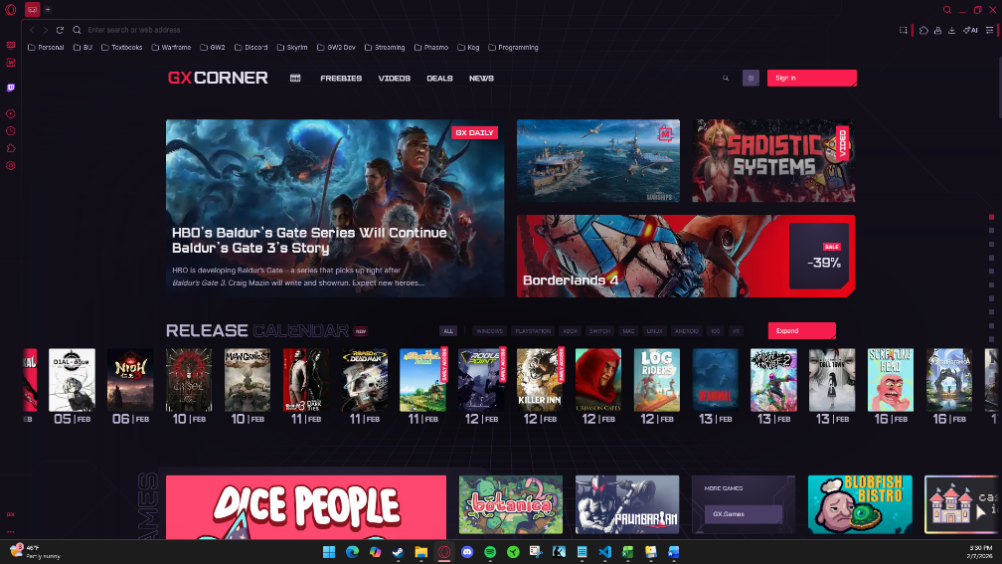
2 | Navigate to https://buwebdev.github.io/todo/ | Todo landing page loads | Yes | Yes  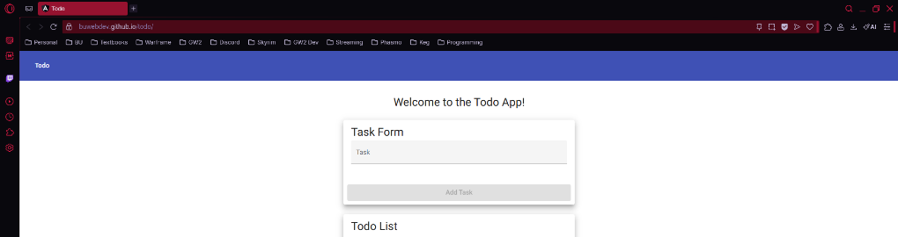
3 | Observe page load | No errors are displayed | Yes | Yes  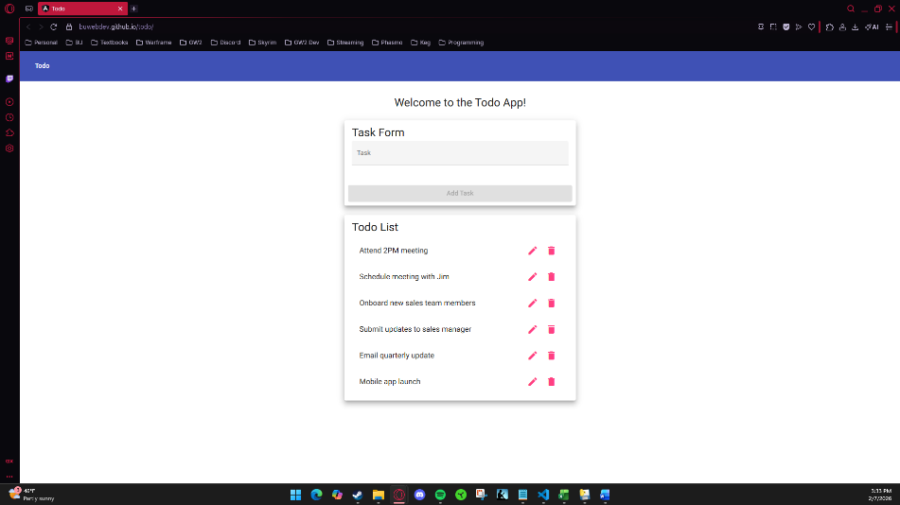
4 | Refresh the page | Page reloads correctly | Yes | Yes  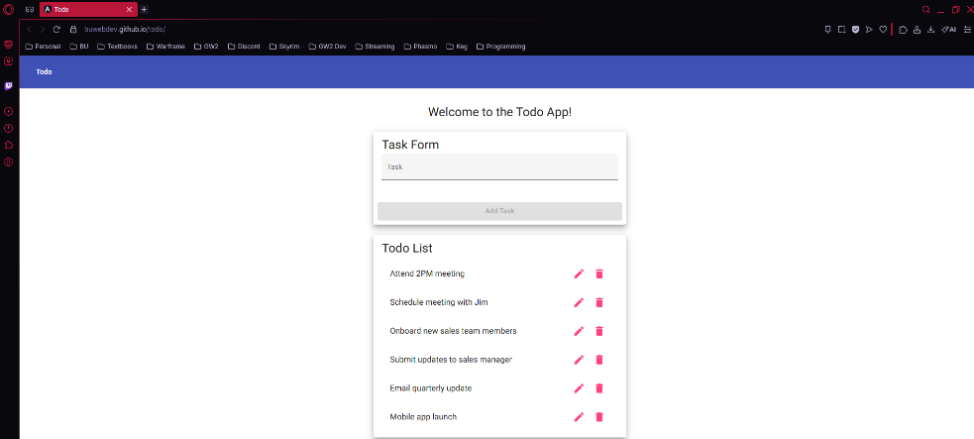
5 | Verify page content | Todo list interface is visible | Yes | Yes  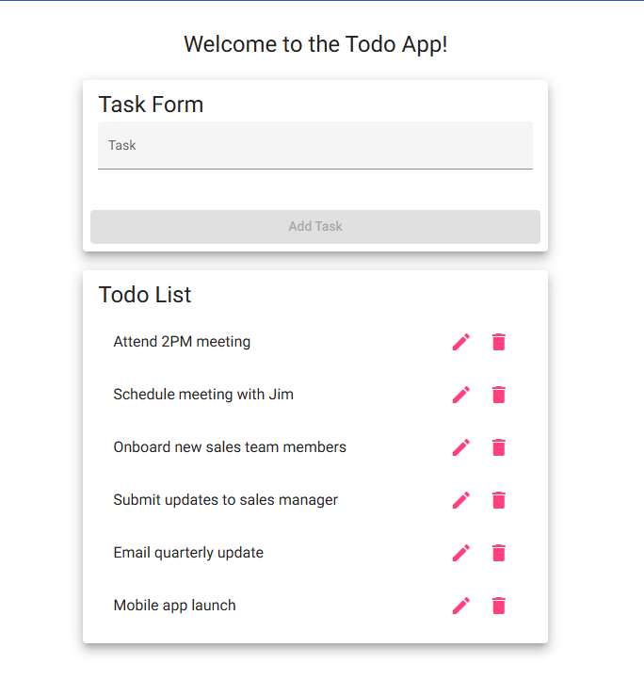
Comments | This test is to ensure that the URL for the web page successfully navigates users to the correct application. I started off by ensuring my browser, Opera GX, successfully opened and entered the URL into the search bar. After successfully navigating to the page, I ensured that no errors were present on the screen and refreshed the page. I then ensured that the Todo List content was present to which everything was successful.

Test 2 | Create a New Todo Item
 | Test Objective: Make sure that users can create a new todo item | Developer: Juan Macias Vasquez  Date tested: 2026/02/06 | Peer tester: Zac Baker  Date tested: 2026/02/07
Step | Action | Expected results: | Developer pass/fail | Tester pass/fail
1 | Access the Todo application | Application loads | Yes | Yes  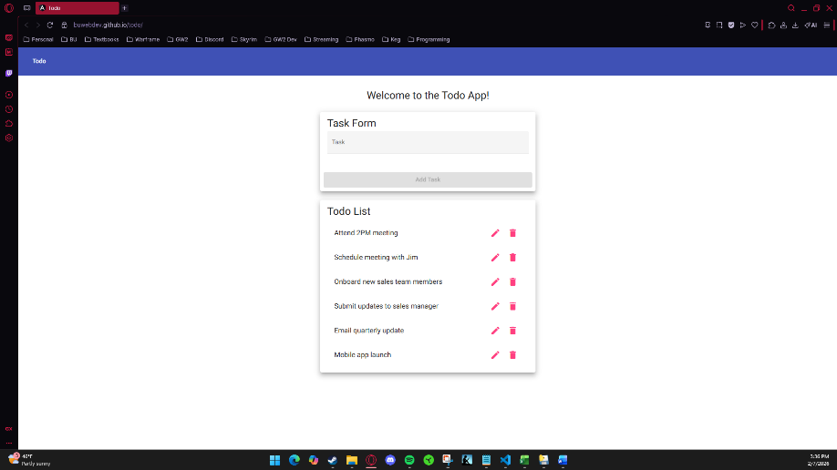
2 | Enter a task in input field | Text is accepted | Yes | Yes  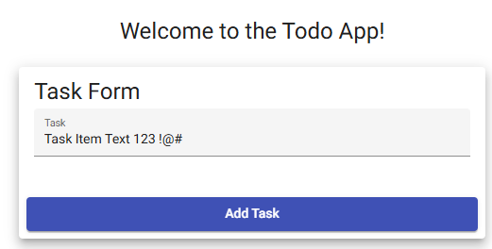
3 | Click Add button | Task is submitted | Yes | Yes  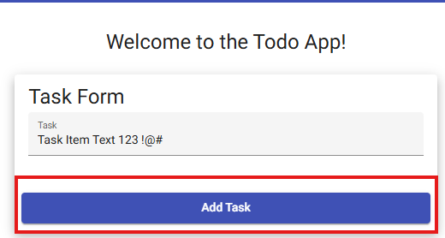
4 | Observe the task list | New task appears | Yes | Yes  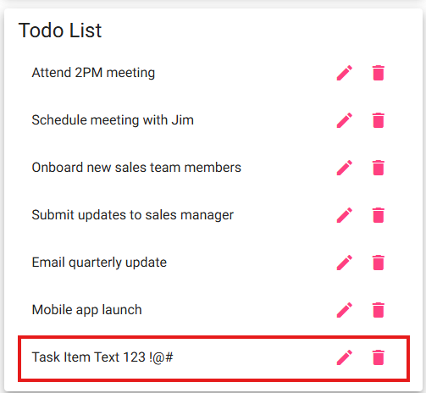
5 | Confirm that there are no errors | Application remains stable | Yes | Yes  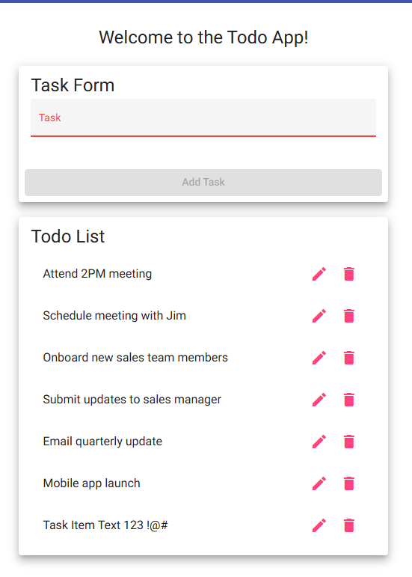
Comments | This test was to ensure that users can enter and add new task items to the Todo List. I started off by ensuring that the web page was loaded correctly and then entered text, numbers, and symbols into the input field. After ensuring this was possible, I clicked the Add Task button and checked to see if it was successfully added to the List. It was appended to the bottom of the list with all text, numbers, and symbols. I then checked to see if any errors occurred or popped up to which none did.

Test 3 | Prevent Empty Todo Submission
 | Test Objective: Verify empty todo items cannot be submitted | Developer: Juan Macias Vasquez  Date tested: 2026/02/06 | Peer tester: Zac Baker  Date tested: 2026/02/07
Step | Action | Expected results: | Developer pass/fail | Tester pass/fail
1 | Access the Todo application | Application loads | Yes | Yes  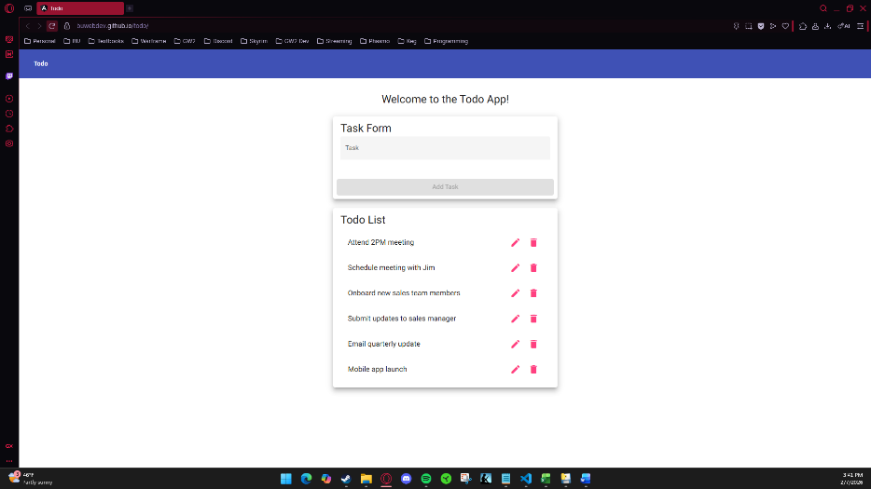
2 | Leave input field empty | No text entered | Yes | Yes  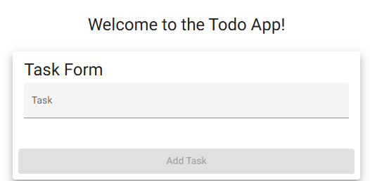
3 | Click Add button | Submission attempted | Yes | Yes  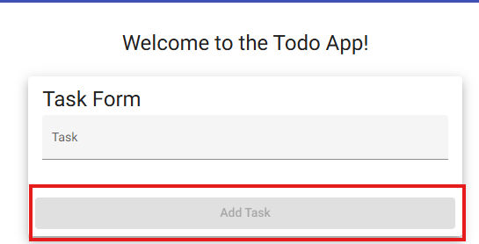
4 | Observe task list | No new task added | Yes | Yes  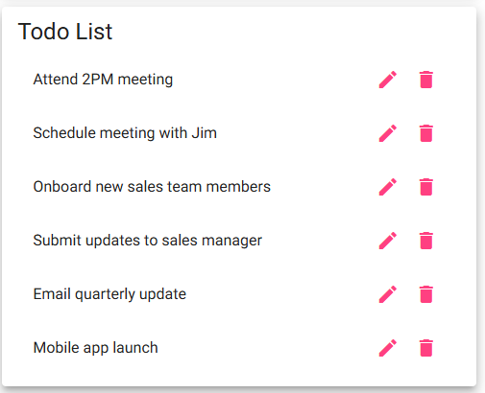
5 | Verify stability | No error or crash occurs | Yes | Yes  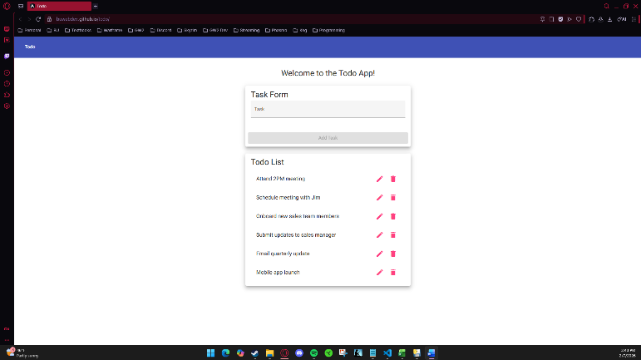
Comments | This test was to ensure that empty task items cannot be added to the Todo List. I started by ensuring that the web page was loaded correctly and that the input field was empty. Noticing the Add Task button was still greyed out, I further tested it by clicking on it. This did not add any empty task item to the List which confirmed that empty task items can not be added. I finished by ensuring that no errors or crashes occurred afterwards.

Test 4 | Edit One of the Existing Todo Item
 | Test Objective: Verify users can edit a todo item and validation is enforced | Developer: Juan Macias Vasquez  Date tested: 2026/02/06 | Peer tester: Zac Baker  Date tested: 2026/02/07
Step | Action | Expected results: | Developer /pass/fail | Tester pass/fail
1 | Add a new todo item | Todo item appears | Yes | Yes  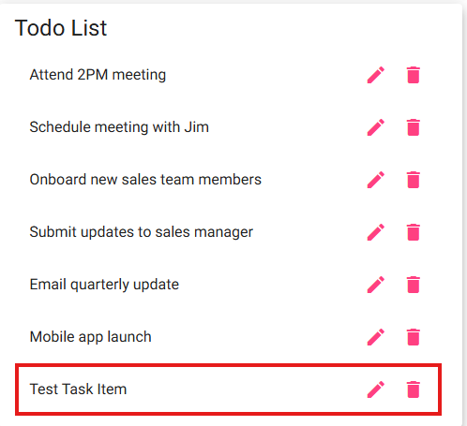
2 | Select edit option | Edit view opens | Yes | Yes  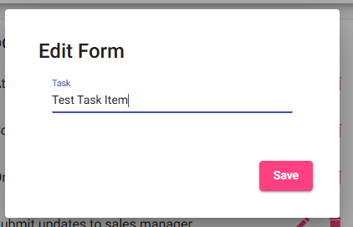
3 | Modify task text | Text is updated | Yes | Yes  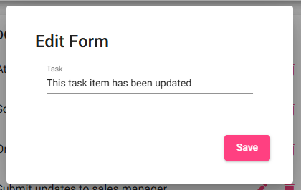
4 | Save changes | Edit is saved | Yes | Yes  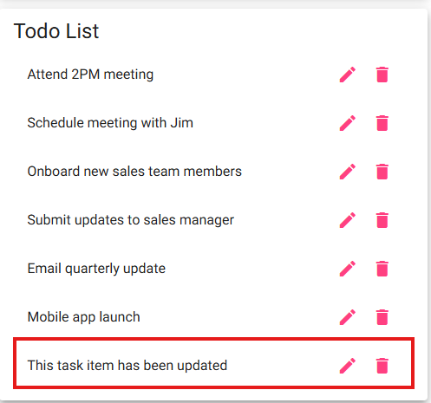
5 | Verify updated text | Updated task is displayed | Yes | Yes  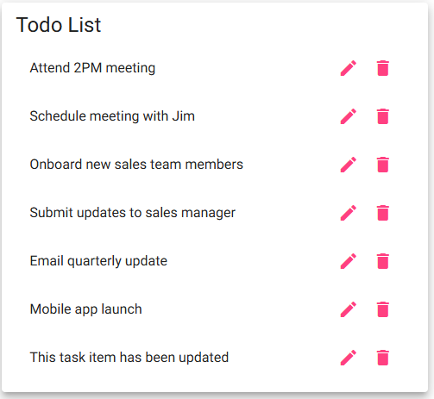
Comments | This test was to ensure that task items can be edited and the List updates for the new task item value. I started by creating a new task item called “Test Task Item” and ensuring that it was appended to the Todo List. Afterwards, I clicked on the edit icon and updated the text to “This task item has been updated.” I then ensured the List was updated properly and successfully. The editing service is easy to understand and works as intended.

Test 5 | Delete Todo Item
 | Test Objective: Delete Todo Item | Developer: Juan Macias Vasquez  Date tested: 2026/02/06 | Peer tester: Zac Baker  Date tested: 2026/02/07
Step | Action | Expected results: | Developer pass/fail | Tester pass/fail
1 | Add a new todo item | Todo item appears | Yes | Yes  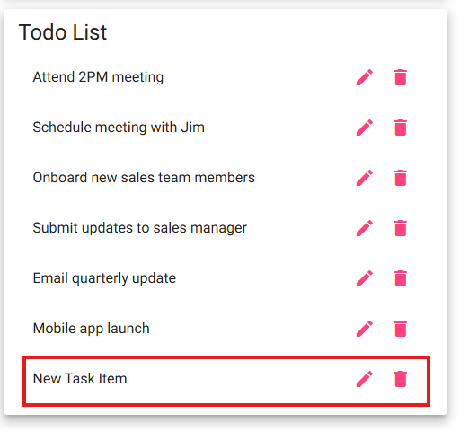
2 | Locate delete option | Delete control is visible | Yes | Yes  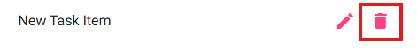
3 | Click delete | Delete action executed | Yes | Yes  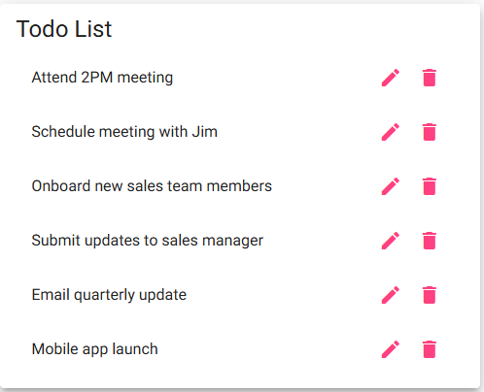
4 | Observe task list | Item is removed | Yes | Yes
5 | Confirm no errors | Application remains stable | Yes | Yes  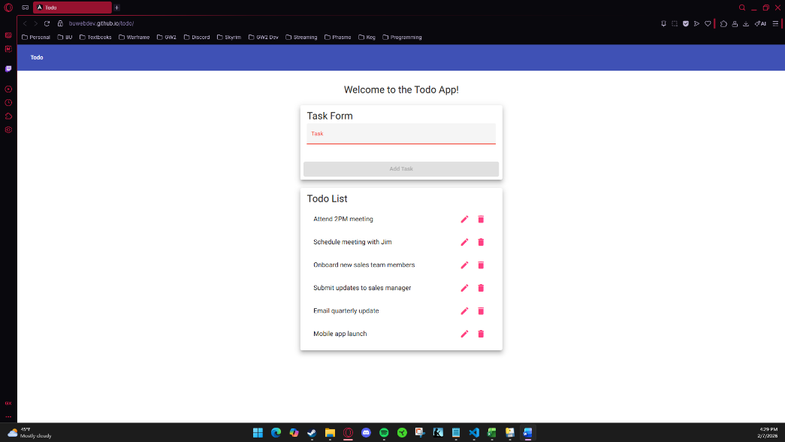
Comments | This test was to ensure that task items can be deleted successfully and that the List will no longer show the item. I started off by created a new task item called “New Task Item” and confirmed that it was successfully added to the bottom of the List. I then confirmed that the delete icon was visible. After clicking the delete icon, the added task was successfully deleted from the list with no visible errors or crashes. Overall, the simple functionality of deleting task items was successful.

