Zac Baker
Module 5.2 Assignment
2/15/26
https://github.com/ZaccBaker/csd-380
Value Stream Mapping (VSM)
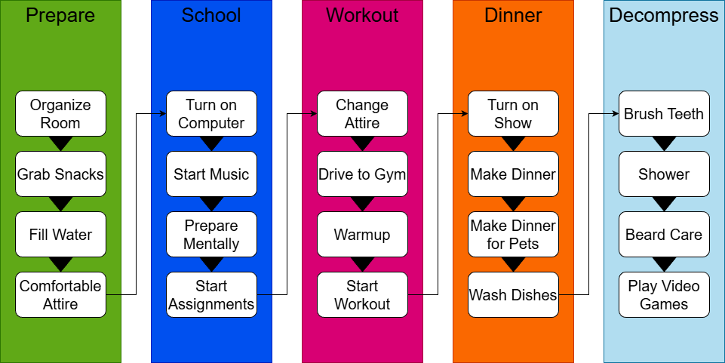
Estimated Average Flow Time
Prepare | 40 Mins
School | 240 Mins
Workout | 90 Mins
Dinner | 50 Mins
Decompress | 120 Mins

Estimated Cycle Time
9 hours

Optimizing Processes
Eliminating Waste
I could start eliminating wasted time by organizing my pantry better, as I lose about ~7 minutes trying to find and figure out what snack I want for my study session. My preparation process varies too often, anywhere from ~10-20 minutes. I can streamline this by introducing meditation practices and consolidate it to ~5 minutes.

Workflow Orchestration
I could move my mental preparation into the preparation process, as it is more fitting category. However, it depends because this is the very last thing I like to do to ensure I am entirely focused on my assignments. Doing this earlier could also aid in becoming organized quicker for my study session which would give me more time allotted for it.

Governance Models
Reviewing my model has shown me that I am away from my house for ~90 minutes which may result in me needing to set my Ring Alarm. When I am focused on my assignments I am disconnected from my surroundings. Though I have a dog, having an added security system set in place might be necessary.

