Zac Baker
Module 1.2 Assignment – GitHub
3/27/26
https://github.com/ZaccBaker/csd-440

Directory
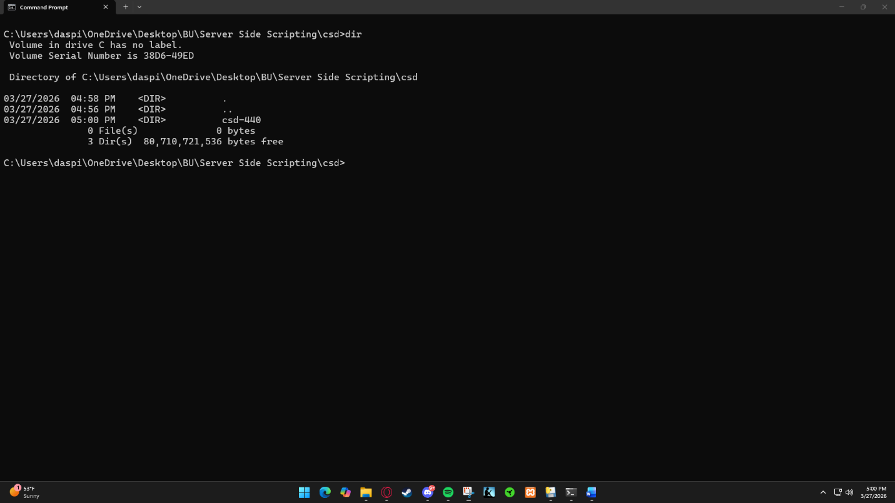

GitHub
