RESEARCH PROJECT – USABILITY

FOLLOWING P:\kmarasek\KCK\wyklady\ENG:

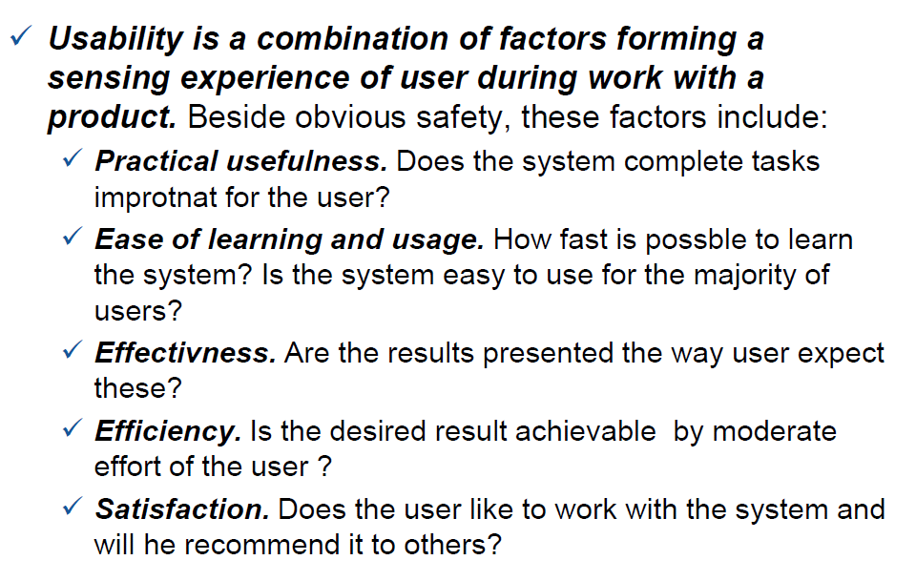

The project should be made **individually** by each student and attach to MS Teams Assignment by **13.01.2022**.

Usability test of program or a service:

Part 1 Heuristics

Compliance with rules/heuristics of good usability (Choose one, recommended: Nielsen and Molich)

* Methods
* Heuristic rules of Nielsen and Molich (<https://www.nngroup.com/articles/ten-usability-heuristics/>)

The most common rules of proper human-computer interaction; rules are correct independent from technical solutions and are based on statistical investigations on factors influencing comfort and satisfaction of software users:

* Visibility of system status

The system should always keep users informed about what is going on, through appropriate feedback within reasonable time.

* Match between system and the real world

The system should speak the users' language, with words, phrases and concepts familiar to the user, rather than system-oriented terms. Follow real-world conventions, making information appear in a natural and logical order.

* User control and freedom

Users often choose system functions by mistake and will need a clearly marked "emergency exit" to leave the unwanted state without having to go through an extended dialogue. Support undo and redo.

* Consistency and standards

Users should not have to wonder whether different words, situations, or actions mean the same thing. Follow platform conventions.

* Error prevention

Even better than good error messages is a careful design which prevents a problem from occurring in the first place. Either eliminate error-prone conditions or check for them and present users with a confirmation option before they commit to the action.

* Recognition rather than recall

Minimize the user's memory load by making objects, actions, and options visible. The user should not have to remember information from one part of the dialogue to another. Instructions for use of the system should be visible or easily retrievable whenever appropriate.

* Flexibility and efficiency of use

Accelerators — unseen by the novice user — may often speed up the interaction for the expert user such that the system can cater to both inexperienced and experienced users. Allow users to tailor frequent actions.

* Aesthetic and minimalist design

Dialogues should not contain information which is irrelevant or rarely needed. Every extra unit of information in a dialogue competes with the relevant units of information and diminishes their relative visibility.

* Help users recognize, diagnose, and recover from errors

Error messages should be expressed in plain language (no codes), precisely indicate the problem, and constructively suggest a solution.

* Help and documentation

Even though it is better if the system can be used without documentation, it may be necessary to provide help and documentation. Any such information should be easy to search, focused on the user's task, list concrete steps to be carried out, and not be too large.

* Gerhardt-Powals' cognitive engineering principles
* Weinschenk and Barker classification

(<https://www.liquisearch.com/heuristic_evaluation/weinschenk_and_barker_classification>)

* Bibliography
* <https://www.nngroup.com/articles/ten-usability-heuristics/>
* P:\kmarasek\KCK\wyklady\ENG\KCK2-usability rules
* P:\kmarasek\KCK\wyklady\ENG\KCK7 - usability of web portals
* <https://en.wikipedia.org/wiki/Heuristic_evaluation>

Part 2 Usability test

* Identify the users
* Minimum number of tests participants: 4-5
* Prepare script (tasks for testers)
* Usability metrics:
* Success rate – in a given scenario was the user able to complete the assigned task?
* Error rate
* Time to Completion – how much time did it take the user to complete the task?
* Subjective Measures – numerically rank a user’s self-determined:
* Satisfaction
* Ease-of-use
* Availability of information
* Type of tests (Choose one. Recommended: Scripted use of product):
* **Scripted use of product**
* **Write clear task scenario**
* **Define the best paths to success**
* **Time each task**
* **Measure user confidence**
* Decontextualized use of the product
* Natural Use of the product
* Hybrid
* Testing Websites:
* Task Success
* Navigability – how fast and how many clicks
* UX Design – user emotional responses
* Readability
* Speed: Google PageSpeed
* Bibliography:
* uxpin_guide_to_usability_testing.pdf
* P:\kmarasek\KCK\wyklady\ENG
* <https://www.nngroup.com/articles/unmoderated-user-testing-tools/>

Part 3 User point of view review

* Methods:
* Surveys and questionnaires (<https://en.wikipedia.org/wiki/Likert_scale>)
* Interviews
* Post-Testing Questions
* Tools:
* [https://www.surveygizmo.com/](http://uxmastery.com/how-to-improve-your-interview-skills/)
* Google Forms
* Bibliography:
* <http://www.infotoday.com/online/sep02/Plosker.htm>
* <http://uxmastery.com/how-to-improve-your-interview-skills/>

Part 4. Accessibility

Verify:

* if the page is consistent across every major browser?
* contrast (<https://www.w3.org/WAI/GL/WCAG3/2021/how-tos/visual-contrast-of-text/>)
* text alternatives (<https://www.w3.org/WAI/GL/WCAG3/2021/how-tos/text-alternatives/>)

Evaluation tools:

<https://www.w3.org/WAI/ER/tools/>

Bibliography:

<https://www.w3.org/WAI/>

<https://www.nngroup.com/topic/accessibility/>

<https://www.bbc.co.uk/accessibility/forproducts/guides/mobile/>