**TASK 2**

**Entropy**

**Gini**

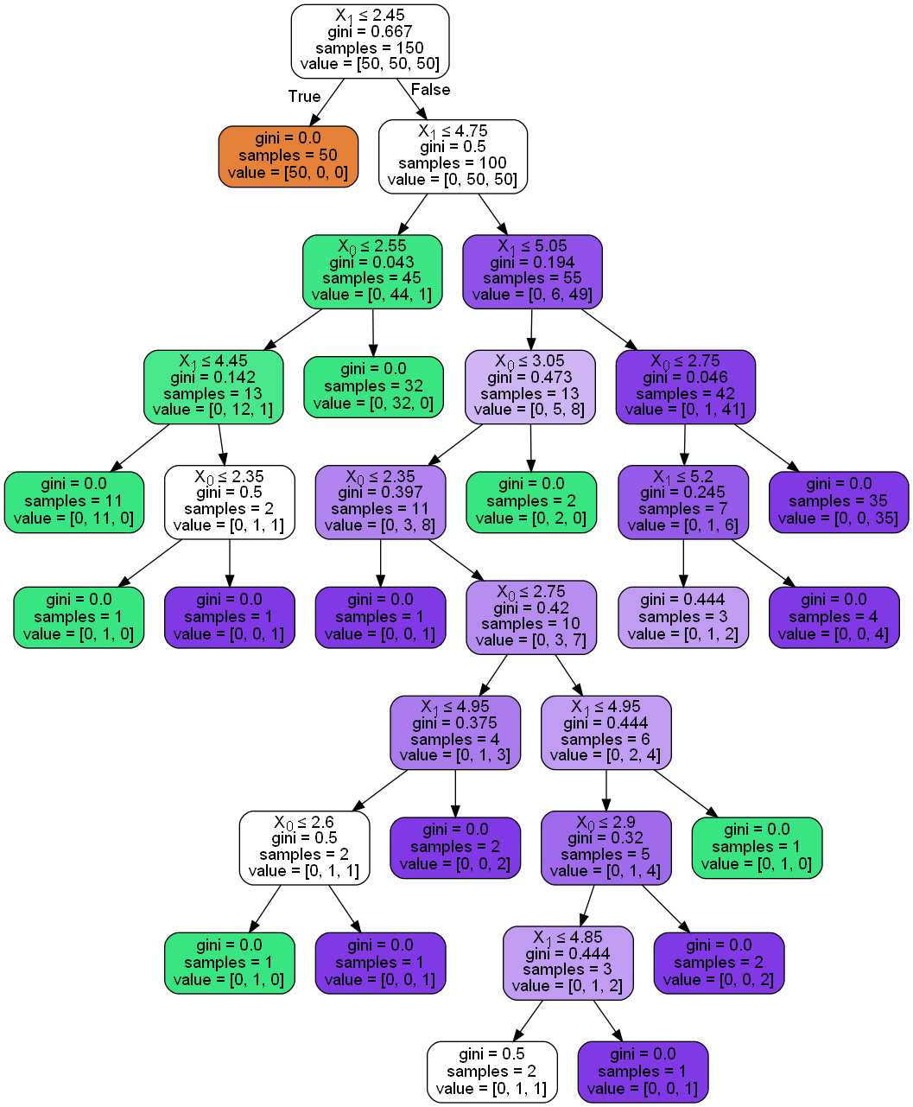

**Explenation:**

So as we can see using Gini we have a slightly deeper tree. Entropy works between 0 and 1 and Gini 0 and 0,5. Gini is also much faster but entropy is slightly better. This comes from differences in computations. P to the power of 2 in Gini and P times log P in entropy.

**TASK 3**

**Max depth 10**

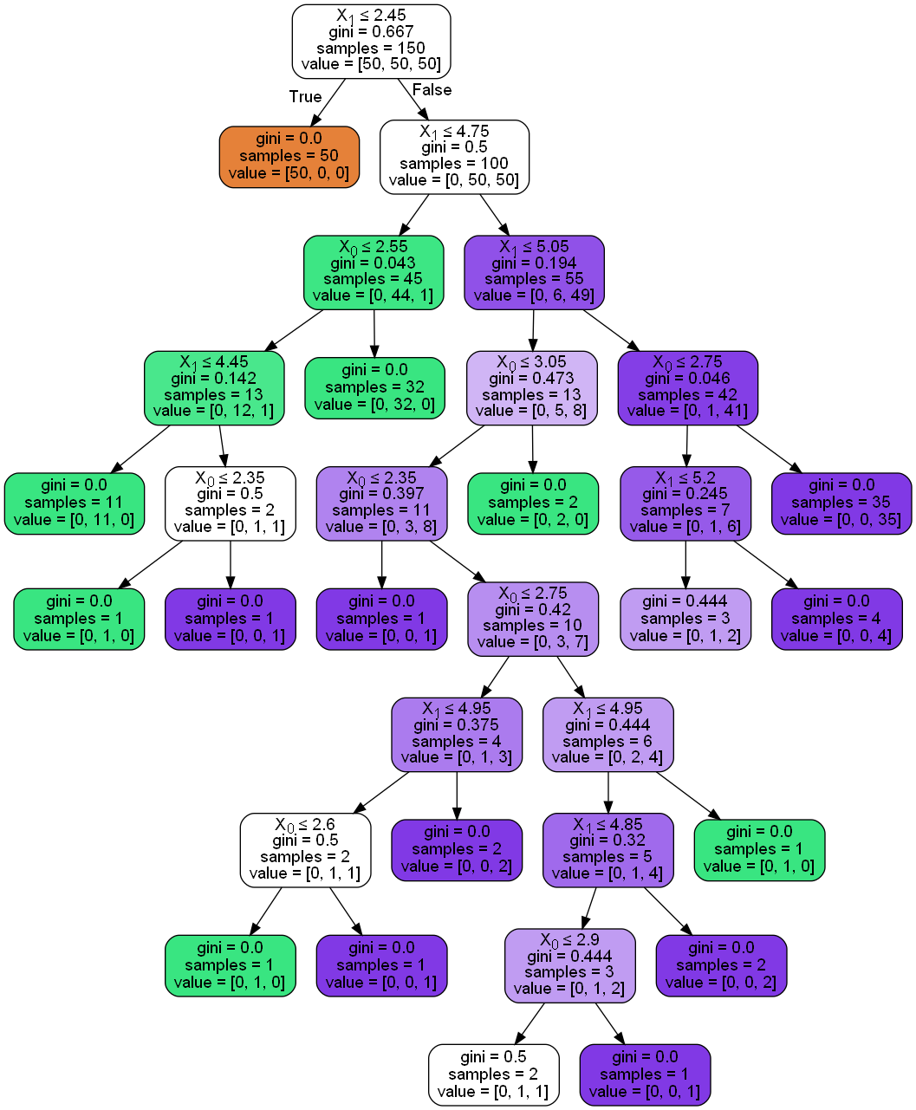

**Max depth 5**

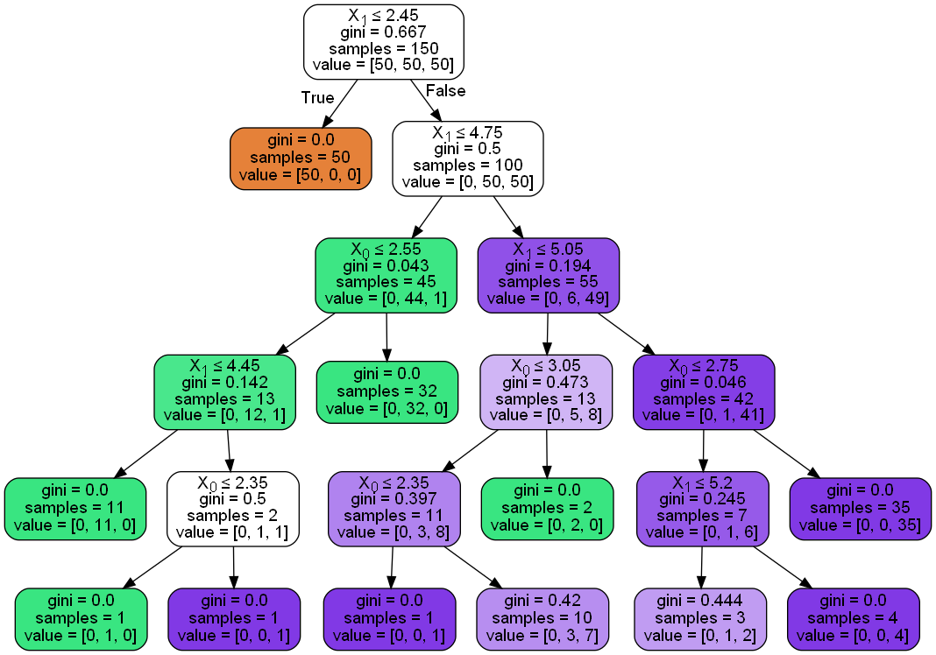

**Explenation:**

As we can see with the lower depth we are getting a much shorter decision tree - less time to make a decision but from the other side, we are losing a lot of accuracy.

**TASK 4**

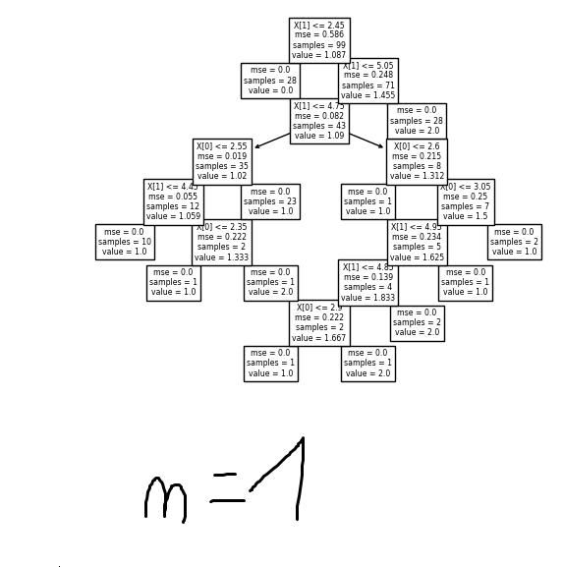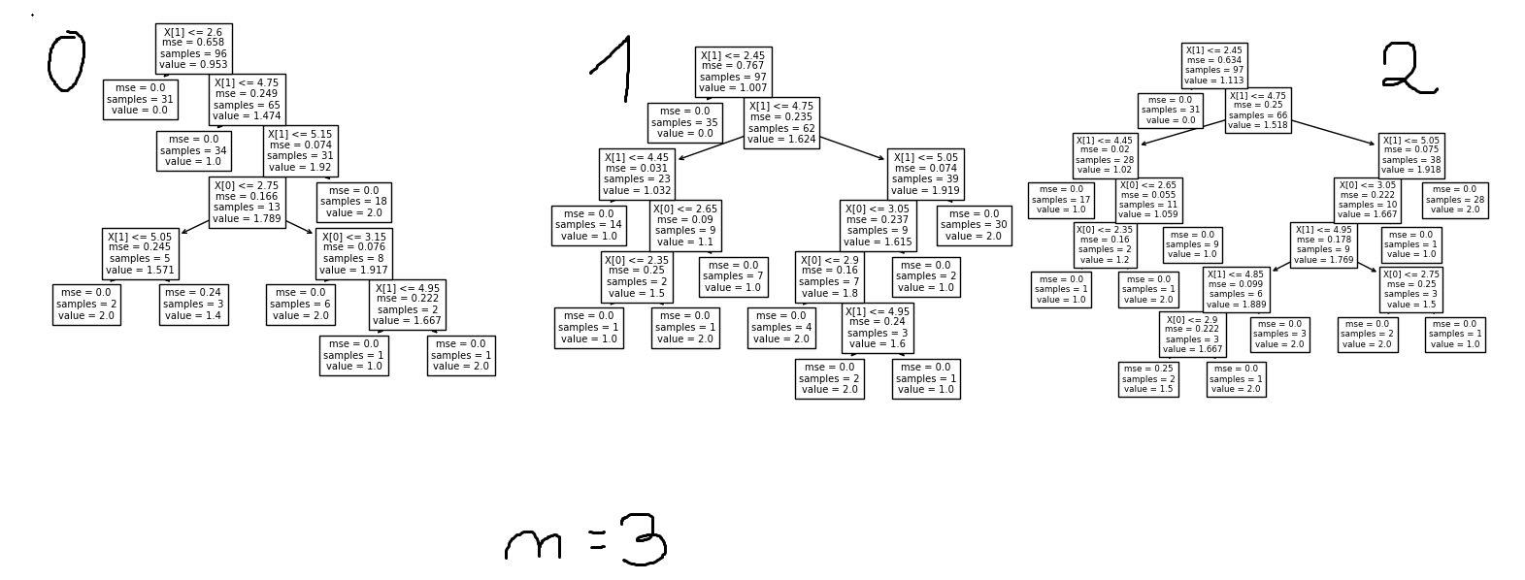

**Explenation:**

As we can see every tree in our random forest is different to create an average decision from all of the trees. Of course, more trees are equal better accuracy but much more computations.