Project Report on In-Depth Interviews

**MKTG 4450: Marketing Research**

**Professor: Dr. Sachin Banker**

**By Group 27: Zachary Fletcher, Wesley Booher, Cathleen Yang, Derek Garibaldi, and Devin Jaster**

## 1. Abstract

As students move off campus, planning for meals becomes more difficult. Research of our problem’s context concluded that university students face financial, nutritional, and resource-related challenges when planning their meals. Our research objectives were to investigate pain points in student meal planning and identify common challenges they face. The information gained helps Edible Software LLC design solutions to aid students in off-campus meal planning. Our research methods included a qualitative approach by recording transcripts of in-depth interviews aided with an interview guide. We performed a voice-of-the-customer analysis and created an affinity diagram to help identify possible solutions. Our findings conclude that students struggle to balance time, budgeting, and nutrition and do not take advantage of available University resources. They struggle to maintain a budget and find affordable nutritional ingredients while lacking the time to cook each week. We recommend that an app be designed with features like a “speed cook recipe hub”, an AI-powered meal planning tool, a smart budgeting feature, and a real-time student discount information board.

## 2. Context and Research Objectives

**Problem Context**

Students moving off campus face financial challenges related to meal planning. Research suggests that students living off campus spend an average of $410 per month on meals, with $250 of that amount going to groceries. In comparison, the average campus meal plan costs $335 per month[1]. Additionally, this comparison does not account for the time and effort required to cook and prepare meals.

The University of Utah offers many resources to its students for cost of food, meal planning, and meal prep, which is an important consideration when determining the best solutions for university students[2]. The university has partnered with numerous community, government, and nonprofit programs which offer food services and basic needs. The University of Utah also funds a few pantries and services of their own, including In A Pinch Pantry and Feed U pantries. These pastries require students and faculty to use their UnIDs[3]. The Feed U Feed you pastries are 3 on campus pastries which are free for student and faculty use and offer non-perishable, nutritious foods[4]. In a pinch Pantry is sponsored by the Office of Student Engagement, and basic needs for students and faculty. The University of Utah offers a meal planning service for both on and off campus students. Prices for meal plans range from $3417-$6642 a semester. Lastly, the university offers 10% student discounts for nearby restaurants, an on-campus cafeteria in the A.Ray Olpin Student Union Building, and several stores to buy food throughout the campus[5].

Place of residence greatly influences how students go about their diet. A study done on 219 college students in New York also highlights this issue. Out of the 219 students, 67% answered that they skipped at least one meal within the last week. Compared with the on-campus students in the study, the off-campus students frequently stated that ‘having no time to prepare’ was a main reason for meal skipping[6]. Another study also shows that over one third of college males and females reported that they do not have time for meal preparation, around 25% cite money as a barrier, and 23% of college males cite cooking skills as another.

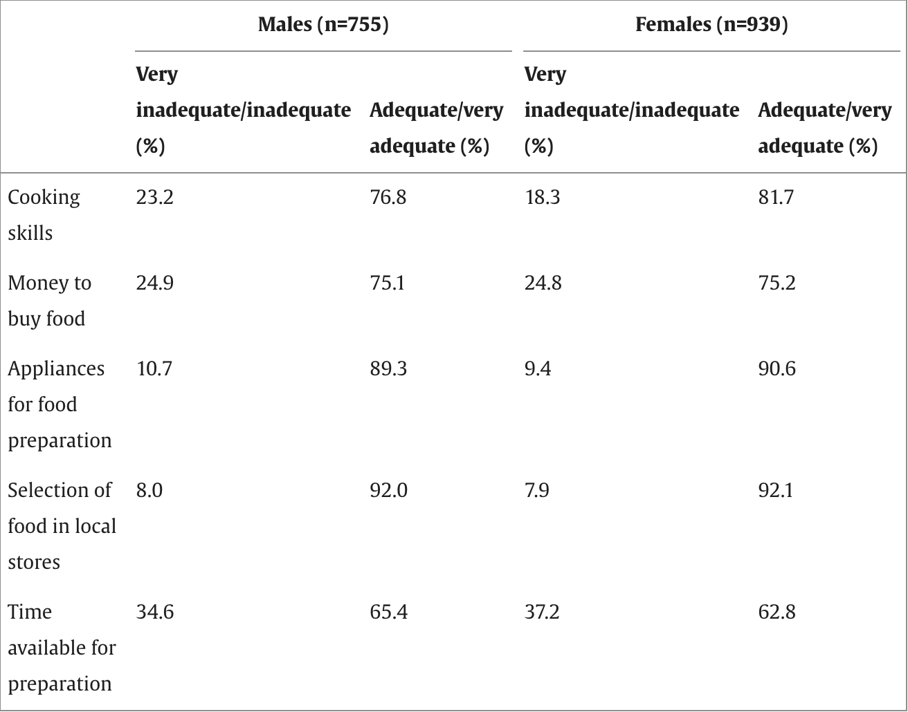

*Percentages of young adult participants in Project EAT (Eating Among Teens)-II who reported the adequacy of their skills and resources for food preparation were very inadequate/inadequate and adequate/very adequate*

By exploring the cost of meals off campus, existing university food programs, and behaviors of college students living off campus, we will be able to successfully evaluate a better way for students to eat while living off university grounds.

**Research Objectives**

The goal of this study was to understand how students currently approach meal planning after moving off-campus and away from campus dining meal plans. Our objective was to identify common challenges they face. Doing so helped us find areas where current solutions fall short or are lacking.

Research participants were students from the University of Utah who have moved off campus. Our goal was to learn from students who have recently transitioned from eating on campus to planning their own meals off-campus. It was essential to study different living arrangements which included students living with roommates, family, and by themselves.

The information gained through our research was aimed to help our company design solutions that resonate with students pivoting from a campus meal plan to off-campus eating. The research will guide our company towards the friction points that off-campus students are feeling, thus helping us to improve their current options with restaurants and grocery stores.

## 3. Methodology

**Research Methods**

Using a qualitative approach our team was able to start with a research problem focused around challenges off campus students face with meal planning. We were able to conduct background research that would then help us prepare research objectives to incorporate in a series of depth interviews. Our team relied on recorded transcripts collected from depth interviews to access the voices that were crucial to finding requirements that we could include when thinking about solutions. A voice of customer analysis was used to put together an affinity diagram that brought structure, so that our team could piece together a solution that involves key requirements of the customers.

**Interview Guide Development**

In an effort to help our team cover all important issues related to our research, we constructed an interview guide prior to conducting any interviews. This guide was designed to help interviewers probe deeply for experiences and explanations that would answer questions our team had listed in relation to our research objectives. These objectives included understanding how students approach meal planning and identifying common challenges they face. Our team also structured the guide around the four stages of a depth interview to create a friendly environment that helped participants warm up before diving deeper into our questions. Projective techniques, like the ZMET activity, were also incorporated toward the beginning as a way for us to understand how these students compared an animal to the way they feel about meal planning.

**Participant Selection**

The research team focused on interviewing participants who could give important insights and perspectives on the problems off-campus students might face with meal planning. To do this, we selected a non-probability method of convenience sampling, where each member of the research team selected a student where they had an existing relationship. While this approach may have allowed for some measurement error, we opted to pursue it to gain insights quickly, as we saw more benefits than drawbacks. A total of five depth interviews were conducted with off-campus students who had recently transitioned from living on campus to off-campus housing.

**Data Collection and Analysis**

Each of the five interviews involved one team member as the interviewer, who conducted the interview using the interview guide. After completing all five interviews, the team analyzed the data through a five-step process that included: 1) identifying the key voices from each transcript, 2) translating statements into needs/benefits seen, 3) organizing our requirements into a diagram (affinity diagram), and 4) creating a solution that targets real customer needs. This framework helped us use data to better understand the challenges students need solved regarding meal planning. As a team, we encountered no perceived problems related to data collection.

## 4. Affinity Diagram

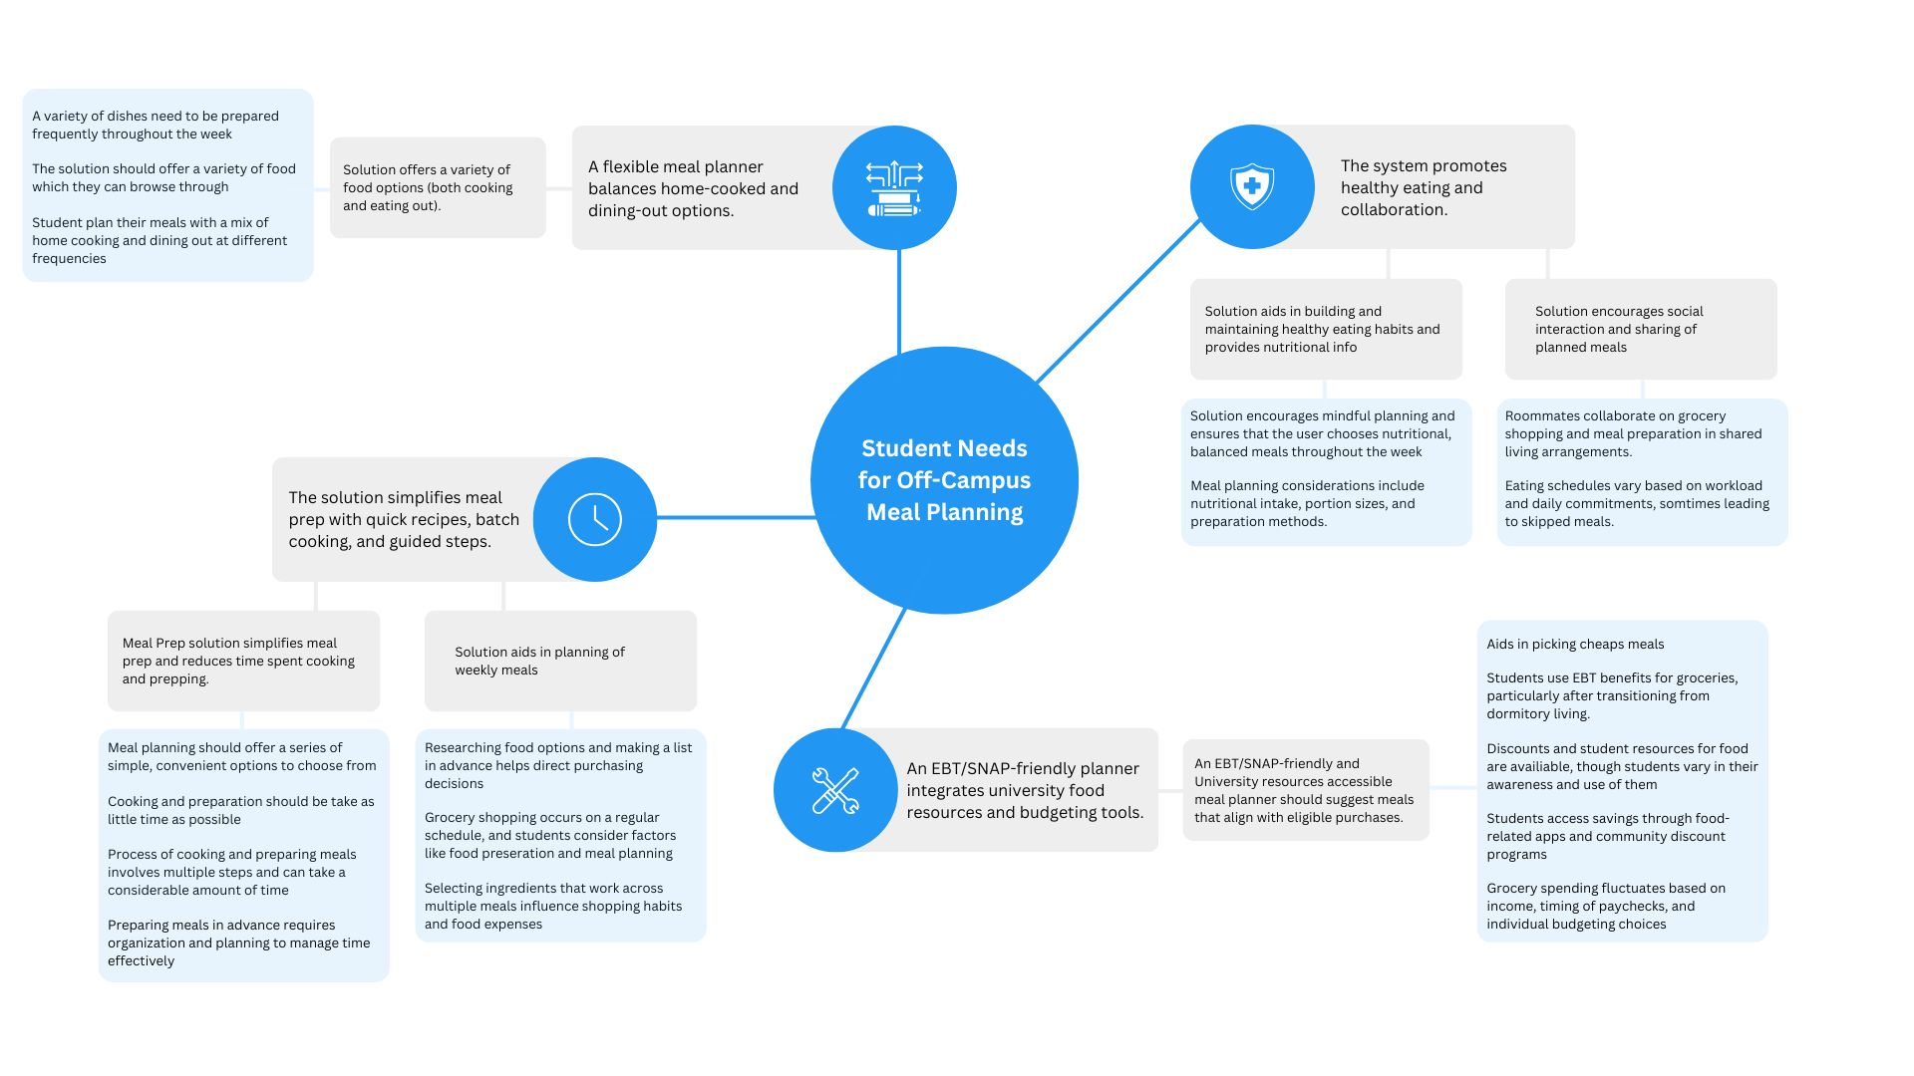

## 5. Qualitative Interpretation

**Making Meal Prep Easier with Quick Recipes, Batch Cooking, and Step-by-Step Guidance**

A more common concern with people was prepping meals efficiently. People described this as overwhelming, especially with the time it takes to cook and prep, which leads to irregularities in their meal planning process.

One person said, “*After a long day, cooking feels like another chore. I need a way to make it quicker and easier.”* This aligns with our assertion that meal planning should help with the cooking process and make things easier.Others said that they want a solution that will make it easier, like recipe suggestions based on ingredients that they have. Like one person said, “*If I had a tool that suggested meals with what I already have, it would be so much more convenient.”*

Batch cooking was another way that people loved. One person noted that “*Batch cooking saves me time, but I struggle with planning it out efficiently.”* This notes the need for a structured meal planning tool that gives step by step guides to make meal prep easier and ease the stress of cooking daily.

**A Flexible Meal Planner that Balances Home Cooking and Eating Out Options**

People we interviewed also pointed out the challenge of balancing cooking at home and eating out. Most that were interviewed base their eating schedules on time issues, social plans, and budget constraints. This makes flexibility key in our design process.

One person described his challenge: *Some weeks I cook a lot, but other times I rely on takeout. It would be nice to have a planner that adapts to that."* Another person added, *"I don't want to feel guilty for eating out, but I also want to make sure I’m getting balanced meals."* Both of these statements show that a dynamic meal planning tool that accommodates varied eating patterns would be necessary in our product.

Grocery shopping is a huge part of meal planning obviously, one person said, “*I usually shop based on what meals I plan, but sometimes I just buy things randomly and figure it out later."* This quote shows that the meal planning process should integrate with the users shopping patterns, helping them save money along the way.

**Features that Promote Healthy Eating and Collaboration**

Users that want to be health conscious as they meal plan show a strong interest in solutions that are based around healthy eating habits. While this is ideal for everyone, it comes with some challenges as maintaining a healthy diet is hard to do consistently.

One person said that, “*I want to eat healthier, but sometimes I just grab whatever is convenient. Having a system that nudges me towards better choices would be great."* Another participant mentioned, *"Portion sizes are tricky. I either cook too much or too little."*  These quotes and insights tell us that our meal planning tools should have suggestions for nutrition, portion size, and balanced meals.

Collaboration was also something that people want involved, especially with people who have roommates or live with their family. Someone said, “*If we had a shared grocery list or meal planner, it would make things so much easier for all of us."* This highlights the fact that we should include a social element into our app. Tools that would include shared meal planning and grocery shopping hauls would promote teamwork and make meal planning more engaging.

**EBT/SNAP-Friendly Planner Integrates University Food Resources and Budgeting Tools**

People's finances are a major burden for those who want to plan and prepare meals. This is especially the case with students and others relying on food assistance programs like EBT and SNAP. A student shared, *"Using EBT for groceries is helpful, but I wish there was a way to plan meals around what I can actually buy with it."* Another user mentioned, *"I’m not always aware of the discounts and student deals available for food. A system that integrates that would be really useful."* These really highlight the need for a feature that includes finances into the meal planning process.

Budgeting at the grocery store is another issue for people. As one user states, “*Some weeks I have more money for food than others, so I have to adjust my grocery shopping accordingly."* Including budgeting tools and expense tracking with meal planning helps with this, allowing users to make more informed decisions with their money.

## 6. Proposed Solution

In response to the qualitative interpretation of our data, our team proposes an app with features that identify the challenges faced by students who have moved off campus. These features include an AI-powered meal planner, college student discounts, smart budgeting, and a “speedcook” college recipe hub. In addition, the app would offer personalized grocery shopping suggestions and real-time alternative costs to help students manage their expenses efficiently, and make sure that they stay within their own budget they have set within the app. These features connect best with the needs of the students we interviewed after recently moving off campus.

**AI-Powered Meal Planner**

Starting with our most important feature, the AI-powered meal planner is one of the key tools in our app that helps students begin the process of planning meals and finding the right balance of nutrition for themselves. The AI-powered meal planner would create a starter meal plan once an account is created on the app and initial preferences are selected by the student. Moving forward, the AI would generate weekly meal plans for users based on their budget, schedule, and available ingredients. It would also adapt to users' preferences and refine meal plans based on their choices of certain types of food, past selections, and evolving nutritional needs and wants. These preferences would be reexamined biweekly through a set of questions to determine if any changes to the current meal plan were necessary.

In addition to meal planning, the AI would provide personalized recommendations and recipe suggestions, making it easier for students to not only know what to prepare for their meal plans but also how to make it. When given a recipe for the meal plan, the feature would also generate a shopping list that can be sent to the grocery store for pickup if an order is placed. This order would be within the budget of the student, and include the brands they often go with.

**College Student Discounts**

The next feature on our app is for College Student Discounts. This feature would have real-time grocery and restaurant discounts for students. As learned from our in-depth interviews, the majority of our interviewees agreed that they would benefit from a service that provided them information on current discounts being given nearby. Furthermore, this feature would also include a personalized deals section that connects discounts based on users’ shopping habits and stores they often shop at. If students were looking for discounts from specific stores, they could also have their app send notifications on new deals from that store.

**Smart Budgeting**

Moving on to our next feature, our app would include a Smart Budgeting tool. This tool would help students, regardless of their budgeting knowledge, manage their meal plan effectively and avoid overspending at the grocery store. Users would have the option to update their budget weekly or monthly. Using the meal plan provided by our AI-powered meal planner, the feature would notify the student if they are approaching their budget limit while grocery shopping and suggest alternative brands to make their shopping more budget-friendly and match what they are trying to spend. Additionally, since some students may use EBT while shopping, our app would inform them whether the store they are going to accepts EBT. This tool would ensure that all students, regardless of their budget and financial situation, can make informed purchasing decisions and maximize their meal plan.

**“Speed Cook” College Recipe Hub**

Lastly, our app would feature a “Speed Cook” College Recipe Hub. As learned from our in-depth interviews, many students live with roommates or siblings who can sometimes affect their eating habits, and students are open to new ideas for meal planning. We wanted to create a hub for these students by providing a space where they can create short cooking videos under 60 seconds and post them in the hub for other students to see and reference. This would seem similar to Tiktok, but for this hub it would be specifically foods that can be made quickly and meal planning. In addition to short-style videos, the hub would feature a 5-Minute Recipe page. This page would include a filter for ingredients the student currently has, and once applied, it would generate a variety of quick and easy recipes to choose from. The College Recipe Hub would also be open for changes and updates that follow well with the social life of sharing recipe’s and connecting among students to follow one another.

**Visual Representation of App:**

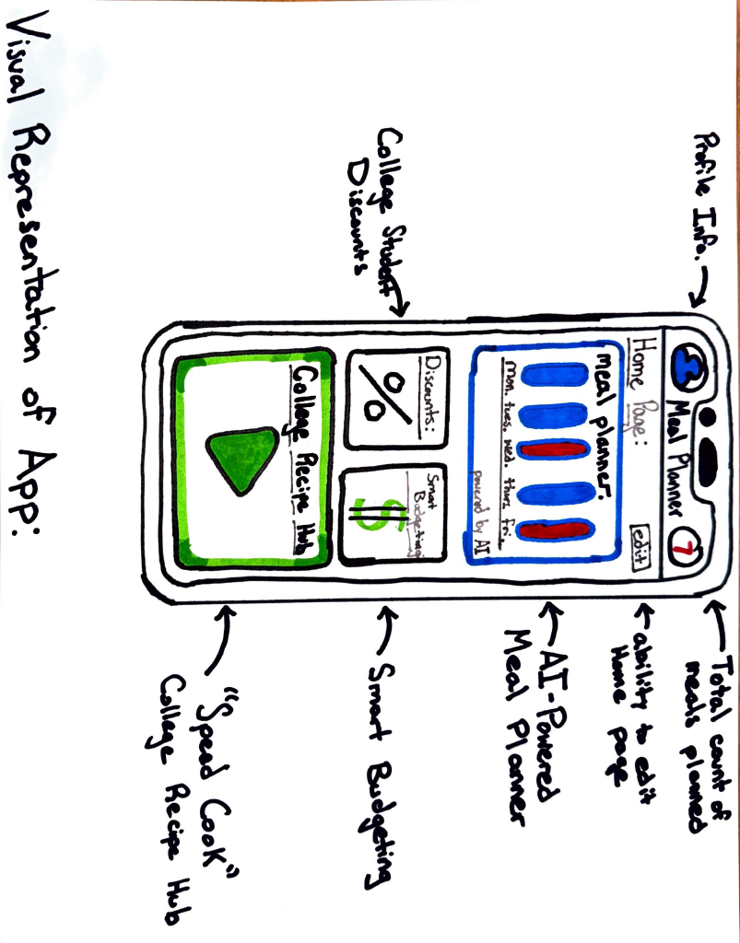

## 7. Limitations & Weaknesses

The sample size used in this research was limited, and we used five interviewers' experiences to study this concept. Our interviewer cannot represent most university students; however, they can still be used as a reference to understand how students currently approach meal planning after being away from campus.

The second is that we would like an app with an AI-powered meal planner. We plan to use this AI tool to generate meals based on their budget, schedule, and available ingredients. There may be uncertainties about how people know this generated meal plan can be trusted. It can be quick and tell a lot of the details and information type to AI, but sometimes, each person may have a different situation; especially, we provide personalized recommendations and recipe suggestions. We are also not sure that AI can always be correct. Therefore, these features must be prepared, and more research must be conducted on how to use an AI-powered meal planner reasonably. Collaboration with the university’s resources to ensure every suggestion is based on nutrition and health knowledge.

Another uncertainty regarding the college student discount is that most coupons will be separate because they are different brands. So we need to sort out all the discount information first and then research how to connect. Learning how to interact with shopping list habits and send notifications will be much work if that app only tracks your budgeting, meal planning, discount, and speed cooking.

In conclusion, our whole report only analyzes the understanding of student meal planning after moving from campus. Based on our in-depth interviewers' experiences, we deeply analyze the targeted ideas to solve this problem. Then, we need an app with features that help students track their budgeting and meal planning and also have discounts that can save them money. However, we still have some uncertainty points that need clarification, such as being responsible and professional and collaborating with health center resources is essential. Students care about cheapness, convenience, and health; therefore, we also need to base these needs on finding concrete solutions, which is our purpose in this research.

## 8. Presentation

Link to Presentation: <https://youtu.be/qzfyyVgerbg>

1. <https://educationdata.org/average-monthly-food-spend-college-student>
2. <https://healthcare.utah.edu/news/tags/meal-prep>
3. <https://eccles.utah.edu/programs/undergraduate/in-a-pinch/>
4. <https://basicneeds.utah.edu/food-resources.php>
5. <https://attheu.utah.edu/students/student-discounts-30/>
6. <https://koreascience.kr/article/JAKO202213650050297.pdf>