About
This project is an interactive web dashboard used to filter animal shelter outcomes. The dashboard allows users to filter animals based on each of their attributes and view the results in a dynamic table. It also includes the capability to filter the data by rescuing capabilities and show the distribution in a visual pie chart.

Getting Started
To run this project locally, complete the following steps:
- Ensure MongoDB is installed.
- Import the Animal Center dataset into MongoDB.
- Download the project files.
- Run the Jupyter Notebook and execute all cells to launch the dashboard.

Installation
The following tools and libraries were used:
- Python 3.x - Main programming language used for dashboard development. Specifically, it was used for
  - Build the CRUD module for database interaction.
  - Process and filter data.
  - Connect the backend logic to the dashboard.
- Dash - Framework for building interactive dashboards in Python with the following components.
  - Radio items for filtering control.
  - Dash DataTable for the data grid.
  - dcc.Graph for the pie chart.
  - Dash leaflet for geolocation mapping.
- PyMongo - Python interface for MongoDB.
- MongoDB - a NoSQL database used to store data in JSON structures. It easily integrates with Python and supports dynamic querying, which is essential to filter the rescue animal data.

Usage
The dashboard includes the following features:
- Interactive Filtering Options - Users can filter animals via a selection of radio buttons:
  - Water Rescue
  - Mountain Rescue
  - Disaster Tracking
  - Reset
- Dynamic Data Table
  - Displays animal records from the Austin Animal Center data set
  - Updates based on each selected filter
- Geolocation Map - Displays the selected animal location from the latitude/longitude fields set to Austin, TX.
- Breed Distribution Chart - Pie chart showing the breed distribution of each rescue category. Dynamically updates based on the selected data filter.

Project Development Steps
- Created the CRUD module
- Imported the Austin Animal Center dataset
- Developed the dashboard layout
- Implemented logic for filtering results by rescue type
- Created visualizations using Plotly and Leaflet
- Ran the dashboard using JupyterDash and tested/debugged filtering functionality.

Challenges
I ran into a few challenges throughout the development of this. The first was getting my linked image to render. I was improperly nesting the HTML structure, causing the image to fail to load. Once I wrapped it in html.A() the image worked. The second error I was getting at first was one with the DataTable, raising an error when returning incorrect data types. The solution to this was ensuring the callback returned df.to_dict(‘records’). My last error was with an error arising if no column was selected. To fix this, I added code to return an empty list if no column is selected.

Screenshots
- Starting State
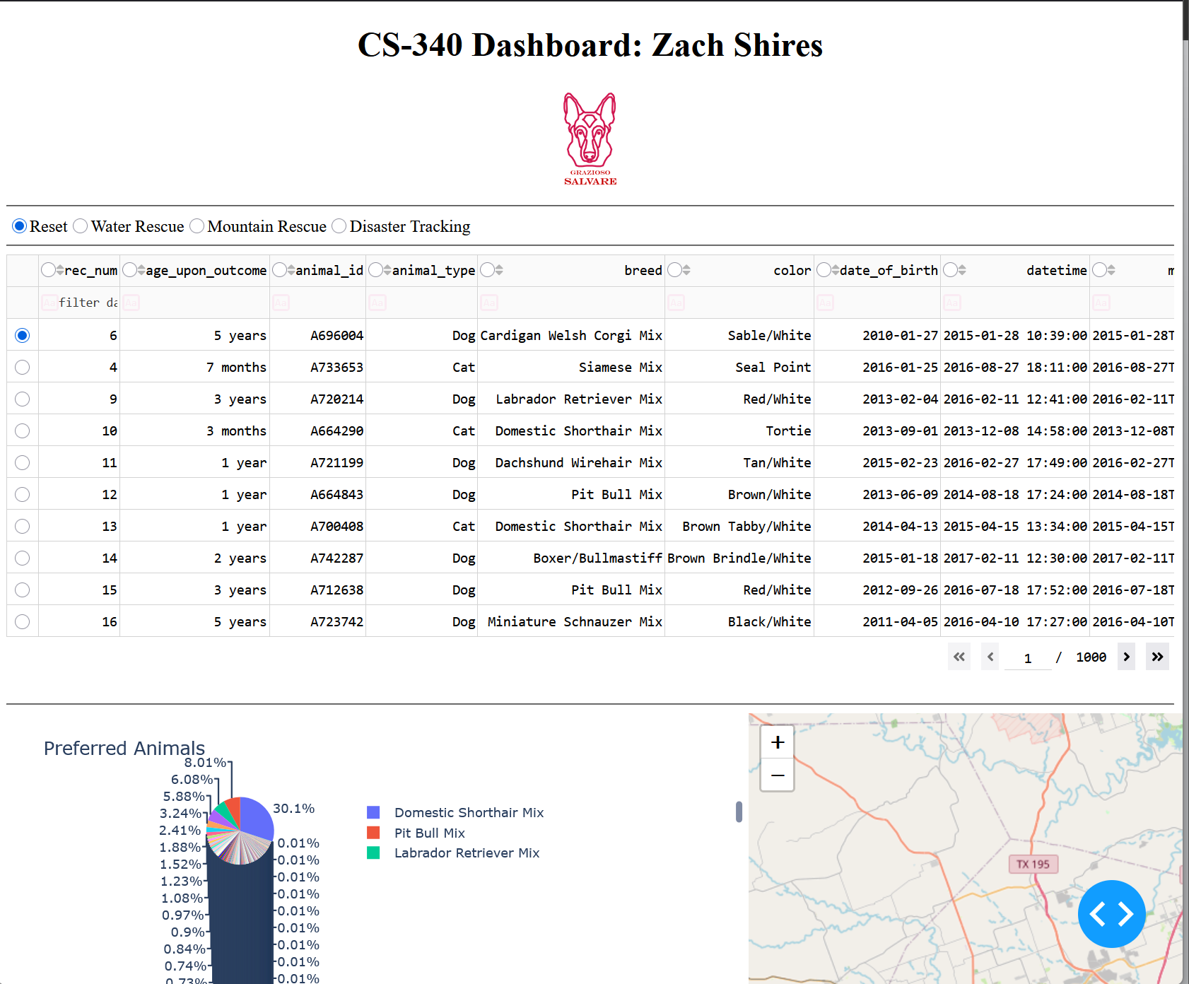

- Water Rescue Filter
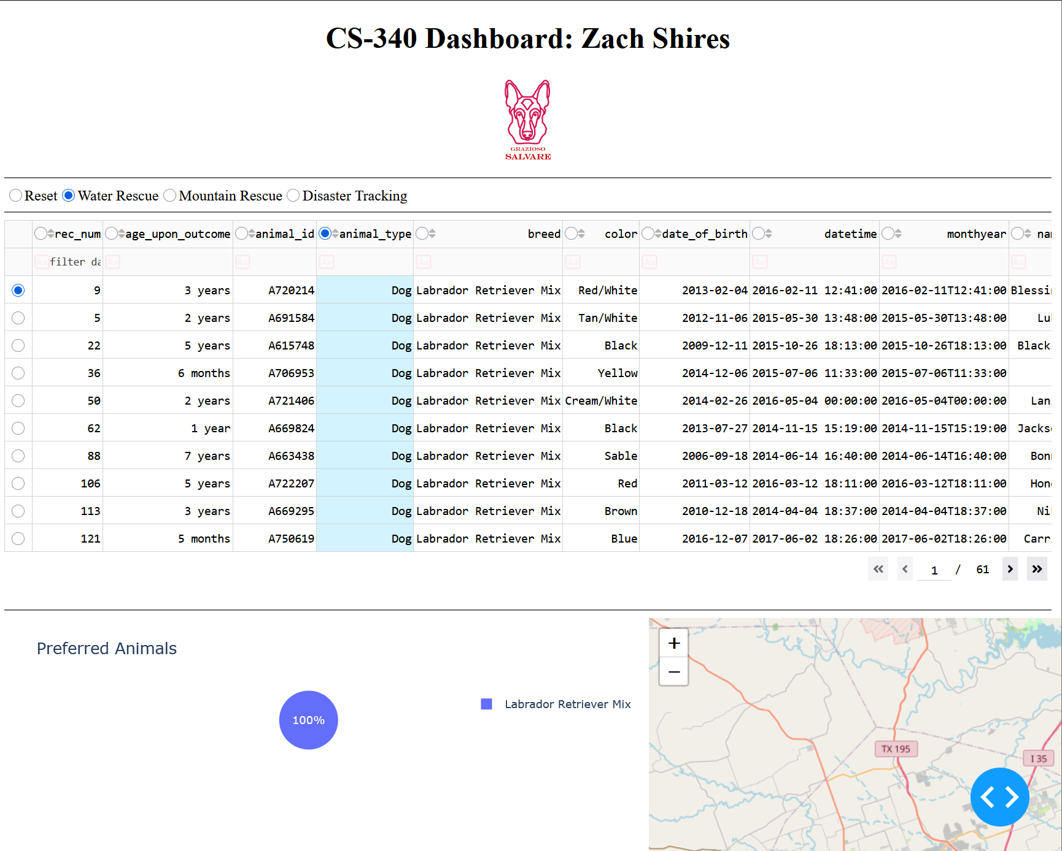

- Mountain Rescue Filter
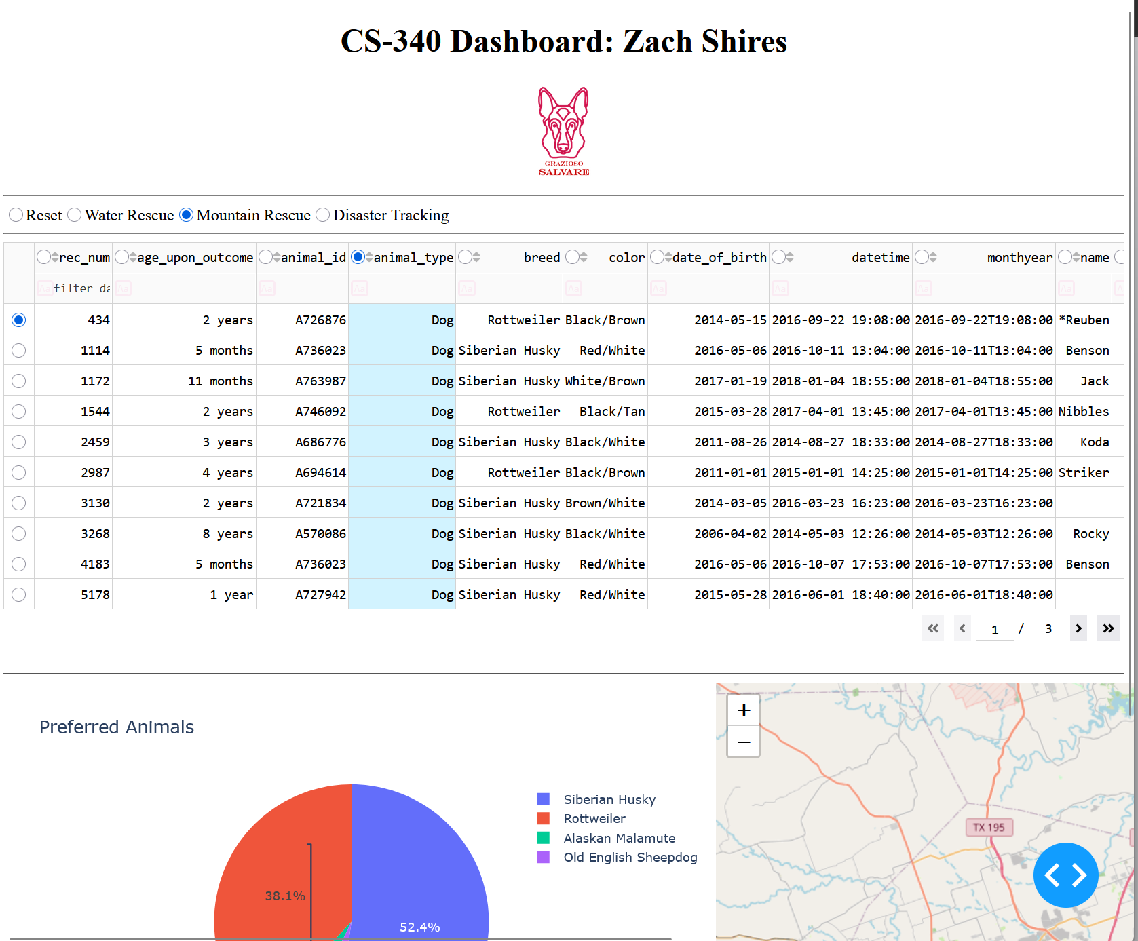

- Disaster Tracking Filter
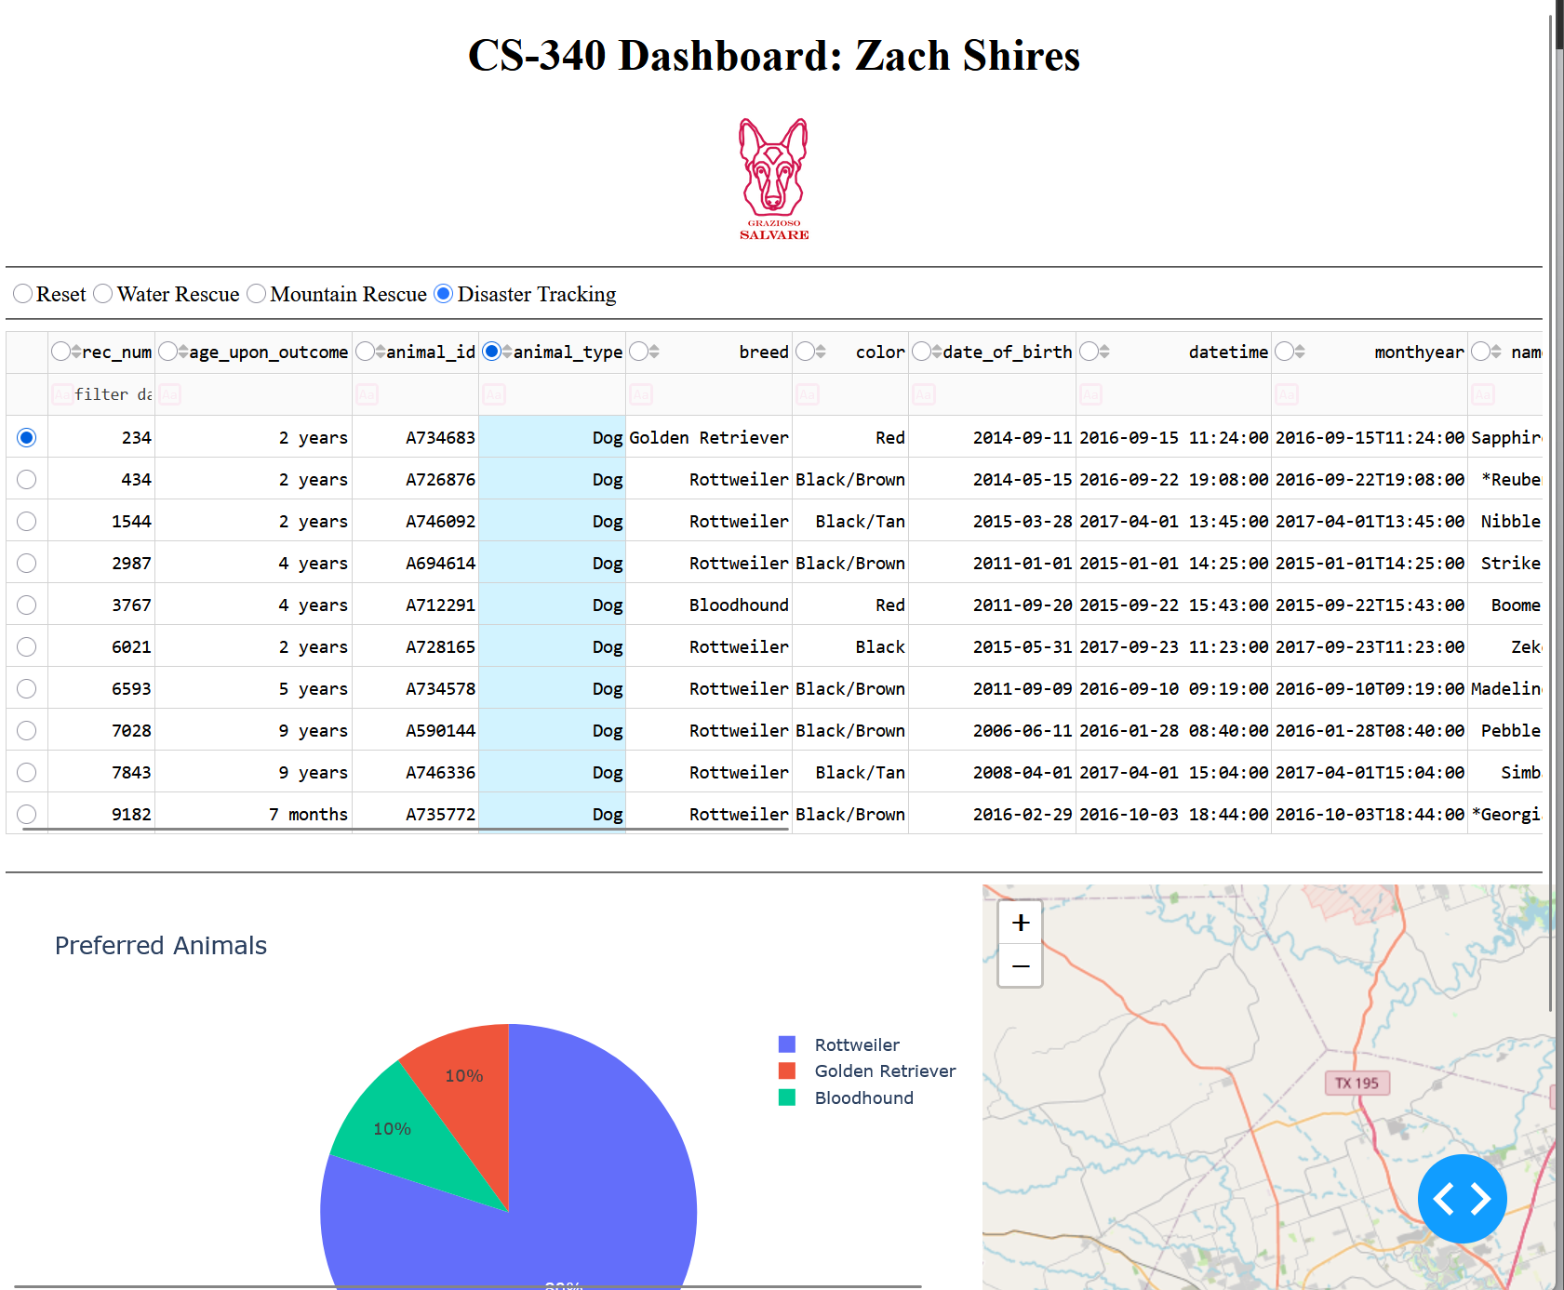

- Rest Filter
