TEAM 02 DB Connection

DUE: 9/29/21

CONTROLLER FUNCTION

IN THE MYSQL TABLE

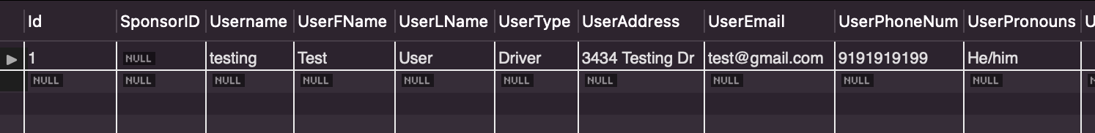

SWAGGER OUTPUT

THE USER LOGIC FOR CONTROLLER

