Zachary Meisner  
8/14/22  
Dr. Kanooni  
Computer Graphics and Visualization CS-330  
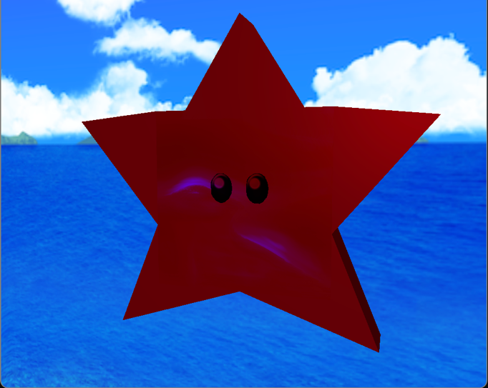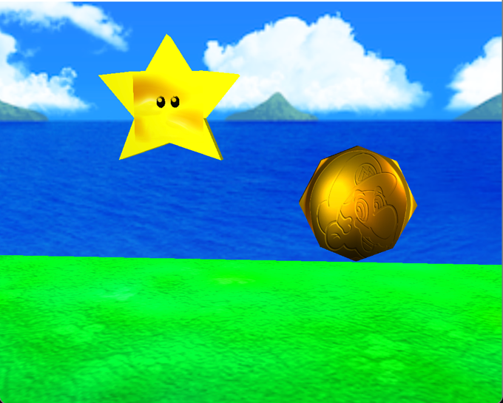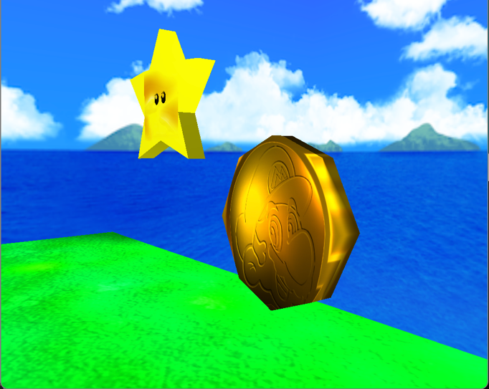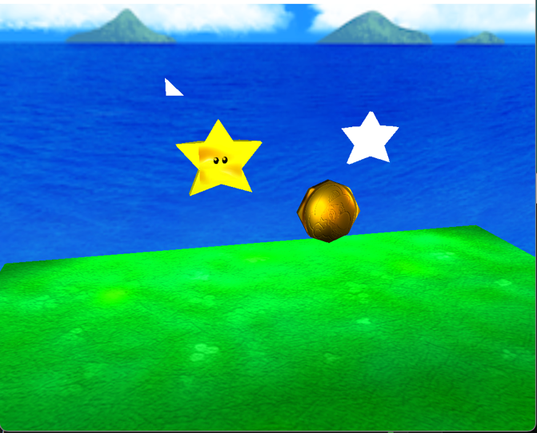

**Justify development choices for your 3D scene. As you write, think about why you chose your selected objects. Also consider how you were able to program for the required functionality.**The objects that I selected were a star, a coin, the plane, and a skybox. I chose these objects mainly because when it came to understanding 3D graphics and scene-building, I believe that a common skill, or talent that people may not take into consideration is the idea of immersion within a scene. In other words, we are attempting to simulate scenarios created specifically to allow the user, or the player, to truly believe that they are within the environment they are interacting with, enamoring them essentially creating that magical feeling you get when you are truly having fun, and exploring a different world. Therefore, I chose to go with the plane, and the skybox, because out of the objects I could have chosen, I thought that these two were the most important for making my scene feel like you were playing the game. This for me worked, because every person that I showed outside of class when I had been talking about my project, instantly knew that it was from Super Mario 64.

**Explain how a user can navigate your 3D scene. As you compose your thoughts, discuss how you set up to control the virtual camera for your 3D scene using different input devices.**  
The controls for the virtual camera in my 3D scene utilize a 3-Dimensional Coordinate system to navigate around a once empty space, that is now filled with objects that I have created and placed at certain points within the geometrical prisms located at different points. There are features that allow you to speed up, and slow down, in addition to being able to turn smoothly as you would in real life when turning your head to look around. These controls take input from the keyboard, and are relevant to the time, and placement that the camera is located within the scene.   
**Controls  
W** Front  
**A** Left   
**S** Back   
**D** Right  
**Q** Up  
**E** Down  
**Scroll** Speed Up and Down  
**Cursor** Look Around  
  
  
**Explain the custom functions in your program that you are using to make your code more modular and organized. Ask yourself, what does the function you developed do and how is it reusable?**  
Two of the functions in my program that make my code more modular and organized are the shaders, and the render function. These were my two favorite functions, mainly because I did not have to adjust either of them very often, or in the case that I did, it was more-so created to introduce something new, instead of having to re-build something from the ground up. In addition to this, in the case that I had wanted something to be created differently, the render function for example allowed me that freedom to move around in my program, without messing a lot of the different objects and variables in my scene up, allowing me to isolate different objects, even though they had all been essentially created in the same function. On the other hand, in the case that I had to have a new shader function, it was only usually to introduce a new type of light, and even then, I was able to create if/else statements within the shader to interact with different textures in interesting ways. If this were to be further developed to interact differently with many types of shapes, realistically you’d only need one vertex and fragment shader.