**Prototype Document**

Ian Fahning

CSCI 412, Spring 2019

**App name:** WWU Classfinder

**Summary:**

This app would take all the functionality of the online classfinder that allows you to come up with and make a schedule and put it on to a mobile device. I like the class finder, but it does not flow very well. In the current classfinder, there are three sections: search, results, and the schedule. The problem with it is that everything flows through search. If you want to add a class to the schedule, you have to search it, find it in the results, and then add it to the schedule. But once in the schedule you cannot go back to the results to add more classes, you must go all the way back to search. And the only way to get to the schedule is the way just described, through all those steps. This is one of the aspects that I want this app to fix, to have the ability to smoothly flow between the search criteria, results, and your current schedule.

**Major Features:**

* looking up classes and adding them to a mock schedule
* going between search, results, and the mock schedule smoothly
* finding when the final times for your classes are and adding them to the calendar
* adding NFC support

**assumptions and dependencies:**This app is entirely dependent on the current online classfinder to get all the classes to display it on the phone.

**Scope of release:**

The release for this class is likely to be all the major features mentioned above. Releases in the future past this class could include other ideas that improve the app or there could be no future releases.

**Where the code runs/data lives:**

All the code will live on the device and it will use a web scraper to pull the data from the classfinder website

**Competitive analysis:**

The only competition that this app has it the classifier that exists in the browser, which is successful

because it allows students to create a mock schedule that you can visualize. This idea is different not

only because it is an app and not in a browser but because it will make it even easier to create a

schedule than the current class finder. It will do this by making an intuitive UI that allows users to go

between search, results, and the schedule all without having to go through search.

**Wire frames:**

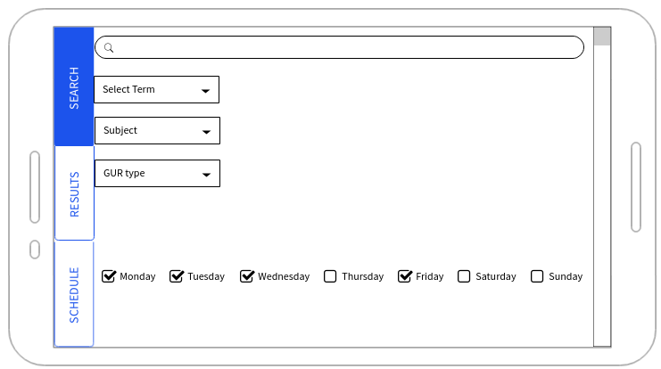

SEARCH

This is the a mock up for the search screen. The user can select a multitude of search criteria to

find their classes. Once they are ready, they can hit the search button and then the app will get

the data from the database and automatically take the user to the results screen as well as

display the data there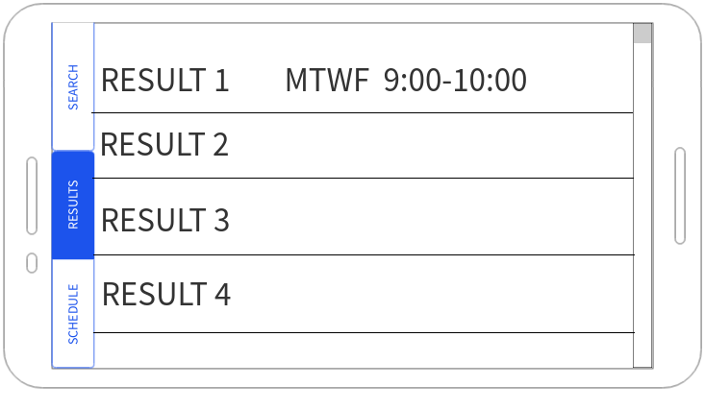

once at the results screen the user can scroll through various results. Once they see a class they

want to take they simply need to tap it and it will add it to their schedule. This will not take

them to the schedule screen because that would be annoying.

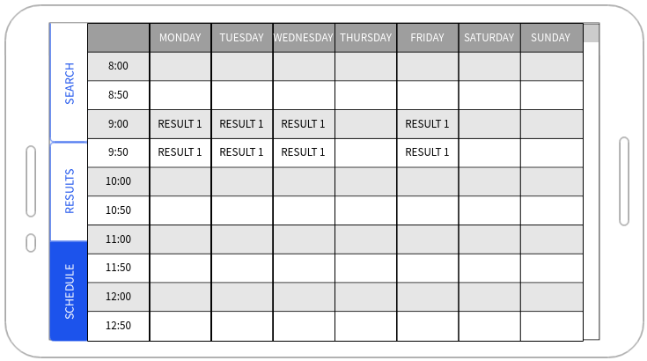

They can look at their mock schedule by simply tapping on the schedule button on the side bar.

**Feature list:**

* look up classes based on certain criteria.
* Add classes to a mock schedule
* Find your final schedule based on the classes
* adding NFC support

**Appendix:**

* Word
* Mockflow.com