Game Analytics and Google Play Store Deployment Report
Zach Ahearn
K00282339

Introduction
The purpose of this report is to explain the implementation process of Game Analytics and deployment of my game to the google play store for my game “Space Bus” which I developed in Unity.

Technical Architecture Overview
The Unity version I used for this project is 2022.3.62f3. In order to implement and upload my game to the google play store, it uses the android build configuration. My project has two custom packages implemented. One of them is the Game Analytics SDK and the other is the Google Play Services plugin. I used https://tool.gameanalytics.com/ to monitor game analytics, and I used google play console to manage uploading the game to the google play store

Implementation of GameAnalytics

Purpose of Analytics
Implementing Game Analytics lets me track different statistics for my game. I implemented 5 different statistics to be tracked. These were:
- How many times the player shoots
- How many times the player dies
- How many enemies the player kills
- How many bosses were spawned
- How many bosses were killed
These statistics let me track different aspects of my game. The biggest ones are enemies killed, bosses spawned, and bosses killed. My game works that progression relates to enemies killed. Through this, I can compare it to how many bosses are spawned, so I can see if players are reaching the bosses. I can also compare how many bosses are spawned to how many bosses are killed. This shows me how many players are reaching the bosses versus how many players are killing the bosses. This gives me insight into how difficult I made my game. I can also judge player retention by looking at the statistics overall. If the statistics continue to increase, then that means players are continuing to play my game.

SDK Integration
To start implementing GameAnalytics into my game, I needed to import the Unity SDK for GameAnlaytics. These are the steps I took to do this:
- Go to the GameAnalytics GIthub repository at https://github.com/GameAnalytics/GA-SDK-UNITY/tree/master?tab=readme-ov-file
- I downloaded the GameAnalytics Unity SDK
- In my unity project, I imported the SDK as a custom package.
Once the package was imported, I needed to edit the setup settings (Figure 1).
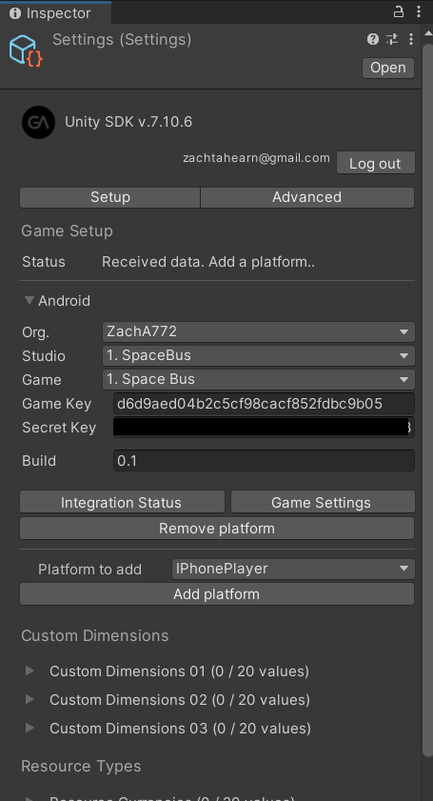
Figure 1 Game Analytics setup inspector
From here, I needed to login to my game analytics account and set up the game for android. To do this, I needed a game key and secret key. I got these by creating a game on the GameAnalytics website. From there, going to the game settings section on the website, I got the two keys I needed and inserted them into corresponding sections in the inspector. Logging into my gameanalytics account in the inspector also fills in these fields automatically.
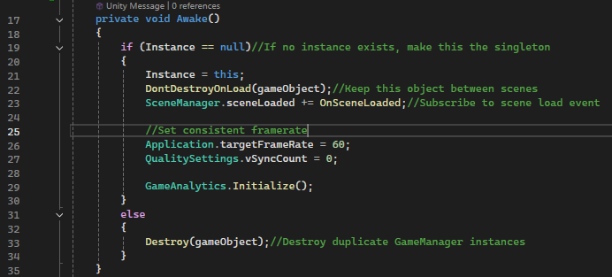
Figure 2 Initialising GameAnalytics in gamemanager.cs
Next step was to initialise GameAnalytics in my game manager script. Shown in figure 2 on line 29, this is simply adding the line “GameAnalytics.Initialize()” in the awake method. Since game manager isn’t destroyed between scenes, game analytics is active throughout the whole game from the beginning.
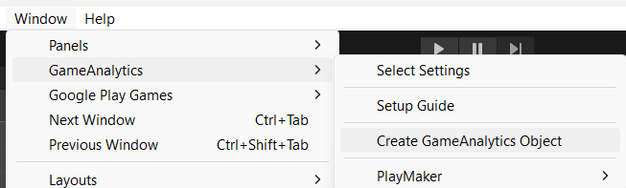
Figure 3 Adding Game Analytics game object to scene
I also then added a Game Analytics game object to my scene. This has its own scripts, working on its own without need for further configuration from me.

Events Implemented
In order to implement my own custom events that I could track, it was as simple as creating an event line of code inside of existing parts of my code. The line is “GameAnalytics.NewDesignEvent("eventID1:eventID2:eventID3:eventID4");”. The event ids in this line of code are swapped out to match the event I’m tracking.
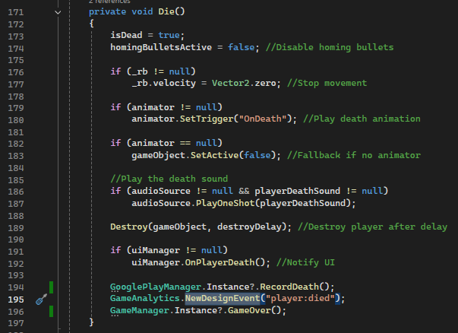
Figure 4 Event for when player dies
The first event I have, shown in figure 4, is my player dying event. Line 195 shows the event I added where eventID1 is ‘player’ and eventID2 is ‘died’. This line exists inside the player controller in the Die() method, so it’s recorded every time the player dies.
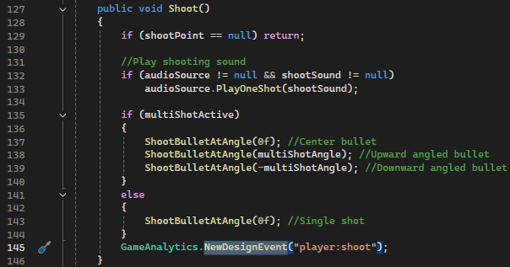
Figure 5 Event for when player shoots
The next event I have, shown in figure 5, is my player dying event. Line 145 shows the event I added where “player” is used again for eventID1 and eventID2 is ‘died’. Reusing the same eventID makes it easier to filter events relating to the player on the Game Analytics website. This line exists inside the player controller in the Shoot() method, so it’s recorded every time the player shoots.

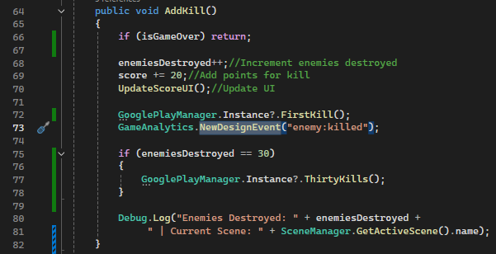
Figure 6 Event for when an enemy is killed
The next event I made, shown in figure 6, is my enemy dying event. Line 73 shows the event I added where eventID1 is ‘enemy’ and eventID2 is ‘killed’. This line exists inside the game manager in the AddKill() method, so it’s recorded every time the player kills an enemy. Since my code had one method that records kills, it made it much easier to add this event rather than adding this one line of code in several different scripts to account for every different enemy type getting killed.

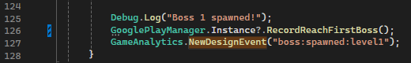
Figure 7 Event for when a boss is spawned
The next event I added, shown in figure 7, is my boss spawning event. Line 127 shows the event I added where eventID1 is ‘boss’, eventID2 is ‘spawned’, and eventID3 is ‘level1’. This line exists inside the boss spawner in all three boss spawning methods. Since each method spawns each different boss, the third eventID relates to level 1, level 2, and level 3. This lets me track each boss spawning individually on the Game Analytics website.
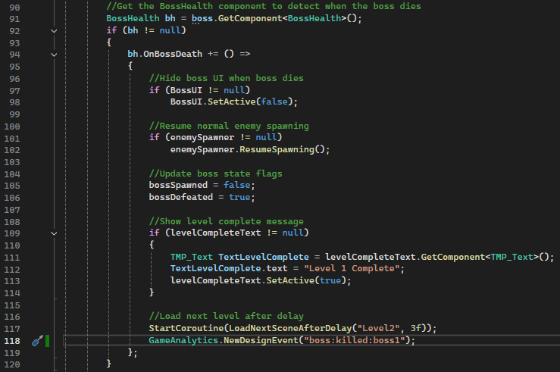
Figure 8 Event for when a boss is killed
The last event I added, shown in figure 8, is my boss dying event. Line 118 shows the event I added where ‘boss’ is reused for eventID1, eventID2 is ‘died’, and eventID3 is ‘boss1’. This line exists inside the Boss Spawner script, inside the same section that checks the boss’s health to see if they died. This line is under all 3 bosses, allowing to check how many times each individual boss is killed.

These events allow me to analysis player performance, difficulty spikes in different sections of the game, and engagement frequency with how far players are getting into the game.

Viewing the data on Game Analytics
After a game is played, I can view the collected data on the GameAnalytics website. TO view the data, I have to first navigate to the explore section in the navigation bar, shown in figure 9.
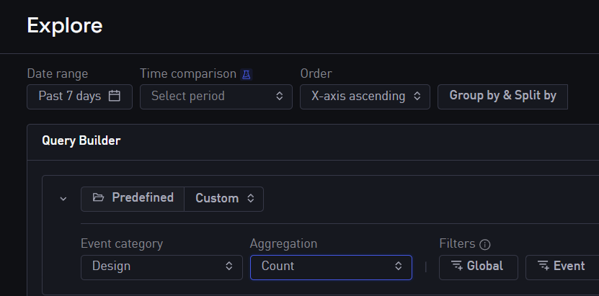
Figure 9 Explore menu
From here, I have to apply filters to view my custom events. Firstly, I set the date range to include today’s date, so I can see the most updated version of the data. Next, I set the event category to design and the aggregation to count.
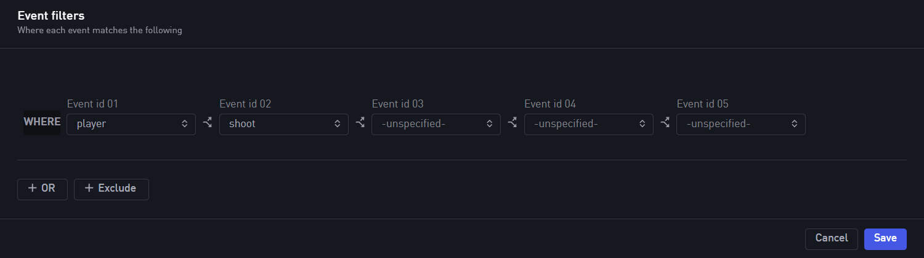
Figure 10 Setting event filters
Finally, I have to set the unique event ids. For example, in figure 10, the first event id is set to player, and the second event id is set to shoot.
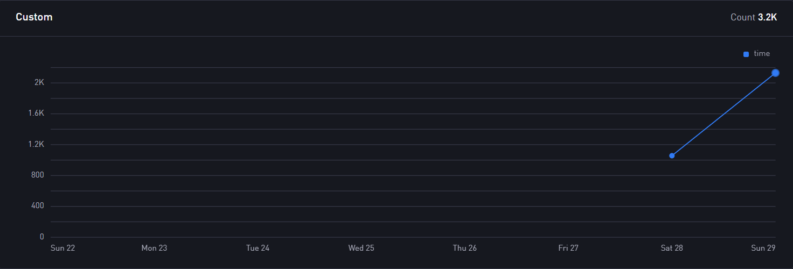
Figure 11 Player Shooting event stats
After clicking save, Figure 11 shows the data for the player shooting event. The overall count shown over two days is 3.2k. If I hover the mouse over the 28th, I can see the count is 1.1k, and 2.1k on the 29th.

Google Play Games Services Integration

Features Implemented
After successfully implementing Game Analytics, I next needed to implement Google Play Games Services and put my game up on the google play store using google play console. On top of putting my game on the google play store, I also added calls to view achievements and a leaderboard through google play game services.

Initial Implementation
To start implementing google play services, I downloaded the official plugin for unity on the google play services GitHub repository at https://github.com/playgameservices/play-games-plugin-for-unity/releases/tag/v2.1.0 . I then imported this as a custom package. With this package imported, the next thing I needed to do was create my game on google play console. This involved a multi-stage process to fill in details about my project. This involved things like answering whether my game had monetization and including a privacy policy. To create a privacy policy, I used the website Termly which generates one for me. To host the privacy policy, added it to my GitHub repository and linked my privacy policy in my repository.

Achievements
The first thing I implemented were Achievements. This is first configured in Google Play Console.
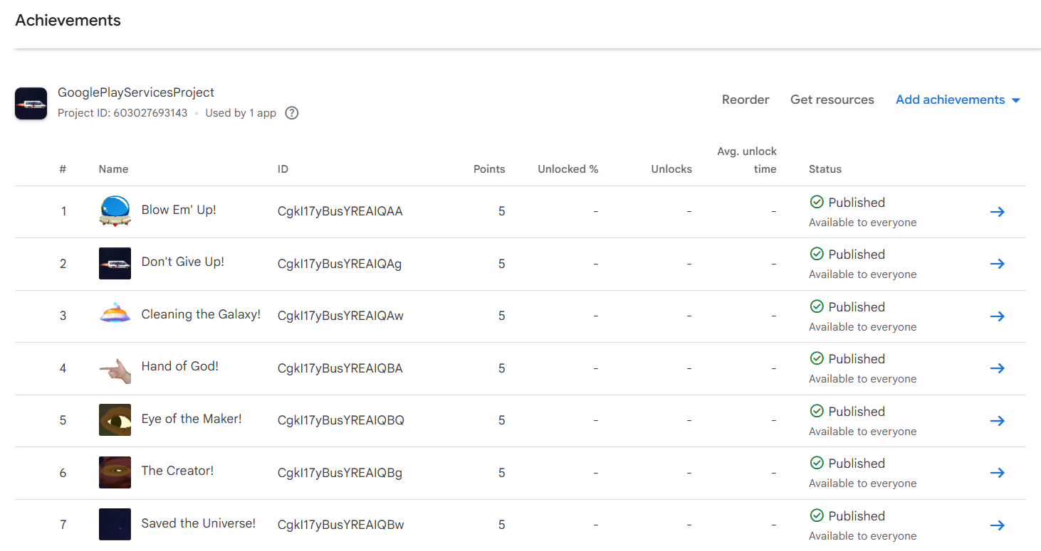
Figure 12 Google Play Console Achievements page
On the achievement page, as in figure 12, I created seven achievements. This involved giving each a name, description, and icon.
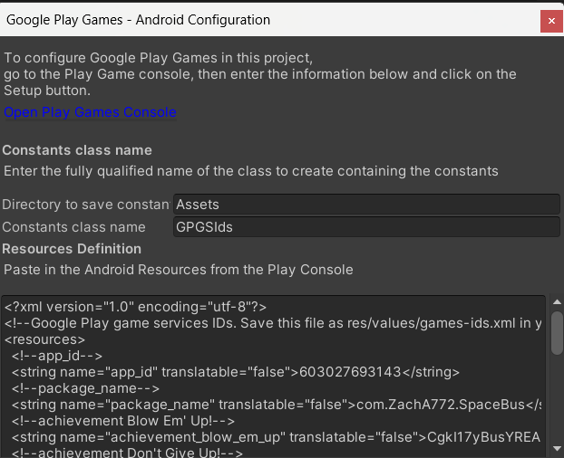
Figure 13 Google Play Games Android Configuration
With each achievement configured, I navigated to the configuration menu where I can get the “android resources”. These resources are automatically updated to include my achievements. I copied the resources and pasted them into the android configuration setup in unity.
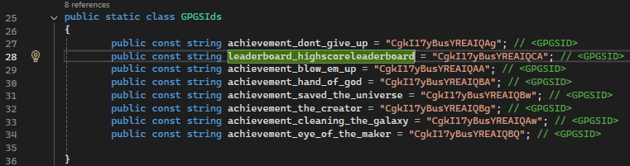
Figure 14 GPGSids script
I created a script named GPGSids which automatically updates with the resources I inputted in the setup.
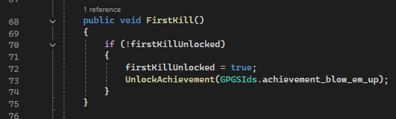
Figure 15 First kill achievement
I next created a script for my google play manager, which is an object in my game that persists through scenes. This script handles authenticating the user for google play and unlocking achievements. It also contains the method for each of my achievements which is to be called whenever the player completes the criteria for that specific achievement. As shown in figure 15, the FirstKill() method controls the player getting an achievement for killing their first enemy. My game has 7 achievements. These are:
- First kill
- 30 kills
- First death
- Reaching each boss
- Game completion
Implementing the call for each method was quite simple, similar to how I implemented the game analytics events. It was just a matter of adding one line of code in the necessary scripts.
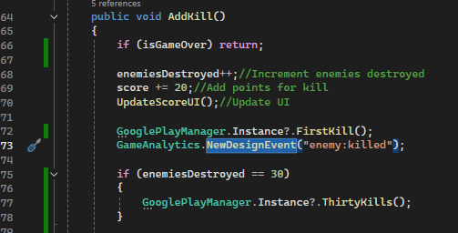
Figure 16 FIrst Kill and Thirty Kills Achievements
Two examples of this take place in the game manager, inside the same AddKill() method as the game analytics event for counting enemies killed. Line 72 in figure 16 shows the code for the fall for the first kill achievement, and lines 75 to 78 checks how many kills have been achieved. If its 30, it called the achievement for 30 kills.

Leaderboard Integration
My other features I implemented was a leaderboard. My leaderboard tracks the players high score and displays it using google play services. I firstly set up the leaderboard in google play console, which was a similar process to the achievements. Creating a leaderboard then involved me having to update my android resources to include the leaderboard. I added the updated resources to the setup again.
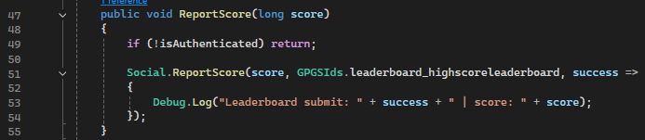
Figure 17 Recording score for the leaderboard in google play manager
Figure 17 shows the method I made for the score to be recorded for the leaderboard. With the same process as the achievements, I added the call to this method both when the player died, and when the final boss is defeated.
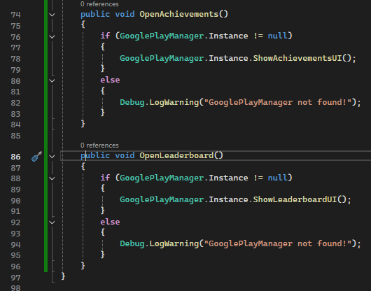
Figure 18 Opening achievements and leaderboard methods
In order to display both the achievements and leaderboard to the player, I created UI buttons in the main menu, end screen, and pause menu which call the corresponding methods in the google play manager to open the matching menu.

Google Play Store Deployment Process

Build Configuration
To start deploying my game to the google play store, I needed to edit various project settings. These settings were:
- Target API Level: 35
- Minimum API Level: 24
- Scripting Backend: IL2CPP
- ARM64 enabled
- Build App Bundle (AAB) enabled
Enabling AAB was required by Google Play to allow deployment.

Internal Testing
I started with internal testing where I needed to create a new release. This involved uploading the .aab file of my game. I had to create a list of testers for my game, for which I got a number of emails from friends and family to. Internal testing was helpful to do first as it doesn’t need to be reviewed before its deployed, allowing for quick testing to make sure the deployment worked. It also helped me test to see if my leaderboard and achievements were working.

Closed Testing
Once internal testing was working, I moved onto closed testing. Closed testing takes longer to deploy has google play must scan through the upload for any issues. This usually took around 14 minutes every time I uploaded a new build. Each time I uploaded a new build, I had to increase the bundle version code, which was inconvenient as I tended to forget this step. It was the same process as internal testing, with creating a release, testers list, as well as adding countries that would be allowed to play my game, of which I allowed all countries.

Challenges
I did face some issues during the implementation of these two different systems into my game.

Game Analytics
The only issue I faced during the implementation of game analytics was that for a while, when I played my game, the analytics weren’t tracking. I tried a few different things, like checking that my app required Wi-Fi to play as well as changing various different settings. I eventually realised that I had a private DNS enabled on my phone, which was blocking my analytics from being sent to the Game Analytics website. After disabling it, the events started successfully tracking.

Google Play
I didn’t have any issues when I was setting up the internal testing, and I got that to work smoothly with little effort. However, the closed testing version gave me more difficulty. When google play scanned my release, it kept returning an error that my app had security issues. Some things I tried were manually setting the target API to a high version rather than leaving it on ‘automatic’ and I also tried downgrading the google play services plugin to the previous version, both of which didn’t work. I eventually realised that the issue was my unity version. In the Unity hub, I spotted the warning next to my project which mentioned that my current version, which was 2022.3.60f, had security issues. It specifically mentioned to not publish the project until a new unity version was used. To confirm this suspicion, I asked my classmates what unity version they were using and if it had a warning. I found out they were using a later version, 2022.3.62f1, and didn’t have the warning message. Upon updating to the newer unity version, my game passed the closed testing scan and the release worked.

Conclusion
Implementing GameAnalytics and Google Play Games Services into my game was one of the most important parts of this project for me. While developing the gameplay itself was important, integrating these external systems made the project feel much closer to a real, proper mobile game. Through GameAnalytics, tracking statistics such as enemy kills, boss progression, and player deaths helped me better understand difficulty balance and player behaviour. It showed me how useful analytics can be in making informed design decisions. Integrating Google Play Games Services also gave me practical experience with uploading games to google play. Setting up achievements and a leaderboard required both configuration in Google Play Console and correct implementation within Unity.

