Zachary Barkhorn
COSC 461
12/5/2025
https://github.com/ZachBarkhorn/FinalProjectAI_Tutor
Dr. Li
AI Python Tutor Report
Goals
The goal of this project was to develop an AI tutor that could teach the fundamentals of Python to beginner programmers. The tutor was designed to provide explanations of core concepts such as variables, loops, and conditionals; assist with debugging; generate example programs; and create practice exercises with feedback. This task was accomplished using the open-source platform “Ollama”, using their model, “gpt-oss”, to fulfill the requirements. The large language model (LLM) is crucial to generating educational content. They allow prompt engineering to take place to guide the response to be tailored for the model’s desired use. Prompt engineering, alongside tokenization, and the evaluation of the quality and clarity of the AI’s response are what allowed the AI Python tutor to be created and specialized to be a suitable tool for a novice Python programmer to use.
Design and Tools
Behind the AI Python Tutor are many systems interacting with one another to allow the bot to respond to the human user. These systems are organized as a modular Python project to enhance scalability and readability. The system’s workflow is as such, First, the user submits a request through a command-line interface, which is then processed by main.py. This input is then routed to tutor.py which formats the prompt, using the prompts.py presets as a reference, and communicates with the LLM through the Ollama cloud. A command is sent through the internet to the “gpt” LLM on Ollama’s LLM servers, and the response is returned to the AI Tutor. While the response is being printed to the user, a log analysis system works in tandem and collects the metadata of the token output and time to complete the response. The logs are then stored into the “logs/” directory containing a list of JSON files with information for each call sent to the Ollama API. Furthermore, there is an example interaction directory too that contains sample interactions with the LLM. To test how the LLM responds to user input, there are a few test examples saved to the “example_interactions/” directory. If these python files are run as main() the test will occur. Altogether, the modular system allows seamless interaction for the user and allows for an easy expansion of the system in the future.
Delving further into the functionality of the tutor is a deeper understanding of how the python code interacts with Ollama’s cloud. The tutor uses Ollama cloud Python API to access their pre-trained LLM’s. API calls consist of internal functions that solely pertain to their cloud LLM. When an API call is made a pre-programmed process on their backend occurs and returns the functionality that the Python tutor needs to work. Their API offers a multitude of options such as streaming (output is returned to the client as it is constructed, as the program runs the user can see its response being built before their eyes) and non-streaming (output is returned to the client all at once after construction). In my solution I chose to use a streaming option as it is more convenient for the user to see immediate progress on their request. The workflow is the API is as follows, a prompt formatted by prompts.py is sent to the LLM, then the LLM starts to conjure a response and sends its progress immediately as it does so back to the AI tutor client which is displayed for the user, once all data is finished transferring a log pertaining to transfer efficiency is saved in the logs folder.
While LLM access is the most important, prompts follow closely behind. Prompts are the backbone of chat bots and streamline the focus of the LLM to respond to the human with something that is useful rather than gibberish. With no prompts, the AI does not know what its desired behavior should be. There is too much data within the LLM for the AI to truly give the user what they are expecting if it’s not told how to behave. In my design I implemented a list of short, focused prompts that give the AI an exact formula to act upon and deliver desired results. Before delving into my exact prompts, I need to elaborate on the different types of prompts that are used in AI development. First and most importantly are System Prompts, they tell the AI what its personality should be and what behaviors are most desired from it, what its main job should be. For example, in my AI tutor I have a system prompt that tells the AI that they “are an AI tutor for beginner Python programmers” and that they need to “explain concepts clearly and step by step” as well as other instructions that I have given it. These prompts are effective in the way that they return an output that the user is expecting from a tutor in that it is insightful, encouraging, and knowledgeable. There are also prompts to focus the AI down the correct path for each function of the tutor. For debug, exercise, and evaluation there are prompts that streamline the AI though process into the correct response for the user. Without these prompts the AI would not be helpful as it would not know what its purpose is and therefore be unable to complete its expected task.
Tokenization and Metrics are also import tools for the proper execution of the AI tutor. These tokenization metrics are essentially data about the process of the LLM response. An example is the amount of time it took to fully respond to the user input, or how many tokens it submitted back to the user. In my project I have created a logs folder that automatically has a log of important tokenization metrics stored for each call to the LLM API. Stored inside these logs are the total_duration, prompt_eval_count, eval_count, and tokens_per_second. These variables hold data about how many tokens are being sent to the LLM and how many are being sent to the client and additionally how long it takes for the entire process to occur. This is important for the AI tutor because in a business setting the company would need to track how much computing power and energy is being used to utilize the power of the AI. If use input was taking an egregious amount of time to be responded to then it may be beneficial to look at using another LLM or to reevaluate the methodology pertaining to how the system was designed. Essentially, it is vital for a person/group to know what is going on with their AI model and if it can be improved upon.
Second to last in the principles of the AI tutor is Error handling and the user experience. The user is the most important part for the AI tutor’s existence to be justified. With no human to utilize the power of the tutor, it cannot accomplish its sole task. To ensure that the tutor maintains users it is vital to ensure that error handling is carefully thought out to maintain the smoothest experience possible. There should be friendly error messages so that the user is able to quickly figure out what they have done wrong or what is occurring within the tutor. This should allow for an easy return to doing what the user wanted to do in the first place, which is to learn how to code in python.
Finally, is the User interface design of my tutor. The interface is built around a simple, menu-driven program in main.py that allows beginners to choose what kind of assistance they need. This menu choice ensures that the user knows what to expect from the AI response. After a new user is lost on what to do or to even ask, the program gives them a few options to choose from. When running the program, the user is presented with options such as “Explain a python concept”, “Debug my code”, “Generate practice exercises”, or “Evaluate my answer” where they will select one option using the number associated with the questions. When the option is selected, the user then inputs their question or code and hits control + z + enter to submit the request. The reason for the oddly specific command to submit the request is that Python has a special package that allows for a multi-line input into the terminal. This kind of input is necessary for code debugging as code takes place on multiple lines.
Sample User Experience
Before moving on, here are some examples of how the code works in practice…
Initial Menu choice
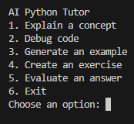
User input
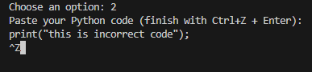

Initial instructions of what is wrong
Correction
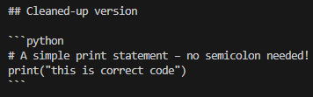
Encouragement to keep learning
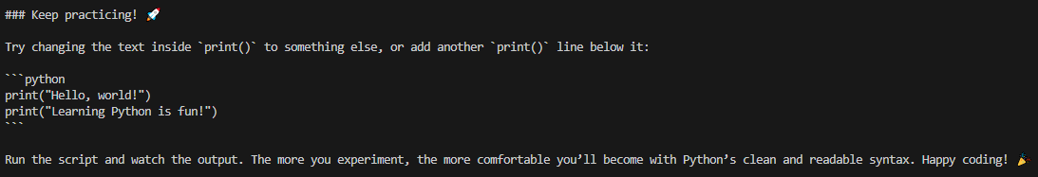
Log save
tokenization metrics
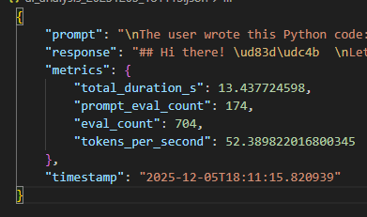
Evaluation
In my evaluation of the system, I took correctness, clarity, and educational impact into account for my judgment. The LLM displayed a correct response to all tests and delivered key insights into the core knowledge of the Python principles that needed to be understood to answer whatever question was thrown its way. The debugging suggestions aligned with Python’s interpreter rules, and it also explained why the previous code had a bug in the first place. The tutor goes above and beyond to ensure that the student is taught what they need to know to learn Python programming.
Clarity was also a strong point for this LLM, with each input an easy-to-understand response was generated. The LLM was not referring to advanced programming techniques or strategies to explain these concepts to beginners. It often used easy to grasp examples that any person, programmer or not, would be able to understand. However, conciseness was not this AI’s strongest aspect. While that may be a benefit to a beginner who wants to know every little detail about their question, I found it to be frustrating during testing. The AI is very good about going into detail and length about the topics it is asked about.
Finally, the educational impact of this AI will have to be studied and decided upon by future groups. It is difficult to assess something on how well it can teach when it has not taught anyone. However, given the fact that I was once a beginner programmer I can say with confidence that this tool is great for learning. It is truly a one stop shop for all things beginner Python; all responses are well thought out and explained thoroughly. I personally enjoyed the motivations messages that were written with every challenging problem that the user was facing. It was able to convey to the user that they were more than capable of learning how to do this and that it was not impossible.
Example Interaction
In my “example_interactions” are 4 files that prompt the AI to deliver a response. Here is one of those files to test the create_exercise feature of the tutor, used for student practice on new topics.
The prompt is to create an exercise on lists
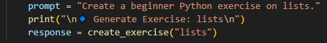
Output
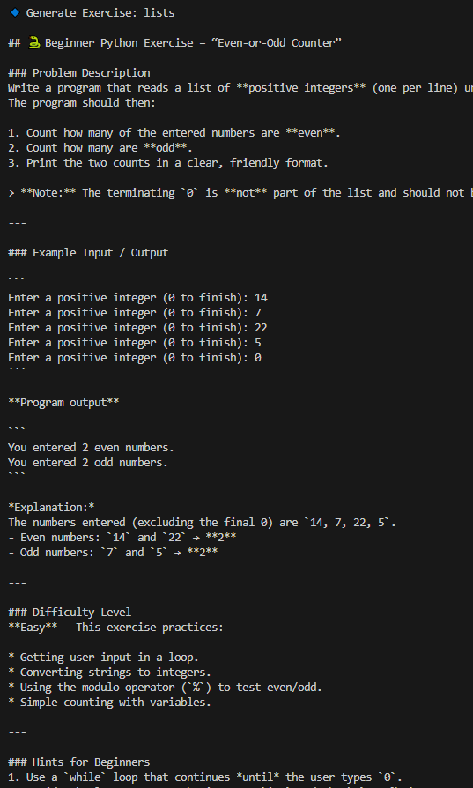
As you can see, the AI creates a very nice example and gives thorough directions to the user to practice their skills with loops, lists, and conditionals.
Conclusion
This project demonstrates a simple AI chatbot that utilizes a pre-trained LLM to harness great power. It is incredibly shocking to see how simple it is to create a chat bot using prompt engineering to harness the full power of the LLM. Throughout this process I gained a much deeper understanding of LLM integration and feel confident in my ability to design my own AI tools to accomplish a specific task I desire a multitude of times. This AI tool is ready to be shipped out to beginner python programmers around the world and assist them in whatever trouble they may have.

References
https://github.com/ollama/ollama-python (guide on ollama-python API)
https://ollama.com/search (Ollama website that the LLM cloud resides on)

