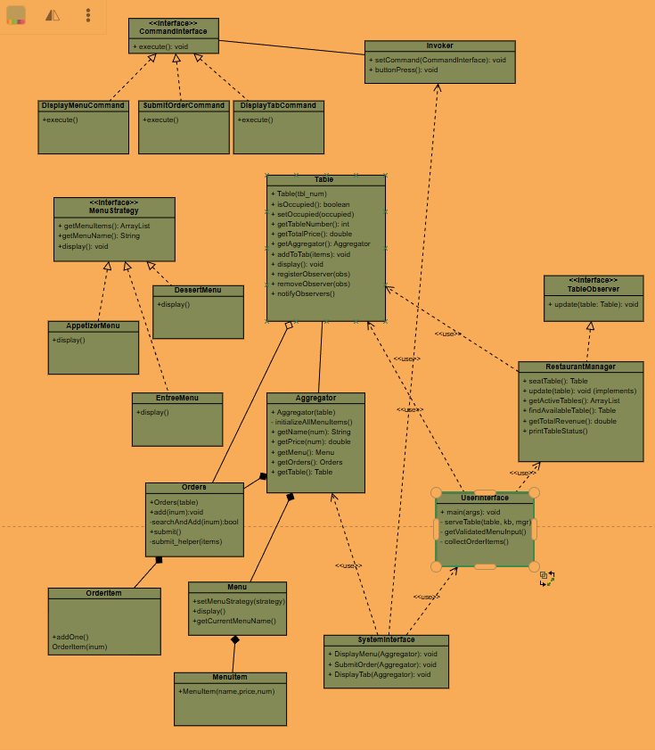

UML DIAGRAM

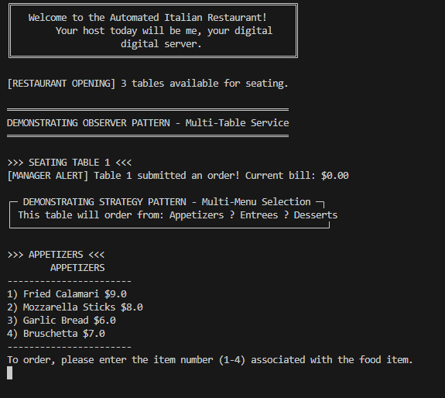
To start, the UserInterface pulls you into table 1 and allows you to play your order with hitting the number next to the item.
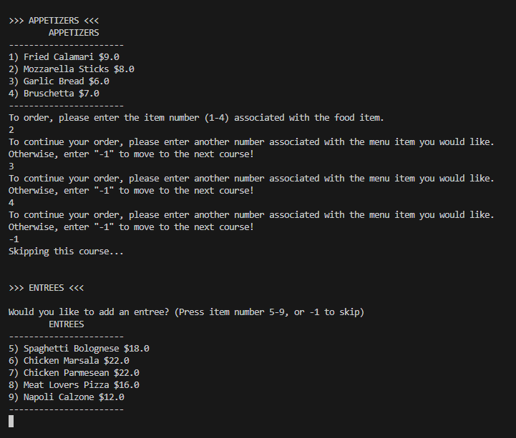You order and keep reordering as much as you want and then use -1 to stop

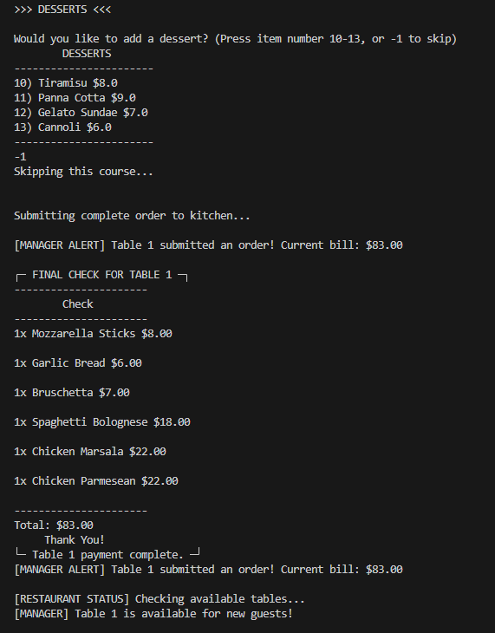

This pattern repeats for all 3 available tables and then computes the total restaurant sales for the day 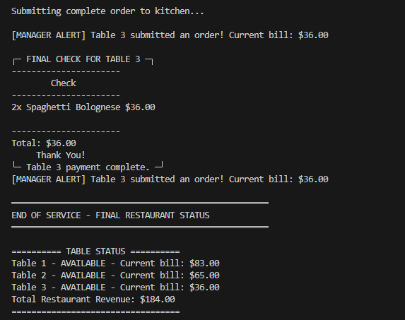
This is the result of placing orders on all 3 tables.
There is input validation to ensure that no improper orders are placed.

