Spencer Gariano, Zach Bowyer, Zakris Pierson

MA 350

Dr. Marcinko

Reality Check 11

1. The outputs of the MDCT for odd values of *f* trace the cosine wave, but the outputs for even values create uniform horizontal lines on the cosine wave. It is observed that the frequencies of even multiples of 64 have more distortions then odd multiples of 64. We also believe this to be true because the frame size is 64. Generally increasing the number of bits makes the reconstructed signal better. We also observed that it requires less bits to reconstruct sound similar to the original when the value *f* is odd.
   1. Even F:

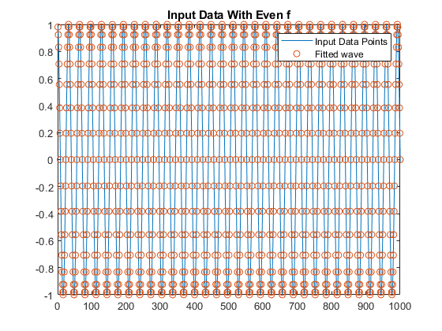

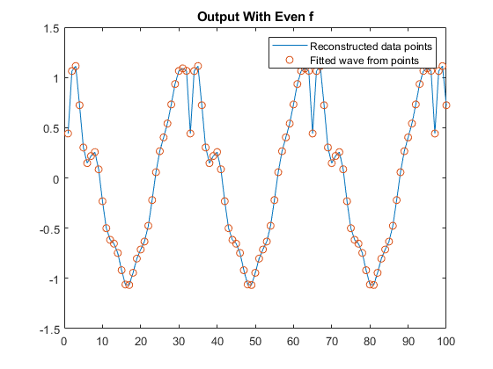

* 1. Odd F:

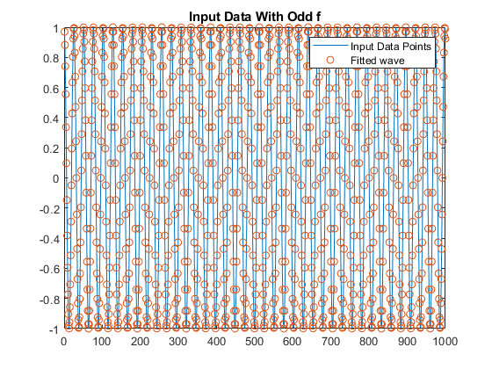

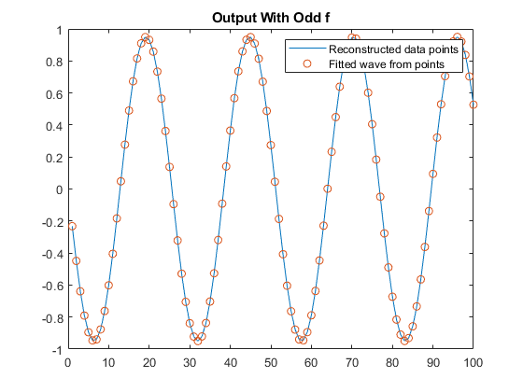

1. We created an H matrix from the formula 

Had to transpose it to make multiplication work

Multiplied all x windows by h

Before windowing, we needed at least 10 bits to make even 64hz frequencies work. (f=4)

Before windowing, we needed at least 2 bits to make odd 64hz frequencies work. (f=5)

After windowing, we needed at least 2 bits to make even 64htz frequencies work. (f=4)

After windowing, all bit values for odd did not work ( up to 1000). (f=5)

Overall, windowing helps out evens but hurts odds because the window range for h.

Therefore, it makes sense to apply windowing depending on whether the frequency is an odd or

even multiple of 64hz.