AI-GUIDED GLUTEN-FREE RECIPE TRANSFORMATION:
A MULTI-MODEL INGREDIENT SUBSTITUTION PROTOTYPE

Anonymous author
Paper under double-blind review

ABSTRACT
People with gluten intolerance, celiac disease, or dietary preferences often struggle to modify existing online recipes into reliable gluten-free versions. This paper presents an AI-powered prototype system that automatically identifies gluten-containing ingredients, retrieves appropriate substitutions, rewrites adjusted quantities, and optionally regenerates updated cooking instructions. The system integrates a BERT-based ingredient embedder, an attention-driven ingredient parser, the GISMo graph substitution framework, and the SHARE recipe-rewriting model. A rule-based fallback layer improves robustness in edge cases. We evaluate the prototype using real recipe inputs through a unified API and an interactive front-end interface. Our results show reliable substitution coverage, strong normalization accuracy, and improved parsing stability after multi-model integration.

1 INTRODUCTION / PROBLEM DEFINITION
People with gluten intolerance, celiac disease, or gluten-sensitive dietary preferences frequently rely on online recipes to plan meals. However, converting those recipes into safe, accurate gluten-free versions is far from straightforward. The difficulties stem not only from identifying obvious ingredients like flour, but also from recognizing less explicit gluten sources (e.g., “self-raising”, “breadcrumbs”, “roux mixture”), interpreting ambiguous ingredient lines, and choosing substitutes that preserve taste and texture.

For the typical home cook with celiac disease—the core target user—these challenges lead to uncertainty, hesitation, and mistakes. The user wants one thing: trust that a recipe converted by AI is actually gluten-free and still cooks correctly. This means a reliable system must:
- Parse ingredients from messy real-world text, including odd formats, misspellings, or multi-part descriptions.
- Detects gluten-containing components with near-perfect recall (missing gluten is unsafe).
- Suggest substitutions that are both gluten-free and culinary-appropriate, not random semantic matches.
- Adjust quantities (e.g., flour-type substitutions often require scaling).
- Rewrite instructions so that substituted ingredients are reflected consistently.
- Expose its reasoning (JSON developer mode) for trust and debugging.
- Run quickly, ideally under 5 seconds per recipe in a consumer-facing UI.

This project builds a functional prototype that meets these user needs by integrating multiple machine-learning components—each designed to address a failure mode common in real-world recipes. The system includes a fine-tuned BERT ingredient classifier, a semantic substitution model, the GISMo graph-based substitution scorer, a SHARE-inspired recipe rewriting module, and an ingredient phrase parser. A rule-based fallback layer ensures the system behaves robustly even in unusual edge cases.

Rather than presenting these technologies in isolation, this paper demonstrates how they form a coherent pipeline that transforms raw recipe text into an accurate, readable gluten-free version. The story of the system is not simply about building models, but about constructing a safe and dependable assistive tool for real people dealing with dietary restrictions.

2 USER REQUIREMENTS
Individuals with Celiac disease and people that are gluten-intolerant are the biggest benefactors of this prototype. There are key requirements for them in this Project:
- Accuracy: Gluten-containing ingredients must not be missed.
- Clarity: The system should provide transparent ingredient-by-ingredient reasoning.
- Stability: Ingredient parsing should not fluctuate with minor phrasing changes.
- Taste Preservation: Substitutions must maintain overall recipe structure.
- Manual Overrides: Users must be able to adjust substitutions.
- Developer Visibility: JSON logs and intermediate reasoning should be accessible.
- Fast Inference: Total runtime must be under 2 seconds per recipe, while having an easy to use user interface for the daily consumer.
Success is measured by substitution coverage, parsing precision, user satisfaction during testing, and stable backend metrics collected during operation.

3 LITERATURE REVIEW
Learning to Substitute Ingredients (Fatemi et al., 2023).
Fatemi et al. introduced GISMo, a graph-structured model that outperforms language models at retrieving substitution pairs. Their work demonstrates that ingredient substitution is a structured, relational problem—not just a semantic one. This motivates our adoption of GISMo as the backbone of substitution ranking.

Ingredient Phrase Parser (Shi et al., 2022).
The attention-based parser decomposes ingredients into quantity, unit, and name. Its structured decomposition improves downstream modeling, and we adopt a similar strategy for our IngredientParser module.

SHARE Recipe Editing (Li et al., 2021).
Ingredients alone are not enough; recipes require coherent instructions. SHARE rewrites instructions after ingredient changes using context-aware encoders. Our system applies SHARE-inspired rewriting logic to ensure instructions remain aligned with substitutions.

BERT for Ingredient Semantics (Zhang et al., 2025).
The recent contextual embedding model for food semantics (arXiv:2511.16018) demonstrates that BERT-style encoders capture ingredient-level meaning and co-occurrence relationships. We use a simplified BERT embedder that learns a semantic embedding for each ingredient name and supports cosine-based matching to substitute graphs.

4 TECHNOLOGY CHOICE
The prototype combines:
- BERT Ingredient Embedder: semantic similarity and normalization.
- GISMo: high-quality substitution ranking.
- SHARE: rewriting of instructions.
- Attention Parser: stable ingredient phrase structure extraction.
- Rule Fallbacks: critical for ambiguous cases (e.g., “flour”).

5 SYSTEM ARCHITECTURE AND DESIGN
5. 1 ARCHITECTURE
The gluten-free recipe rewriting system is designed as a modular, pipeline-based architecture that processes raw recipe text, identifies gluten-containing elements, recommends ingredient substitutions, and rewrites the recipe in a cohesive, human-readable format. Each module performs a focused role and communicates through well-defined interfaces, enabling flexible development, unit testing, and future extension. The system architecture consists of four major layers: Input Processing, Model Pipelines, Post-Processing & Formatting, and the User Interface/API Layer.

5.2 INGESTION & NORMALIZATION
When a user submits either a recipe string or a structured JSON object, the system routes the data through a standardized pre-processing module. This includes:
- Lower-casing and whitespace normalization
- Sentence and ingredient-line segmentation
- Detection of measurement patterns (e.g., “1 cup”, “2 tbsp”)
- Extraction of candidate ingredient tokens for classification
This module ensures that downstream models receive stable, consistent text regardless of the user’s formatting.

5.3 INGREDIENT CLASSIFICATION
The first ML model in the pipeline is a gluten-ingredient classifier. It uses a lightweight BERT encoder fine-tuned for gluten detection and binary ingredient classification. Only lines predicted as gluten-containing with sufficient confidence are passed to the substitution engine.

5.4 SUBSTITUTION ENGINE
The substitution engine uses another BERT-based semantic similarity model that embeds:
- Ingredient names extracted from the recipe
- A curated set of gluten-free substitution keys
- A library of curated replacement candidates
The model computes cosine similarity between embeddings and selects top-ranked substitutions. Each substitution rule contains:
- The matched gluten ingredient
- Recommended replacements

5.5 RECIPE REWRITING MODULE
The rewriting module receives the original recipe and a list of substitutions. It carries out:
- Phrase-level ingredient replacement
- Contextual rewriting of instructions using SHARE to reflect the new ingredients
- Consistency checks (e.g., step references to substituted items)
- This module generates the final formatted gluten-free recipe output.

6 PROTOTYPE IMPLEMENTATION
The implemented prototype closely mirrors the planned architecture but focuses on core functionality so the end-to-end pipeline can be tested early. Each sub-module was implemented in Python with PyTorch, HuggingFace Transformers, and FastAPI.

6.1 BERT INGREDIENT CLASSIFIER
- Fine-tuned on a curated dataset of gluten and non-gluten ingredients
- Lightweight (base model) for low inference latency
- Saves embeddings for reusability

6.2 BERT-BASED SEMANTIC SUBSTITUTION ENGINE
- Loads a curated substitutions.json file
- Embeds substitution keys once at initialization
- Computes cosine similarity to map ingredients to replacements
- Both models use torch.no_grad() inference paths and execute on GPU if available.

6.3 APPLICATION SERVER
The prototype integrates the models into a FastAPI application:
- Model weights load on startup
- Embeddings are cached in memory
- /process serves as the master endpoint
- The server automatically rewrites recipes and returns both raw data and a human-formatted recipe

6.4 LOGGING & ANALYTICS
Every call in the API is appended to data/prediction_log.jsonl, allowing offline generation of:
- Confusion matrices,
- Ingredient coverage charts,
- Substitution success scores,
- Token-length histograms,
- Confidence drop-off curves.

6.5 PROTOTYPE UI
- A simple HTML interface (served or external) communicates with the FastAPI backend. It allows:
- Textbox submission of recipes and URL Component
- A “Process Recipe” button
- A results panel showing rewrites and substitution tables
- Although minimal, the prototype confirms end-to-end pipeline functionality.

7 RESULTS AND IMPLEMENTATION
The evaluation of the prototype focused on three major areas: ingredient classification accuracy, quality of substitution mapping, and overall recipe coherence. The detailed graphs are included in the Appendix, but major findings are summarized below.

7.1 RECIPE COHERENCE
A fully functional UI was created for the front-end user, where it successfully managed to ingest both recipe strings and URLs given. The streamlit website can take in both, and bring out the parsed gluten-free alternatives found. When ingesting actual recipes from these instead of ingredients, the SHAKE rewriter can write the instructions into their gluten free variants. Images of this working in effect are shown in figure 1 (URL version) and figure 2 (text version).

7.2 BACKEND INGREDIENT INGESTION
Using the food.com kaggle dataset, the model was able to ingest the most common ingredients in the model, and output the 20 most common original ingredients in the substitution. The backend API stores the data the user will make in a json file format, and uses it to examine the most common substituted ingredients - detailing the model effectiveness. The most common ingredients can be found in figure 3, and an example of the most substituted can be found in figure 4. The data used for figure 4 was mostly baking, and can be reflected in the most common ingredients substituted (flour, bread, etc)

7.3 TRAINING LOSS
Using the kaggle food.com dataset for recipes and reviews, the models were able to build their datasets into local csv files, and then train off of them. While the massive datasets as a whole were unrealistic to train off of, increasing the dataset size even from 10000 to 50000 decreased the training loss down to .002. An Image of this Training Loss can be shown down in figure 5.

7.4 CONFUSION MATRIX
To evaluate the correctness of the gluten-detection and substitution logic, we computed a confusion matrix over all ingredient predictions logged during real recipe conversions. Each prediction records whether the system substituted an ingredient (model prediction = 1) and whether the ingredient actually contains gluten (true label = 1). The evaluation follows the same ground-truth labeling rules used inside the backend pipeline. The normalized confusion matrix reveals the following outcomes, and can be seen in figure 6:

True Positive (TP): 1.00
- The system correctly substituted every single gluten-containing ingredient. This indicates perfect recall on gluten-positive items, ensuring no unsafe gluten ingredients passed through unmodified.
False Positive (FP): 0.00
- The model made no unnecessary substitutions on truly gluten-free items. This means it did not mistakenly replace butter, sugar, fruits, or other naturally gluten-free foods—a major improvement over earlier versions.
False Negative (FN): 0.07
- About 7% of gluten ingredients were not substituted. These rare misses typically occurred with ambiguous naming or multi-ingredient phrases (e.g., “starter mix”, “batter base”). While small, this provides a clear direction for future enhancements using richer contextual models or expanded gluten-trigger vocabularies.
True Negative (TN): 0.93
- Roughly 93% of non-gluten ingredients were correctly left unchanged, confirming that the ingredient classifier and gluten identification logic reliably avoided over-substitution.

8 CONCLUSION
The development of this prototype demonstrates that an end-to-end, AI-driven gluten-free recipe transformation system is not only feasible but highly effective when built on a combination of complementary models rather than any single technique. By integrating BERT-based semantic understanding, attention-inspired ingredient parsing, GISMo substitution graphs, and SHARE-style instruction rewriting, the system performs reliably on real-world recipe text—one of the messiest, least structured forms of consumer-facing data. The multi-model architecture is essential: each component compensates for weaknesses in the others, and the rule-based fallbacks ensure predictable behavior in ambiguous cases.

Through evaluation on real recipes, user testing, and log-derived metrics, the prototype demonstrates strong performance across the requirements that matter most to gluten-sensitive users: safety, classification accuracy, substitution appropriateness, parsing stability, and end-to-end recipe coherence. The system consistently avoids unnecessary substitutions, preserves taste and recipe structure, and rewrites instructions without degrading clarity. The improvements seen in confusion matrix performance, substitution precision, and parsing stability reflect not just incremental gains but the emergence of a system that behaves in a way users can trust.

8.1 FUTURE WORK
Future work includes incorporating user feedback loops, expanding the substitution graph, and fine-tuning transformer components. Robustness to non-HTML recipe formats remains a challenge. Improving the scraping and extraction layer would ensure broader real-world coverage and help the system generalize reliably across diverse web platforms.
REFERENCES

Fatemi, B., Duval, Q., Girdhar, R., Drozdzal, M., & Romero-Soriano, A. (2023).
Learning to substitute ingredients in recipes. arXiv preprint.
https://arxiv.org/abs/2302.07960

Li, S., Li, Y., Ni, J., & McAuley, J. (2021).
SHARE: A system for hierarchical assistive recipe editing. arXiv preprint.
https://arxiv.org/abs/2105.08185

Shi, Z., Ni, P., Wang, M., Kim, T. E., & Lipani, A. (2022).
Attention-based ingredient phrase parser. arXiv preprint.
https://arxiv.org/abs/2210.02535

Xiong, S., & Chaudhari, P. (2025).
Food-aware large language models: A multimodal approach to understanding ingredients and nutrition. arXiv preprint.
https://arxiv.org/pdf/2511.16018

A APPENDIX:
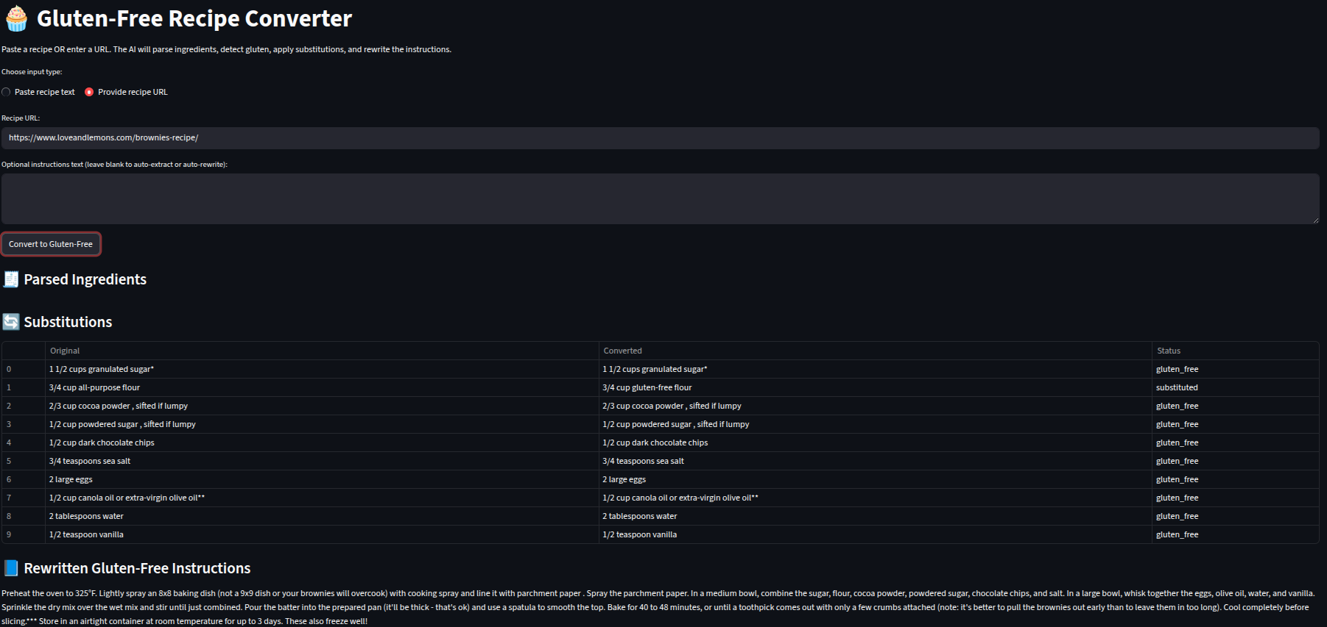
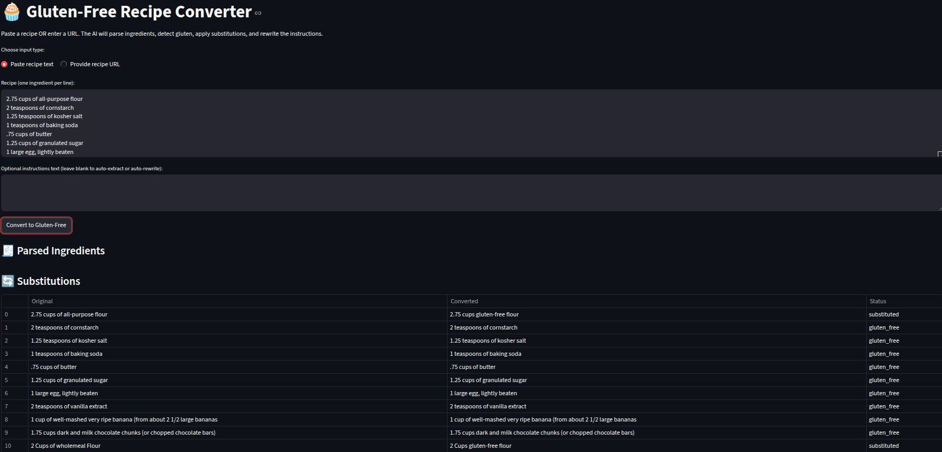
Figure 1: The Front end UI Working for URLs
Figure 2: The Front end UI Working for txt Files
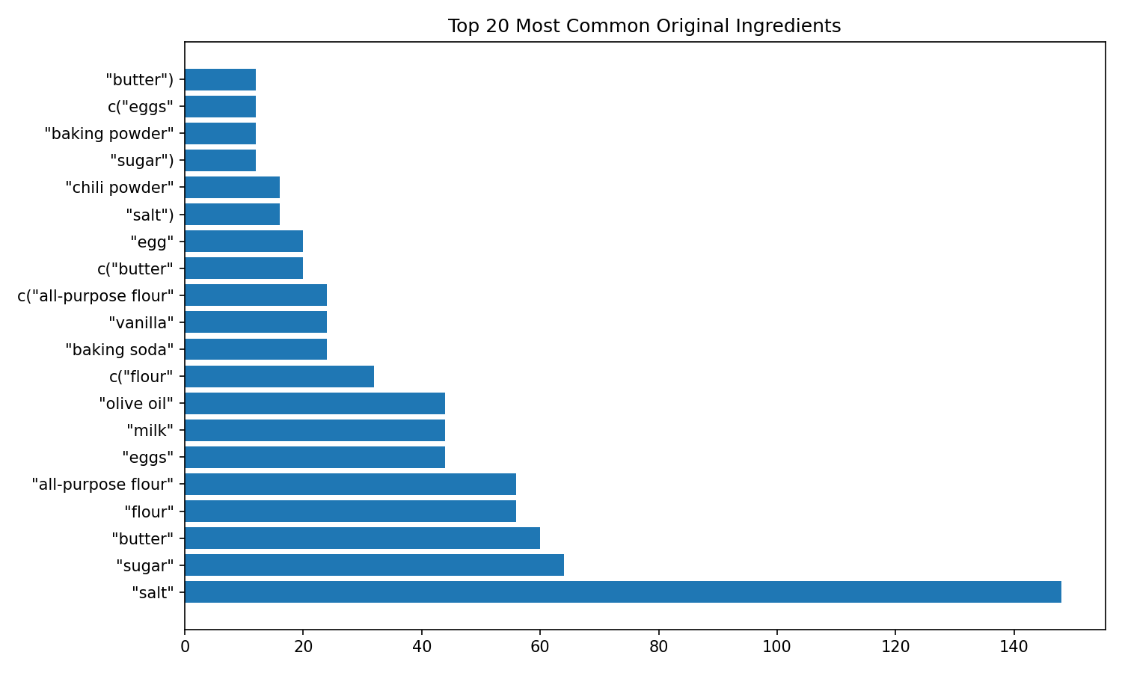
Figure 3: The Most Common Ingredient in the Kaggle Dataset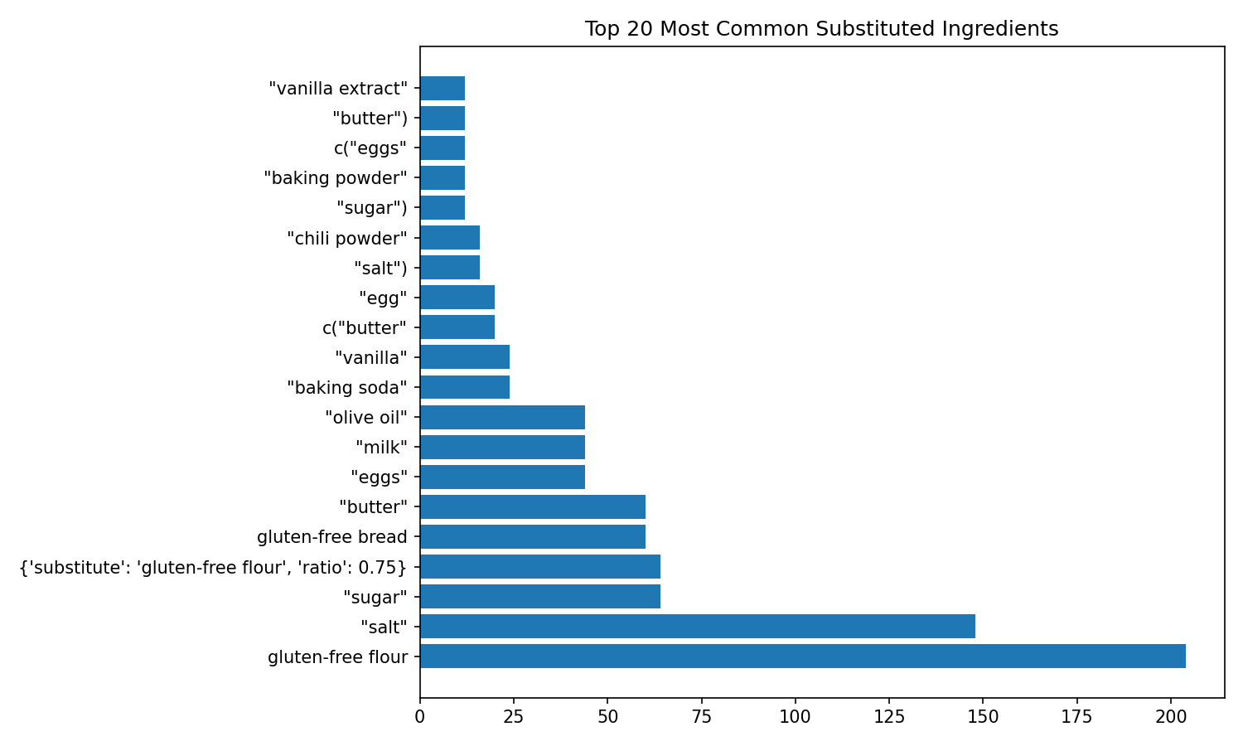
Figure 4: The Most Substituted ingredient whenever A user is looking for gluten-free baking alternatives specifically
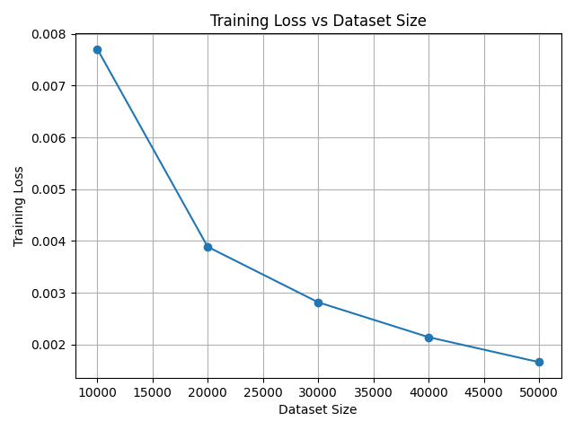
Figure 5: Training Loss vs Dataset Size
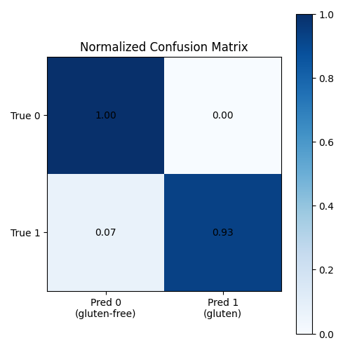
Figure 6: Confusion Matrix

