Name: Zacharie Happel

CST141-FA2023

Project 2 for Week 03

Due: 9/17/2023

Note: My desktop name is zkhap. I hope this suffices for my name being in the output. Next time I will ensure that it is there.

Source Code:

**WeekThree.java**

**package** ProjectsFolder**.**ProjectWeekThree**;**

*import* java**.**util**.**Scanner**;**

*import* java**.**io**.**FileInputStream**;**

*import* java**.**io**.**IOException**;**

*public* class WeekThree **{**

*public* *static* *double* computeAverage(Scanner **scnr,** *int* **numCount**) **{**

*double* valuesSum **=** 0**;**

*int* currValue **=** 0**;**

**for** (*int* i **=** 0**;** i **<** numCount**;** **++**i) **{**

           System**.***out***.**println("Enter number: ")**;**

           currValue **=** scnr**.**nextInt()**;**

           valuesSum **+=** currValue**;**

**}**

**return** valuesSum **/** numCount**;**

**}**

*public* *static* *void* main(String[] **args**) *throws* IOException **{**

*// Figure 6.6.1: Computing the average of a list of numbers .*

        Scanner scnr **=** **new** Scanner(System**.***in*)**;**

*int* numValues**;**

*double* averageVal**;**

        System**.***out***.**println("Enter number of values: ")**;**

        numValues **=** scnr**.**nextInt()**;**

        averageVal **=** computeAverage(scnr**,** numValues)**;**

        System**.***out***.**print("Average: ")**;**

        System**.***out***.**printf("%.3f"**,** averageVal)**;**

        System**.***out***.**println("")**;**

*// Figure 7.6.1: SoccerTeam and TeamPerson classes*

        SoccerTeam teamCalifornia **=** **new** SoccerTeam()**;**

        TeamPerson headCoach **=** **new** TeamPerson()**;**

        TeamPerson asstCoach **=** **new** TeamPerson()**;**

        headCoach**.**setFullName("Mark Miwerds")**;**

        headCoach**.**setAgeYears(42)**;**

        asstCoach**.**setFullName("Stanley Lee")**;**

        asstCoach**.**setAgeYears(30)**;**

        teamCalifornia**.**setHeadCoach(headCoach)**;**

        teamCalifornia**.**setAssistantCoach(asstCoach)**;**

        teamCalifornia**.**print()**;**

*// Figure 9.4.2: How many times a word appears in a file.*

        FileInputStream fileByteStream **=** null**;**

        Scanner inFS **=** null**;**

        String userWord**;**

        String currWord**;**

*int* wordFreq **=** 0**;**

        System**.***out***.**println("Opening file wordFile.txt.")**;**

        fileByteStream **=** **new** FileInputStream("wordFile.txt")**;** *// throws IO error if file doesn't exist*

        System**.***out***.**print("Enter a word: ")**;**

        userWord **=** scnr**.**next()**;**

        inFS **=** **new** Scanner(fileByteStream)**;**

**while** (inFS**.**hasNext()) **{**

            currWord **=** inFS**.**next()**;**

**if**(currWord**.**equals(userWord)) **{**

**++**wordFreq**;**

**}**

**}**

        System**.***out***.**println(userWord **+** " appears in the file " **+**

                            wordFreq **+** " times.")**;**

        fileByteStream**.**close()**;** *// close() may throw IOException if fails*

**}**

**}**

**SoccerTeam.java**

**package** ProjectsFolder**.**ProjectWeekThree**;**

*public* class SoccerTeam **{**

*private* TeamPerson headCoach**;**

*private* TeamPerson assistantCoach**;**

*public* *void* setHeadCoach(TeamPerson **teamPerson**) **{**

        headCoach **=** teamPerson**;**

**}**

*public* *void* setAssistantCoach(TeamPerson **teamPerson**) **{**

        assistantCoach **=** teamPerson**;**

**}**

*public* TeamPerson getHeadCoach() **{**

**return** headCoach**;**

**}**

*public* TeamPerson getAssistantCoach() **{**

**return** assistantCoach**;**

**}**

*public* *void* print() **{**

        System**.***out***.**println("HEAD COACH: ")**;**

        headCoach**.**print()**;**

        System**.***out***.**println()**;**

        System**.***out***.**println("ASSISTANT COACH: ")**;**

        assistantCoach**.**print()**;**

        System**.***out***.**println()**;**

**}**

**}**

**TeamPerson.java**

**package** ProjectsFolder**.**ProjectWeekThree**;**

*public* class TeamPerson **{**

*private* String fullName**;**

*private* *int* ageYears**;**

*public* *void* setFullName(String **firstAndLastName**) **{**

       fullName **=** firstAndLastName**;**

**}**

*public* *void* setAgeYears(*int* **ageInYears**) **{**

       ageYears **=** ageInYears**;**

**}**

*public* String getFullName() **{**

**return** fullName**;**

**}**

*public* *int* getAgeYears() **{**

**return** ageYears**;**

**}**

*public* *void* print() **{**

       System**.***out***.**println("Full name: " **+** fullName)**;**

       System**.***out***.**println("Age (years): " **+** ageYears)**;**

**}**

**}**

**Screenshot(s) of Output:**

**(Successful compilation)**

**Output:**

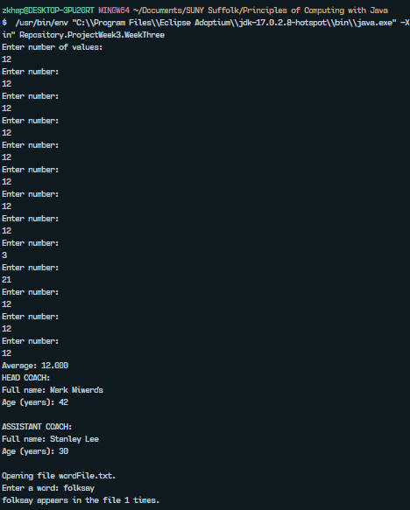

-------------------------------------------------------------------------------

I certify that the above work is my own. I did not copy work from the Internet

or from a classmate. This project will count as part of my grade for the course.