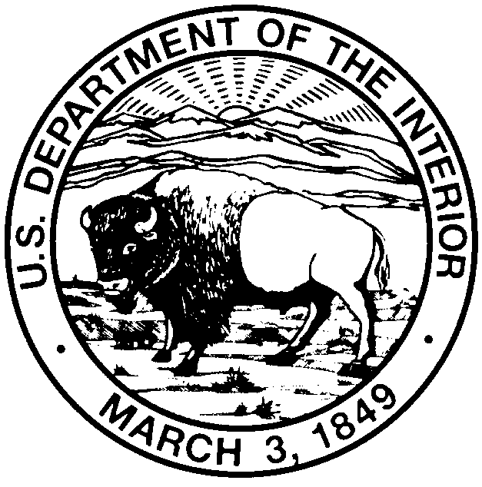
United States Department of the Interior

GEOLOGICAL SURVEY
WATER RESOURCES DIVISION
3215 Marine Street, Suite E127
Boulder, CO 80303

STUDENT LABORATORY ASSISTANT POSITION
SURFACE WATER CHEMISTRY LABORATORY
Posted: 3/25/2016
U.S. GEOLOGICAL SURVEY

1. Types of Services Required:

We are hiring 2 students to fulfill the following activities:
Preparing water and soil samples for analyses; chemical analyses of water samples; use of analytical instruments including an organic carbon analyzer and UV spectrophotometer; weighing of chemicals and mixing solutions for chemical analyses; preparing standard solutions for analytical calibration curve analyses; washing glassware; operating and maintaining laboratory equipment; entering data into spreadsheets and databases; compiling data spreadsheets; graphing and analyzing data; writing up results; photocopying; filing; cleaning; sweeping; and additional tasks that may be assigned based on worker’s aptitude. Student may be required to drive a government vehicle. Must be motivated and a self-starter. Inquire for further job requirements.

We are also hiring 1 student to fulfill the following activities:
Preparing water and soil samples for analyses; DNA extraction; DNA quantification; PCR amplification; washing glassware; operating and maintaining laboratory equipment; entering data into spreadsheets and databases; compiling data spreadsheets; graphing and analyzing data; writing up results; photocopying; filing; cleaning; sweeping; and additional tasks that may be assigned based on worker’s aptitude. Student may be required to drive a government vehicle. Must be motivated and a self-starter. Inquire for further job requirements.

2. Required Expertise/Skills:

Student Position: Must be enrolled or accepted for enrollment as a degree-seeking student and taking at least half-time course load. Must have a cumulative GPA of 2.5 or higher. Skill in applying standard laboratory techniques and use of related equipment (such as volumetric flasks, analytical balance). General knowledge of physical science principles and terminology. Completed at least 1 semester, including laboratory coursework, of college-level chemistry and/or biology. Knowledge of basic computer operations and programs (such as Microsoft Word and Excel). Student must pay attention to detail, have the ability to follow written and oral directions, and must be reliable, punctual, responsible and able to work independently.

3. Description of Working Conditions:

Work will be performed in a laboratory. Long periods of standing will be required. Some heavy lifting may be required. Student will be required to wear safety apparel and to closely observe safety requirements. Duties require good manual dexterity. Student should be able to lift up to 40 lb packages.

4. Compensation:

$14.25 per hour (inquire for details)

5. Principal Duty Station:

Boulder, Colorado (east campus of University of Colorado)

6. Other Information:

Hours worked can vary depending on student’s and supervisor’s schedules, but the laboratory is seeking a student who is willing to work some hours per week during the regular school semester and full time in the summer.

Application Deadline: 4/1/2016

Start Date: April or May 2016, depending on arrangement agreed to by supervisor and employee.

Hours/week (approximate): up to 40 hrs/wk for the summer, and part time during the school semesters.

Send resume and unofficial transcript to:
Sara Breitmeyer
U.S. Geological Survey
3215 Marine St. STE E-127
Boulder, CO, 80303

or by e-mail to sbreitmeyer@usgs.gov.
Resume should consist of a one or two page resume or statement of qualifications including: full legal name; mailing address; telephone number; e-mail address; date of birth; citizenship (if not a U.S. citizen, immigration/VISA status); education, including descriptions of relevant classes and GPA; work or volunteer experience related to the scientific field; laboratory work experience. Please also include your major and expected graduation date.

