**CS311 Yoshii HW5 - Balanced Search Trees and Heap Sort (based on Notes-8B – 9B)**

**DUE: Week 10 Sat**

**TOTAL 35 points Your score is:**

**Your Name: Zachary Mekaelian**

**Date turned in:11/6/21**

**----------------------------------------------------------------------**

**Balanced Binary Search Tree = AVL tree [9 pts] Your score is:**

**---------------------------------------------------------------------**

**Given ((4 5* (6 7* 8)) 9* 10) where 4, 5*, 6, 7*, 8, 9*,10 are the nodes.**

**I am putting * next to the nodes which are sub-tree roots.**

**Draw the corresponding tree and indicate the balance factor for each internal node.**

**(i.e. 0, +1, -1, +2 or -2) [3pts]**

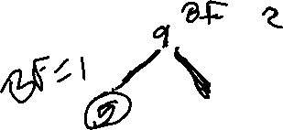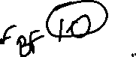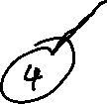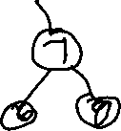

**Identify its case (case 1,2,3,or 4 of the Notes) [2pts]**

Case 4

**What is the balanced expression after the required rotation is done? [2pts]**

((45*6)7*(89*10))

**And then draw the rotated/balanced tree. [2pts]**

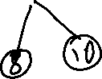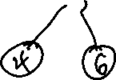

**-------------------------------------------------------------**

**Balanced Search Tree - B-tree [9 pts] Your score is:**

**-------------------------------------------------------------**

**Start with this 2-3 tree (i.e. M=3). Be sure to show all links from all nodes!!!!**

**GK**

**C I M**

**AB DE H J L N**

**000 000 00 00 00 00**

**Add O to this tree. Show the resulting tree. [3pts]**

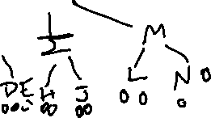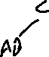

**Then, add P to the result. Show the resulting tree. [3pts]**

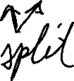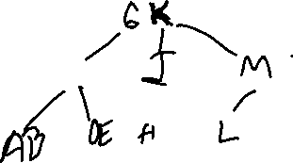

**Finally, add Q. Show the resulting tree which has O and P and Q. [3pts]**

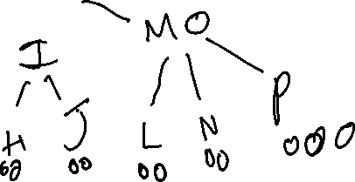

**------------------------------------------------------------------**

**PROGRAM: Heap Tree Printer Q [17 pts] Your score is:**

**Q) Prepration before Programming:**

1. **If the parent is in slot P, what is the locaiton of the left child? The right child? [1]**

**LeftChild= 2P+1 RightChild=2P+2**

1. **If the child is in slot C, what is the location of the parent? (depends on C even or odd).[1]**

**P=(C-1)/2 for left child (odd), P=(C-2)/2 for right child(even)**

1. **For each function in pqueue.cpp, state who calls what as follows:[3]**

**InsertJob calls _______________trickleup();**

**TrickleUp calls ____________ and _______getParent(x); and swap(x,p);**

**GetParent calls ____________even(childloc)**

**PrintJob calls __________________reheapify();**

**ReHeapify calls ____________ and _______getSmallerchild(X); and swap(X,s)**

**Q) State of the program [2pts]**

* **Does your program compile without errors? Yes**
* **List any bugs you are aware of, or state “No bugs”: No bugs**

**Implementation:**

**Test results (required):**

**Total 10 points:**

**Q’s 6.5 points:**

**\*\* Make sure you have used the** [**Priority Q Visualizer**](http://cgi.csusm.edu/ryoshii/MyVisualizers/pqVis.html)**. \*\***

**Implement a priorory printer queue using an array.**

**Use my pqueue.h as is.**

**Complete pqueue.cpp based on the comments.**

**Test with my pqclient.cpp (as is) 🡺 Test.txt**

**\*\* Make sure the ouput matches what you expect to see for a heap tree. \*\***

**SUBMIT 3 FILES: KEEP IT FOR CS433**

**Drawings can be done by hand and scanned or photographed.**

1. **This assignment sheet with your answers and pictures inserted into the file.**
2. **Pqueue.cpp**
3. **Test.txt showing the test results of pqueue.cpp**

* **Whether working or not, test result must include the lines for compiling your files or we will not grade your program i.e. 0 points for the program.**
* **Did you check your comments and style against CS311 How To Comment.doc??**
* **Did you answer all the questions?**