**CS421 - Krell - HW 2A (based on week4) RE to FA by Hand ; Matrix Program**

**============================================================================**

**Please always type your answers in black (wherever you see *??*). You can insert pictures into this file.**

**DUE: Week 5 Friday before midnight (11:55)**

**TOTAL: 100 pts [6.422 % of total semester grade]**

**\*??* Name: Zachary Mekaelian**

**================================================================================**

**-------------------------------------------------------------------------------------**

**Problem 1: Token --> RE (week 4a) [6 pts per prompt = 24 pts]**

**RE can use only *, +, and |. No numbers or variables.**

**--------------------------------------------------------------------------------------**

**Your first task as a scanner designer is to turn each token into a regular expression.**

**First, describe what you want to write as RE in English. Then, give the RE for it.**

**e.g. {x^n y^m | n >= 0 and m >= 1}**

**English: 0 or more x's followed by 1 or more y's; shortest is “y”**

**RE: x^* y^+**

**Alphabet is {x,y} for all of the following. OK to use e for empty strings.**

**A) {x^2n y^2m+1 | n >= 0 ; m >= 0 }**

**Describe the language completely in English without using n or m: None, or an even number of x’s followed by one or more odd amount of y’s. The shortest is “y”**

**RE for it: (xx)* y (yy)\***

**B) {w | w has at least one pair of consecutive x's } only x’s and y’s allowed in w**

**Describe the language completely in English, noting the shortest string: None, or Any number of x’s or y’s, followed by two consecutive x’s, followed by none or any number of x’s or y’s. The shorest string is xx**

**RE for it: (x|y)* xx (x|y)\***

**--------------------------------------------------**

**Problem 2: RE -> FA (week 4b) [8 pts per prompt = 24 pts] (You can draw as I did for Problem 3 below)**

**Make sure you have reviewed the PDF file of example DFAs and used the FA Visualizers.**

**--------------------------------------------------**

* **(x | y) z**

**Draw a DFA: *??**

* **x^* y**

**Draw a DFA: *??**

**- x^+ y**

**Draw an NFA with 3 states (Note it says NFA) without e-moves: *??**

**--------------------------------------------------------**

**Problem 3: Reading NFA (week 4b) [4 pt per prompt = 24 pts]**

**Make sure you have used the NFA Visualizers!**

**--------------------------------------------------------**

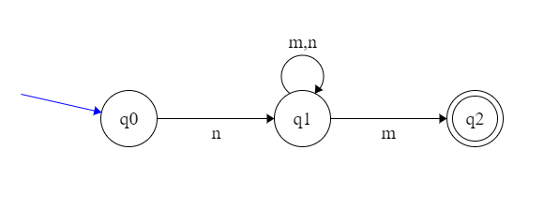

**First give the Trs for this NFA:**

1. **Trs(q0, n) *??* = {q1}**
2. **Trs(q1, m) *??* = {q1,q2}**
3. **Trs(q1, n) *??* = {q1}**

**Then give the following Trs for a set of current states:**

**Trs({q0, q1}, n) *??* = {q1 }**

**What are the possible states you end up in after reading nnmm? Trs*(q0, nnmm) = { q1,q2 } *??\***

**Should nnmm be accepted? Why? *??* Yes because you can make it from the starting state q0 to the final state q2 while accepting nnmm.**

**Problem 4:**

**===========================================**

**Program: Practice with Matrices and Files [28 pts]**

**This can be found in empress at**

**/cs/cs421LK/CS421Progs/HW2A_Matrix**

**or in Cougar Courses in folder Empress Files – HW2A – Matrix (mat.cpp)**

**You need to be able to read table contents from a file to do well on future programming assignments.**

**\*??* State of the program *??*: <required to be graded. Explain the state of your program here. – bugs etc,>**

**Look at the file mat.cpp I have provided. Study it carefully.**

**Run my mat.out with lines.txt as the input file to see how your program should work.**

1. **Submit this sheet**
2. **Submit the source code file mat.cpp with comments**
3. **Submit the test results (Test1.txt script or screen dump) from Empress with lines for compiling the file!**