**Module 8: Portfolio Project Code, Analysis, and Github**

Zachary Morrow

Colorado State University Global

MIS581: Capstone – Business Intelligence and Data Analytics

Dr. Osama Morad

10/7/2023

**Figure 1**

*SAS Code to Import Student Data to SAS Studio*

**Figure 2**

*SAS Code to Create a Summary Statistics Table of Continuous Student Variables*

**Figure 3**

*Summary Statistics Table of Continuous Student Variables*

**Figure 4**

*Histograms and Box-and-Whisker Plots of Continuous Variables*

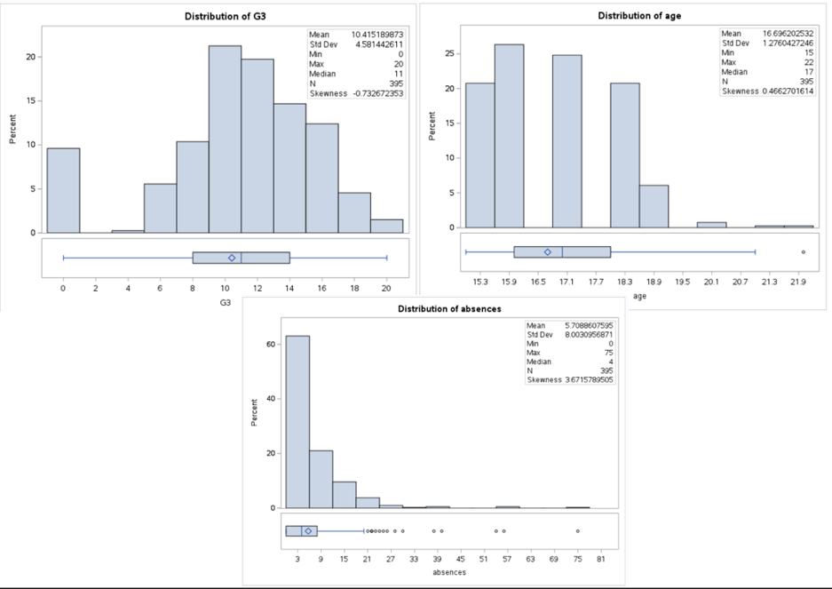

**Figure 5**

*SAS Code to Create Frequency Distribution Tables/Graphs of Categorical Student Variables*



**Figure 6**

*Frequency Distribution Tables/Graphs of Categorical Student Variables*

**Figure 7**

SAS *Code to Create a Multiple Linear Regression Model*

**Figure 8**

*Model Information – Multiple Linear Regression*

**Figure 9**

*Model Fit Statistics – Multiple Linear Regression*

**Figure 10**

*Parameter Estimates – Multiple Linear Regression Model*

**Figure 11**

*Parameter Estimates – Stepwise Selection*

**Github Account Link:** https://github.com/ZachMorrow32?tab=repositories