Local Eats with Kandyce Style Guide
Logo:
Typography:
Heading:
- Anton
- Rubik (Marker Hatch)
- Permamnent marker
Body:
- Space Gotesk
- Nunito
- Inter
Colors:

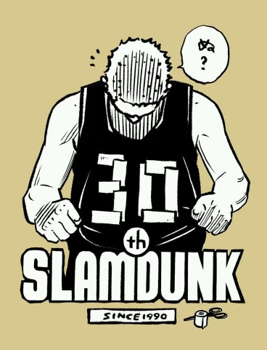
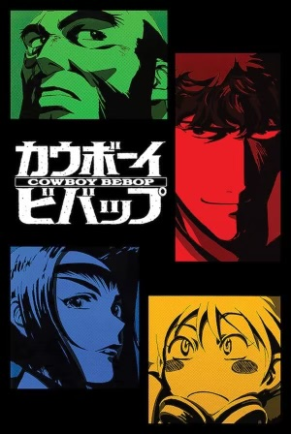
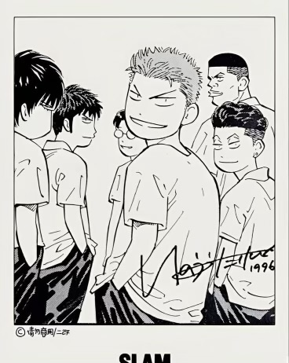
Imagery Style:

