

Written Assignment: Case Study
DLBDSME01 - Model Engineering
Bachelor: Data Science

Model Engineering
(Task 1: Development of an Interpretable Model for Breast Cancer Prediction)

Zach Simpson
Matriculation Number: 32212726
Supervisor/ Tutor: Dr. Markus Pak
Submission date: 18 August 2026
Contents
List of Figures 3
List of Tables 3
1. Introduction 4
1.1 Business Context 4
1.2 Problem Statement & Objectives 4
1.3 Success Criteria 4
2. Project Organization & Methodology 4
3. Data Understanding 5
4. Data Preparation 7
5. Modeling: Candidate Models of Increasing Complexity 8
5.1 Benchmark Models 8
5.2 Logistic Regression (fully interpretable GLM) 8
5.3 Decision Tree (transparent IF-THEN rules) 8
5.4 Random Forest (deliberate black-box candidate) 8
5.5 Hyperparameter Tuning & Cross-Validation 8
6. Model Evaluation & Comparison 9
7. Model Interpretation 11
7.1 Logistic Regression Coefficients. 11
7.2 Decision Tree Structure. 11
7.3 Random Forest (Feature Importance). 12
7.4 Partial Dependence Plot. 13
7.5 SHAP (Global and Local Explanations) 14
7.6 Synthesis: The Accuracy/Interpretability Trade-off. 15
8. Error Analysis 15
9. Deployment Proposal 18
10. Conclusion & Critical Reflection 19
References 19
List of Appendices 20
Appendix A: Full Python Code 21

List of Figures
Figure 1: Class distribution of the Breast Cancer Wisconsin dataset (n = 569), showing 357 benign (62.7%) and 212 malignant (37.3%) samples
Figure 2: Correlation heatmap of the mean-value features, showing strong positive correlation between radius, perimeter, and area
Figure 3: Boxplots comparing radius, texture, concavity, and area (mean values) between benign and malignant tumors
Figure 4: Top 10 logistic regression coefficients (standardized)
Figure 5: Decision tree structure showing transparent IF-THEN decision rules
Figure 6: Random forest permutation feature importance (F1-based, test set)
Figure 7: Partial dependence plot for concave_points_worst
Figure 8: Global SHAP summary plot showing feature impact on malignancy prediction
Figure 9: Local SHAP waterfall explanation for one individual patient prediction
Figure 10: Confusion matrix for random forest
Figure 11: ROC curve for random forest (AUC = 0.990)

List of Tables
Table 1: Descriptive statistics for key numerical features
Table 2: Best hyperparameters and cross-validated F1 score per candidate model
Table 3: Model comparison across all benchmark and candidate models, sorted by F1 score
Table 4: Misclassified test instances with predicted probabilities

1. Introduction

1.1 Business Context
Breast cancer is one of the most common cancers and diagnosing it quickly can have a significant effect on the treatment and survival of the cancer patient. During a fair a group of Oncologists saw an impressive AI algorithm that shows impressive results in categorizing tumors into malignant and benign groups. However, the model’s validity was questioned as the group did not understand why the algorithm predicted certain tumors as malign and others as benign. Therefore, there is a need to produce a model that is both accurate and auditable by non-experts.

1.2 Problem Statement & Objectives
The objective of this task is to build a model that is able to accurately predict whether a tumor is malignant or benign. The model needs to be interperatable for non-experts who do not understand in depth model engineering, without losing its accuracy. This will allow groups such as the group of oncologists at the fair to understand why the model produces a certain result.
1.3 Success Criteria
Following the CRISP-DM methodology, this project defines two distinct success criteria (Gong, 2023, pp. 16-17). The business success criterion is that the model's predictions must be interpretable enough for non-experts, such as the group of oncologists, to understand and trust why a given tumor was classified as malignant or benign. The data mining success criterion is that the model must achieve an F1 score greater than 0.95 on unseen test data, ensuring the model is accurate enough to be clinically useful. Both criteria must be met for the project to be considered successful, as a highly accurate model that cannot be explained would fail to gain the oncologists' trust, while a fully interpretable model that is not sufficiently accurate would not be safe to use in a clinical setting.

2. Project Organization & Methodology
This project is organized using the CRISP-DM (Cross-Industry Standard Process for Data Mining) methodology, as it provides a structured, iterative framework that is well suited to the exploratory and non-linear nature of building an interpretable classification model (Gong, 2023, pp. 14–17; Chapman et al., 2000). Unlike a purely linear pipeline, CRISP-DM allows for revisiting earlier stages as new insights emerge from the data. For example, returning to data preparation after an initial modeling attempt reveals a data quality issue.
There are six stages of CRISP-DM, and they map onto this project as follows: business understanding establishes the dual success criteria of accuracy and interpretability (Section 1); data understanding involves exploring and assessing the quality of the breast cancer dataset (Section 3); data preparation covers the train-test split and feature scaling (Section 4); modeling develops a collection of candidate models of increasing complexity (Section 5); evaluation compares these models against the defined success criteria and analyzes their errors (Sections 6 and 8); and deployment proposes how the final model would be integrated into the oncologists' daily workflow (Section 9).
To support reproducibility and version control, the project follows the Git repository structure below. Generated outputs (figures and models) are deliberately excluded from version control, since both are fully reproducible by re-running the analysis script and would otherwise bloat the repository with regenerable files.
The repository, named breast-cancer-case-study, is organized as follows:
- src — contains the full analysis pipeline as a single script, breast_cancer_case_study.py
- reports — holds the written case study document
- README.md — describes the project and how to run it
- .gitignore — excludes the figures and models folders from version control, since both are generated automatically by the script in src and do not need to be tracked
The following link contains a Github repository that contains both the code for this project as well as a README file.
https://github.com/ZachSimpson123/breast-cancer-case-study.git

3. Data Understanding
The Breast Cancer Wisconsin dataset consists of 569 tumor samples described by 30 continuous numerical features (e.g., mean radius ranges from 6.98–28.11 mm), organized into three tiers. These are mean, standard error, and worst value for each of 10 underlying cell nucleus properties: radius, texture, perimeter, area, smoothness, compactness, concavity, concave points, symmetry, and fractal dimension (Street, Wolberg, & Mangasarian, 1993). The diagnosis label is nominal and binary (Malignant and Benign) and is used only as a grouping variable; all descriptive statistics below apply to the numerical features. Of the 569 samples, 357 (62.7%) are benign and 212 (37.3%) are malignant, a moderate class imbalance addressed later through stratified sampling.
Table 1: Descriptive statistics for key numerical features
Feature | Count | Mean | Std | Min | 25% | 50% | 75% | Max
radius_mean | 569 | 14.13 | 3.52 | 6.98 | 11.70 | 13.37 | 15.78 | 28.11
texture_mean | 569 | 19.29 | 4.30 | 9.71 | 16.17 | 18.84 | 21.80 | 39.28
perimeter_mean | 569 | 91.97 | 24.30 | 43.79 | 75.17 | 86.24 | 104.10 | 188.50
area_mean | 569 | 654.89 | 351.91 | 143.50 | 420.30 | 551.10 | 782.70 | 2501.00
smoothness_mean | 569 | 0.096 | 0.014 | 0.053 | 0.086 | 0.096 | 0.105 | 0.163

Data quality checks found no missing values and no duplicate records. An IQR-based outlier checks flagged area_se (65 outliers) and radius_se (38 outliers) as the features with the most extreme values — expected given the right-skewed nature of size-related measurements, and retained rather than removed, since extreme values can be clinically meaningful in malignant cases.
Figure 1 shows the class distribution. Figure 2, a correlation heatmap of the mean features, shows radius, perimeter, and area are highly correlated, as expected since all three measure tumor size. Figure 3 compares four key features (radius, texture, concavity, area) across diagnosis groups: malignant tumors show consistently higher medians and wider spread, particularly for concavity and area, suggesting these features carry strong discriminative value for later modeling.
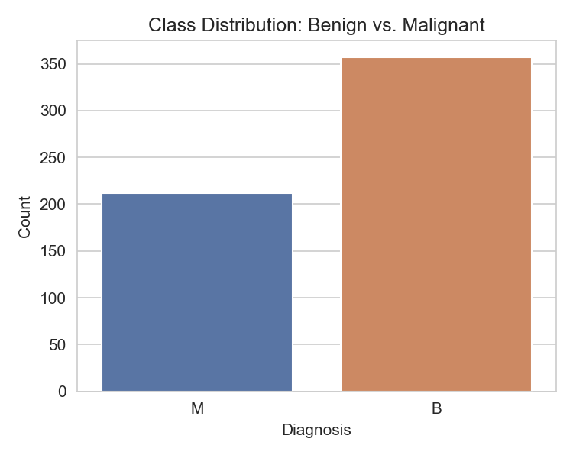
Figure 1: Class distribution of the Breast Cancer Wisconsin dataset (n = 569), showing 357 benign (62.7%) and 212 malignant (37.3%) samples

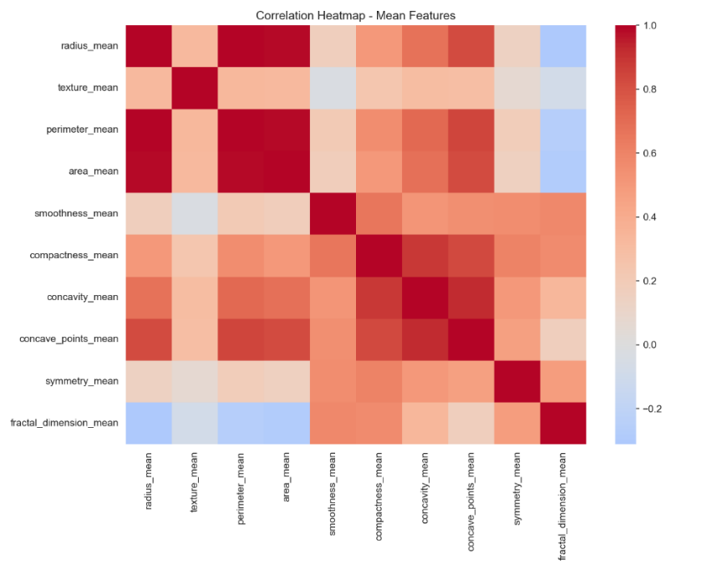
Figure 2: Correlation heatmap of the mean-value features, showing strong positive correlation between radius, perimeter, and area

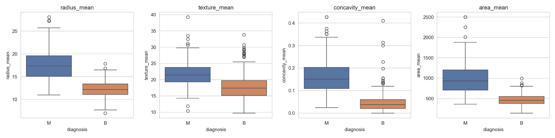
Figure 3: Boxplots comparing radius, texture, concavity, and area (mean values) between benign and malignant tumors

4. Data Preparation
The dataset was split into training (80%) and test (20%) sets using stratified sampling, which preserves the original 63/37 class ratio in both sets. This is important given the moderate class imbalance identified in Section 3, and consistent with the benchmark modeling approach demonstrated in the course book (Gong, 2023, pp. 40-50). All 30 numerical features were then standardized (zero mean, unit variance) using a scaler fitted only on the training set and applied to both sets, preventing information from the test set leaking into training. Scaling is necessary for distance-based and gradient-based models such as logistic regression and KNN, which are sensitive to feature magnitude, whereas tree-based models (decision tree, random forest) are scale-invariant and a single scaled dataset was used across all candidate models for consistency, since scaling does not harm the tree-based models' performance.

5. Modeling: Candidate Models of Increasing Complexity
This section directly establishes a collection of candidate models while gradually increasing complexity.
5.1 Benchmark Models
Four benchmark models were established first, to set a minimum performance threshold that any serious candidate must clearly exceed: a majority-class classifier, Naive Bayes, KNN, and a shallow decision tree (Gong, 2023, pp. 40–50).
5.2 Logistic Regression (fully interpretable GLM)
Logistic regression, a generalized linear model, was selected as the first real candidate. As a fully transparent model, its coefficients can be read directly to show how each feature increases or decreases the odds of malignancy (Gong, 2023, p. 49).
5.3 Decision Tree (transparent IF-THEN rules)
A decision tree was included as a second interpretable candidate. Predictions are represented as explicit IF-THEN rules, making the model's reasoning fully traceable and visualizable as a tree structure (Gong, 2023, p. 43).
5.4 Random Forest (deliberate black-box candidate)
A random forest was introduced as a deliberate black-box candidate, to test whether the added complexity of an ensemble method meaningfully improves on the two interpretable models above (Breiman, 2001; Gong, 2023, pp. 98–101, 124–131.)
5.5 Hyperparameter Tuning & Cross-Validation
All three candidates were tuned using GridSearchCV combined with stratified 10-fold cross-validation, which preserves class proportions in every fold. This is important given the moderate class imbalance identified in Section 3 (Gong, 2023, pp. 83–92). This setup allows a direct, like-for-like comparison in Section 6 of whether the random forest's added complexity is actually justified by a meaningful accuracy gain, or whether the fully interpretable logistic regression is sufficient on its own (Saarela & Jauhiainen, 2021)
Table 2: Best hyperparameters and cross-validated F1 score per candidate model
Model | Best Hyperparameters | CV F1 (mean)
Logistic Regression | C = 1 | 0.969
Decision Tree | max_depth = 4, min_samples_leaf = 5 | 0.926
Random Forest | n_estimators = 100, max_depth = 6, min_samples_leaf = 1 | 0.938

Cross-validated tuning produced three viable candidates. Logistic regression and random forest performed almost identically on the test set (F1 = 0.964 and 0.963 respectively), both exceeding the target of F1 > 0.95, while the decision tree lagged behind (F1 = 0.824), showing that a single tree's simplicity comes at a real accuracy cost on this dataset. Notably, the fully interpretable logistic regression matched the black-box random forest's performance almost exactly. This is an early indication, developed further in Section 7, that the added complexity of an ensemble model may not be necessary here.

6. Model Evaluation & Comparison
Table 3 compares all seven models on the test set. All three tuned candidates clearly outperformed the majority-class benchmark (F1 = 0.00) and the shallow decision tree benchmark (F1 = 0.810), confirming they add genuine predictive value (Gong, 2023, pp. 40–50).

Table 3: Model comparison across all benchmark and candidate models, sorted by F1 score
Model | Type | Test Accuracy | Precision | Recall | F1 | ROC-AUC
Logistic Regression (tuned) | Candidate | 0.974 | 0.976 | 0.952 | 0.964 | 0.998
KNN (k=5) | Benchmark | 0.974 | 0.976 | 0.952 | 0.964 | 0.986
Random Forest (tuned) | Candidate | 0.974 | 1.000 | 0.929 | 0.963 | 0.990
Naive Bayes | Benchmark | 0.939 | 0.907 | 0.929 | 0.918 | 0.987
Decision Tree (tuned) | Candidate | 0.868 | 0.814 | 0.833 | 0.824 | 0.903
Decision Tree (depth=3) | Benchmark | 0.860 | 0.810 | 0.810 | 0.810 | 0.836
Majority Class | Benchmark | 0.632 | 0.000 | 0.000 | 0.000 | 0.500

Both logistic regression and random forest exceeded the target of F1 > 0.95, with logistic regression marginally ahead. Comparing train and test performance reveals different overfitting profiles: the decision tree scored 0.976 train accuracy but only 0.868 test accuracy, and random forest scored a perfect 1.000 train accuracy against 0.974 test accuracy. These are both consistent with high-variance models that memorize training data (Gong, 2023, pp. 72–82). Logistic regression showed the smallest train-test gap (0.989 vs 0.974), consistent with its lower model complexity. The 10-fold cross-validated F1 scores confirm this ranking is stable rather than a lucky split: logistic regression (0.969 ± 0.039) and random forest (0.938 ± 0.044) clearly outperform the decision tree (0.926 ± 0.031) with reasonably tight variance across folds (Gong, 2023, pp. 83–92).

7. Model Interpretation

7.1 Logistic Regression Coefficients.
The largest standardized coefficients belong to texture_worst, radius_se, and radius_worst, indicating that both the "worst" tier and the standard-error tier carry substantial predictive weight, not only the mean values (Gong, 2023, p. 49).
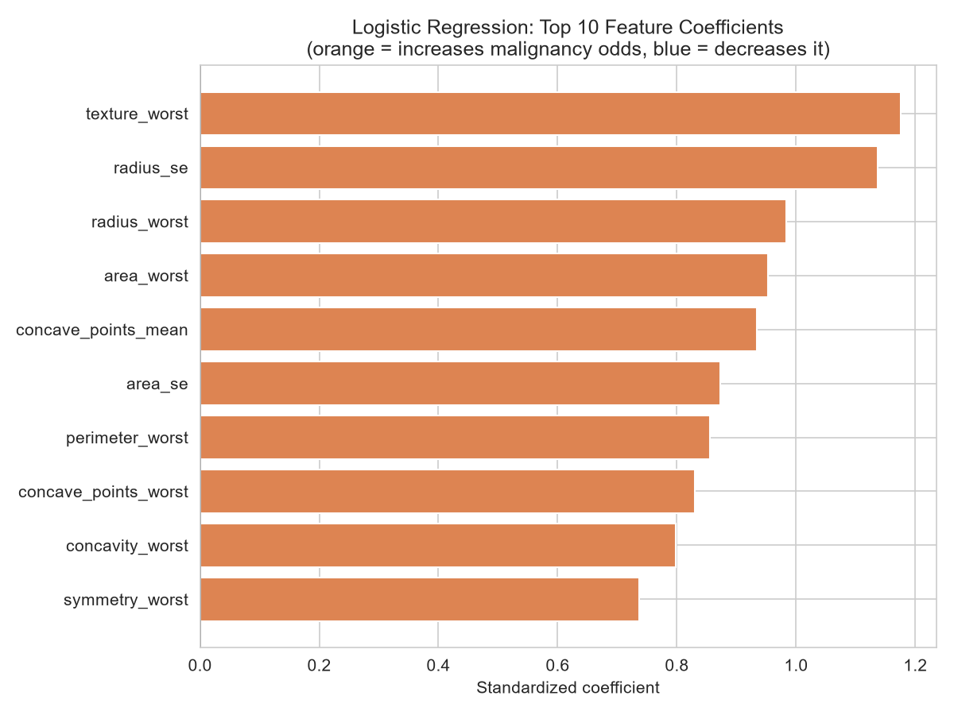
Figure 4: Top 10 logistic regression coefficients (standardized)

7.2 Decision Tree Structure.
The tuned tree relies overwhelmingly on a single feature: perimeter_worst accounts for 75% of total feature importance, with concave_points_worst a distant second (14%). This concentration explains the tree's weaker test performance. Therefore, a model built almost entirely on one feature is brittle to borderline cases (Gong, 2023, p. 43).
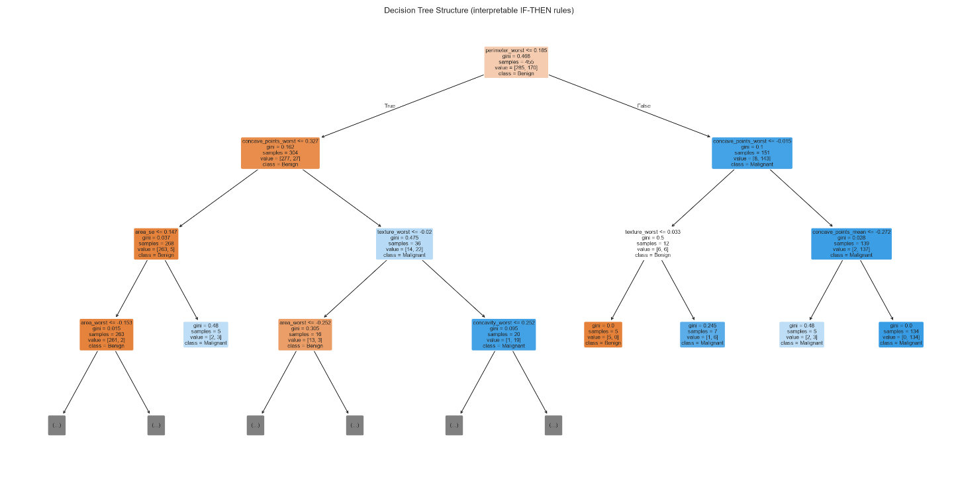
Figure 5: Decision tree structure showing transparent IF-THEN decision rules

7.3 Random Forest (Feature Importance).
Built-in importance ranks concave_points_worst, perimeter_worst, and concave_points_mean highest. Permutation importance, computed on the held-out test set, gives a related but not identical ranking (concave_points_worst, texture_mean, texture_worst), which the course book flags as more trustworthy since built-in importance is biased toward high-cardinality continuous features (Gong, 2023, pp. 116–117). Both methods agree that concave_points_worst is the single most important feature.
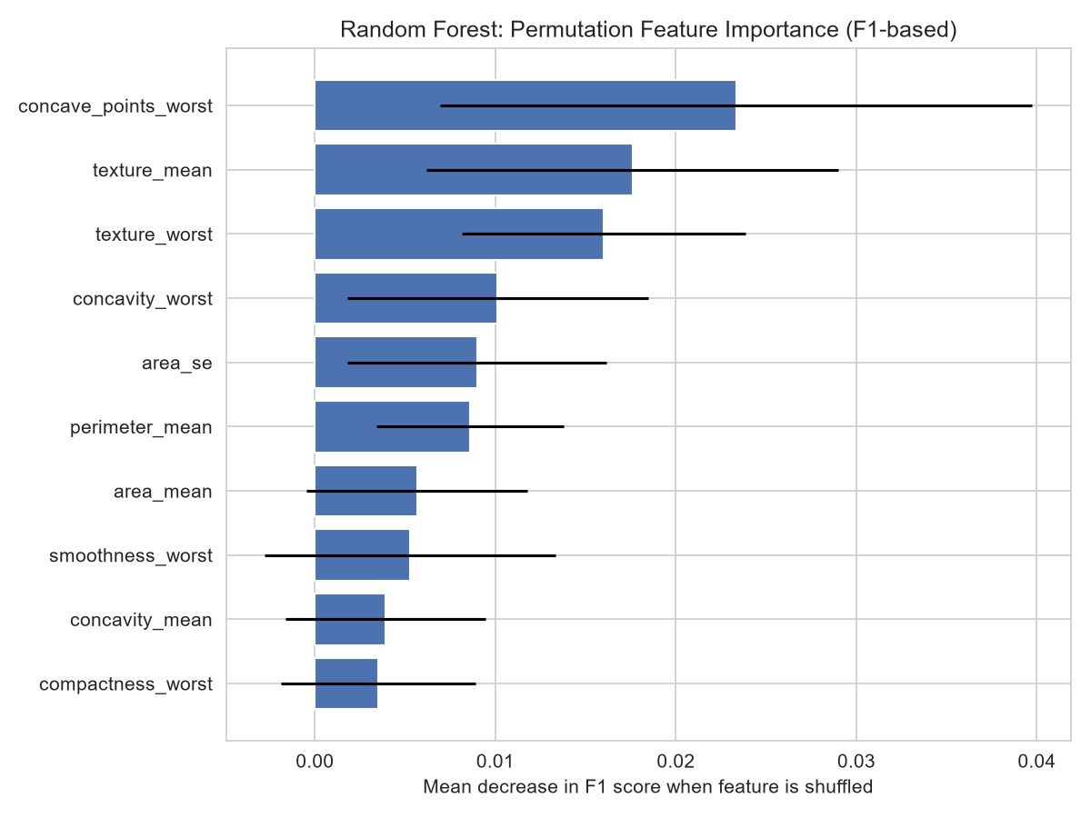
Figure 6: Random forest permutation feature importance (F1-based, test set)

7.4 Partial Dependence Plot.
Figure 7 shows predicted malignancy probability rising sharply as concave_points_worst increases, with the steepest change in the middle of its range, consistent with it being the model's most decisive feature (Gong, 2023, p. 117).
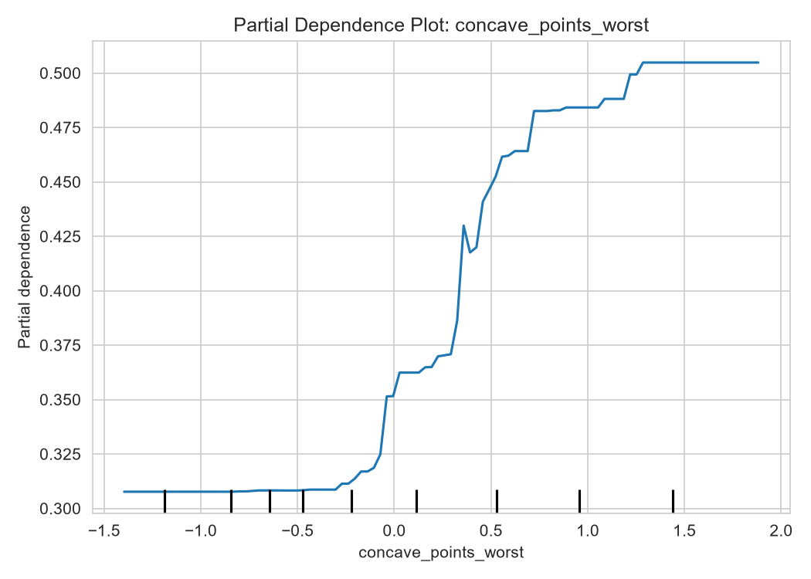
Figure 7: Partial dependence plot for concave_points_worst

7.5 SHAP (Global and Local Explanations)
The global SHAP summary (Figure 8) confirms concave_points_worst, perimeter_worst, and radius_worst as the dominant features, aligned with both importance methods above (Lundberg & Lee, 2017). For one individual test case correctly predicted as malignant with 99% confidence, the local SHAP waterfall (Figure 9) shows perimeter_worst and concave_points_worst as the largest individual contributors. This is the kind of patient-specific explanation the oncologists in Section 1 actually asked for (Gong, 2023, pp. 119–122).
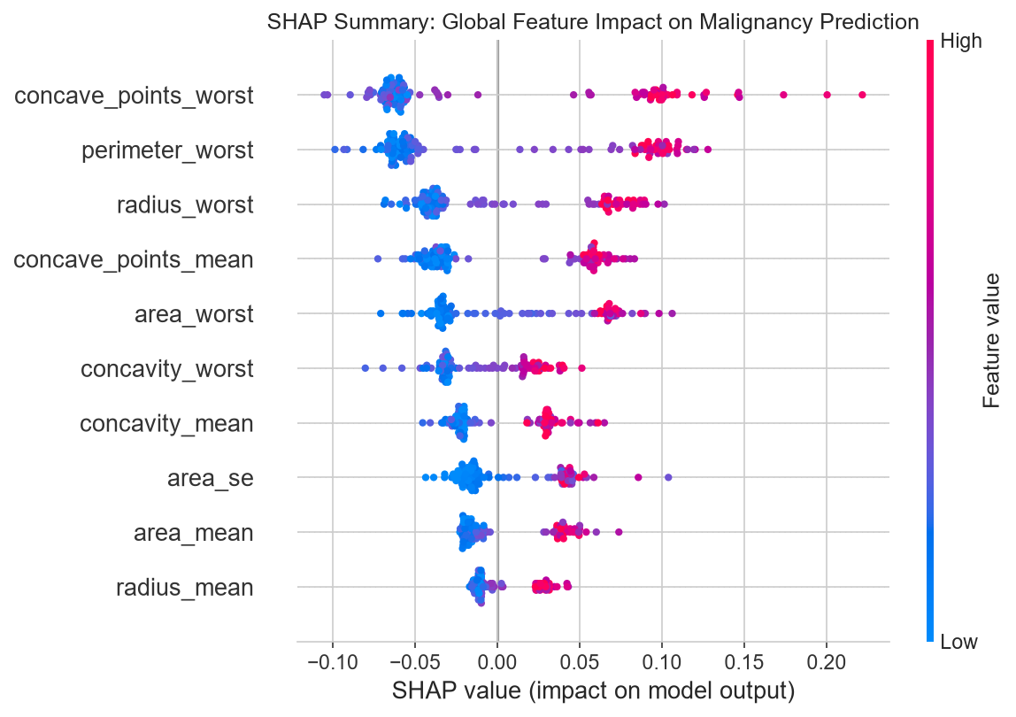
Figure 8: Global SHAP summary plot showing feature impact on malignancy prediction
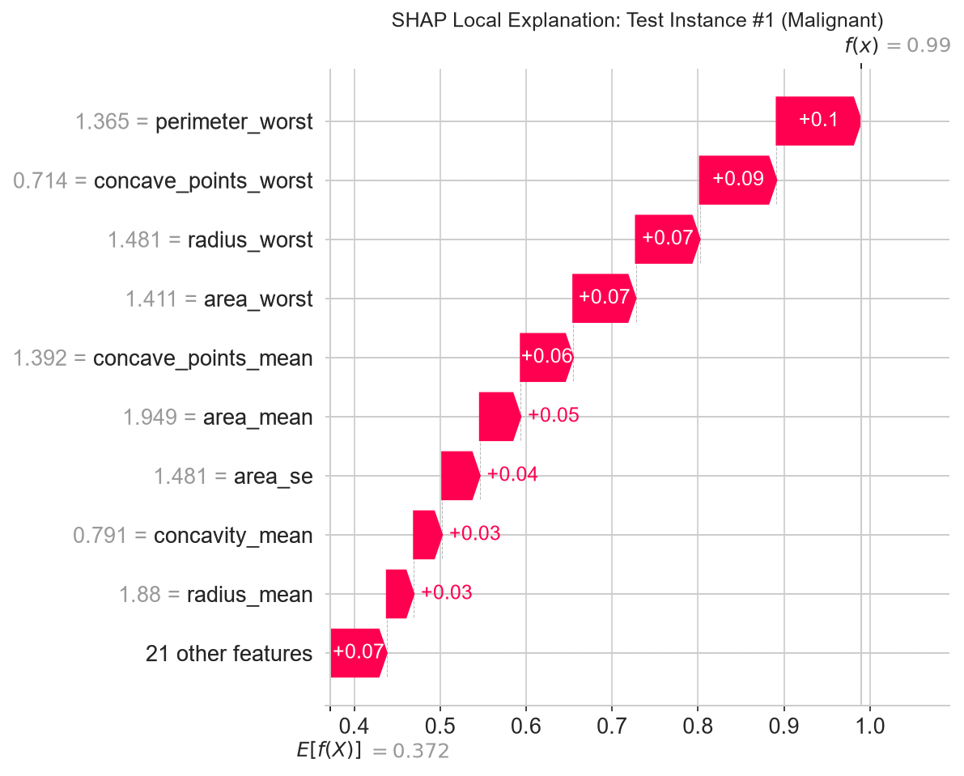
Figure 9: Local SHAP waterfall explanation for one individual patient prediction

7.6 Synthesis: The Accuracy/Interpretability Trade-off.
Random forest does not meaningfully outperform logistic regression here (F1 = 0.963 vs 0.964), and closer inspection of the confusion matrices reveals logistic regression actually makes fewer of the clinically costly errors: 2 false negatives (missed malignancies) versus random forest's 3, at the cost of 1 false positive versus random forest's 0. Given that a missed malignancy is substantially more dangerous than a false alarm, logistic regression is arguably the stronger candidate on both accuracy and interpretability grounds. This is a conclusion consistent with (Rudin, 2019) argument that inherently interpretable models should be preferred over "explained" black boxes whenever they perform comparably, and with (Saarela & Jauhiainen, 2021) finding of similar feature-importance agreement between linear and ensemble models on this exact dataset.

8. Error Analysis
Figure 10 shows the confusion matrix and Figure 11 the ROC curve (AUC = 0.990) for random forest, the model used to demonstrate the SHAP-based interpretation methods in Section 7. Of 114 test cases, random forest misclassified 3 malignant tumors as benign (false negatives) and 0 benign tumors as malignant. For direct comparison, logistic regression (the model proposed for deployment in Section 9) misclassified 2 malignant tumors as benign and 1 benign tumor as malignant on the same test set. False negatives are clinically the most serious error type, since a missed malignancy delays treatment; on this measure, logistic regression's error profile is the more favorable of the two.
Inspecting the three random forest false negatives individually shows two borderline predicted probabilities (0.469 and 0.427, both near the 0.5 decision threshold) and one confidently wrong case (0.020). The two borderline cases are consistent with genuinely ambiguous tumors sitting close to the model's decision boundary, whereas the confidently wrong case warrants closer, case-by-case audit using the same local SHAP method demonstrated in Section 7.5, rather than being dismissed as an inherent model limitation (Gong, 2023, pp. 72–82).

Table 4: Misclassified test instances with predicted probabilities
ID | True Label | Predicted Label | P(Malignant) | radius_mean | texture_mean | concave_points_worst
135 | Malignant | Benign | 0.020 | 12.77 | 22.47 | 0.093
146 | Malignant | Benign | 0.469 | 11.80 | 16.58 | 0.187
86 | Malignant | Benign | 0.427 | 14.48 | 21.46 | 0.123

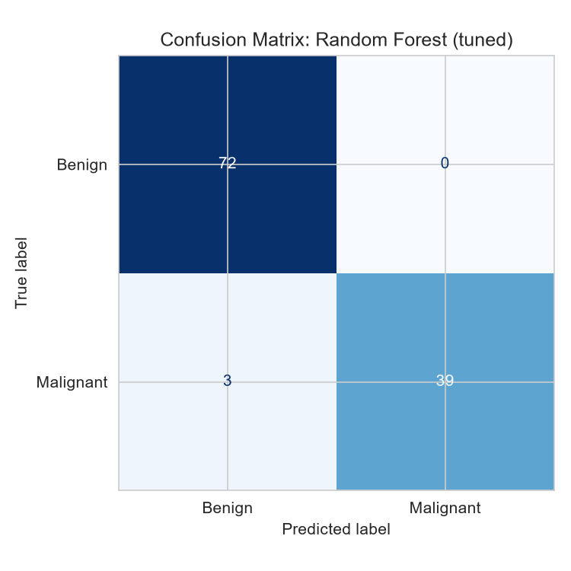
Figure 10: Confusion matrix for random forest
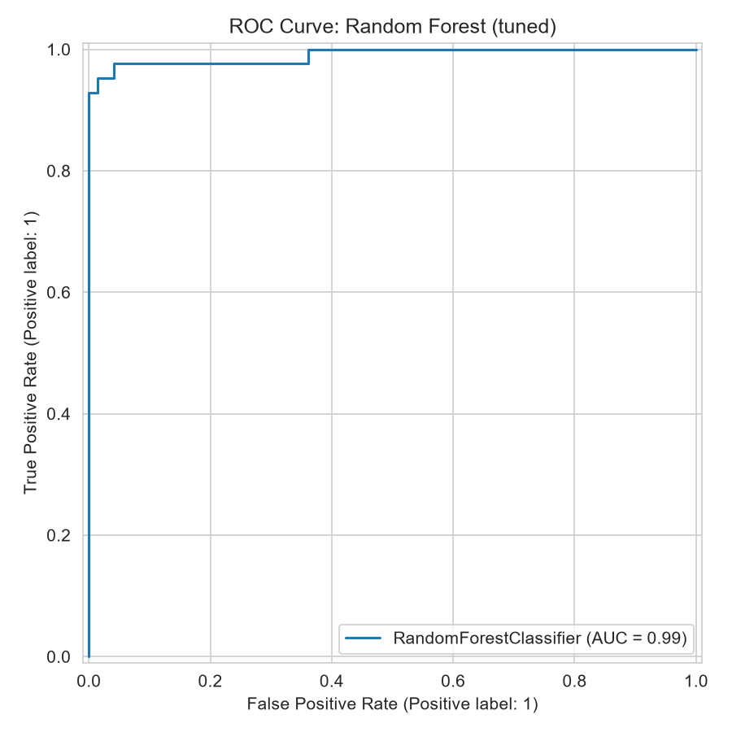
Figure 11: ROC curve for random forest (AUC = 0.990)

9. Deployment Proposal
Given the findings in Section 7.6, logistic regression is proposed as the deployed model, packaged behind a simple clinician-facing interface: an oncologist would enter a tumor's 30 measured features, and the system would return the predicted diagnosis, the associated probability, and the top three contributing features drawn from the SHAP explanation method demonstrated in Section 7.5. This directly addresses the trust problem described in Section 1. Consistent with the course book's guidance on production readiness, the trained model and its scaler are persisted as versioned artifacts (final_model.joblib, scaler.joblib) alongside a JSON model report recording configuration, performance, and interpretation results, so that future retraining can be tracked and compared against this baseline (Gong, 2023, pp. 61–70).

10. Conclusion & Critical Reflection
Both success criteria defined in Section 1.3 were met: the data-mining criterion (F1 > 0.95) was achieved by logistic regression (F1 = 0.964) and random forest (F1 = 0.963), and the business criterion of interpretability was directly addressed through coefficient analysis, decision tree visualization, permutation importance, and SHAP explanations. The central finding, that the fully transparent logistic regression model matched or exceeded the black-box random forest while making fewer clinically costly errors, suggests that, for this dataset, pursuing model complexity beyond a simple GLM was unnecessary. The main limitation is that both the dataset (569 samples, single source) and the false-negative cases identified in Section 8 are small enough that these error patterns cannot be generalized with confidence; further validation on an independent, larger patient cohort would be needed before any operational deployment.

References
Breiman, L. (2001). Random Forests. Machine Learning, 5-32.
Chapman, P., Clinton, J., Kerber, R., Khabaza, T., Reinartz, T., Shearer, C., & Wirth, R. (2000). CRISP-DM 1.0: Step-by-Step Data Mining Guide. Copenhagen: SPSS Inc.
Gong, D. (2023). Model Engineering. Erfurt, Germany: IU International University of Applied Sciences.
Lundberg, S., & Lee, S.-I. (2017). A Unified Approach to Interpreting Model Predictions. Advances in Neural Information Processing Systems, (pp. 4765–4774).
Rudin, C. (2019). Stop Explaining Black Box Machine Learning Models for High Stakes Decisions and Use Interpretable Models Instead. Nature Machine Intelligence, 206–215.
Saarela, M., & Jauhiainen, S. (2021). Comparison of Feature Importance Measures as Explanations for Classification Models. SN Applied Sciences.
Street, W. N., Wolberg, W. H., & Mangasarian, O. L. (1993). Nuclear feature extraction for breast tumour diagnosis., 1905, pp. 861–870.

List of Appendices
Appendix A: Full Python Code

Appendix A: Full Python Code
The following is the complete, well-documented Python code used to produce every figure, table, and result reported in this case study (breast_cancer_case_study.py). Each major section of the code is labelled with the corresponding section number from this document. You can also view this in the Github repository. See Section 2 for the link to the repository.
"""
================================================================================
Breast Cancer Prediction - Case Study Code (DLBDSME01, Task 1)
================================================================================
This script matches the write-up "Date_Zach_Simpson_32212726_DLBDSME01.docx".
Each part of the code is labelled with the section number it belongs to in
that document, so you can follow along side by side.

HOW TO RUN (VS Code):
pip install numpy pandas matplotlib seaborn scikit-learn shap joblib
python breast_cancer_case_study.py

This creates two folders next to the script:
figures/ -> all plots (Figures 1-11 in the write-up)
models/ -> saved model, scaler, and result files (Tables 1-4)
================================================================================
"""

import os
import numpy as np
import pandas as pd
import matplotlib
matplotlib.use("Agg") # saves plots to file instead of popping up windows
import matplotlib.pyplot as plt
import seaborn as sns

from sklearn.datasets import load_breast_cancer
from sklearn.model_selection import (
train_test_split, StratifiedKFold, cross_val_score, GridSearchCV
)
from sklearn.preprocessing import StandardScaler
from sklearn.dummy import DummyClassifier
from sklearn.linear_model import LogisticRegression
from sklearn.tree import DecisionTreeClassifier, plot_tree
from sklearn.ensemble import RandomForestClassifier
from sklearn.naive_bayes import GaussianNB
from sklearn.neighbors import KNeighborsClassifier
from sklearn.inspection import permutation_importance, PartialDependenceDisplay
from sklearn.metrics import (
accuracy_score, precision_score, recall_score, f1_score, roc_auc_score,
confusion_matrix, ConfusionMatrixDisplay, classification_report, RocCurveDisplay
)
import joblib
import json
import shap

# Fixed seed so results are exactly reproducible every time this runs
RANDOM_STATE = 24

# Output folders (created next to this script)
FIG_DIR = "figures"
MODEL_DIR = "models"
os.makedirs(FIG_DIR, exist_ok=True)
os.makedirs(MODEL_DIR, exist_ok=True)
sns.set_style("whitegrid")

# ==========================================================================
# SECTION 3: DATA UNDERSTANDING
# ==========================================================================
print("=" * 80)
print("SECTION 3: DATA UNDERSTANDING")
print("=" * 80)

# Load the dataset (same data as described in the case study, built into sklearn)
data = load_breast_cancer(as_frame=True)
df = data.frame.copy()
df["diagnosis"] = df["target"].map({0: "M", 1: "B"})
df = df.drop(columns=["target"])

# Rename columns to match the naming used in the write-up (e.g. radius_mean)
def rename_column(col):
if col.startswith("mean "):
return col.replace("mean ", "") + "_mean"
if col.startswith("worst "):
return col.replace("worst ", "") + "_worst"
if col.endswith(" error"):
return col.replace(" error", "") + "_se"
return col

df = df.rename(columns=rename_column)
df.columns = [c.replace(" ", "_") for c in df.columns]

print(f"Records: {df.shape[0]}, Features: {df.shape[1] - 1}")
print(df["diagnosis"].value_counts())

# Table 1: descriptive statistics for the first 5 features
print("\nTable 1 - Descriptive statistics:")
print(df.iloc[:, :5].describe().T.round(3))

# Data quality checks (missing values, duplicates, outliers)
print("\nMissing values:", df.isnull().sum().sum())
print("Duplicate rows:", df.duplicated().sum())

def count_outliers_iqr(series):
q1, q3 = series.quantile(0.25), series.quantile(0.75)
iqr = q3 - q1
return ((series < q1 - 1.5 * iqr) | (series > q3 + 1.5 * iqr)).sum()

feature_cols = [c for c in df.columns if c != "diagnosis"]
outliers = df[feature_cols].apply(count_outliers_iqr).sort_values(ascending=False)
print("\nMost outliers:\n", outliers.head(3))

# Figure 1: class balance
plt.figure(figsize=(5, 4))
sns.countplot(data=df, x="diagnosis", hue="diagnosis", legend=False,
palette=["#4C72B0", "#DD8452"])
plt.title("Class Distribution: Benign vs. Malignant")
plt.tight_layout()
plt.savefig(f"{FIG_DIR}/01_class_distribution.png", dpi=150)
plt.close()

# Figure 2: correlation heatmap (mean features only)
mean_cols = [c for c in feature_cols if c.endswith("mean")]
plt.figure(figsize=(9, 7))
sns.heatmap(df[mean_cols].corr(), cmap="coolwarm", center=0)
plt.title("Correlation Heatmap - Mean Features")
plt.tight_layout()
plt.savefig(f"{FIG_DIR}/02_correlation_heatmap.png", dpi=150)
plt.close()

# Figure 3: boxplots of 4 key features by diagnosis
key_features = ["radius_mean", "texture_mean", "concavity_mean", "area_mean"]
fig, axes = plt.subplots(1, 4, figsize=(15, 4))
for ax, feat in zip(axes, key_features):
sns.boxplot(data=df, x="diagnosis", y=feat, hue="diagnosis", ax=ax,
legend=False, palette=["#4C72B0", "#DD8452"])
ax.set_title(feat)
plt.tight_layout()
plt.savefig(f"{FIG_DIR}/03_boxplots_key_features.png", dpi=150)
plt.close()

# ==========================================================================
# SECTION 4: DATA PREPARATION
# ==========================================================================
print("\n" + "=" * 80)
print("SECTION 4: DATA PREPARATION")
print("=" * 80)

df["target"] = df["diagnosis"].map({"M": 1, "B": 0})
X = df[feature_cols]
y = df["target"]

# 80/20 split, stratified so both sets keep the same 63/37 class ratio
X_train, X_test, y_train, y_test = train_test_split(
X, y, train_size=0.80, random_state=RANDOM_STATE, stratify=y
)
print(f"Train: {X_train.shape[0]} rows | Test: {X_test.shape[0]} rows")

# Scale features (fit on train only, then apply to both - avoids data leakage)
scaler = StandardScaler()
X_train_scaled = pd.DataFrame(scaler.fit_transform(X_train), columns=X_train.columns, index=X_train.index)
X_test_scaled = pd.DataFrame(scaler.transform(X_test), columns=X_test.columns, index=X_test.index)

# ==========================================================================
# SECTION 5: MODELING - CANDIDATE MODELS OF INCREASING COMPLEXITY
# ==========================================================================
print("\n" + "=" * 80)
print("SECTION 5: MODELING")
print("=" * 80)

results = [] # every model's scores get collected here for Table 3 (Section 6)

def evaluate_model(name, model, is_benchmark=False):
"""Train a model, score it on train + test, and save the results."""
model.fit(X_train_scaled, y_train)
pred_train = model.predict(X_train_scaled)
pred_test = model.predict(X_test_scaled)
proba_test = model.predict_proba(X_test_scaled)[:, 1]

scores = {
"model": name,
"type": "benchmark" if is_benchmark else "candidate",
"train_accuracy": accuracy_score(y_train, pred_train),
"test_accuracy": accuracy_score(y_test, pred_test),
"precision": precision_score(y_test, pred_test, zero_division=0),
"recall": recall_score(y_test, pred_test, zero_division=0),
"f1": f1_score(y_test, pred_test, zero_division=0),
"roc_auc": roc_auc_score(y_test, proba_test),
}
results.append(scores)
print(f"{name}: F1={scores['f1']:.3f} Precision={scores['precision']:.3f} "
f"Recall={scores['recall']:.3f} ROC-AUC={scores['roc_auc']:.3f}")
return model

# --- Section 5.1: Benchmark models ---------------------------------------
print("\n-- 5.1 Benchmark models --")
evaluate_model("Majority Class", DummyClassifier(strategy="most_frequent", random_state=RANDOM_STATE), is_benchmark=True)
evaluate_model("Naive Bayes", GaussianNB(), is_benchmark=True)
evaluate_model("KNN (k=5)", KNeighborsClassifier(n_neighbors=5), is_benchmark=True)
evaluate_model("Decision Tree (depth=3)", DecisionTreeClassifier(max_depth=3, random_state=RANDOM_STATE), is_benchmark=True)

# --- Sections 5.2-5.4: the three main candidates, tuned with CV ----------
cv = StratifiedKFold(n_splits=10, shuffle=True, random_state=RANDOM_STATE)

def tune_with_cv(name, estimator, param_grid):
"""Try every combination in param_grid using 10-fold cross-validation,
and keep whichever one scores best on average (Section 5.5)."""
search = GridSearchCV(estimator, param_grid, cv=cv, scoring="f1", n_jobs=-1)
search.fit(X_train_scaled, y_train)
print(f"{name}: best params = {search.best_params_}, CV F1 = {search.best_score_:.3f}")
return search.best_estimator_

print("\n-- 5.2 Logistic Regression --")
best_logreg = tune_with_cv("Logistic Regression", LogisticRegression(),
{"C": [0.01, 0.1, 1, 10], "max_iter": [5000]})
evaluate_model("Logistic Regression (tuned)", best_logreg)

print("\n-- 5.3 Decision Tree --")
best_tree = tune_with_cv("Decision Tree", DecisionTreeClassifier(random_state=RANDOM_STATE),
{"max_depth": [3, 4, 5, 6, 8], "min_samples_leaf": [1, 5, 10]})
evaluate_model("Decision Tree (tuned)", best_tree)

print("\n-- 5.4 Random Forest --")
best_rf = tune_with_cv("Random Forest", RandomForestClassifier(random_state=RANDOM_STATE),
{"n_estimators": [100, 200, 300], "max_depth": [4, 6, 8, None], "min_samples_leaf": [1, 2, 4]})
evaluate_model("Random Forest (tuned)", best_rf)

# --- Section 5.5: cross-validated F1 (mean +/- std) for Table 2 ----------
print("\n-- 5.5 Cross-validated F1 scores (Table 2) --")
for name, model in [("Logistic Regression", best_logreg), ("Decision Tree", best_tree), ("Random Forest", best_rf)]:
cv_scores = cross_val_score(model, X_train_scaled, y_train, cv=cv, scoring="f1")
print(f"{name}: {cv_scores.mean():.3f} +/- {cv_scores.std():.3f}")

# ==========================================================================
# SECTION 6: MODEL EVALUATION & COMPARISON
# ==========================================================================
print("\n" + "=" * 80)
print("SECTION 6: MODEL EVALUATION & COMPARISON (Table 3)")
print("=" * 80)

results_df = pd.DataFrame(results).sort_values("f1", ascending=False)
print(results_df.to_string(index=False))
results_df.to_csv(f"{MODEL_DIR}/model_comparison.csv", index=False)

# ==========================================================================
# SECTION 7: MODEL INTERPRETATION
# ==========================================================================
print("\n" + "=" * 80)
print("SECTION 7: MODEL INTERPRETATION")
print("=" * 80)

# --- 7.1 Logistic Regression coefficients ---------------------------------
coef_df = pd.DataFrame({"feature": X_train_scaled.columns, "coefficient": best_logreg.coef_[0]}) \
.sort_values("coefficient", key=abs, ascending=False)
print("\n7.1 Top logistic regression coefficients:\n", coef_df.head(5).to_string(index=False))

plt.figure(figsize=(7, 5))
top10 = coef_df.head(10).sort_values("coefficient")
colors = ["#DD8452" if c > 0 else "#4C72B0" for c in top10["coefficient"]]
plt.barh(top10["feature"], top10["coefficient"], color=colors)
plt.axvline(0, color="black", linewidth=0.8)
plt.title("Logistic Regression: Top 10 Coefficients")
plt.tight_layout()
plt.savefig(f"{FIG_DIR}/04_logreg_coefficients.png", dpi=150)
plt.close()

# --- 7.2 Decision Tree structure ------------------------------------------
plt.figure(figsize=(14, 7))
plot_tree(best_tree, feature_names=X_train_scaled.columns, class_names=["Benign", "Malignant"],
filled=True, rounded=True, fontsize=8, max_depth=3)
plt.title("Decision Tree Structure")
plt.tight_layout()
plt.savefig(f"{FIG_DIR}/05_decision_tree.png", dpi=150)
plt.close()

# --- 7.3 Random Forest: built-in importance + permutation importance ------
rf_importance = pd.DataFrame({"feature": X_train_scaled.columns, "importance": best_rf.feature_importances_}) \
.sort_values("importance", ascending=False)
print("\n7.3 Top random forest importances:\n", rf_importance.head(5).to_string(index=False))

perm = permutation_importance(best_rf, X_test_scaled, y_test, n_repeats=30, random_state=RANDOM_STATE, scoring="f1")
perm_df = pd.DataFrame({"feature": X_test_scaled.columns, "importance": perm.importances_mean}) \
.sort_values("importance", ascending=False)

plt.figure(figsize=(7, 5))
top10_perm = perm_df.head(10).sort_values("importance")
plt.barh(top10_perm["feature"], top10_perm["importance"], color="#4C72B0")
plt.title("Random Forest: Permutation Importance")
plt.tight_layout()
plt.savefig(f"{FIG_DIR}/06_permutation_importance.png", dpi=150)
plt.close()

# --- 7.4 Partial dependence plot for the top feature -----------------------
top_feature = perm_df.iloc[0]["feature"]
fig, ax = plt.subplots(figsize=(6, 5))
PartialDependenceDisplay.from_estimator(best_rf, X_train_scaled, [top_feature], ax=ax)
plt.title(f"Partial Dependence: {top_feature}")
plt.tight_layout()
plt.savefig(f"{FIG_DIR}/07_partial_dependence.png", dpi=150)
plt.close()

# --- 7.5 SHAP: global summary + one local explanation -----------------------
explainer = shap.TreeExplainer(best_rf)
shap_values = explainer(X_test_scaled)
shap_malignant = shap_values[:, :, 1] if len(shap_values.shape) == 3 else shap_values

plt.figure()
shap.summary_plot(shap_malignant, X_test_scaled, show=False, max_display=10)
plt.tight_layout()
plt.savefig(f"{FIG_DIR}/08_shap_summary_global.png", dpi=150, bbox_inches="tight")
plt.close()

# pick one correctly-predicted malignant case to explain individually
rf_test_pred = best_rf.predict(X_test_scaled)
malignant_correct = np.where((y_test.values == 1) & (rf_test_pred == 1))[0]
sample_idx = malignant_correct[0]

plt.figure()
shap.plots.waterfall(shap_malignant[sample_idx], show=False, max_display=10)
plt.tight_layout()
plt.savefig(f"{FIG_DIR}/09_shap_local_waterfall.png", dpi=150, bbox_inches="tight")
plt.close()
print(f"\n7.5 SHAP figures saved (local explanation for test case #{sample_idx})")

# ==========================================================================
# SECTION 8: ERROR ANALYSIS
# ==========================================================================
print("\n" + "=" * 80)
print("SECTION 8: ERROR ANALYSIS")
print("=" * 80)

# Random Forest confusion matrix + ROC curve (Figures 10-11)
rf_pred = best_rf.predict(X_test_scaled)
rf_proba = best_rf.predict_proba(X_test_scaled)[:, 1]
cm_rf = confusion_matrix(y_test, rf_pred)
print("Random Forest confusion matrix:\n", cm_rf)

fig, ax = plt.subplots(figsize=(5, 5))
ConfusionMatrixDisplay(confusion_matrix=cm_rf, display_labels=["Benign", "Malignant"]).plot(ax=ax, cmap="Blues", colorbar=False)
plt.title("Confusion Matrix: Random Forest (tuned)")
plt.tight_layout()
plt.savefig(f"{FIG_DIR}/10_confusion_matrix.png", dpi=150)
plt.close()

fig, ax = plt.subplots(figsize=(6, 6))
RocCurveDisplay.from_estimator(best_rf, X_test_scaled, y_test, ax=ax)
plt.title("ROC Curve: Random Forest (tuned)")
plt.tight_layout()
plt.savefig(f"{FIG_DIR}/11_roc_curve.png", dpi=150)
plt.close()

# Logistic Regression confusion matrix (quoted as numbers in Section 8 text)
lr_pred = best_logreg.predict(X_test_scaled)
cm_lr = confusion_matrix(y_test, lr_pred)
print("Logistic Regression confusion matrix:\n", cm_lr)

# Table 4: misclassified test cases (using Random Forest's predictions)
misclassified_mask = rf_pred != y_test.values
misclassified = X_test.loc[X_test_scaled.index[misclassified_mask]].copy()
misclassified["true_label"] = y_test[misclassified_mask].map({1: "Malignant", 0: "Benign"})
misclassified["predicted_label"] = "Benign" # all misclassified cases here are false negatives
misclassified["predicted_probability_malignant"] = rf_proba[misclassified_mask].round(3)
print("\nTable 4 - Misclassified cases:\n", misclassified[["true_label", "predicted_probability_malignant"]])
misclassified.to_csv(f"{MODEL_DIR}/misclassified_instances.csv")

# ==========================================================================
# SECTION 9: DEPLOYMENT PROPOSAL
# ==========================================================================
print("\n" + "=" * 80)
print("SECTION 9: DEPLOYMENT PROPOSAL")
print("=" * 80)

# Logistic Regression is the model proposed for deployment (see Sections 7.6 and 9):
# it matches Random Forest's accuracy while making fewer false negatives and
# staying fully interpretable.
final_model = best_logreg
FINAL_MODEL_NAME = "Logistic Regression (tuned)"

joblib.dump(final_model, f"{MODEL_DIR}/final_model.joblib")
joblib.dump(scaler, f"{MODEL_DIR}/scaler.joblib")

model_report = {
"model_configuration": {
"target_variable": "diagnosis (malignant=1, benign=0)",
"algorithm": "LogisticRegression",
"hyperparameters": best_logreg.get_params(),
},
"model_performance": {
"test_f1": float(f1_score(y_test, lr_pred)),
"test_precision": float(precision_score(y_test, lr_pred)),
"test_recall": float(recall_score(y_test, lr_pred)),
"test_roc_auc": float(roc_auc_score(y_test, best_logreg.predict_proba(X_test_scaled)[:, 1])),
},
}
with open(f"{MODEL_DIR}/model_report.json", "w") as f:
json.dump(model_report, f, indent=2, default=str)

print(f"Saved: {MODEL_DIR}/final_model.joblib ({FINAL_MODEL_NAME})")
print(f"Saved: {MODEL_DIR}/scaler.joblib")
print(f"Saved: {MODEL_DIR}/model_report.json")

print("\n" + "=" * 80)
print(f"FINAL RESULT: {FINAL_MODEL_NAME} -> F1 = {model_report['model_performance']['test_f1']:.3f} "
f"(target: F1 > 0.95)")
print("=" * 80)

