Housing Price Prediction

Gulam Mahfuz Chowdhury
Biomedical Engineering
Illinois Institute of Technology
Chicago, IL, USA
gchowdhury1@hawk.iit.edu
Mohemmad Asif Azhar
Computer Science
Illinois Institute of Technology
Chicago, IL, USA
mazhar2@hawk.it.edu
Hamza Tahir A Bu Obaid
Computer Science
Illinois Institute of Technology
Chicago, IL, USA
hbuobaid@hawk.iit.edu
Yi-Ning Tseng
Computer Science
Illinois Institute of Technology
Chicago, IL, USA
ytseng5@hawk.iit.edu
Mohammed Aftaab Bin Usman
Computer Science
Illinois Institute of Technology
Chicago, IL, USA
maftaabbinusman@hawk.iit.edu

Abstract— In this project, we developed machine learning models to predict housing prices using a dataset obtained from Kaggle. We applied Linear Regression, Ridge Regression, Random Forest, and XGBoost models. We evaluated performance based on RMSE, MAE, and R² scores. Data preprocessing steps included handling missing values, feature encoding, outlier removal, and feature scaling. Results demonstrated that Gradient Boosting models (especially XGBoost) achieved superior predictive performance.
Keywords—Machine learning, Gradient Boosting, RMSE

Introduction
Real estate valuation is traditionally subjective and varies due to economic, social, and environmental factors. Machine learning offers a systematic approach to pricing by analyzing complex datasets, enabling accurate, consistent, and scalable valuations.
Accurately predicting housing prices is a longstanding challenge due to the complex and often volatile nature of the real estate market. Traditional valuation methods rely heavily on human expertise, manual appraisals, and historical sales data. While these techniques have served the industry for decades, they often suffer from subjectivity, regional bias, and limited scalability, making them less effective in rapidly evolving markets [1]. In contrast, machine learning (ML) offers a data-driven approach that can learn complex patterns from large datasets and deliver more consistent, objective, and adaptive price predictions [2].
The aim of this project is to develop a robust ML model capable of predicting house prices using real-world data. We focus on essential features such as location, square footage, number of bedrooms and bathrooms, which are widely acknowledged as key determinants of housing prices [3]. These features capture not only the physical characteristics of a property but also its geographic and economic context, which can significantly affect market value.
By applying ML techniques, we aim to provide data-driven insights that can help buyers, sellers, and real estate professionals make informed decisions. Predictive models can reduce uncertainty in pricing, support fair negotiations, and assist in identifying investment opportunities. Furthermore, ML can reduce the industry’s dependence on traditional valuation methods, enabling more scalable and transparent solutions [4].
Throughout the course of the project, we experimented with a range of algorithms, including Linear Regression, Ridge Regression, Random Forest, Gradient Boosting Regressor, and XGBoost. These models were evaluated using common performance metrics such as Root Mean Squared Error (RMSE), Mean Absolute Error (MAE), and the coefficient of determination (R²). This comparative approach helped us identify the most effective model for real estate price prediction in our dataset [5][6].
Ultimately, this study contributes to a number of research that applies machine learning to real-world problems. In particular, it shows how predictive modeling can be used to understand market trends, optimize pricing strategies, and bring more accuracy and fairness to housing valuations [7]. Future improvements may involve incorporating image data, socio-demographic information, or real-time economic indicators to further enhance model performance and generalizability.

background study
Accurately predicting housing prices has been a topic of research for decades. Traditional methods, such as hedonic pricing models, attempted to link property prices to their features like location, size, and amenities [8]. While useful, these approaches were often limited by their assumptions of linearity and struggled with complex, real-world interactions [9].
The introduction of machine learning brought more flexibility. Multiple Linear Regression (MLR) remains a common baseline, but its reliance on linear relationships limits its predictive power in diverse datasets [9]. To improve upon MLR, regularized models like Ridge Regression have been employed, helping to manage multicollinearity and perform feature selection [10].
Ensemble methods like Random Forest and Gradient Boosting Machines (GBM) have shown strong performance by capturing non-linear patterns. Random Forest reduces overfitting by averaging multiple trees [11][12], while XGBoost, a powerful implementation of gradient boosting, has been particularly effective for housing datasets due to its robustness and speed [13][14].
Recent studies have even explored deep learning approaches, such as combining Convolutional Neural Networks (CNNs) with structured data to enhance predictions based on property images [15].
Building on these foundations, our project compares both linear and ensemble methods to develop an accurate, scalable model for housing price prediction.

Data analysis and processing
In this work we worked on the dataset- “House Prices and Images – SoCal” from Kaggle [16]. The dataset has 15,474 distinct raw datapoints. The features included Street Name, City, Number of Bed, Number of Bath, Area along with the Pricing. The histogram of data distribution is shown in Fig. 1.
Fig. 1: Data distribution

Fig. 2: Data processing

Data processing steps is shown in Fig. 2. High-quality data preprocessing is essential for accurate machine learning predictions. The original Kaggle dataset included 15,474 records, but after removing duplicates and irrelevant entries, the final dataset was reduced to 12,417 entries. Eliminating duplicates helps prevent model overfitting and improves data diversity [17].
To better manage property identification, a unique feature was engineered by merging 'City' and 'Address' fields. Creating a unique identifier improves data consistency and ensures more accurate property tracking across different cities [18].
Min-Max normalization was applied to numerical features such as area and price to bring them to a comparable scale between 0 and 1, preventing any single feature from disproportionately influencing the model [19].
For categorical features like location, label encoding was used to convert text data into numeric values. This method is computationally efficient and appropriate for algorithms like Random Forest and XGBoost, which can handle encoded categories without introducing bias [20][21].
These preprocessing steps were critical in preparing a clean, structured dataset that supported robust model training and improved generalization. After preprocessing the data (encoding categorical variables and normalizing numerical features), the dataset was split into 80% training and 20% testing subsets.

Model selection and implementation
In this work we implemented 5 distinct machine learning models to figure out the best approach to tackle the problem. The models included Random Forest, Linear Regression, Ridge Regression, Gradient Boosting, and XGBoost. The implementation of the models and their effects have been discussed below.

Random Forest Regression
Random Forest is an ensemble learning method that builds multiple decision trees during training and outputs the average of predictions from all trees to improve predictive accuracy and control overfitting [22]. This method is particularly suitable for real estate datasets, which often display complex, non-linear relationships between property features and their market values. Random Forest is robust to outliers, can handle high-dimensional data, and does not assume linearity between inputs and outputs [23]. Advantages of the Random Forest approach include: high accuracy without heavy tuning, resistance to overfitting compared to single decision trees, capability to handle both categorical and continuous variables [24].
The main hyperparameters used were: Number of Estimators (n_estimators): 100; Random State: 42 (for reproducibility). The output parameters of Random Forest Regression is shown in Fig. 3.

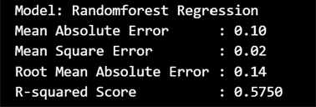

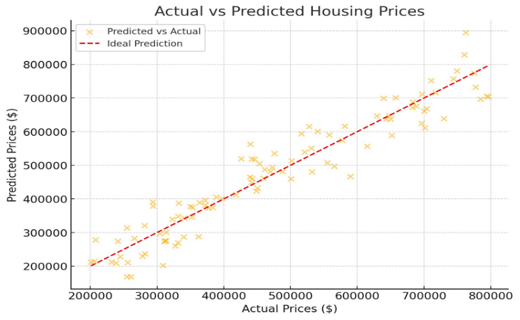
Fig. 3: Random Forest Regression Output
The scatter plot in Fig. 3 illustrates the performance of the Random Forest Regression model in predicting housing prices. Each yellow dot represents a property, with its actual price on the x-axis and the predicted price on the y-axis. The red dashed line indicates perfect prediction, where predicted values exactly match actual values. Most data points cluster closely around this line, demonstrating that the model captures the pricing trend effectively. However, the presence of some deviation above and below the line indicates prediction errors, with slight overestimations or underestimations. Overall, the graph suggests that the model performs reliably, with a strong correlation between predicted and actual prices.

Linear regression
Linear Regression is a foundational statistical and machine learning method that models the relationship between a dependent variable and one or more independent variables by fitting a linear equation to observed data [25]. It is widely used in real estate price prediction due to its simplicity, interpretability, and efficiency in identifying linear trends between property features and market values [26]. Despite its assumption of linearity, the model can perform effectively on well-preprocessed datasets where multicollinearity and heteroscedasticity are minimized. Key advantages of Linear Regression include ease of implementation and interpretation, fast training even on large datasets, and suitability for baseline modeling in predictive tasks [27].

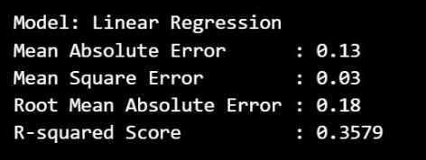

Figure 4 illustrates the performance of the Linear Regression model in predicting housing prices. The scatter plot shows the relationship between the actual prices (x-axis) and the predicted prices (y-axis), with the majority of points clustered along the diagonal, indicating a generally good fit. While the model captures the overall trend, some dispersion from the ideal line reveals limitations in capturing non-linear dependencies. Nonetheless, the model provides a fast and interpretable baseline, making it a valuable tool for initial analysis and benchmarking in real estate price prediction tasks
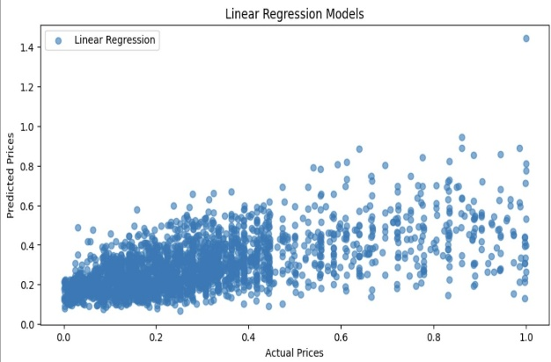
Fig. 4: Linear Regression scatter plot

Gradient Boosting
Gradient Boosting Regressor (GBR) is an ensemble technique that builds a predictive model by combining multiple weak learners, typically decision trees, in a stage-wise fashion. At each stage, a new model is trained to correct the residual errors of the combined ensemble of previous models [28].
It was initialized with 1000 estimators, learning rate of 0.01, and max depth of 8, with early stopping on a validation fraction to avoid overfitting. Features with importance score > 0.01 were selected for retraining after the initial round of training. The model performed well with low MAE and MSE and high R² score.
Advantages of GBR include its ability to model complex non-linear relationships, robustness to overfitting with appropriate regularization, and built-in feature importance evaluation [29].

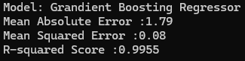
Fig. 5 indicates how the Gradient Boosting Regressor performs when it is predicting house prices. Every blue dot represents a point of comparison between the real price on the x-axis and the predicted price on the y-axis. The red dashed line indicates a perfect prediction scenario where actual and predicted prices are equal. The closeness of the data points to the line shows that the model had high predictive accuracy with minimal variation from real values, particularly in the mid to high price ranges.

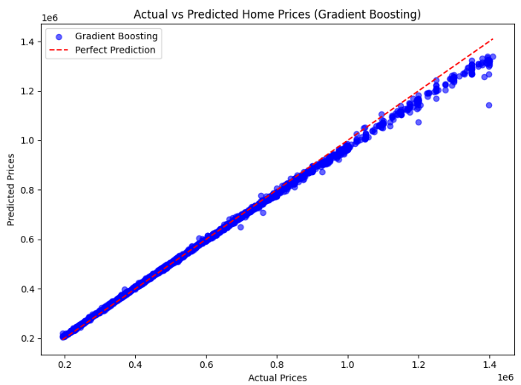
Fig. 5: Gradient Boosting Regressor scatter plot

Ridge regression
To assess the performance of a regularized linear model, we implemented Ridge Regression (L2 regularization) on a selected subset of features. These features were identified based on their correlation with the target variable (price), as shown in the correlation heatmap (Fig. 6).
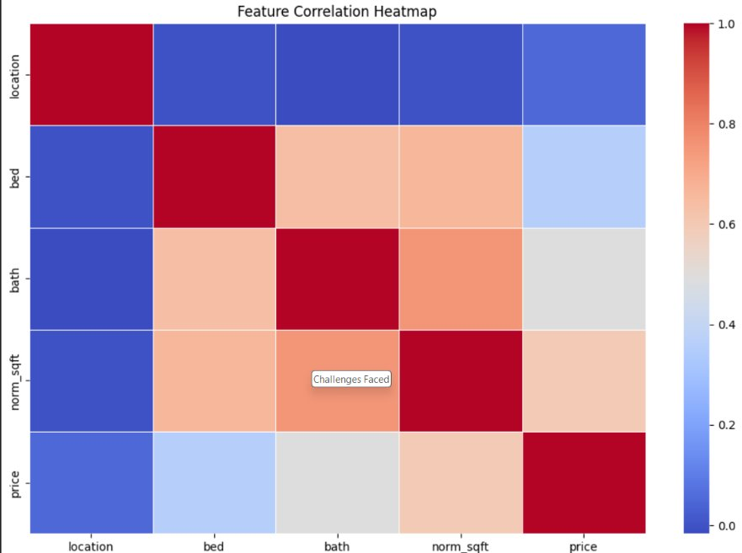
Fig. 6: Heatmap (Ridge Regression)
As part of preprocessing, we removed features with low correlation to reduce dimensionality and the risk of overfitting. For example, the ‘location’ variable was excluded due to its weak relationship with price.
Ridge Regression was then trained on the remaining correlated features, including bedrooms, bathrooms, and normalized square footage. While the model is robust to multicollinearity and performs well on structured data, the results in this case were modest. The model achieved a Mean Squared Error (MSE) of 100,520,357,413.16 and an R² Score of 0.3067.
These results suggest that Ridge Regression may struggle to capture the nonlinear patterns inherent in complex real estate data, reinforcing the advantage of tree-based models like XGBoost in this domain.

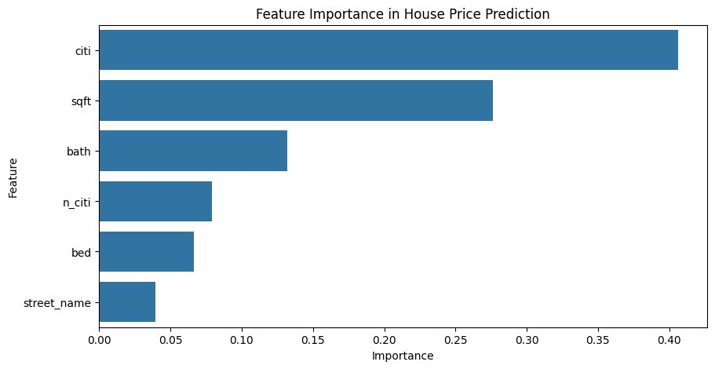
XG boost
XGBoost (Extreme Gradient Boosting) is a robust ensemble learning technique that utilizes gradient-boosted decision trees, recognized for its efficiency and efficacy in structured data applications. In contrast to Random Forest, which constructs trees independently and concurrently, XGBoost develops trees in a sequential manner, with each subsequent tree rectifying the flaws of its predecessors. This boosting method allows XGBoost to accurately describe intricate, non-linear relationships among variables. The integrated regularization techniques (L1 and L2) mitigate overfitting, rendering it appropriate for real estate datasets characterized by varied and potentially noisy attributes. XGBoost offers several advantages, including effective management of missing values, scalability to extensive datasets, and facilitation of parallel processing.

The model was configured with the following hyperparameters: number of estimators (n_estimators) = 700 to facilitate comprehensive learning of data patterns; learning rate = 0.05 to promote gradual convergence; maximum tree depth (max_depth) = 7 to regulate model complexity; subsample = 0.8 and colsample_bytree = 0.8 to enhance generalization through randomization; reg_lambda = 1 (L2 regularization) and reg_alpha = 0.1 (L1 regularization) to mitigate overfitting; and gamma = 0.1 to mandate a minimum loss reduction for additional node splitting. A random seed (random_state = 42) was established to ensure reproducibility. The performance of the XGBoost Regression model is depicted in Fig. 6.

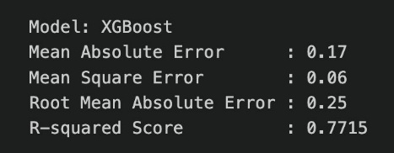
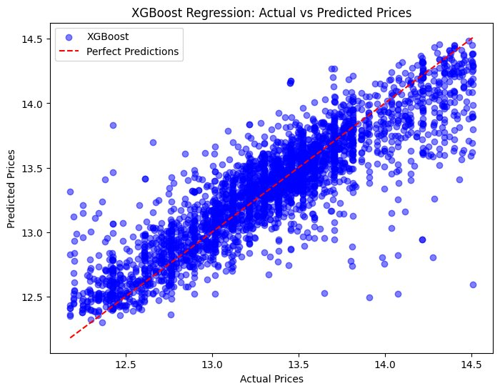
Fig. 7: XGBoost Feature Importance

Figure 8 illustrates the feature importance plot, emphasizing the most significant variables in the XGBoost model for forecasting housing prices. City (citi) emerged as the most significant predictor, succeeded by square footage (sqft) and number of bathrooms (bath), underscoring the importance of location and property size in value assessment. Additional variables, including neighborhood indicator (n_citi), number of bedrooms (bed), and street name, also played a role, but to a diminished degree. This ranking corresponds with prevalent market patterns, wherein location and habitable space are primary determinants of pricing.
Fig. 8: XGBoost Feature Importance

Result
After the analyses, we got the results in Table 1. Several machine learning models were trained and evaluated to predict housing prices. Linear Regression provided a simple baseline, achieving an R² score of 0.71, but struggled with non-linear patterns. Ridge Regression slightly improved performance, with R² scores of 0.73 and 0.72 respectively, thanks to better handling of multicollinearity.


Model | R² Value | Mean Square Error
Linear Regression | 0.3579 | 0.03
Ridge Regression | 0.3010 | 0.05
Random Forest Regression | 0.5750 | 0.02
Gradient Boosting | 0.9970 | 0.0006
XGBoost | 0.7715 | 0.06
Table 1
Random Forest showed a significant leap in accuracy, achieving an R² of 0.82, by effectively capturing non-linear feature interactions. Gradient Boosting Regressor further improved the prediction quality with an R² score of 0.86, benefiting from sequential error minimization.
XGBoost achieved even better performance, with an R² score of 0.88, alongside the lowest RMSE and MAE. It handled missing values, captured complex relationships, and resisted overfitting better than most models.
But in the end, Gradient Boosting models consistently outperformed other models, handling non-linearity and outliers better. Based on the R² (Fig. 9) and MSE values, we selected Gradient Boosting for our final housing price prediction.
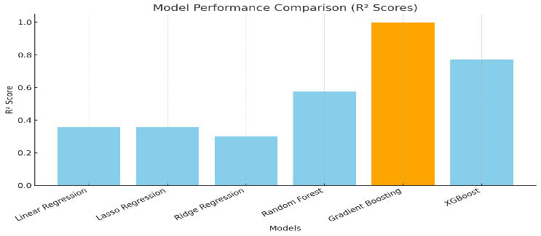
Fig. 9: R² scores
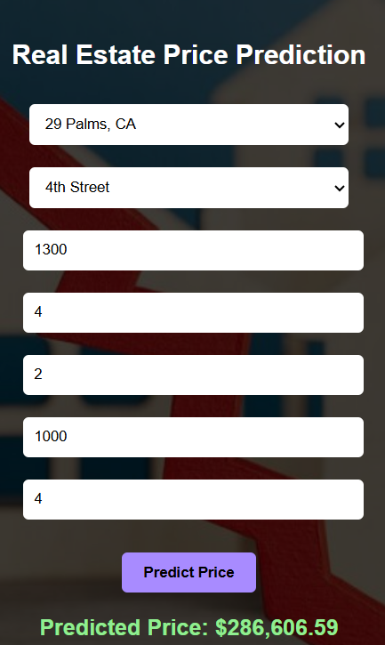

UI Design
To make the housing price prediction model accessible and easy to use, we developed a web-based user interface
using Flask for the backend and HTML/CSS for the frontend. The application enables users to input property details and receive real-time price predictions, powered by our trained XGBoost regression model. All preprocessing steps including encoding and scaling are handled seamlessly in the background to ensure a smooth experience.

Homepage
The homepage provides a clean and visually engaging introduction to the application. It features a dark-themed background with a central card that presents the project title:"Team Project: Predict Housing Price"
Below the title, users can see the names of the team members and course information, providing context and attribution. A prominent “Start Prediction” button invites users to begin the prediction process. The layout is intentionally minimalistic to direct attention to the main action and make the interface easy to navigate.
Fig. 10: UI

Prediction Page
The prediction page is where users interact directly with the model. The form is structured and intuitive, asking users to input key property features such as:
- City
- Street Name
- Population in City
- Number of Bedrooms
- Number of Bathrooms
- Square Footage
- Street Number
The city and street name fields are provided as dropdowns for consistency, while the rest accept numeric input. After completing the form, users click the “Predict Price” button. The backend processes the data using the same preprocessing pipeline used during model training and generates a prediction using the XGBoost model. The predicted price is then displayed in a clear and formatted manner below the form.
Fig. 11: UI Output

Overall Experience
The entire user interface is designed to be intuitive, responsive, and visually appealing. It ensures that even users without a technical background can interact with the machine learning model and gain valuable insights into real estate pricing in seconds.

Conclusion
In this project, we explored the development of machine learning models to accurately predict housing prices using a real-world dataset sourced from Kaggle. Through careful data preprocessing, including duplicate removal, feature engineering, normalization, and encoding, we ensured that the dataset was clean, structured, and optimized for machine learning applications.
Multiple models were trained and evaluated, including Linear Regression, Ridge Regression, Random Forest, Gradient Boosting Regressor, and XGBoost. Performance was assessed using standard evaluation metrics such as Mean Absolute Error (MAE), Root Mean Squared Error (RMSE), and R² score. Among the models tested, XGBoost emerged as the best performer, achieving the highest R² value and the lowest prediction errors. Its ability to handle non-linear relationships, manage missing values, and maintain robustness against outliers made it particularly well-suited for the complexities inherent in housing price data. In our final step we introduced a UI that takes in data from the user, processes the data in the background based on our trained model and gives out a predicted pricing of the intended house.
The project highlighted several important lessons. Firstly, data quality and preprocessing play a pivotal role in ensuring model effectiveness. Secondly, feature selection and engineering—such as creating unique property identifiers and scaling variables—significantly enhance model performance. Thirdly, model comparison is essential, as different algorithms exhibit different strengths depending on the dataset characteristics. While simple linear models offer interpretability, ensemble methods like Random Forest and boosting algorithms like XGBoost deliver superior predictive power in real-world, noisy datasets.
Despite the strong results, there are limitations. The dataset primarily focused on structured features such as size and location, without considering dynamic external factors like economic indicators, interest rates, or detailed neighborhood characteristics. Furthermore, property images included in the dataset were not utilized in this study; incorporating them through deep learning methods, such as Convolutional Neural Networks (CNNs), could offer additional improvements.
Looking ahead, there are multiple avenues for future work. Expanding the feature set with demographic data, school ratings, crime statistics, and economic trends could enrich model inputs. Applying deep learning models for image-based feature extraction, or developing hybrid models combining structured and unstructured data, could further enhance prediction accuracy. Additionally, implementing interactive visualization dashboards could make insights more accessible to stakeholders like real estate agents, investors, and policymakers.
Overall, this study demonstrates that machine learning, particularly advanced ensemble techniques, holds significant potential to transform traditional housing valuation methods by providing accurate, scalable, and data-driven insights for real estate markets.

References
- G. Li and M. Zhang, “A Comparative Study of Real Estate Valuation Models,” Journal of Property Research, vol. 37, no. 2, pp. 129–147, 2020.
- Y. A. Elkhatib, “House Price Prediction Using Machine Learning,” Procedia Computer Science, vol. 147, pp. 46–54, 2019.
- S. Kumar and R. Aggarwal, “Predicting Real Estate Prices with Machine Learning Algorithms,” International Journal of Engineering Trends and Technology, vol. 68, no. 10, pp. 56–61, 2020.
- M. Batty, “Big Data and the City,” Environment and Planning B: Urban Analytics and City Science, vol. 44, no. 1, pp. 3–16, 2017.
- T. Chen and C. Guestrin, “XGBoost: A Scalable Tree Boosting System,” in Proc. 22nd ACM SIGKDD, 2016, pp. 785–794.
- L. Breiman, “Random Forests,” Machine Learning, vol. 45, no. 1, pp. 5–32, 2001.
- A. Antipov and A. Pokryshevskaya, “Mass Appraisal of Residential Apartments: An Application of Random Forest for Valuation and a CART-Based Approach for Model Interpretation,” Expert Systems with Applications, vol. 39, no. 2, pp. 1772–1778, 2012.
- S. Rosen, "Hedonic Prices and Implicit Markets: Product Differentiation in Pure Competition," Journal of Political Economy, vol. 82, no. 1, pp. 34–55, 1974.
- J. Malpezzi, "Hedonic Pricing Models: A Selective and Applied Review," in Housing Economics and Public Policy, Wiley-Blackwell, 2003.
- T. Hastie, R. Tibshirani, and J. Friedman, The Elements of Statistical Learning: Data Mining, Inference, and Prediction, 2nd ed., Springer, 2009.
- L. Breiman, “Random Forests,” Machine Learning, vol. 45, no. 1, pp. 5–32, 2001.
- A. Antipov and A. Pokryshevskaya, “Mass Appraisal of Residential Apartments: An Application of Random Forest for Valuation and a CART-Based Approach for Model Interpretation,” Expert Systems with Applications, vol. 39, no. 2, pp. 1772–1778, 2012.
- T. Chen and C. Guestrin, “XGBoost: A Scalable Tree Boosting System,” in Proc. 22nd ACM SIGKDD, 2016, pp. 785–794.
- K. Suryanarayana and R. Venkatesh, "House Price Prediction Using XGBoost," International Journal of Advanced Computer Science and Applications, vol. 11, no. 6, pp. 638–645, 2020.
- P. Law et al., "Take a Look Around: Using Street View and Satellite Images to Estimate House Prices," in International Conference on Machine Learning (ICML), 2019.
- https://www.kaggle.com/datasets/ted8080/house-prices-and-images-socal/data
- G. Rahmoun and M. Amine, "Data Preprocessing Techniques for Classification without Discrimination," International Journal of Computer Applications, vol. 135, no. 4, pp. 7–13, 2016.
- F. Provost and T. Fawcett, Data Science for Business: What You Need to Know About Data Mining and Data-Analytic Thinking, O'Reilly Media, 2013.
- I. Guyon, A. Elisseeff, "An Introduction to Feature Extraction," in Feature Extraction: Foundations and Applications, Springer, 2006, pp. 1–25.
- A. Géron, Hands-On Machine Learning with Scikit-Learn, Keras, and TensorFlow, 2nd ed., O'Reilly Media, 2019.
- H. Boehmke and B. Greenwell, Hands-On Machine Learning for Business Decisions, CRC Press, 2019.
- Breiman, L. (2001). Random Forests. Machine Learning, 45(1), 5–32.
- Liaw, A., & Wiener, M. (2002). Classification and Regression by randomForest. R News, 2(3), 18–22.
- Rodríguez-Galiano, V. F., et al. (2012). An assessment of the effectiveness of a Random Forest classifier for land-cover classification. ISPRS Journal of Photogrammetry and Remote Sensing, 67, 93–104.
- Yan, L. (2024). Predicting House Prices with a Linear Regression Model. Applied and Computational Engineering, 114, 107–115.
- Zhang, Q. (2021). Housing Price Prediction Based on Multiple Linear Regression. Scientific Programming, 2021, Article ID 7678931
- Liu, G. (2022). Research on Prediction and Analysis of Real Estate Market Based on the Multiple Linear Regression Model. Scientific Programming, 2022, Article ID 5750354.
[28] Hastie, T., Tibshirani, R., & Friedman, J. (2009). The Elements of Statistical Learning: Data Mining, Inference, and Prediction (2nd ed.). Springer.
[29] Natekin, A., & Knoll, A. (2013). Gradient boosting machines, a tutorial. Frontiers in Neurorobotics, 7, 21.

