Video 1

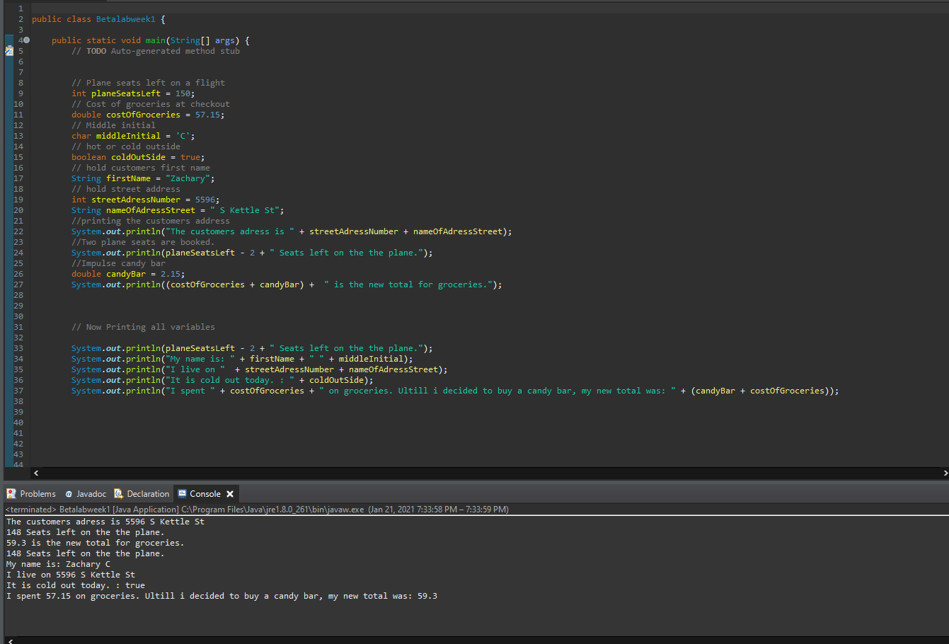

public class Betalabweek1 {

public static void main(String[] args) {

// **TODO** Auto-generated method stub

// Plane seats left on a flight

int planeSeatsLeft = 150;

// Cost of groceries at checkout

double costOfGroceries = 57.15;

// Middle initial

char middleInitial = 'C';

// hot or cold outside

boolean coldOutSide = true;

// hold customers first name

String firstName = "Zachary";

// hold street address

int streetAdressNumber = 5596;

String nameOfAdressStreet = " S Kettle St";

//printing the customers address

System.***out***.println("The customers adress is " + streetAdressNumber + nameOfAdressStreet);

//Two plane seats are booked.

System.***out***.println(planeSeatsLeft - 2 + " Seats left on the the plane.");

//Impulse candy bar

double candyBar = 2.15;

System.***out***.println((costOfGroceries + candyBar) + " is the new total for groceries.");

// Now Printing all variables

System.***out***.println(planeSeatsLeft - 2 + " Seats left on the the plane.");

System.***out***.println("My name is: " + firstName + " " + middleInitial);

System.***out***.println("I live on " + streetAdressNumber + nameOfAdressStreet);

System.***out***.println("It is cold out today. : " + coldOutSide);

System.***out***.println("I spent " + costOfGroceries + " on groceries. Ultill i decided to buy a candy bar, my new total was: " + (candyBar + costOfGroceries));

Result

The customers adress is 5596 S Kettle St

148 Seats left on the the plane.

59.3 is the new total for groceries.

148 Seats left on the the plane.

My name is: Zachary C

I live on 5596 S Kettle St

It is cold out today. : true

I spent 57.15 on groceries. Ultill i decided to buy a candy bar, my new total was: 59.3

Video 2

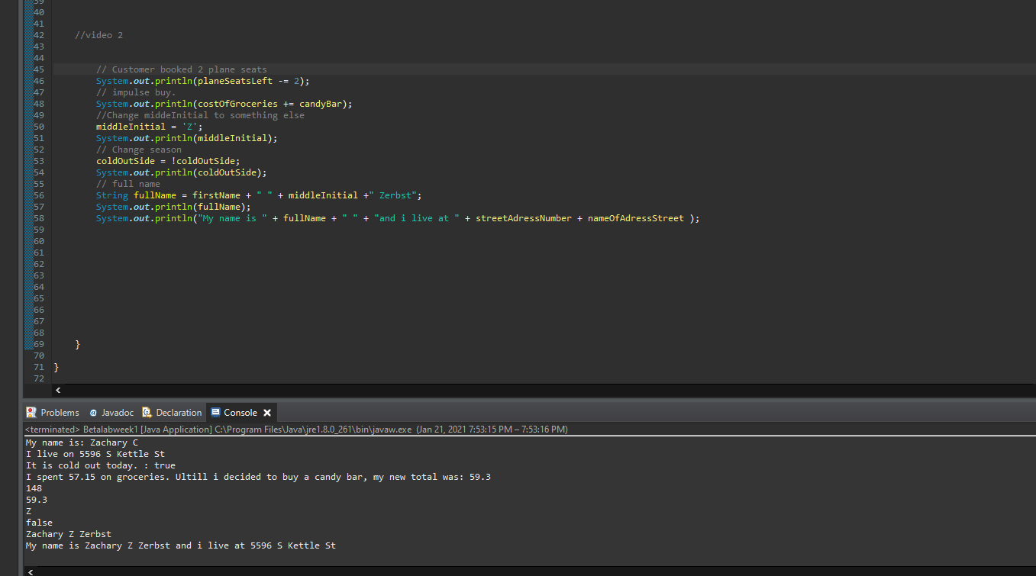

//video 2

// Customer booked 2 plane seats

System.***out***.println(planeSeatsLeft -= 2);

// impulse buy.

System.***out***.println(costOfGroceries += candyBar);

//Change middeInitial to something else

middleInitial = 'Z';

System.***out***.println(middleInitial);

// Change season

coldOutSide = !coldOutSide;

System.***out***.println(coldOutSide);

// full name

String fullName = firstName + " " + middleInitial +" Zerbst";

System.***out***.println(fullName);

System.***out***.println("My name is " + fullName + " " + "and i live at " + streetAdressNumber + nameOfAdressStreet );

Result

148

59.3

Z

false

Zachary Z Zerbst

My name is Zachary Z Zerbst and i live at 5596 S Kettle St

GIT LINK

https://github.com/ZachZ22/week1lab