

Computer Vision

Homework 3

Student name : Wang Huai – Mu

ID : 606415050

TA : **Tran, Van Luan**

In this , I will made a brief of descriptions my project (step by step).

**Roberts Cross Edge Detector**

These kernels are designed to respond maximally to edges running at 45° to the pixel grid, one kernel for each of the two perpendicular orientations. The kernels can be applied separately to the input image, to produce separate measurements of the gradient component in each orientation (call these Gx and Gy). These can then be combined together to find the absolute magnitude of the gradient at each point and the orientation of that gradient. The gradient magnitude is given by:



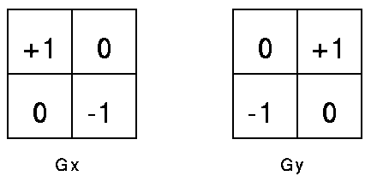

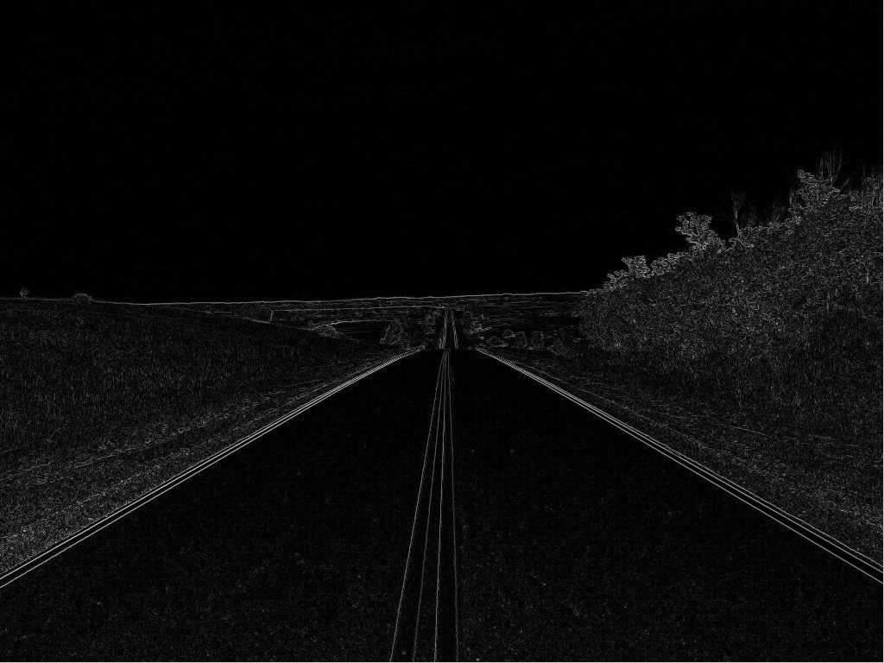 

# Prewitt Edge Detector

The Prewitt operator is based on convolving the image with a small, separable, and integer valued filter in horizontal and vertical directions

{\displaystyle \mathbf {G_{x}} }Gx and Gy {\displaystyle \mathbf {G_{y}} }GGGare two images which at each point contain the horizontal and vertical derivative approximations, the latter are computed as:

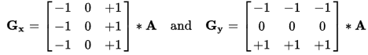



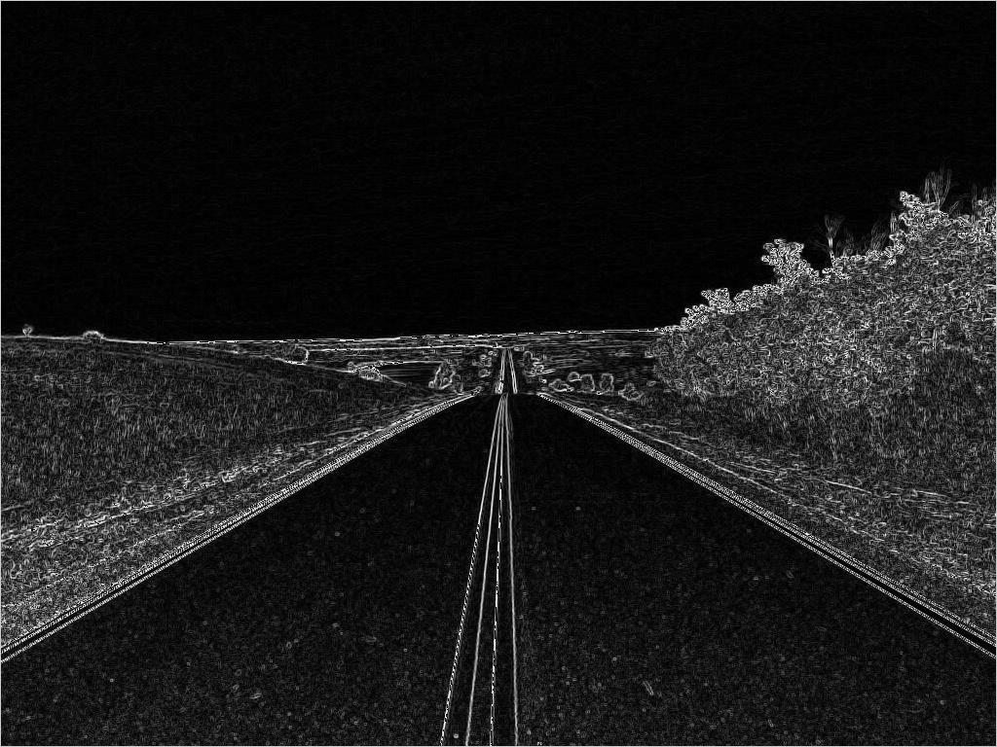 

# Sobel Edge Detector

The Sobel operator performs a 2-D spatial gradient measurement on an image and so emphasizes regions of high spatial frequency that correspond to edges

In theory at least, the operator consists of a pair of 3×3 convolution kernels as shown in Figure 1. One kernel is simply the other rotated by 90°. This is very similar to the Roberts Cross operator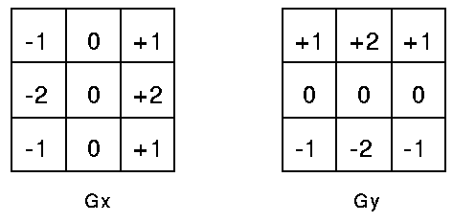

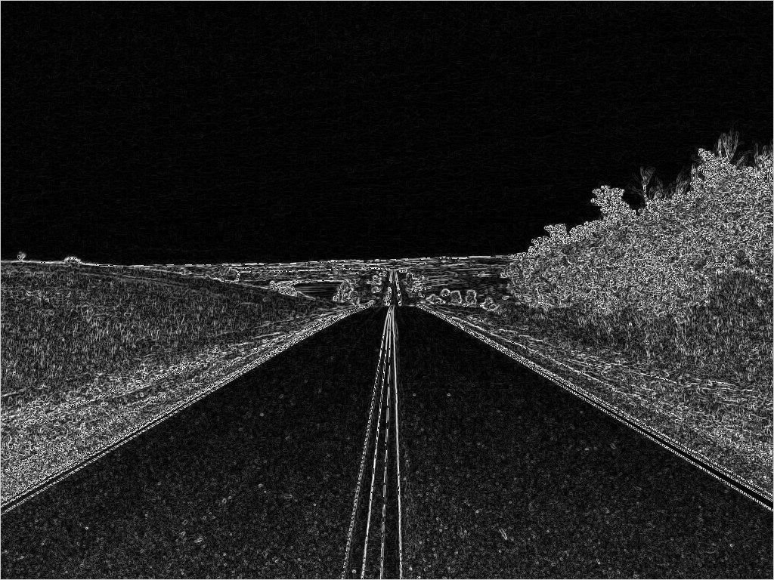 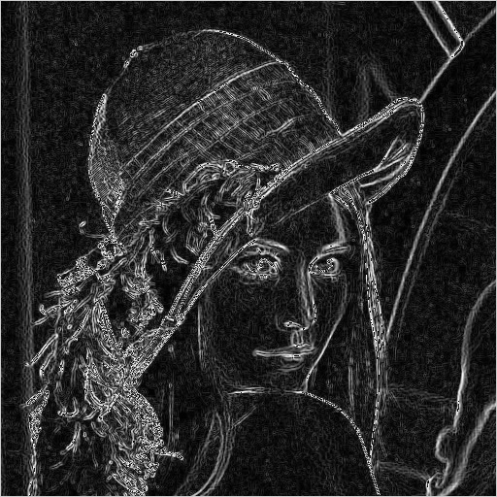

# Canny Edge Detector

The Canny operator works in a multi-stage process. First of all the image is smoothed by Gaussian convolution. Then a simple 2-D first derivative operator (somewhat like the Sobel Cross) is applied to the smoothed image to highlight regions of the image with high first spatial derivatives. Edges give rise to ridges in the gradient magnitude image. The algorithm then tracks along the top of these ridges and sets to zero all pixels that are not actually on the ridge top so as to give a thin line in the output, a process known as non-maximal suppression. The tracking process exhibits hysteresis controlled by two thresholds: TH and TL. Tracking can only begin at a point on a ridge higher than TH. Tracking then continues in both directions out from that point until the height of the ridge falls below TL. This hysteresis helps to ensure that noisy edges are not broken up into multiple edge fragments.

TH = 100 ,TL = 50

