MZ MOLEFE
| 29088089
CMPG313 practical3
8 Puzzle game documentation

Contents
Introduction 3
Heuristics 3
Accuracy and precision 3
Execution time 3
Algorithms 3
The game is 8 puzzle 4
The game GUI explained 4
Steps of running the game 4
Step 1 4
Step 2 5
Step 3 5
Step 5 6
Step 6 7
Reflections of building the game 7
Screen shot of what was difficult 7
Screen shot of the most easiest part 8
Overall Reflections 9
References 10

Introduction

The 8/9/15 puzzle is a game that contains series of code. This game requires some level of intelligence in terms of certain algorithms and heuristics.
To explain this game, we going to start with the origin of the game. This game dates to the 1870s. it was designed and invented by Noyes Palmer Chapman. In the making of this game he was showing his friends what he came with. This game was furthered by his son Frank.
There is confusion on who first came with the game, Sam Loyd also claimed on inventing the game, he also even made an encyclopaedia calming so, though it can’t be proved that he came with the game because he started claiming it in the 1890s.
The game contains two basics heuristics and algorithms. To further explain the game, we are going to look at these topics respectively with source code from the game. The game has a lot of possible positions, that can be called a God’s number. In an 8-puzzle the number is 9!/2 .

Heuristics

Heuristics is a technique designed for solving a problem more quickly when classic methods are too slow, or for finding an approximate solution when classic methods fail to find any exact solution. Another example of heuristic making an algorithm faster occurs in certain search problems. Initially, the heuristic tries every possibility at each step, like the full-space search algorithm. But it can stop the search at any time if the current possibility is already worse than the best solution already found. In such search problems, a heuristic can be used to try good choices first so that bad paths can be eliminated early. In the case of best-first search algorithms. (Anon. 2020). Wikipedia

Accuracy and precision

Heuristics are accurate at search and have the O(n) time which is what makes it precise at synthetics and running of the program.

Execution time

Some heuristics converge faster than others. Some heuristics are only marginally quicker than classic methods.

Algorithms

Algorithms are a set of finite sequence of well-defined, computer-implementable instructions, typically to solve a class of problems or to perform a computation. These algorithms are used for specific tasks such as arithmetic calculations, data processing and most automated reasoning.

The game is 8 puzzle

I have built this game using Java, as it is the language, I am familiar with and because of my computer is running on Linux.
Java is a object orientated programming language that makes it easier to build applications such as games. I have used java libraries such as swing and awt to build the GUI of the game
Screenshot of first page after loading the run.bat file.


The game GUI explained

Steps of running the game

Step 1

In the folder MOLEFE_MZ_29088089_CMPG313_Practical3 there is a run.bat file for Windows users to run, after executing this file the game files will compile and the game will run. For linux users open terminal in the game folder then execute “javac *.java” command to compile every java class in the folder, to run the game execute the “java Launcher” command to start the game. The GUI above will load after this.

Step 2

On the top panel of the GUI there is a add button to add a picture to the game.
This button loads a GUI class to the game that helps the user to add an image they want to the game.

Step 3
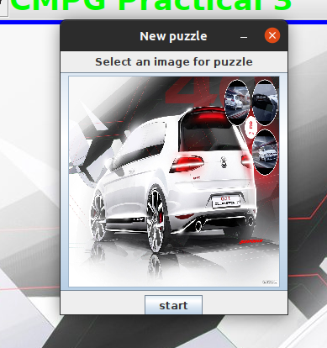
The user must select the picture button (the Golf GTI) to add a new image that will load the following GUI class.

Step 4

The user must navigate to the /.../MOLEFE_MZ_29088089_CMPG313_Practical3/src directory and select the capture.PNG to load the following GUI that is the game.

Step 5
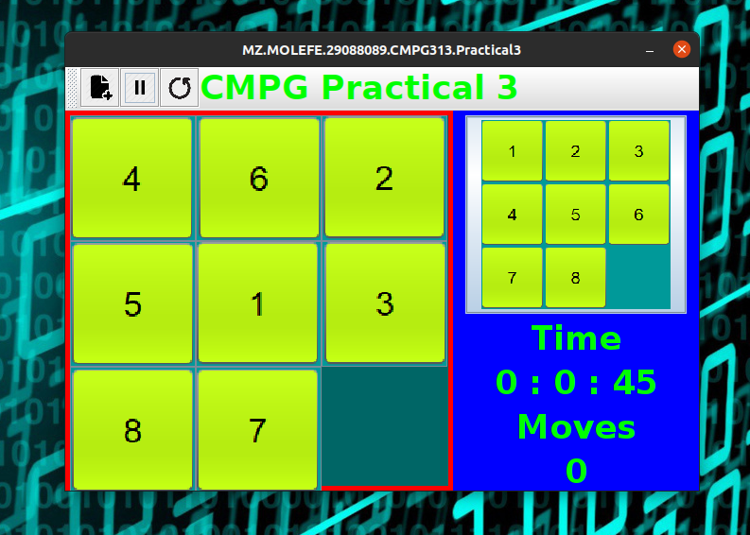
The user must play the scrambled puzzle and make it look like the picture on the right panel. The game keeps track of number of moves and the time the user takes to play the game.

Step 6
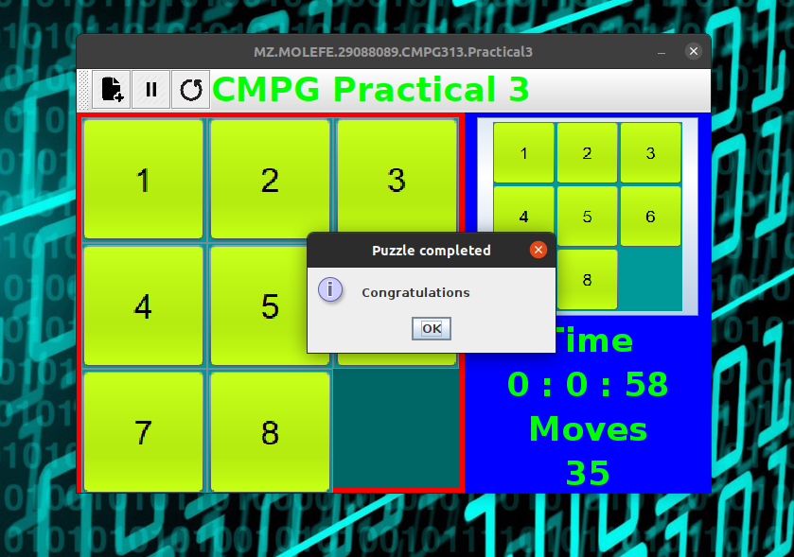
Once the user has unscrambled the puzzle on the left panel, the puzzle will be completed, and the win condition will be shown to the user.

Reflections of building the game

The game was difficult in designing, it was difficult following the directions given by the lecturer. I couldn’t place a CSV file as instructed since i found it hard. The game is fully functional and is platform independent since I used Java programming language to build it. Java was very nice to work with since I am familiar with the language. I chose Java also because I want to be a Java developer. Java is an awesome language with awesome libraries. The thing I found difficult with Java was adding the image, which i had to do it using two classes.

Screen shot of what was difficult

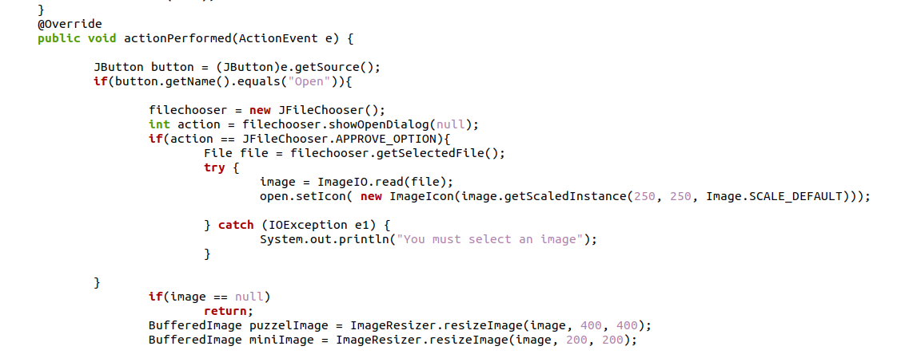
(Anon. 2020) Geeksforgeeks
It was hard adding an image with a normal Java implementation. The code above is what I had to do. I added a JfileChooser which was my first time using it, I had to go to stack overflow to understand how it works. The implementation of BufferedImage I had to use Geeksforgeeks to understand it.

Screen shot of the most easiest part

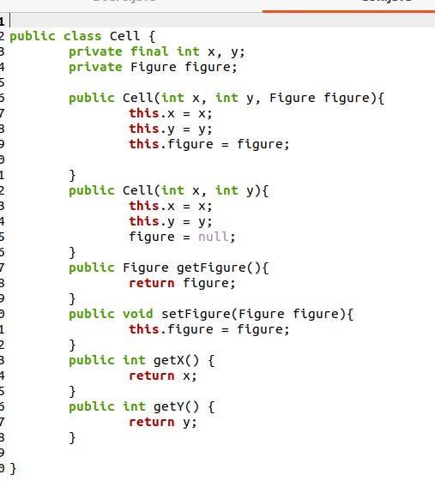

It was easy coding the Cell class because it was the repeat of what i did in the class of ITRW211 Java Programming, its a class with accessors methods. These methods are used to maintain the structure of the puzzle, the position at which the picture is placed and moved around.

Overall Reflections
It was a fun experience making the game and making people at home play it.

References

Anon. 2020. Geeksforgeeks https://www.geeksforgeeks.org/java-io-bufferedreader-class-java date of access: 24 May. 2020.
Anon. 2020. Wikipedia. https://en.wikipedia.org/wiki/15_puzzle date access: 29 May. 2020.
Indu Joshi. 2020. stack overflow https://stackoverflow.com/questions/12231453/syntax-for-creating-a-two-dimensional-array date of access: 30 May. 2020.

