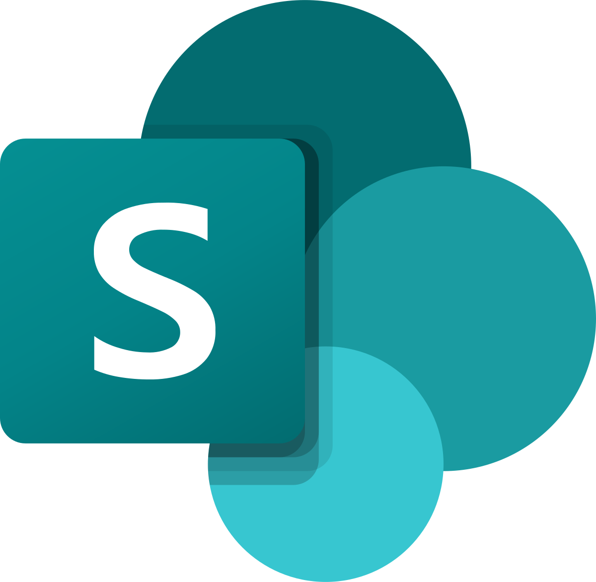

SharePoint Dev

Mockapp

Intern

# Introduction

An Intern MockApp

* We were handed an assignment to test our understanding and knowledge in PowerApps.
* We started leaning SharePoint which is a base of PowerApps (I think).
* In SharePoint we learned how to make lists (data tables).
* We used the lists in PowerApps same way we connect to a database.

# Development

Our mentor, MR Ross, has been helping us through the development of the MockApp

We developed the same application in different ways. We are being trained to be Junior Developers in SharePoint.

My Application feature 6 screens which are:-

HomeScreen – A welcome screen that displays the user name, a logout function and a button to carry on to the navigation screen which is nav.

Nav – A screen that a user can navigate to 3 below screens.

Hours – This screen a user can add their own overtime hours as well as normal working hours for the day.

My Hours – This screen displays the users own hours and overtime hours, the user can also edit their own hours or delete

Overtime – Here the user views the number of overtime entries they’ve made (other functions not working according to logic implemented)

SuccessScreen – This is the screen the user will see after adding hours. This screen navigates to HomeScreen