Zachary Bensley

2/18/2014

**Project 1**

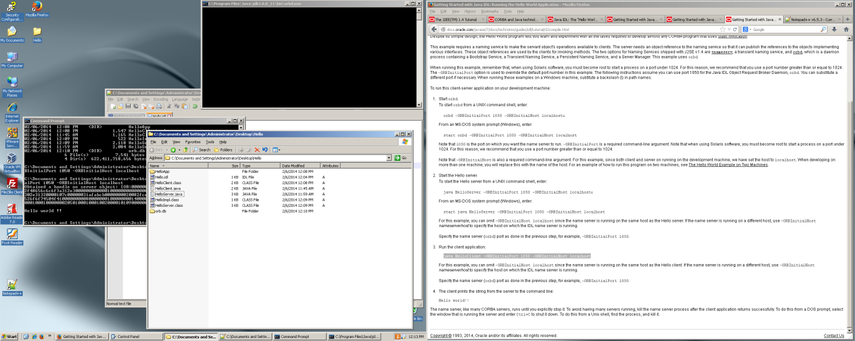

**Project 2**

<http://docs.oracle.com/javase/7/docs/technotes/guides/idl/tutorial/jidl2machines.html>

http://docs.oracle.com/javase/7/docs/technotes/guides/idl/jidlExample.html

**Client Screen**

**-The servername was sent to the server’s computer name**

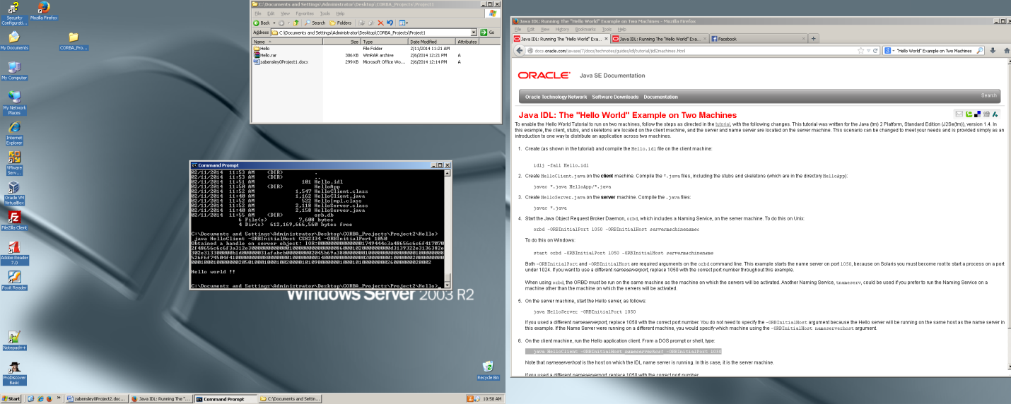

**Server Screen**

**-The servername was set to localhost**

