杉达学院
数据结构
实 验 任 务 书

学号： F16011709
姓名： 成子彦

日期：2018年5月11日
17学年—18学年第 2 学期 数据结构实验任务书
专业名称： 软件工程 实验学时： 4
课程名称：数据结构 任课教师： 林士玮
实验题目： 二叉树的基本操作
实验环境： GNU g++ 7.3 (C++17, Linux)
实验目的：
1．掌握二叉树的定义；
2．掌握二叉树的基本操作，如二叉树的建立、遍历、结点个数统计、树的深度计算等。
实验内容：
用递归的方法实现以下算法：
1．以二叉链表表示二叉树，建立一棵二叉树（算法5.3）；
2．输出二叉树的中序遍历结果（算法5.1）；
3．输出二叉树的前序遍历结果（见PPT讲稿）；
4．输出二叉树的后序遍历结果（见PPT讲稿）；
5．计算二叉树的深度（算法5.5）；
6．统计二叉树的结点个数（算法5.6）；
7．统计二叉树的叶结点个数；
8．统计二叉树的度为1的结点个数；
9．输出二叉树中从每个叶子结点到根结点的路径。

选做内容
1．交换二叉树每个结点的左孩子和右孩子；
2．设计二叉树的双序遍历(DblOrderTraverse)算法（双序遍历是指对于二叉树的每一个结点来说，先访问这个结点，再按双序遍历它的左子树，然后再一次访问这个结点，接下来按双序遍历它的右子树）。

实验提示：
7．统计二叉树的叶结点个数
int LeafNodeCount(BiTree T ){
如果是空树，则叶子个数为0;
如果是叶子结点，则叶子结点个数为1（如何表示叶子结点？？？）
否则叶结点个数为左子树的叶结点个数+右子树的叶结点个数
}
实验要求：
(1) 程序要具在一定的健壮性，即当输入数据非法时，程序也能适当地做出反应。
(2) 程序要添加适当的注释，程序的书写要采用缩进格式。
(3) 根据实验报告模板详细书写实验报告,上交一份实验报告打印稿。
(4) 源程序保存为“sy2.cpp”，实验报告命名为“实验报告2.doc”。将这两个文件压缩为一个文件，按以下方式命名：学号姓名.rar，上传到ftp的相应班级所在文件夹。

实验结果：
注：请将实验截图复制在下面，截图可以采用Alt+PrtScr获得。
实验截图：
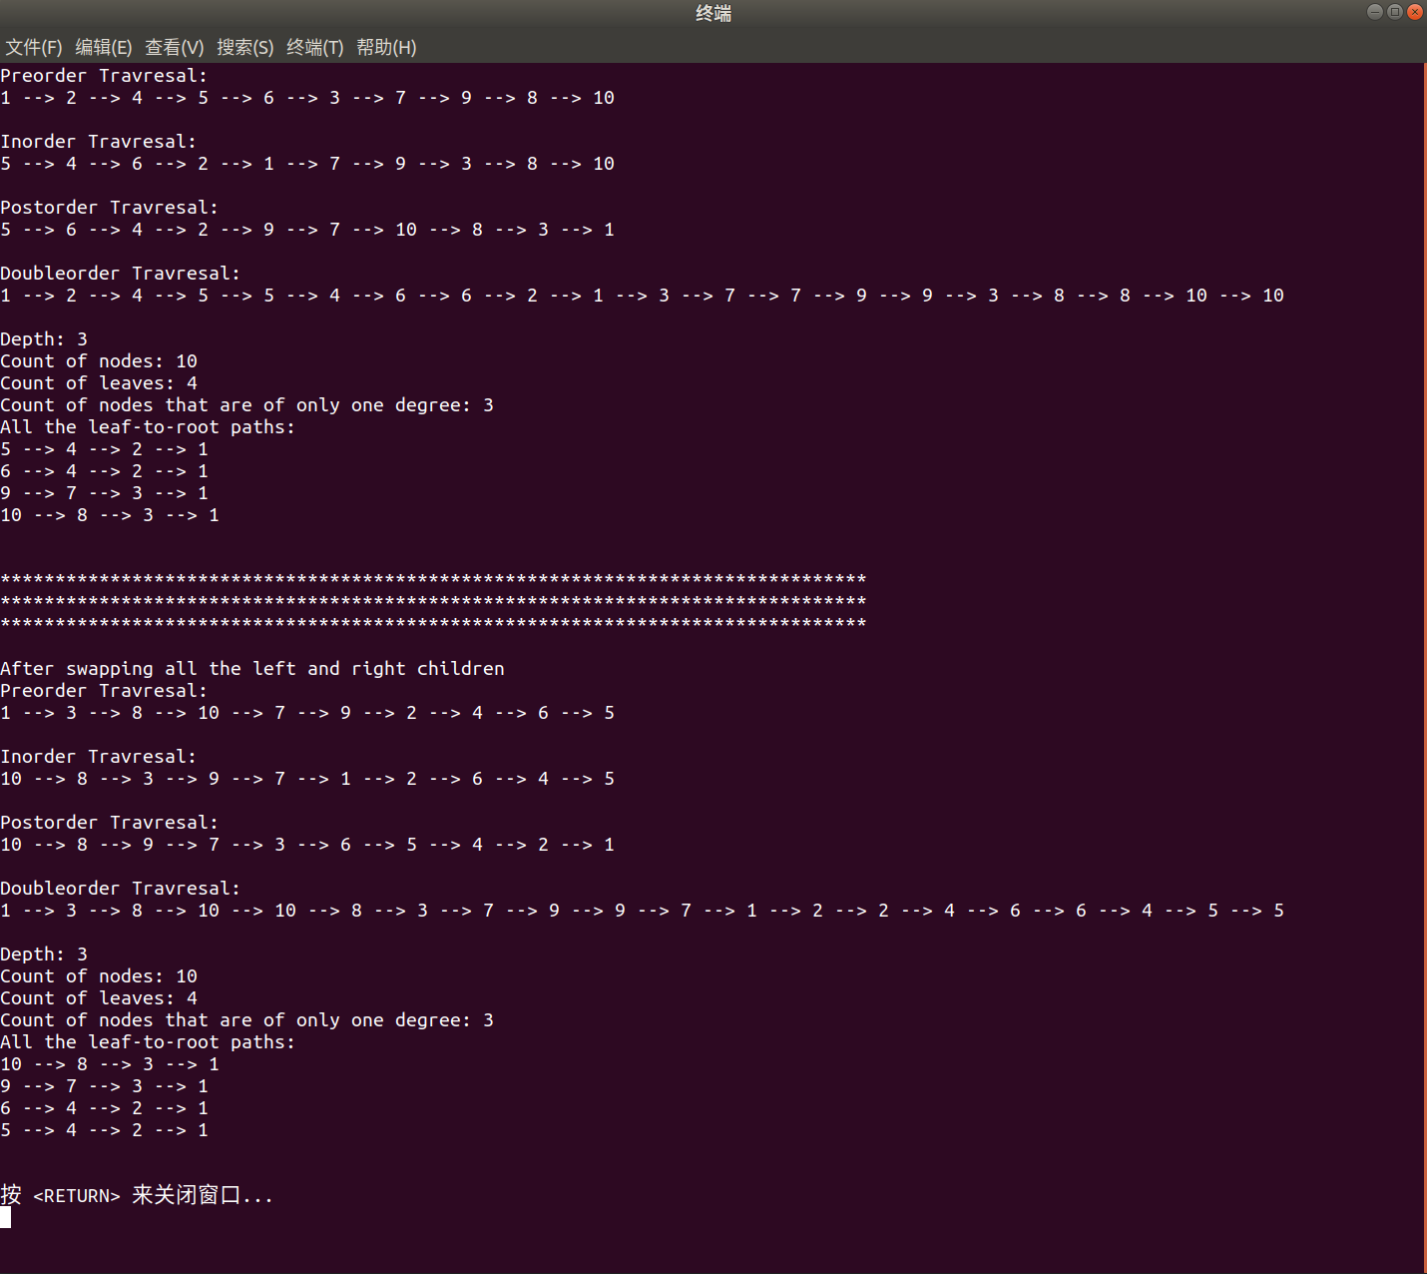

实验源代码：
(BinaryTree.h + main.cpp)
****************BinaryTree.h*********************
// BinaryTree.h
#ifndef BINARY_TREE_H
#define BINARY_TREE_H
/*
* Construct a BinaryTree.
*
* ********************************** Preliminaries *********************************
* We set the leaf's height as 0, and the root's depth is 0 vice versa.
*
* ********************************** Functions *************************************
* void makeEmpty() --> Make the tree empty
* void preorderTraverse() const --> Preorder traversal
* void inorderTraverse() const --> Inorder Traversal
* void postorderTraverse() const --> Postorder Traversal
* int depth() const --> Return the depth
* size_t countNodes() const --> Return the count of all the nodes
* size_t countLeaves() const --> Return the count of all the leaves
* size_t countNodesOfOneDegree() const --> Return one degree nodes' count
* void printLeafToRootPath() const --> Print leaf-to-root path
* void swapLeftAndRightChild() --> Swap the tree's left and right child
* void doubleorderTrraverse() const --> Doubleorder traversal
*
* **********************************************************************************
*/
#include <iostream>
#include <algorithm>
#include <stack>
using std::stack;
template <typename Comparable>
class BinaryTree {
public:
// The Node class of the tree.
struct Node {
Comparable element {};
Node* left {};
Node* right {};
Node(const Comparable ele = Comparable {}, Node* lt = nullptr, Node* rt = nullptr)
: element {ele}, left {lt}, right {rt} {}
};
// Root of the tree.
Node* root {};
private:
// Internal method to make the subtree empty.
void makeEmpty(Node*& rt) {
if ( !rt) {
return;
}
makeEmpty(rt->left);
makeEmpty(rt->right);
delete rt;
rt = nullptr;
}
// Internal method to determine if a node is a leaf.
bool isLeaf(Node* rt) const {
if ( !rt->left && !rt->right) {
return true;
}
return false;
}
// Internal method to traverse the subtree preorderly.
void preorderTraverse(Node* rt) const {
if ( !rt) {
return;
}
std::cout << rt->element << " --> ";
preorderTraverse(rt->left);
preorderTraverse(rt->right);
}
// Internal method to traverse the subtree inorderly.
void inorderTraverse(Node* rt) const {
if ( !rt) {
return;
}
inorderTraverse(rt->left);
std::cout << rt->element << " --> ";
inorderTraverse(rt->right);
}
// Internal method to traverse the subtree postorderly.
void postorderTraverse(Node* rt) const {
if ( !rt) {
return;
}
postorderTraverse(rt->left);
postorderTraverse(rt->right);
std::cout << rt->element << " --> ";
}
// Internal method to calculate the subtree's height.
// Return the subtree's height if the subtree exists,
// and -1 vice versa.
/*
* For convenience, we set the leaf's height as 0.
*/
int height(Node* rt) const {
if ( !rt) {
return -1;
}
return std::max(height(rt->left), height(rt->right) ) + 1;
}
// Internal method to count the subtree's nodes.
size_t countNodes(Node* rt) const {
if ( !rt) {
return 0;
}
return countNodes(rt->left) + countNodes(rt->right) + 1;
}
// Internal method to count the subtree's leaves.
size_t countLeaves(Node* rt) const {
if ( !rt) {
return 0;
}
if (isLeaf(rt) ) {
return 1;
}
return countLeaves(rt->left) + countLeaves(rt->right);
}
// Internal method to count the subtree's nodes that are only of 1 degree.
size_t countNodesOfOneDegree(Node* rt) const {
if ( !rt) {
return 0;
}
size_t count {};
if ( (rt->left && !rt->right) || ( !rt->left && rt->right) ) {
count++;
}
count += countNodesOfOneDegree(rt->left) + countNodesOfOneDegree(rt->right);
return count;
}
// Auxiliary method to print the stack.
void printPath(stack<Comparable> stk) const {
while ( !stk.empty() ) {
std::cout << stk.top() << " --> ";
stk.pop();
}
// Remove the last " --> ".
std::cout << "\b\b\b\b\b ";
std::cout << std::endl;
}
// Internal method to print the subtree's leaf-to-root path.
// Use a stack to reverse the path.
void printLeafToRootPath(Node* rt, stack<Comparable>& stk) const {
if ( !rt) {
return;
}
stk.push(rt->element);
if (isLeaf(rt) ) {
printPath(stk);
} else {
// Temporary stacks for the recursives.
stack<Comparable> stk1 {stk};
stack<Comparable> stk2 {stk};
printLeafToRootPath(rt->left, stk1);
printLeafToRootPath(rt->right, stk2);
}
}
// Internal method to swap all the nodes' left child and right child.
void swapLeftAndRightChild(Node* rt) {
if ( !rt) {
return;
}
std::swap(rt->left, rt->right);
swapLeftAndRightChild(rt->left);
swapLeftAndRightChild(rt->right);
}
// Internal method to traverse the subtree by doubleorder.
void doubleorderTraverse(Node* rt) const {
if ( !rt) return;
std::cout << rt->element << " --> ";
doubleorderTraverse(rt->left);
std::cout << rt->element << " --> ";
doubleorderTraverse(rt->right);
}
public:
// Non-parameter constructor.
BinaryTree(Node* rt = nullptr) : root {rt} {}
// Destructor.
~BinaryTree() {
makeEmpty();
}
// Make the tree empty.
void makeEmpty() {
makeEmpty(root);
}
// Preorder traverse the tree.
void preorderTraverse() const {
preorderTraverse(root);
// Remove the last " --> "
std::cout << "\b\b\b\b\b ";
std::cout << std::endl;
}
// Inorder traverse the tree.
void inorderTraverse() const {
inorderTraverse(root);
// Remove the last " --> "
std::cout << "\b\b\b\b\b ";
std::cout << std::endl;
}
// Postorder traverse the tree.
void postorderTraverse() const {
postorderTraverse(root);
// Remove the last " --> "
std::cout << "\b\b\b\b\b ";
std::cout << std::endl;
}
// Return the tree's depth if the tree exists,
// and -1 vice versa.
int depth() const {
return height(root);
}
// Return the nodes' count in the tree.
size_t countNodes() const {
return countNodes(root);
}
// Return the leaves' count in the tree.
size_t countLeaves() const {
return countLeaves(root);
}
// Return the count of the nodes that are of only one degree in the tree.
size_t countNodesOfOneDegree() const {
return countNodesOfOneDegree(root);
}
// Print the leaf-to-root path.
void printLeafToRootPath() const {
stack<Comparable> stk;
printLeafToRootPath(root, stk);
}
// Swap all the Nodes' left and right child in the tree.
void swapLeftAndRightChild() {
swapLeftAndRightChild(root);
}
// Doubleorder traversal.
void doubleorderTraverse() const {
doubleorderTraverse(root);
// Remove the last " --> "
std::cout << "\b\b\b\b\b ";
std::cout << std::endl;
}
};
#endif

*****************main.cpp************************
// main.cpp
// Drive unit to test "BinaryTree.h"
/*
* we create a tree as below:
* 1
* / \
* 2 3
* / / \
* 4 7 8
* / \ \ \
* 5 6 9 10
*
* Then print the tree using preorder traversal, inorder traversal,
* postorder traversal and doubleorder traversal respectively.
*
* Expective Output
* Preorder traversal: 1 --> 2 --> 4 --> 5 --> 6 --> 3 --> 7 --> 9 --> 8 --> 10
* Inorder Traversal: 5 --> 4 --> 6 --> 2 --> 1 --> 7 --> 9 --> 3 --> 8 --> 10
* Postorder Traversal: 5 --> 6 --> 4 --> 2 --> 9 --> 7 --> 10 --> 8 --> 3 --> 1
* Doubleorder Traversal: 1 --> 2 --> 4 --> 5 --> 5 --> 4 --> 6 --> 6 --> 2 -->
* 1 --> 3 --> 7 --> 7 --> 9 --> 9 --> 3 --> 8 --> 8 --> 10 --> 10
*
*
* After swapping all the left and right child in the tree, it might be as below:
* 1
* / \
* 3 2
* / \ \
* 8 7 4
* / / / \
* 10 9 6 5
*
* And all the requirements are CORRECT!
*/
#include <iostream>
#include "BinaryTree.h"
using Node = BinaryTree<int>::Node;
int main() {
// Construct a tree.
BinaryTree<int> bT;
auto* p5 {new Node {5} };
auto* p6 {new Node {6} };
auto* p9 {new Node {9} };
auto* p10 {new Node {10} };
auto* p4 {new Node {4, p5, p6} };
auto* p7 {new Node {7, nullptr, p9} };
auto* p8 {new Node {8, nullptr, p10} };
auto* p2 {new Node {2, p4} };
auto* p3 {new Node {3, p7, p8} };
auto* p1 {new Node {1, p2, p3} };
bT.root = p1;
// Accomplish constructing.
std::cout << "Preorder Travresal:\n";
bT.preorderTraverse();
std::cout << std::endl;
std::cout << "Inorder Travresal:\n";
bT.inorderTraverse();
std::cout << std::endl;
std::cout << "Postorder Travresal:\n";
bT.postorderTraverse();
std::cout << std::endl;
std::cout << "Doubleorder Travresal:\n";
bT.doubleorderTraverse();
std::cout << std::endl;
std::cout << "Depth: ";
std::cout << bT.depth();
std::cout << std::endl;
std::cout << "Count of nodes: ";
std::cout << bT.countNodes();
std::cout << std::endl;
std::cout << "Count of leaves: ";
std::cout << bT.countLeaves();
std::cout << std::endl;
std::cout << "Count of nodes that are of only one degree: ";
std::cout << bT.countNodesOfOneDegree();
std::cout << std::endl;
std::cout << "All the leaf-to-root paths:\n";
bT.printLeafToRootPath();
std::cout << std::endl << std::endl;
// Swap all the left and right child.
bT.swapLeftAndRightChild();
std::cout << "*******************************************************************************\n";
std::cout << "*******************************************************************************\n";
std::cout << "*******************************************************************************\n\n";
std::cout << "After swapping all the left and right children\n";
std::cout << "Preorder Travresal:\n";
bT.preorderTraverse();
std::cout << std::endl;
std::cout << "Inorder Travresal:\n";
bT.inorderTraverse();
std::cout << std::endl;
std::cout << "Postorder Travresal:\n";
bT.postorderTraverse();
std::cout << std::endl;
std::cout << "Doubleorder Travresal:\n";
bT.doubleorderTraverse();
std::cout << std::endl;
std::cout << "Depth: ";
std::cout << bT.depth();
std::cout << std::endl;
std::cout << "Count of nodes: ";
std::cout << bT.countNodes();
std::cout << std::endl;
std::cout << "Count of leaves: ";
std::cout << bT.countLeaves();
std::cout << std::endl;
std::cout << "Count of nodes that are of only one degree: ";
std::cout << bT.countNodesOfOneDegree();
std::cout << std::endl;
std::cout << "All the leaf-to-root paths:\n";
bT.printLeafToRootPath();
std::cout << std::endl << std::endl;
}

