1) Here is a research article that claims to be able to predict the future point production per NBA legend almost to a T. The most interesting part for me was the appendix, which has the breakdown of the NBA advanced metric formulas for 2012
http://www.sloansportsconference.com/wp-content/uploads/2012/02/46-Forecasting-NBA-Player-Performance_DouglasHwang.pdf

2) Wins above replacement article regarding creating an advanced overall efficiency metric
https://en.wikipedia.org/wiki/Wins_Above_Replacement

3) This website has all of the necessary statistics to conduct a thorough analysis on players advanced stats, etc.
http://www.nbaminer.com/player-trackings/

4) More about predicting overall career likelihood or failure
http://fivethirtyeight.com/features/how-were-predicting-nba-player-career/

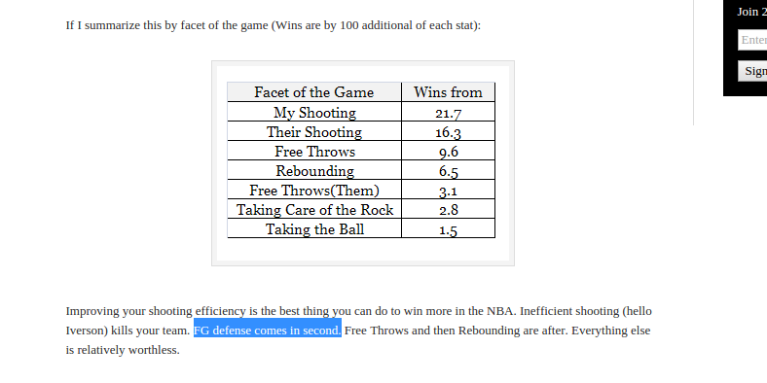
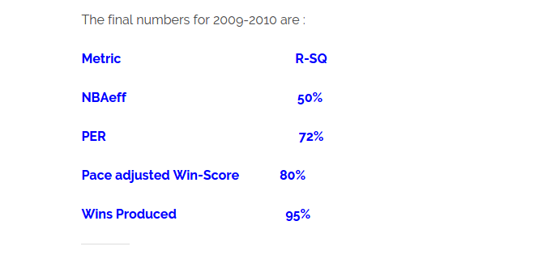

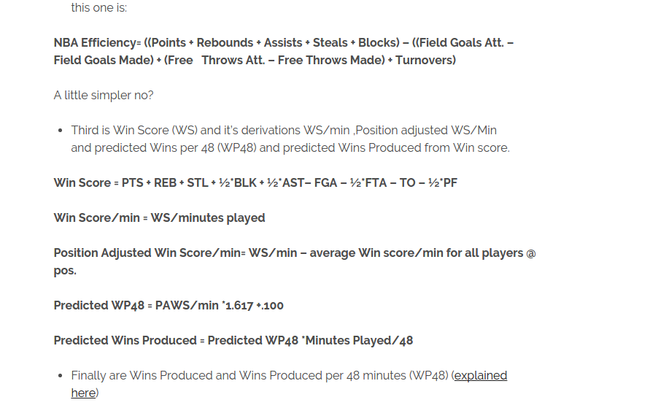
In terms of measuring defense of a specific team, maybe we can generate heat maps to determine the weakest position on the floor for a given team by utilizing the location of the shots generally taken against them which were scored (we can then associate a given value to those areas for example if it is a certain distance passed the three pt line then it may be given a high value or within a short distance from the hoop you give it a particularly high value, therefore whoever has the highest value is at the most risk of being scored on).

Maybe think about defense now in terms of guarding the 3 point area – for example how do you stop Stephan Curry? Or is that too specific? Considering his 3 point percentage is likely higher than compared to the average percentage. What percentage of the top teams have a high three point percentage?

How does pace play into defense? Like what role does it play? Are teams who play at a higher/faster pace more likely to have a higher defensive ranking? Maybe use some type of dimensionality reduction to remove the variables with the least amount of effective information for certain datasets

Must merge certain data sets in order to maximize the amount of information gained

Are we allowed to use stackoverflow, obviously not with the specific data, but in the general regard to ask certain questions if we have trouble coding

What is the true downfall of R

http://www.cbssports.com/nba/news/predicting-the-best-defensive-teams-in-the-nba-for-2016-17-season/

Maybe the way to go about whatever task we are given, decide which metrics are important for a particular model, create a specific “database” and/or table instance with the specified data, make sure data has been cleaned, then begin using it for calculations and graphical outputs.

Main two questions: What metrics do we use, and why? And what type of analysis do we use? And why?

