**CSE 212 – Programming with Data Structures**

**W01 Prove – Response Document**

|  |  |
| --- | --- |
| **Name:** | Zach Newby |
| **Date:** | September 16, 2023 |
| **Teacher:** | Zachariah Alvey |

*It is a violation of BYU-Idaho Honor Code to post or share this document with others or to post it online. Storage into a personal and private repository (e.g. private GitHub repository, unshared Google Drive folder) is acceptable.*

**Question 1: For the rotate right problem, provide a description of how you solved the problem.**

**For the desired number of numbers “rotated” I removed the number at the end of the list and inserted it at the first index.**

**Question 2: For the rotate right problem, draw a picture of how you solved the problem.**









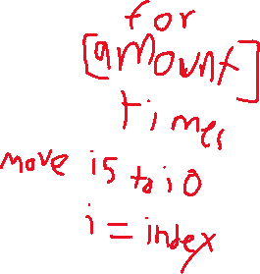

Remember: You need to submit the following code files in addition to this document:

* 01-prove_multiples_of.py
* 01-prove_rotate_list_right.py