Bountiful Foods Website Planning Document (Due Wednesday July 19)

Zach Newby

## Site Name:

boutiful-foods.com

## Site Purpose:

To provide information on Bountiful foods and allow people to order their products online.

## Target Audience:

The target audience is people trying to live a healthy lifestyle by eating fresh and organic foods but still want a degree of convenience. This includes both locals and visitors to the Carlsbad area, individuals, families, and smaller events.

## Site Map:

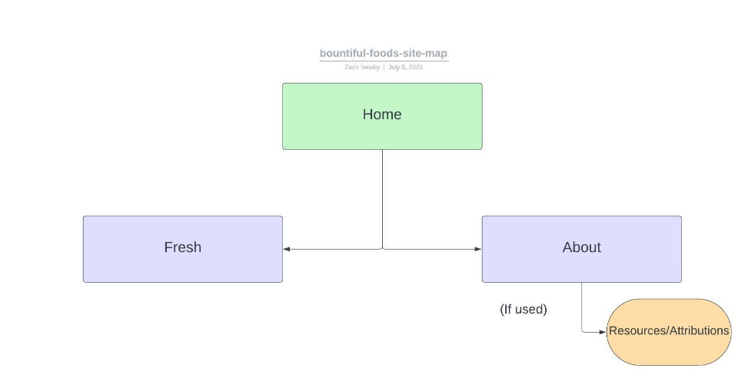

## Color Scheme

|  |  |  |  |  |
| --- | --- | --- | --- | --- |
| 20bf55 | fdf7fa | da4167 | 3a2e39 | 01baef |
| 20bf55 | fdf7fa | da4167 | 3a2e39 | 01baef |
| primary | relief | accent | text | accent |

## Typography



## Wireframe Sketches

**Large:**

**Medium:**

**Small:**