Zachary Heras
Summer 2024

Screenshot of cargo build and cargo run:

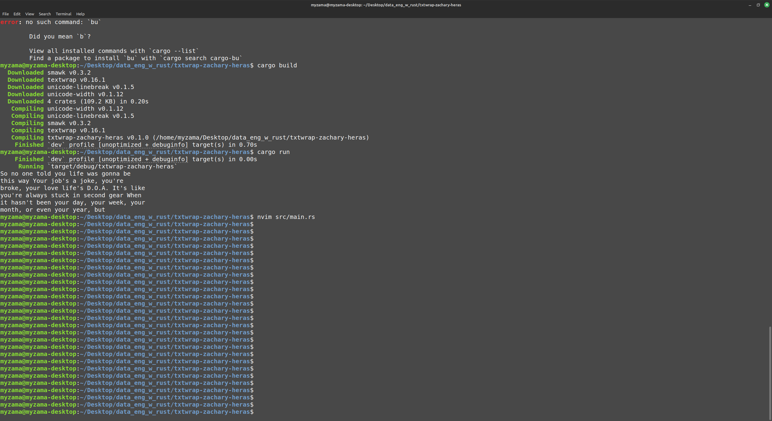

Cargo.toml contents:

[package]
name = "txtwrap-zachary-heras"
version = "0.1.0"
edition = "2021"

[dependencies]
textwrap = "0.16.1"

