CUNY DATA 608/2 – Prof. C. Ferrari Zachary Herold
Final Project Proposal October 28, 2019

Chinafundnews.com Equity Dashboard

According to the proposal description, the final project is to “create a public visualization using data relevant to a current policy, business, or justice issue.” My prime area of interest is the Chinese equity markets, particularly the US dollar denominated B-shares, whose valuation is impacted by Chinese financial market liberalization, US-China trade policy and US Fed monetary policy. About 200 qualified foreign institutional investors (QFII) are permitted to directly trade foreign currency denominated Chinese shares with a capital quota of $52.3 billion as of February 2014. With a highly transparent system (every exchange-based trade is public) and extreme volatility, this market is an ideal playing field and testing site for financial analytics.

My proposal is to develop and deploy a web application on my own registered domain chinafundnews.com, an interactive financial dashboard for the full universe of China B-share companies listed on the Shanghai Stock Exchange (approx. 50 companies). Users of the application will be able to filter candidate public companies for portfolio inclusion according to market capitalization, average daily trading volume, and such fundamentals as revenue, net income, and net cash flow from their 2019 Annual Report. For each individual stock, the dashboard will automatically generate the following financial metrics, based on up-to-date weekly stock prices, benchmarked against a self-designed proprietary market-cap weighted index:

- Raw & Adjusted Beta
- Sharpe & Sortino Ratios
- Selected Volume Indicators
- A/B-share P/E differential

If the scope permits, the app will also include a Portfolio Generator function that makes use of Python's Pyportfolio package, with portfolio weightings constructed across the candidate stocks.

The data will be collected from download of materials on Chinese financial information websites (eastmoney.com, jrj.com.cn, cn.investing.com, finance.sina.com.cn., stockstar.com, cn.info.com.cn, etc.), or through web scraping extraction with BeautifulSoup. The data will be stored on Postgresql, and accessed through SQLAlchemy, and the application itself will be developed using Dash and Flask.

The following page displays sample interactive dashboard designs from the Rodriguez text and Bloomberg terminal with my proposal may derive from.

In summary, the main phases are as follows:
- Data Collection – APIs, BeautifulSoup
- Data Storage – Postgresql, SQLAlchemy
- Index Construction – Python
- Metric Calculation & Presentation – Python
- Universe Crossfiltering – Dash
- Dashboard Design & Implementation – Plotly / Dash
- Portfolio Construction Tool – Pyportfolio
- Live Deployment – CGI (GoDaddy/ Control Panel)

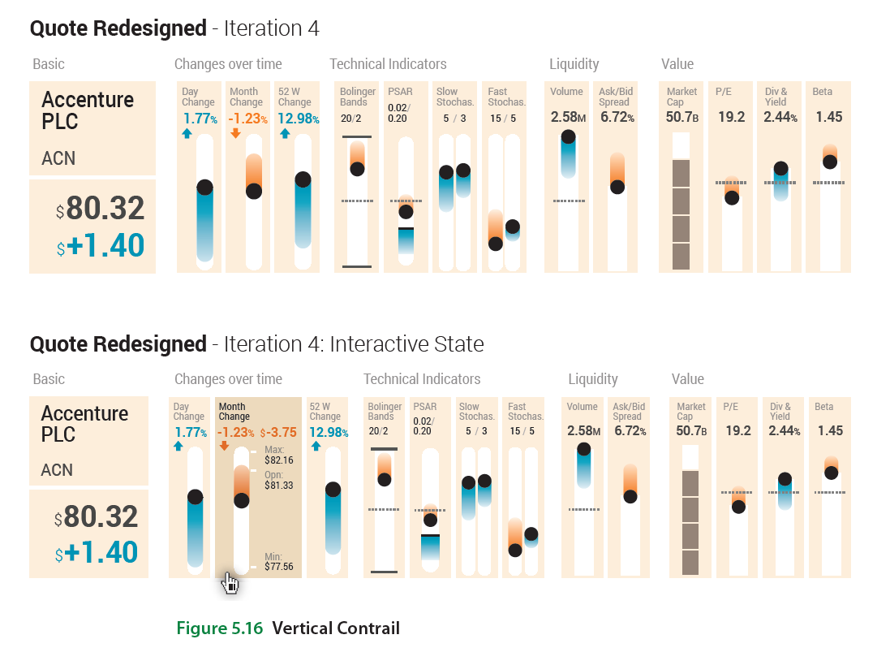

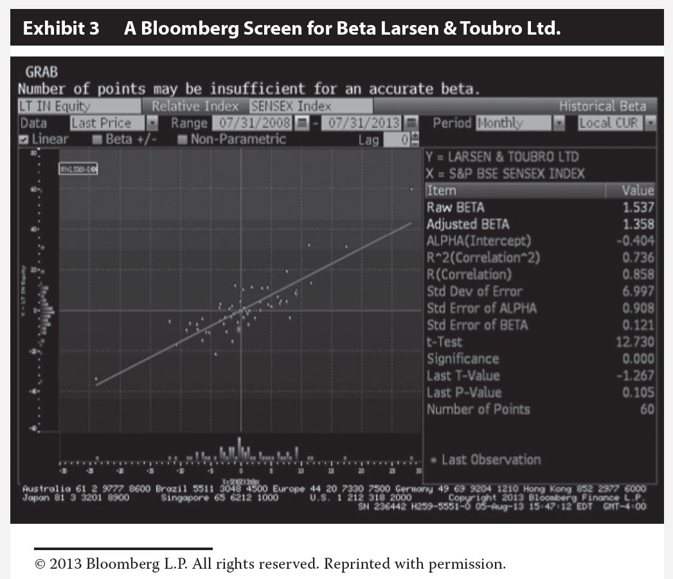

Sources:

- Cano-Berlanga S & Gimenez-Gomez JM 2017, “On Chinese stock markets: How have they evolved over time?”, Analytical Models for Financial Modeling and Risk Management, Springer, https://doi.org/10.1007/s10479-017-2602-4

- Copperwaite, M & Leifer, C 2015, Learning Flask Framework, Packt Publishing

- Grinberg, M 2018, Flask Web Development, O'Reilly Media

- Level II CFA Study Guide 2015, Wiley

- Maia, I 2015, Building Web Applications with Flask, Packt Publishing

- Rodriguez, J & Kaczmarek, P 2016, Visualizing Financial Data, Wiley

- Yao, Juan 2014, “Market Segmentation, Information Asymmetry and Investor Responses in the Chinese A- and B-Markets”, AABFJ, Vol. 8

Links:
- https://campus.datacamp.com/courses/introduction-to-portfolio-analysis-in-python
- https://blog.miguelgrinberg.com/post/the-flask-mega-tutorial-part-i-hello-world
- https://pyportfolioopt.readthedocs.io/en/latest/
- https://github.com/robertmartin8/PyPortfolioOpt
- https://github.com/systematicinvestor/systematicinvestor.github.io
- https://dash-gallery.plotly.host/Portal/
- https://www.quantopian.com/lectures

https://www.crystalbull.com/sharpe-ratio-better-with-log-returns/

