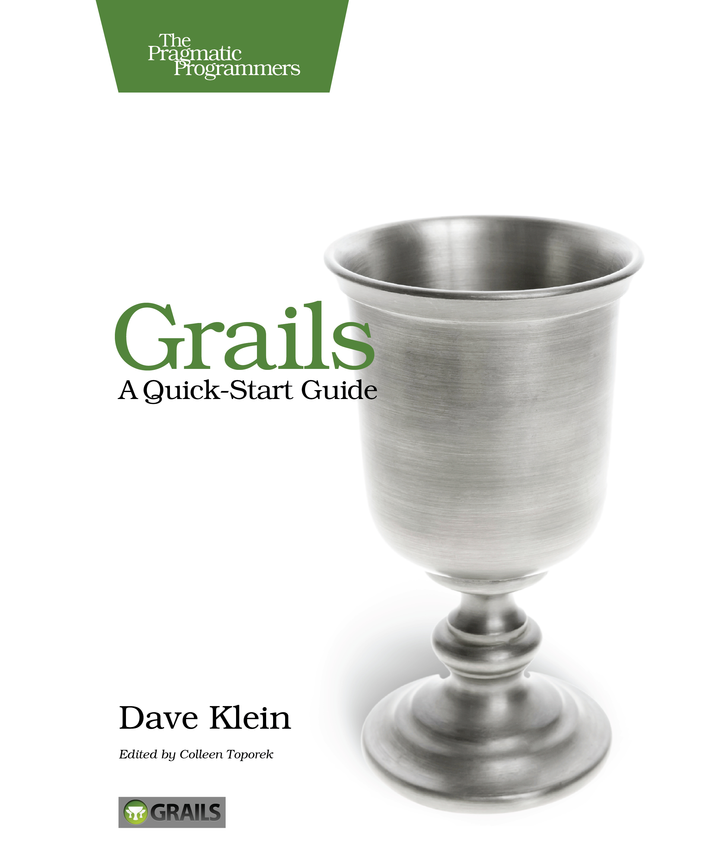

This book, like Grails, is common sense distilled. You’ll be productive in Grails in no time.
- Scott Davis , Thirstyhead.com

This book absolutely delivers value. Whether you’re an experienced web developer or just getting started and you want to give Grails a try, I heartily recommend Grails: A Quick Start Guide. It is quite possibly the best introductory book I’ve ever read about any framework, not just Grails.
- Review by Matt Stine at DZone.com

Grails is a full stack web development framework that enables you to build complete web applications in a fraction of the time and with less code than other frameworks.
In Grails: A Quick-Start Guide, you’ll see how to use Grails by iteratively building a unique, working application. By the time we’re done, you’ll have built and deployed a real, functioning website.
Along the way, we’ll learn about domain classes, controllers, and GSP views. We’ll see how Grails allows us to use powerful frameworks like Spring and Hibernate without even knowing it.
Using this hands-on, pragmatic approach, we’ll explore topics such as AJAX in Grails, custom tags, and plugins. We’ll dig into Grails’ powerful view technology, Groovy Server Pages, and see how we can easily leverage the help given to us by scaffolding to create custom user interfaces faster than you would have thought possible.
With Grails, you can get a lot done with little effort. With this book, you’ll get a lot done as well. It’s time to bring the fun back into web programming. Get started with Grails today.



Discount for SpringOne2GX attendees!
Use this magic code: _ _ _ _ at http://pragprog.com/titles/dkgrails

