Presented by: Robert Peterson

Prince bizimana

Zachary Lessard



SVR DRS Requirements

Specification

Version [1.1]

February 7, 2017

## Table of contents

| 1. System Overview  1.1 Problem Definition  1.2 Proposed Solution | 2  2  2 |
| --- | --- |
| 1.3 Object-Flow Diagram | **3** |
| 1.4 Information Topology Chart | **4** |
| 2. Storage Requirements  2.1 Storage Overview  2.2 Storage Details | **5**  **5**  **6** |
| 3. Operational Requirements | **11** |
| 4. Business Rules | **21** |
| 5. Summary and Conclusion | **22** |
|  |  |
|  |  |
|  |  |
|  |  |
|  |  |

## System Overview

#### **1.1 Problem Definition**

When diagnosing multiple diseases, a database of disease information can be a fundamental part of a doctor’s office or a large hospital.  The absence of such a system could result in several problems:

• It is almost impossible for a doctor to remember all the symptoms of diseases because everyday something new is discovered.  
• Using sources like books and the internet is not very practical in a doctor’s office or at a hospital because either doctors or patients are under time constraints and need their time free.  
• Doctors have to keep track of patient’s current medication and medications prescribed by the diagnosis system.

• Some diseases have similar symptoms preventing doctors from easily narrowing down possible diseases.  Doctors need to be able to do this swiftly and quickly so that they can discuss the matter at hand.

**1.2 Proposed Solution**

This project seeks to address the problem by developing a Disease Recognition System which would query an extensive database of symptoms and associated diseases. This software system must be portable and platform independent (if possible).  The recommended software development includes PHP enabled html web front-end, and MySQL as the back-end DBMS because it allows for processing of large volumes of information.

**Overview of Storage Requirements**

It is anticipated that the system will contain the following main information entities:

• Disease Definition

• Disease Category

• Disease Symptoms

• Disease Treatments

• Prescription Log

• Patients

• Patients Medical History

• Physicians

**Anticipated Outputs**  
It will be possible to input symptoms and receive a list of possible diseases associated with the symptom. Operations will be provided to extract and display the following information from the above mentioned information entities. Some of the more prominent outputs are as follows:

• Disease Master Listings

• Symptoms Master Listings

• Treatment Master Listings

• Medication Master Listings

• Physician Master Listings

• Medical History Master Listings

• Patient Master Listings

**1.3 Object-Flow Diagram**

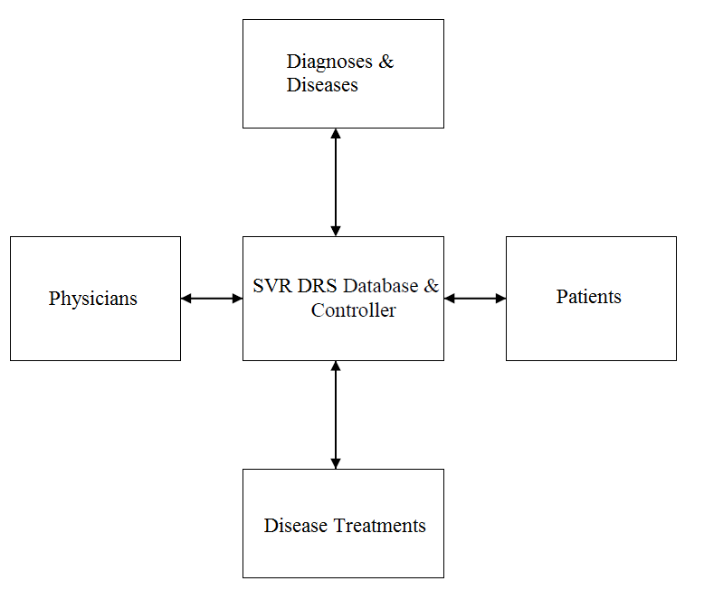

**1.4 Information Topology Chart**

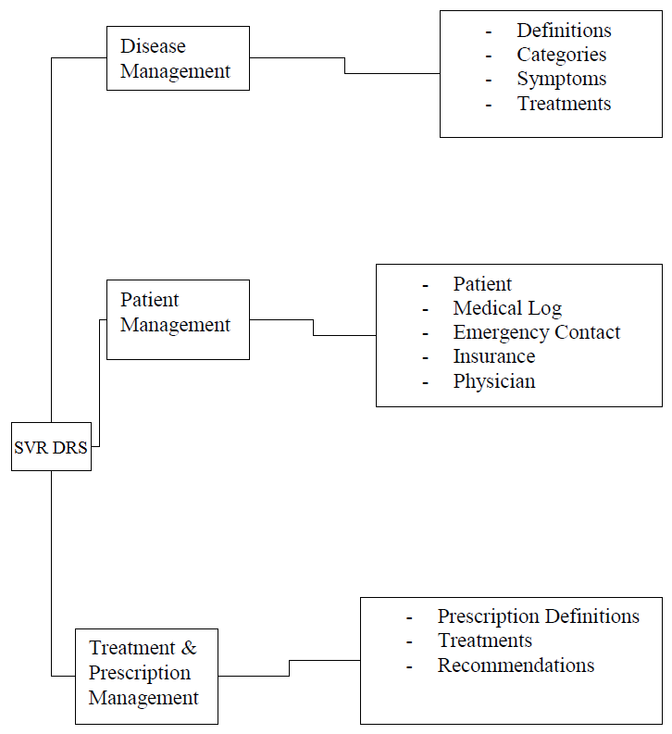

## 2. Storage Requirements

The main storage requirements of the system will be covered below. Each of the conventions used within the storage requirements are listed below:

* Each information entity that is referenced is identified by a reference code and a descriptive name.
* For each data entity, the attributes that are stored are identified.
* The entities in which are listed, can be easily transitioned into a set of normalized relations in a normalized relational database
* Data elements that are implemented as foreign keys within the normalized relational database. These elements are identified by parenthesized comments, specifying what entity they reference.
* Data elements that are implemented as primary key attributes (or part of a primary key) at database implementation time are also identified by parenthesized comments
* For each of the elements a detailed description will be provided

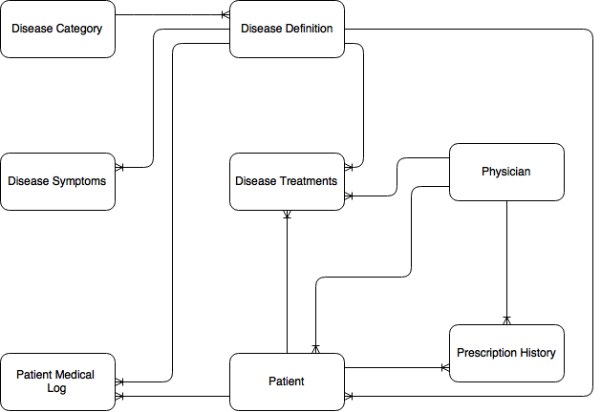

The main storage requirements of the system that are shown above. The conventions used are summarized below:

* Each information entity referenced is identified by a reference code and a descriptive name.
* For each entity, the attributes (data elements) to be stored are identified.
* The entities as presented, will easily transition into a set of normalized relations in a normalized relational database.
* Data elements that will be implemented as foreign keys, in the normalized relational database, are identified a parenthesized comment, specifying what entity they reference.
* Data elements that will be used as primary key attributes (or part of the primary key) at database implementation time are also identified by parenthesized comments.
* For each entity a comment describing the data is to be provided.

|  |
| --- |
| E1 – Disease Definition |
| Attributes:  1. Disease Code [Key]  2. Disease Name  3. Disease Category (Refers to E2) |
| Comments: The entity stores information about Diseases |

|  |
| --- |
| E2 – Disease Category |
| Attributes:  1. Category Code [Key]  2. Category Description |
| Comments: The entity stores information about Disease Categories |

|  |
| --- |
| E3 – Disease Symptoms |
| Attributes:  1. Symptom Code [Key]  2. Symptom Name/Description  3. Symptom Comment |
| Comments: The entity stores information about Disease Symptoms |

|  |
| --- |
| E4 – Disease Treatments |
| Attributes:  1. Treatment Code [Key]  2. Treatment Description  3. Treatment Comment |
| Comments: The entity stores information about Disease Treatments |

|  |
| --- |
| E5 – Patient |
| Attributes:  1. Patient Code [Key]  2. Patient Social Security Number  3. Patient Name  4. Address Line 1  5. Address Line 2  6. State / Province Code (Refers to E9)  7. Zip Code  8. Telephone Number  9. Email Address  10. Emergency Contact Code (Refers to E10)  11. Health Insurance Code  12. Medical Log (Refers to E6) |
| Comments: The entity stores information about Patients |

|  |
| --- |
| E6 – Patient Medical Log |
| Attributes:  1. Medical Log Code [Key]  2. Patient Code (Refers to E5)  3. Occurrence Date  4. Disease Diagnosed (Refers to E1)  5. Medical Summary  6. Ref Physician Code (Refers to E8) |
| Comments: The entity stores information about the Patient’s Medical Log |

|  |
| --- |
| E7 – Prescription Definition |
| Attributes:  1. Prescription Code [Key]  2. Medication |
| Comments: The entity stores information about the Patient’s Medical Log |

|  |
| --- |
| E8 – Physician |
| Attributes:  1. Physician Code [Key]  2. Physician Name  3. Address Line 1  4. Address Line 2  5. State / Province Code (Refers to E9)  6. Zip Code  7. Telephone Number  8. Email Address |
| Comments: The entity stores information about Physicians |

|  |
| --- |
| E9 – State |
| Attributes:  1. State Code [Key]  2. State Name |
| Comments: The entity stores information about States/Provinces |

|  |
| --- |
| E10 – Emergency Contact |
| Attributes:  1. Contact Code (Refers to E5) [Key]  2. Contact Name  3. Address Line 1  4. Address Line 2  5. State / Province Code (Refers to E9)  6. Zip Code  7. Telephone Number  8. Email Address |
| Comments: The entity stores information about Emergency Contacts |

|  |
| --- |
| E11 – Patient Insurance |
| Attributes:  1. Patient Code (Refers to E5) [Key 1]  2. Health Policy Code (Refers to E13) [Key 2]  3. Health Policy Number  4. Policy Note |
| Comments: The entity stores information about Patient Insurance |

|  |
| --- |
| E12 – Health Insurance Companies |
| Attributes:  1. Company Code [Key]  2. Company Name  3. Company Contact Person  4. Address  5. Telephone  6. E-mail |
| Comments: The entity stores information about Health Insurance Companies |

|  |
| --- |
| E13 – Health Insurance Policies |
| Attributes:  1. Policy Code [Key]  2. Policy Description  3. Policy Company Code (Refers to E12) |
| Comments: The entity stores information about Patient Insurance |

|  |
| --- |
| E14 – Disease-Symptom Matrix |
| Attributes:  1. Disease Code (Refers to E1) [Key 1]  2. Diagnosis Sufficiency Flag  3. Symptom Sequence  4. Symptom Code (Refers to E3) [Key 2] |
| Comments: The entity stores information about which diseases have which symptoms. |

|  |
| --- |
| E15A – Disease-Treatment Summary |
| Attributes:  1. Treatment Reference  2. Diagnosis Date  3. Prescription Date  4. Patient (Refers to E5)  5. Treatment Physician (Refers to E8)  6. Treatment Detail (Refers to E15B)  7. Disease Code (Refers to E1) [Key 1] |
| Comments: The entity stores information about which diseases have which treatments. |

|  |
| --- |
| E15B – Disease-Treatment Detail |
| Attributes:  1. Treatment Reference  2. Treatment Code (Refers to E4) [Key 2]  3. Prescription Code (Refers to E7) |
| Comments: The entity stores detail on the treatment of the disease. |

## Operational Requirements

The information entities of the previous section will be implemented as a relational database using Oracle 10G. Superimposed on this database will be an Object-Oriented GUI consisting of various operations that provide functionality and flexibility to the end users.

The user functionality and flexibility will be provided base on the following approach:

* For each information entity, define an object type of the same name.
* For each object type, define a set of basic operations that will facilitate addition, modification, deletion, inquiry, and reporting of data related to that object type (note that each object type does not require all five basic operations).
* For selected object types, introduce flexibility and sophistication such as additional and or more complex inquiry and or report operations that facilitate end users specifying selection criteria of their choice.
* Define additional utility operations that will support the user interface of the system.

This is an initial list of operations that will be present in the database system:

**Disease Management Subsystem**

E1. Disease Definition

- Add Disease Item [E1 A]

- Modify Disease Item [E1 M]

- Delete Disease Item [E1 Z]

- Inquire Disease Item [E1 I]

- Report Disease Item [E1 R]

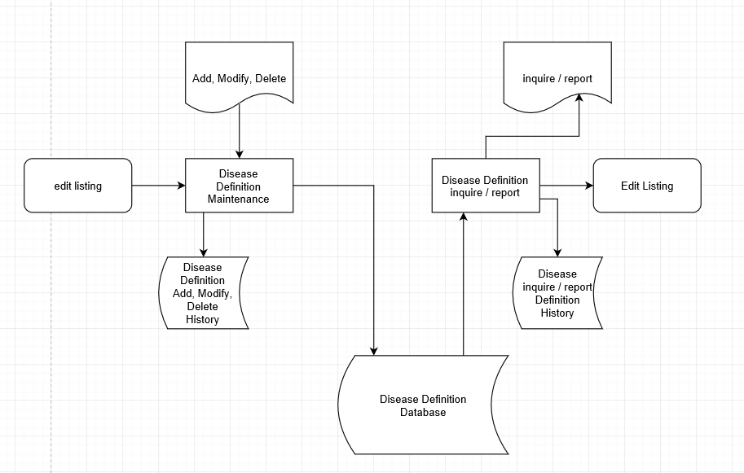

E2. Disease Category

- Add Category Item [E2 A]]

- Delete Category Item [E2 Z]

- Inquire Category Item [E2 I]]

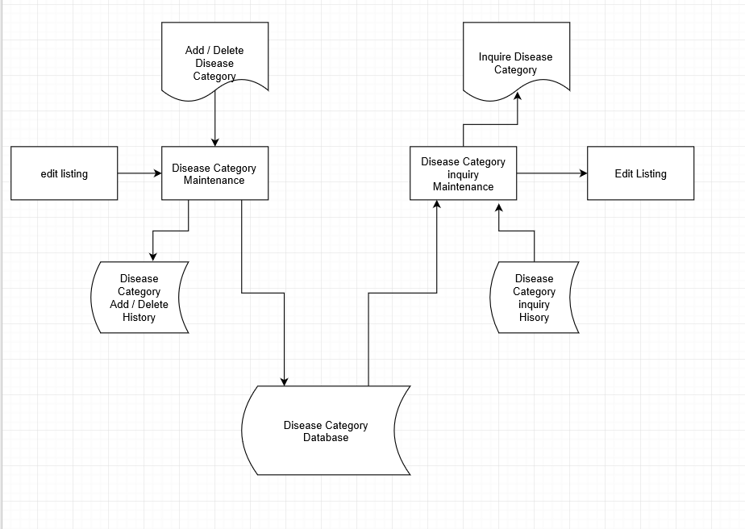

E3. Disease Symptoms

- Add Symptoms Item [E3 A]

- Modify Symptoms Item [E3 M]

- Delete Symptoms Item [E3 Z]

- Inquire Symptoms Item [E3 I]

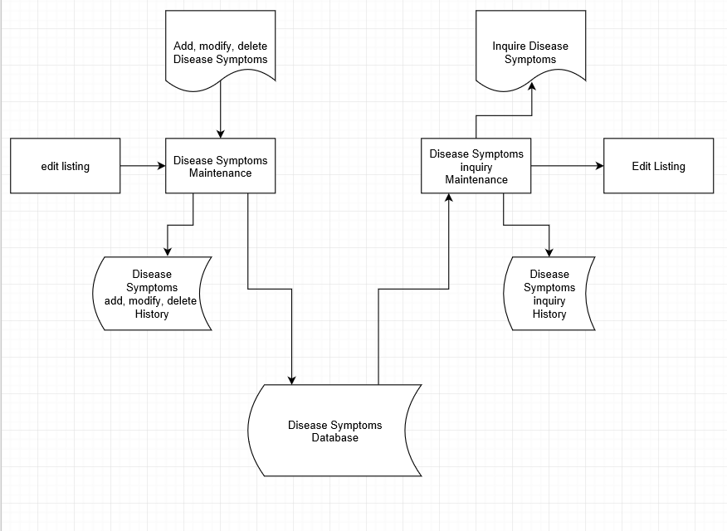

E4. Disease Treatments

- Add Treatment Item [E4 A]

- Modify Treatment Item [E4 M]

- Delete Treatment Item [E4 Z]

- Inquire Treatment Item [E4 I]

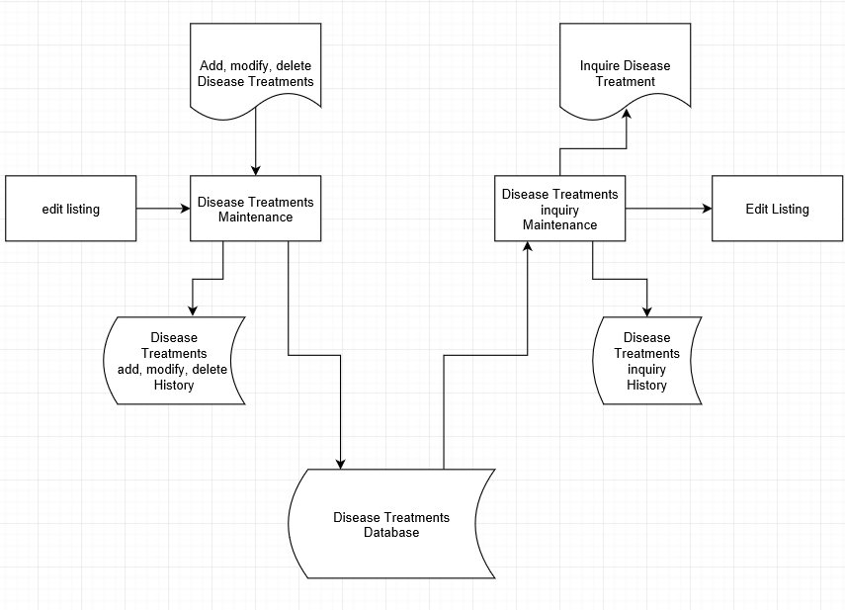

**Patient Management Subsystem**

E5. Patients

- Add Patient Item [E5 A]

- Modify Patient Item [E5 M]

- Delete Patient Item [E5 Z]

- Inquire Patient Item [E5 I]

- Report Patient Item [E5 R]

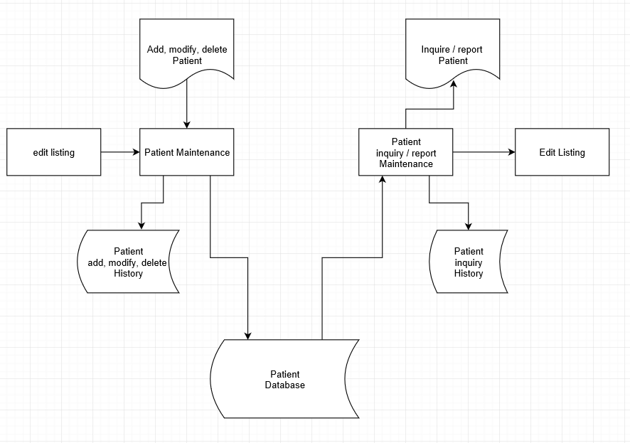

E6. Patient Medical Log

- Diagnose Patient Disease [E6_X]

- Add Patient Medical Log [E6 A]

- Modify Patient Medical Log [E6 M]

- Delete Patient Medical Log [E6 Z]

- Inquire Patient Medical Log [E6 I]

- Report Patient Medical Log [E6 R]

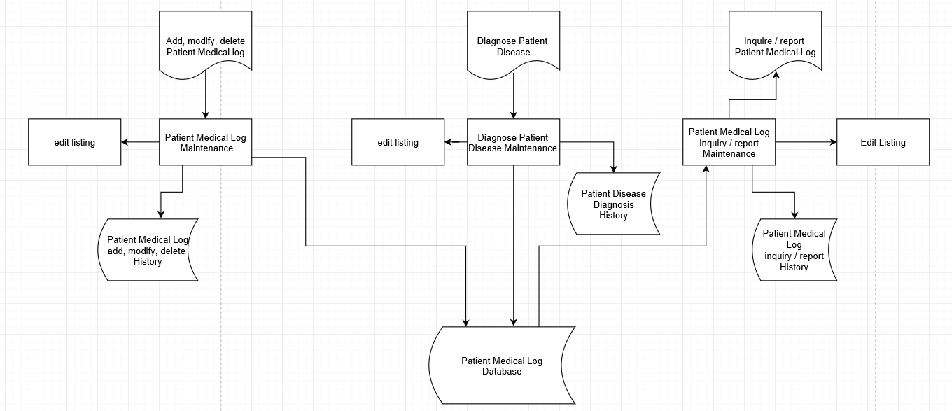

E7. Prescription Definition

- Add Prescription Item [E7 A]

- Modify Prescription Item [E7 M]

- Delete Prescription Item [E7 Z]

- Inquire Prescription Item [E7 I]

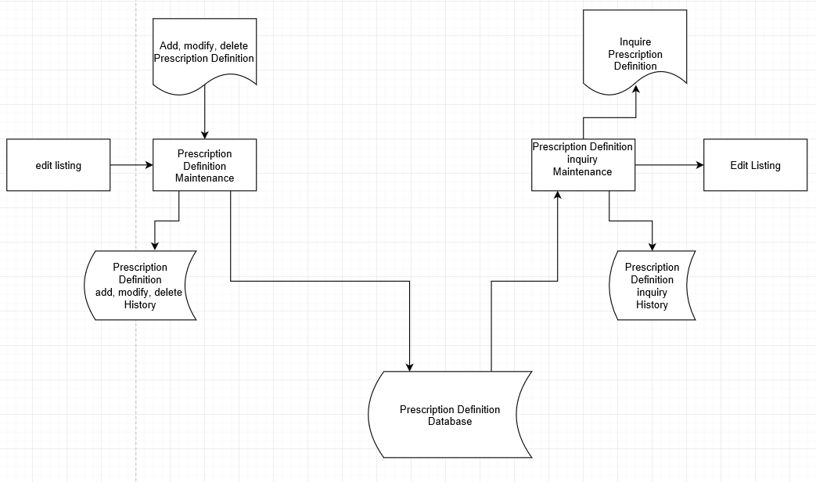

E8. Physicians

- Add Physician Item [E8 A]

- Modify Physician Item [E8 M]

- Delete Physician Item [E8 Z]

- Inquire Physician Item [E8 I]

- Report Physician Item [E8 R]

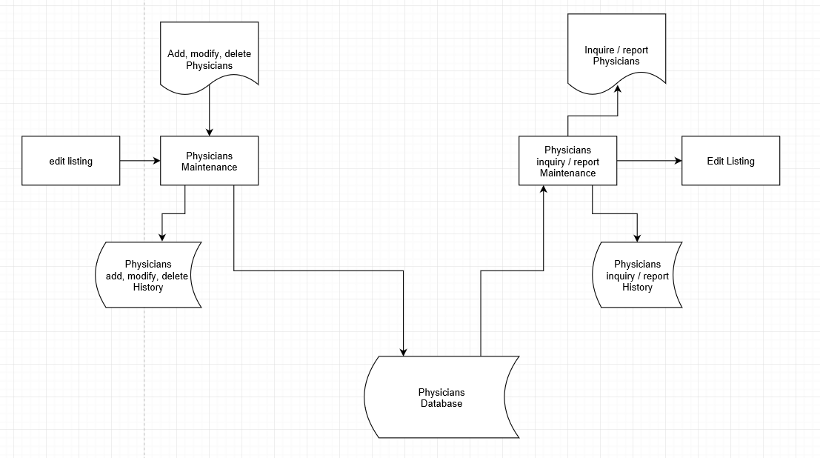

E9. State/Province

- Add State Item [E9 A]

- Modify State Item [E9 M]

- Delete State Item [E9 Z]

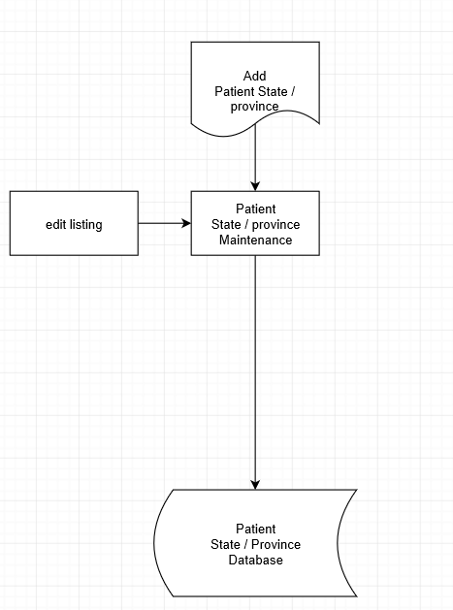

E10. Emergency Contact

- Add Emergency Contact Item [E13 A]

- Modify Emergency Contact Item [E13 M]

- Delete Emergency Contact Item [E13 Z]

- Inquire Emergency Contact Item [E13 I]

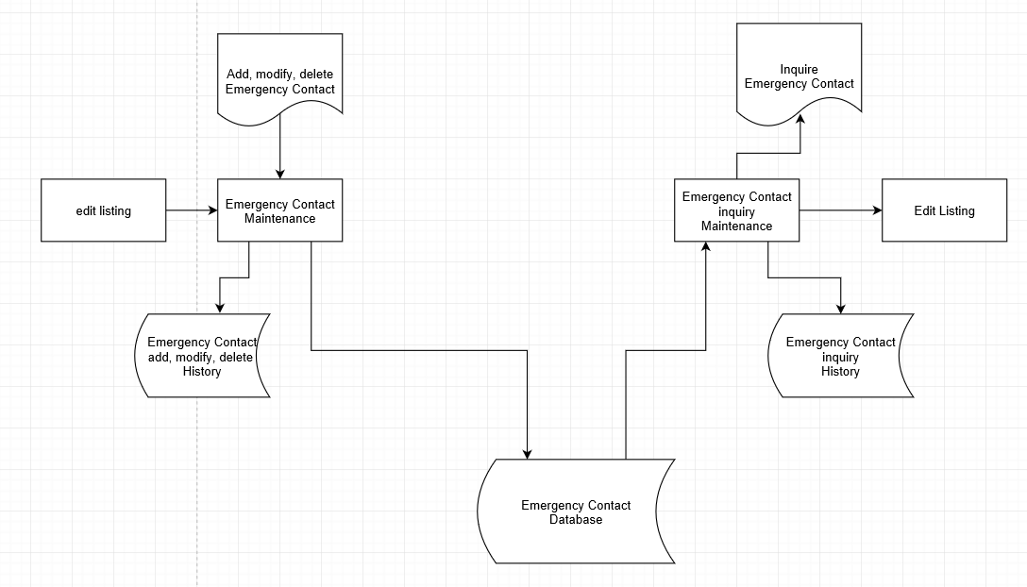

**Insurance Management Subsystem**

E11. Patient Insurance

- Add Patient Insurance Item [E10 A]

- Modify Patient Insurance Item [E10 M]

- Delete Patient Insurance Item [E10 Z]

- Inquire Patient Insurance Item [E10 I]

- Report Patient Insurance Item [E10 R]

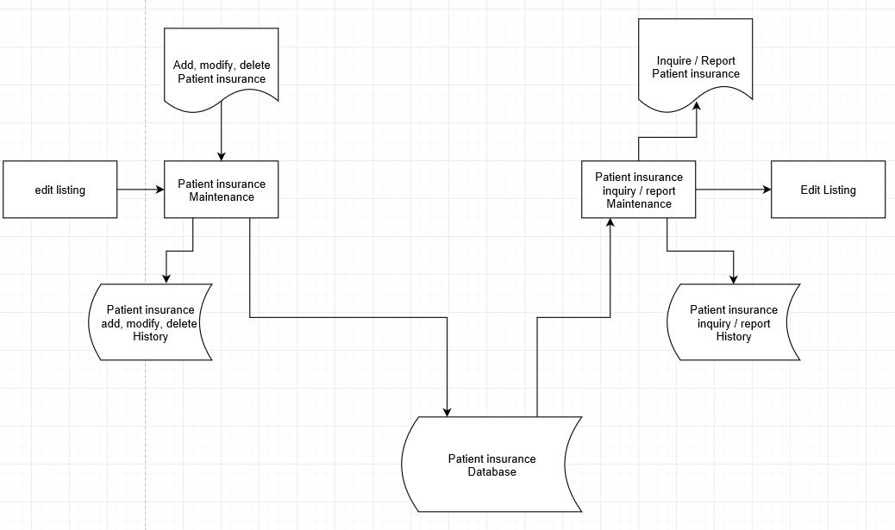

E12. Health Insurance Companies

- Add Company Item [E11 A]

- Modify Company Item [E11 M]

- Delete Company Item [E11 Z]

- Inquire Company Item [E11 I]

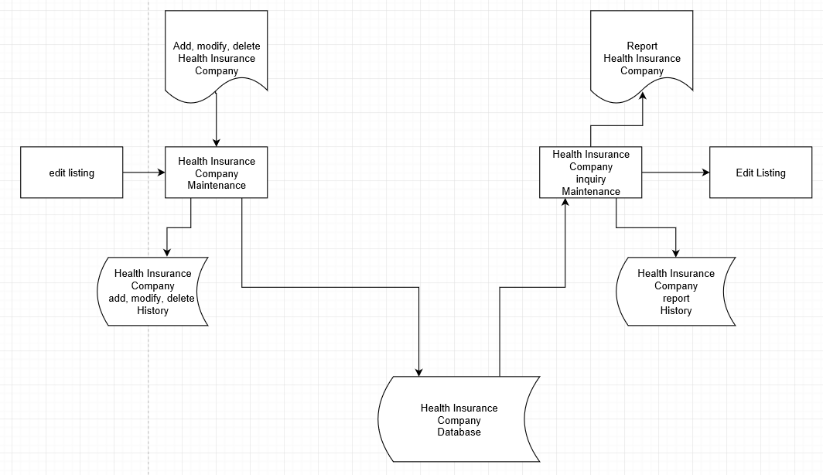

E13. Health Insurance Policies

- Add Health Insurance Policy Item [E13 A]

- Modify Health Insurance Policy Item [E13 M]

- Delete Health Insurance Policy Item [E13 Z]

- Inquire Health Insurance Policy Item [E13 I]

- Report Health Insurance Policy Item [E13 R]

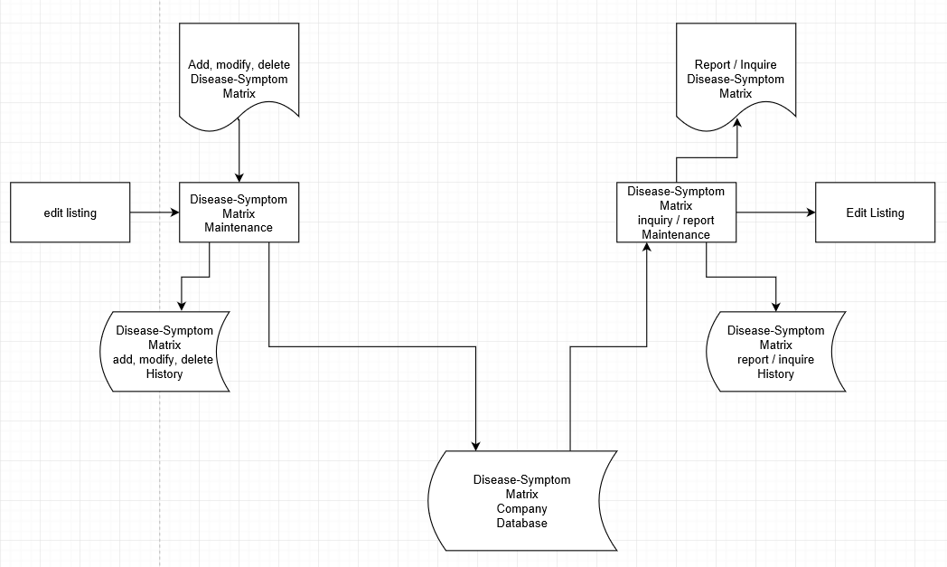

E14. Disease-Symptom Matrix

- Add Disease-Symptom Item [E14 A]

- Modify Disease-Symptom Item [E14 M]

- Delete Disease-Symptom Item [E14 Z]

- Inquire Disease-Symptom Item [E14 I]

- Report Disease-Symptom Item [E14 R]

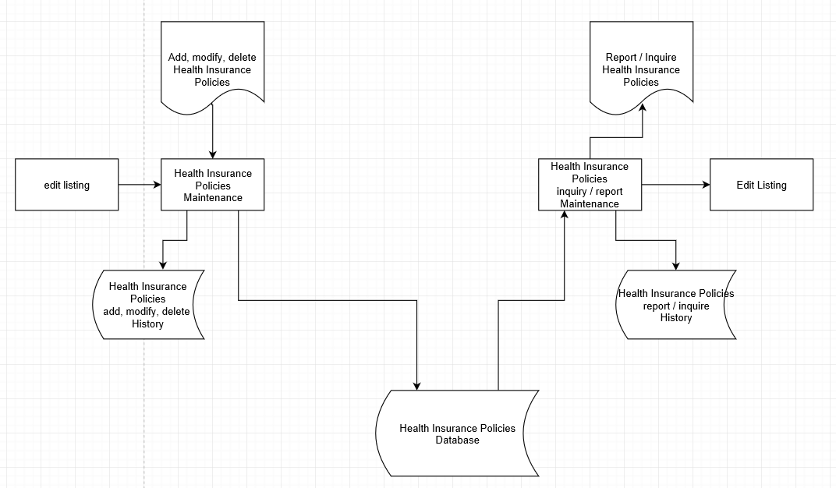

E15A. Disease-Treatment Summary

- Add Disease-Treatment Summary Item [E15A-A]

- Modify Disease-Treatment Summary Item [E15A-M]

- Delete Disease-Treatment Summary Item [E15A-Z]

- Inquire Disease-Treatment Summary Item [E15A-I]

- Report Disease-Treatment Summary Item [E15A-R]

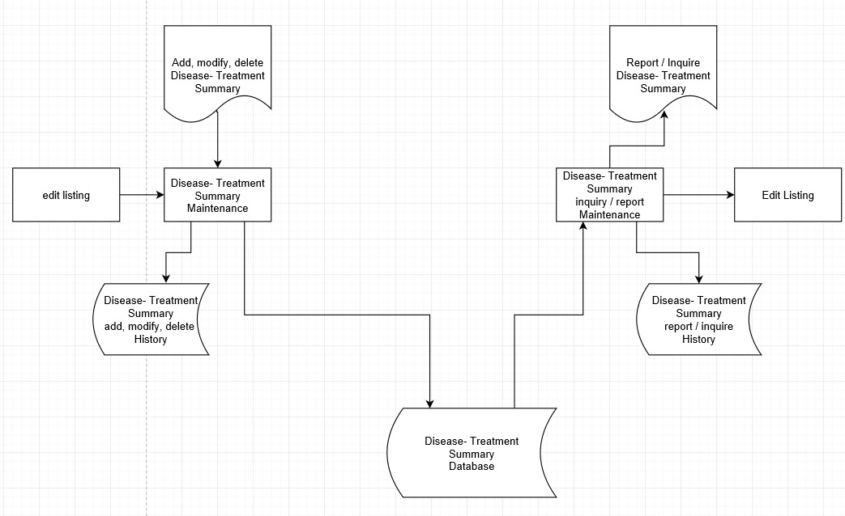

E15B. Disease-Treatment Detail

- Modify Disease-Treatment Detail Item [E15B-M]

- Inquire Disease-Treatment Detail Item [E15B-I]

- Report Disease-Treatment Detail Item [E15B-R]

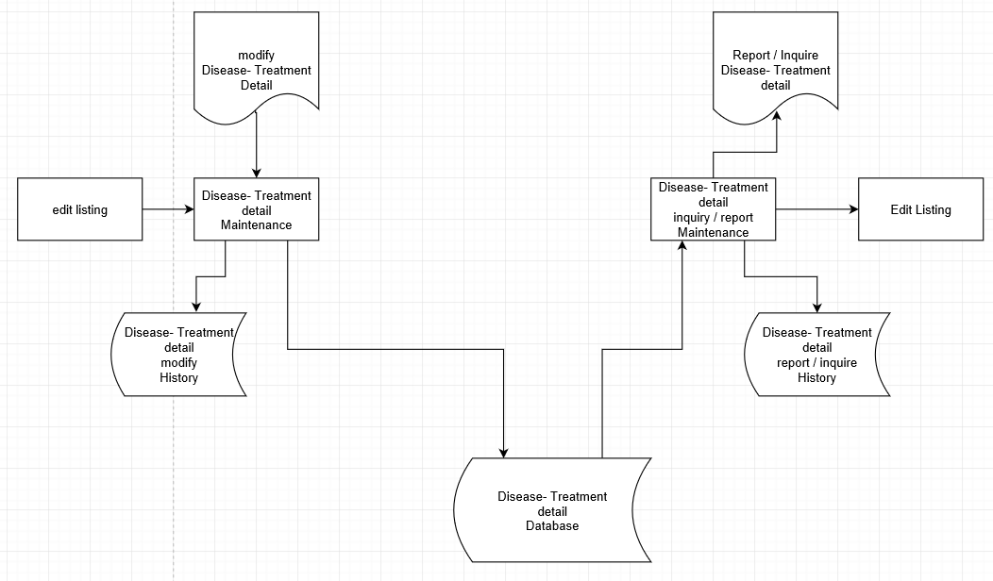

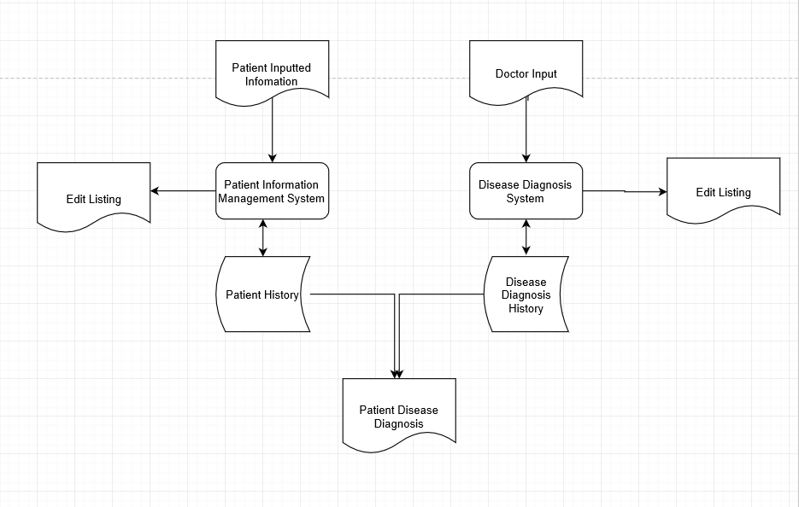

## Business Rules

The following derivation and procedural rules will be enforced:

1. When using operation E6_X: Diagnose Patient Diseases, the following will take place:

1. Prompt for disease symptoms.

2. Match symptoms against predetermined symptoms in the disease symptoms matrix (E14) and the Symptoms Definitions (E3).

3. Return determined disease results.

2. When using operation E1_A: Add Disease Item, the following will take place:

1. Prompt for the addition of a new disease category or selection of an existing category.

3. When using operation E15A_A: Add Disease-Treatment Summary Item, the following will take place:

1. Prompt for selection of existing Patient.

2. Prompt for selection of existing Physician.

3. Prompt for the Disease for which the treatment is prescribed.

4. Write a corresponding Disease-Treatment Detail Item.

5. Prompt for selection of existing Treatment Code in the Disease-Treatment Detail Item.

6. Prompt for selection of existing Prescription Code in the Disease-Treatment Detail Item.

4. When using operation E5_A: Add Patient Item, the following will take place:

1. Prompt for selection of existing state/province.

2. Write a new medical log for the patient.

3. Prompt for creation of a new contact.

5. When using operation E13_A: Add Health Insurance Policy Item, the following will take place:

1. Prompt for selection of existing Health Insurance Company.

6. When using operation E11_A: Add Patient Insurance Item, the following will take place:

1. Prompt for selection of existing Patient Code.

2. Prompt for selection of Health Insurance Policy Code

7. When using operation E14_A: Add Disease-Symptom Matrix, the following will take place:

1. Prompt for selection of an existing Disease.

2. Prompt for the selection of an existing Symptom.

## Summary and Conclusion

## 

This document provided a basic blueprint for a Disease Diagnosis System’s database and related operations. It includes the following:

* An overview of the system, including problem definition, proposed solution, and system architecture.
* Storage requirements, including draft outlines for the basic information entities comprising the system.
* Operational requirements, including an initial list of basic user operations.
* Business rules, including derivation and procedural rules.

The design specification will use these requirements to prepare a more detailed set of specifications from which the system will be developed.