**CS3354 Software Engineering Final Project Deliverable 1**

Sundial – Event Manager

**Team members:**

Abinash Bhattarai

Jason Garza

John Marshall

Sarah Burris

Sean McGuire

Zachary Maeshima

`

**Project Description**

The project is a calendar and scheduling app that students can use to schedule their time. Named Sundial, it shares the same name as the ancient time-keeping device that is based off the shadow created by the sun’s movement to measure the passing of time. Events that can be added to the app include homework, projects, school-based events, and minor tasks related to the previously stated. Each item scheduled can be configured with details and time restraints and checking is done so items do not overlap or are added twice. If configured, the app is possible to connect to UT Dallas’s eLearning platform to submit homework or documents as well as import assignments and add their due date to the app. The app is designed to be visually friendly and organized by traditional weekly-monthly layout and can be stretched to device screen and zoomed in/out when needed.

From the initial layout, our project has a different software process model adopted for the project. Moreover, the design has been specialized and some of the features have been reduced.

**Delegated tasks:**

|  |  |
| --- | --- |
| **Task** | **Assigned to** |
| Respond to feedback for final proposal. | Abinash Bhattarai |
| Describe Software Process Model used and why? | Sean McGuire |
| Define 5-7 functional and 12 non-functional requirements.  (Based on: Fig 4.3, Chapter 4) | Sarah Burris |
| Use Case Diagram | Marshall Morton,  Abinash Bhattarai |
| Sequence Diagram | Marshall Morton |
| Class Diagram | Jason Garza |
| Architectural Design | Zachary Maeshima  Abinash Bhattarai |

**Software Process Model:**

**Software Process Model**

Prototyping was selected as our software development process model as per each iteration we could add updates and security features as well as any extra features later needed in the future. However, we will be still relying on the agile development method for distributing the work and will have the scrum master to review the work and give feedback. As time progresses, updates will be pushed to the app and any needed features developed in the future could be added per each update and the software process allows us to quickly develop working versions that can be pushed out to users. This allows users quick access to updated versions as time progresses and allows us a working version to be published.

**Use Case Diagram**

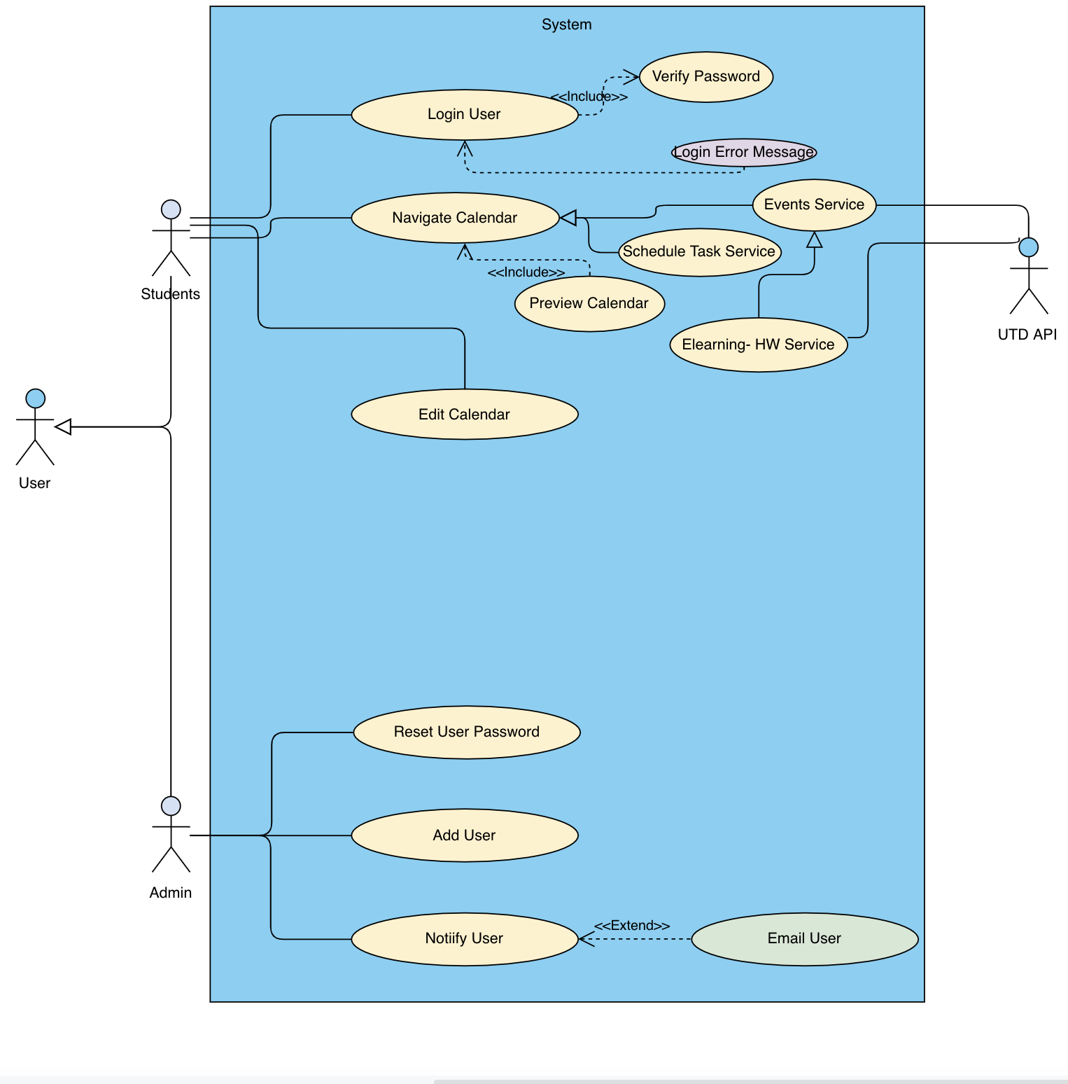

**Sequence Diagram:**

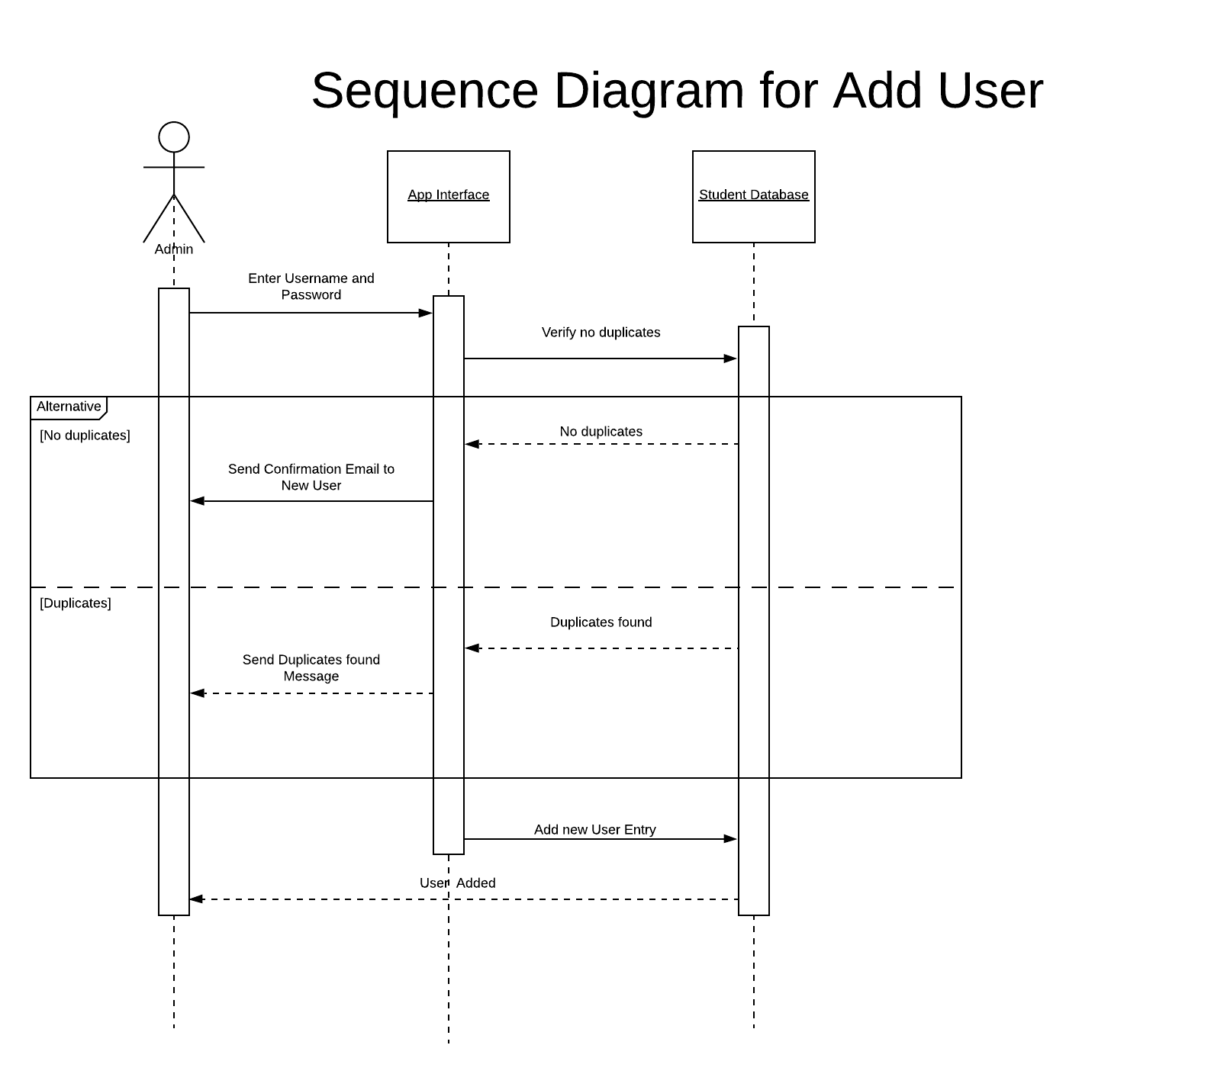

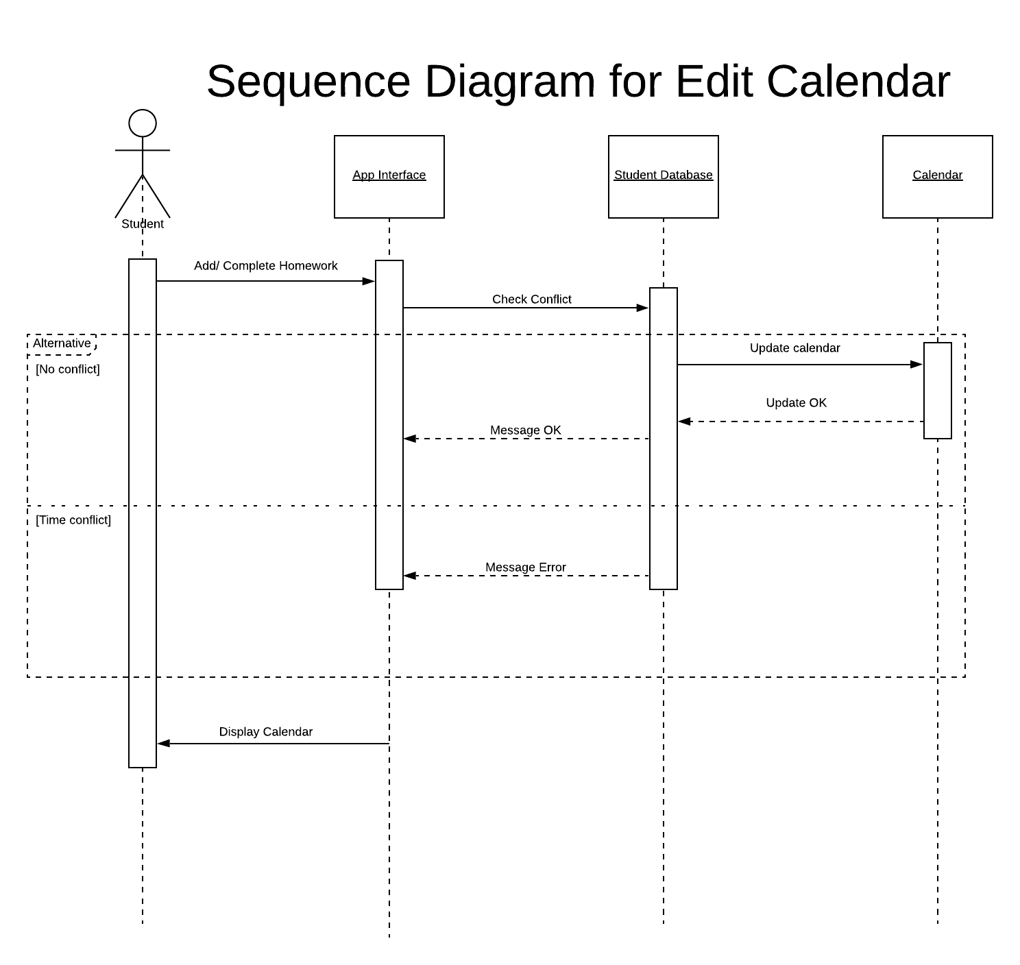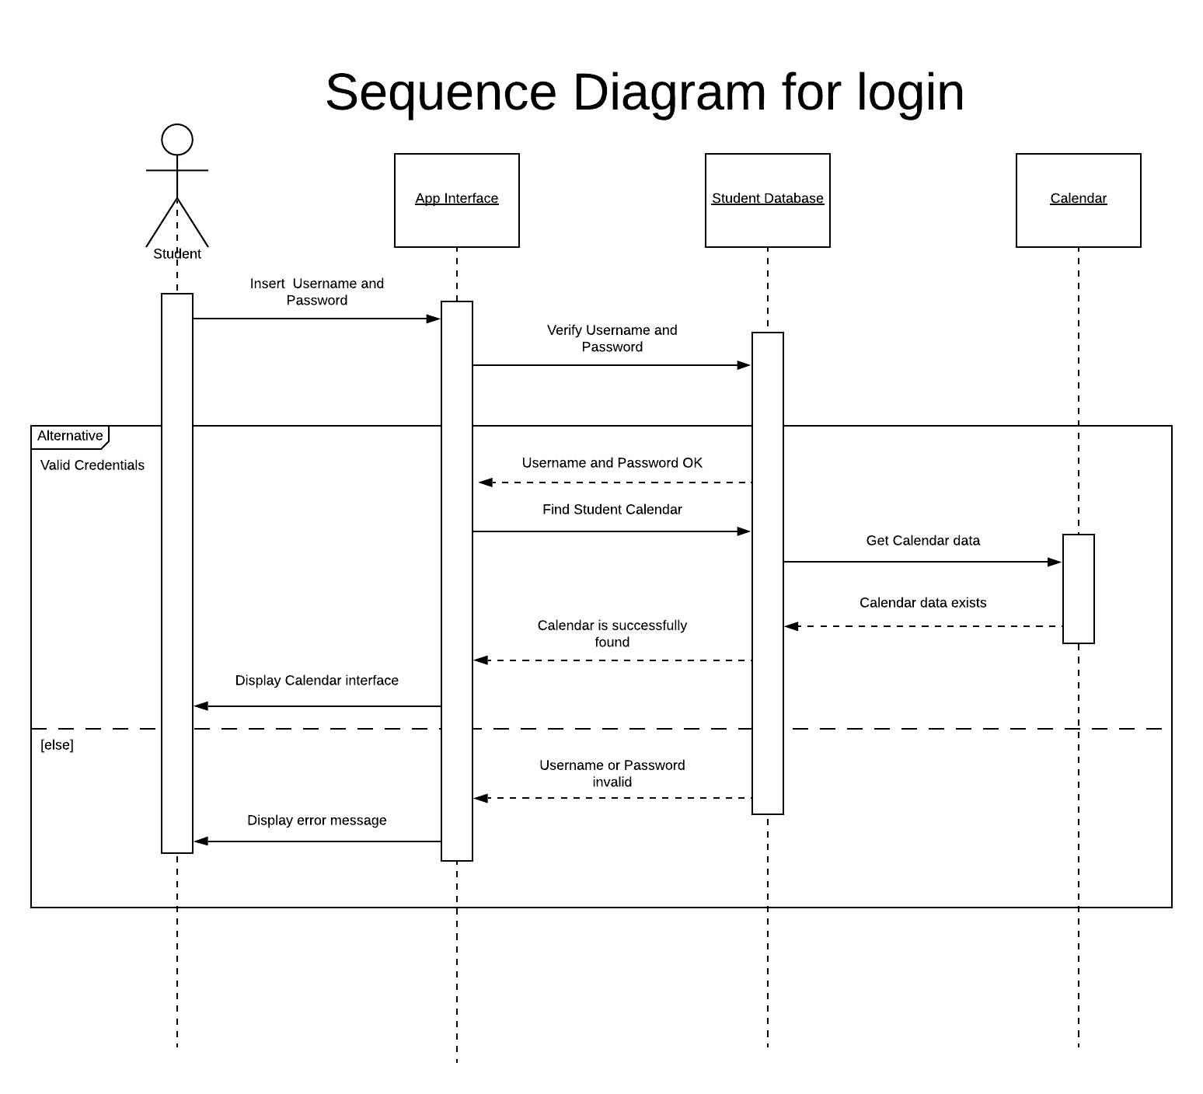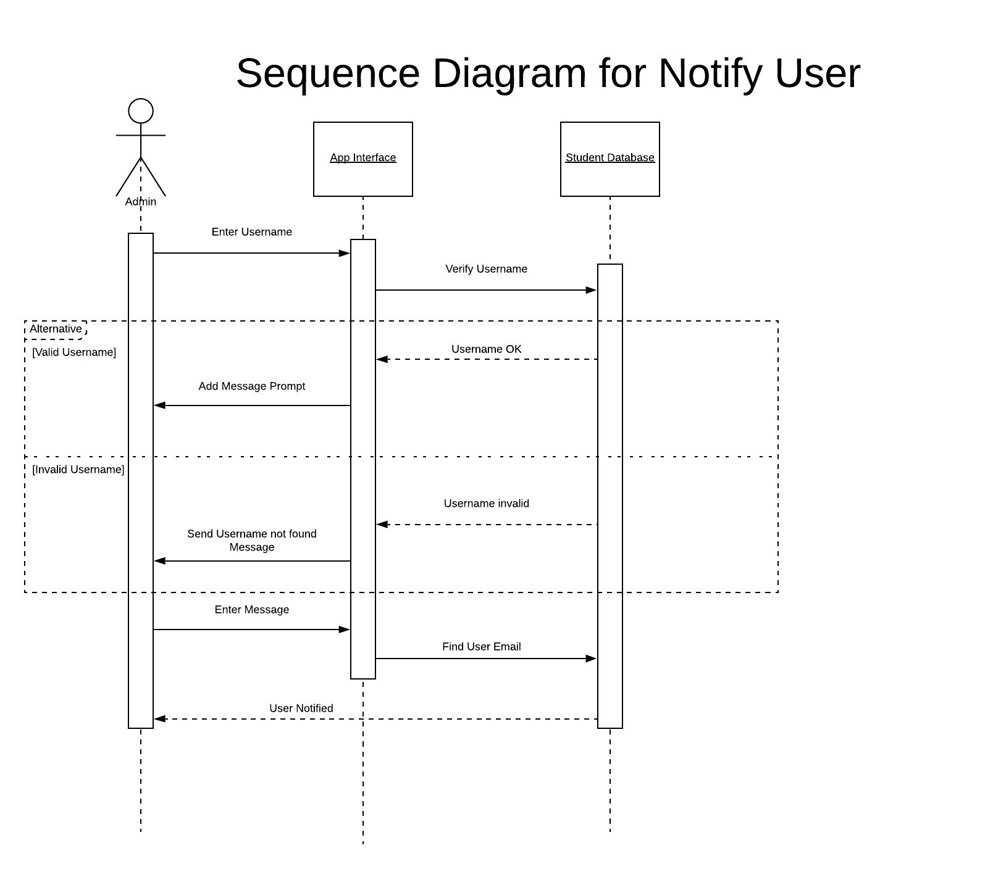

**Project Class Diagram**

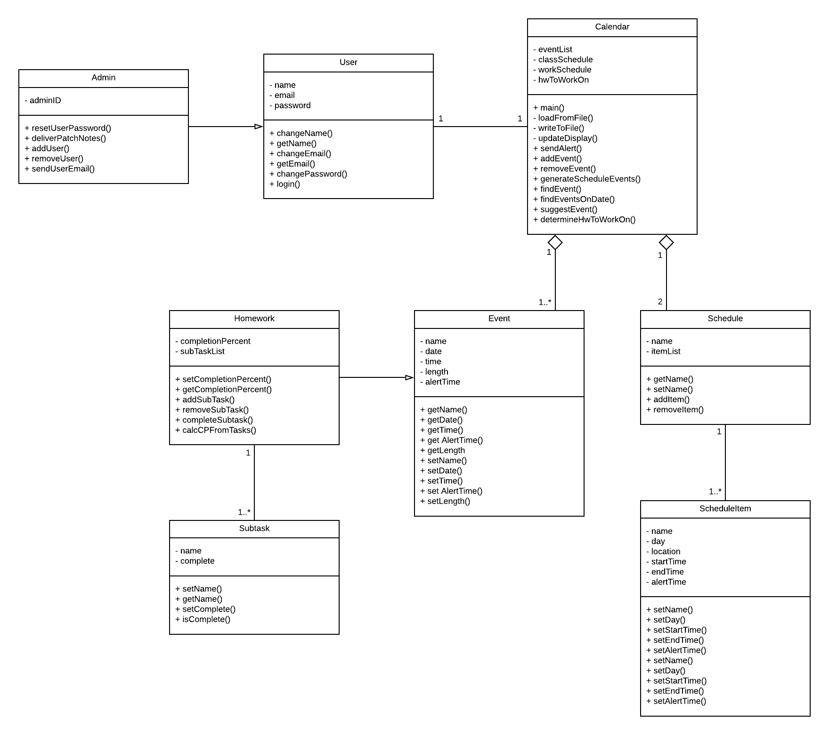

**Architectural design**

