Project Scheduling

Generalized Project Schedule for Prototype Iterations.

Table:

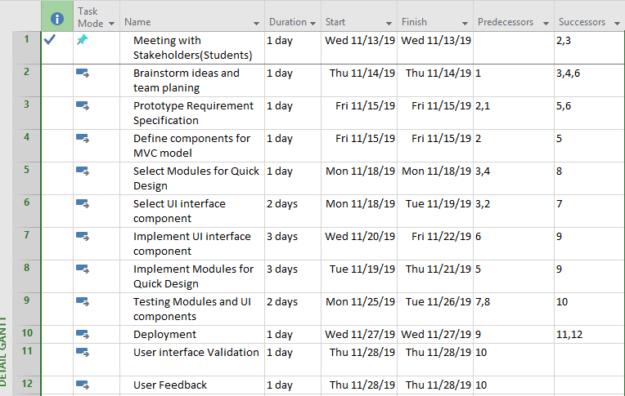

Bar chart:

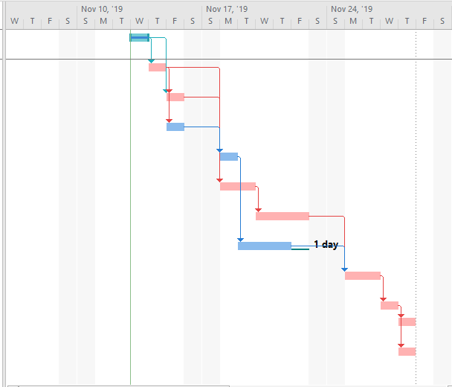

Together:

