CptS 475 Project Check-In
Sports Injury Risk Analysis
Team: Sideline Science | November 2026
Team members: Zachary Marseglia, Edwin Bucio, Christian Iverson, Hunter Dang
Repository: https://github.com/ZacharyMarseglia/CptS-475-Sports-Injury-Risk-Analysis/tree/main

1. Project objective
Which athlete workload, training, performance, and injury-history factors are associated with injury, and which of Logistic Regression, Decision Tree, and Random Forest best predicts the dataset’s injury outcome? The project combines NFL and NBA data preparation with supervised prediction and exploratory clustering. The current quantitative model and clustering results presented below are based on the NFL analysis; the NBA injury-label issue remains unresolved.

2. Dataset and work completed
NFL: A multi-season nflverse pipeline (2012–2024) joins weekly player statistics, snap counts, and official injury reports. It includes player-identifier matching, automated data-quality reporting, and prior-week workload and injury-history features designed to avoid using future information. For the 2024 run, the report records 27,356 merged rows, 18,130 regular-season statistics rows, 25,359 GSIS-matched snap records, and 5,952 injury player-week rows, with a reported 99.8% injury match rate.
NBA: The report records a model-ready table with 29,738 rows and 84 columns, combining nba_api player game logs with historical injury data. However, the team reported that candidate NBA injury-target columns did not contain positive injury cases in the attempted modeling run. NBA injury prediction is therefore not presented as a validated result here.
Feature engineering: The NFL pipeline produces lagged workload summaries over prior 1-, 2-, and 4-week windows, injury-report history, and matching/missingness audits. The team has also implemented baseline supervised models, hyperparameter experiments, and K-Means clustering.

3. Supervised model results
The following NFL model results are transcribed from the team’s existing report. The evaluation split, exact hyperparameters, and saved run artifacts should be checked against the repository before treating these numbers as independently reproducible.
Model | Accuracy | Precision | Recall | F1 | ROC-AUC
Logistic Regression | 0.8874 | 0.7167 | 0.7985 | 0.7554 | 0.9306
Decision Tree | 0.8918 | 0.7371 | 0.7817 | 0.7588 | 0.9159
Random Forest | 0.8953 | 0.7562 | 0.7657 | 0.7610 | 0.9211
Random Forest has the highest reported accuracy (89.53%), precision (0.7562), and F1 score (0.7610). Logistic Regression has the highest recall (0.7985) and ROC-AUC (0.9306). This tradeoff matters for injury screening: higher recall identifies more of the observed positive injury cases, whereas precision indicates how many predicted positive cases were actually positive. The results do not establish that one model is universally best; the preferred model depends on the cost of missed injuries versus false alarms.
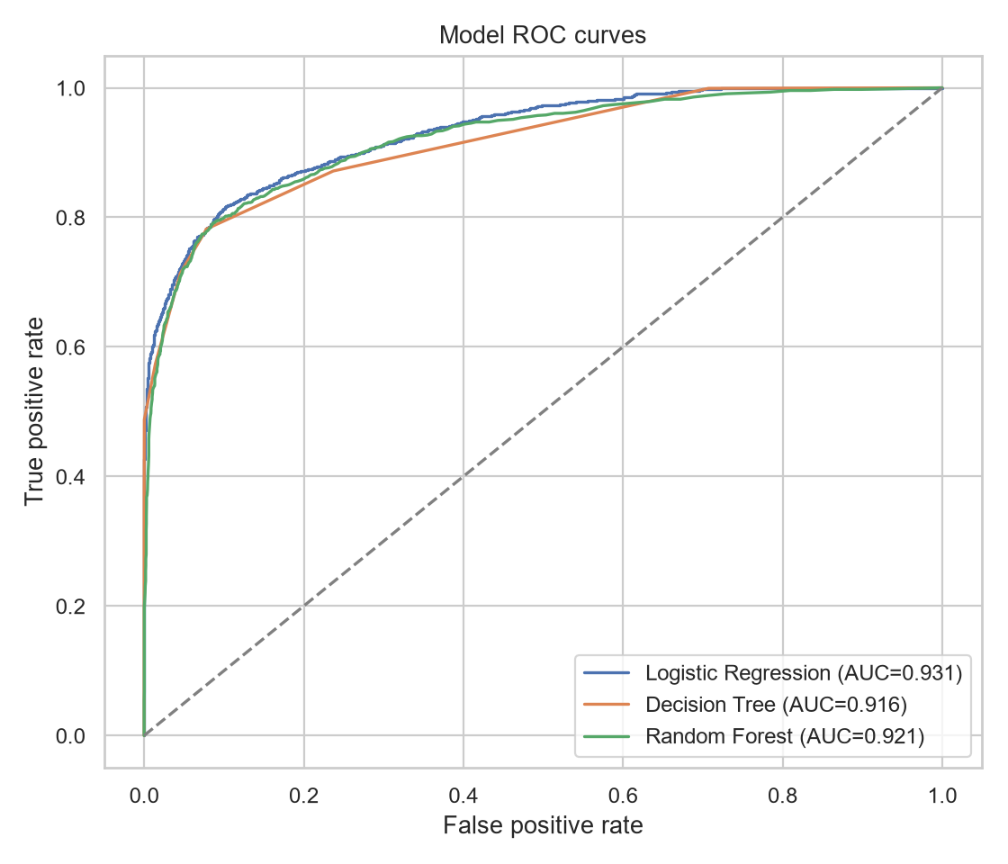
Figure 1. ROC curves for the three reported NFL classification models.

4. Exploratory data analysis
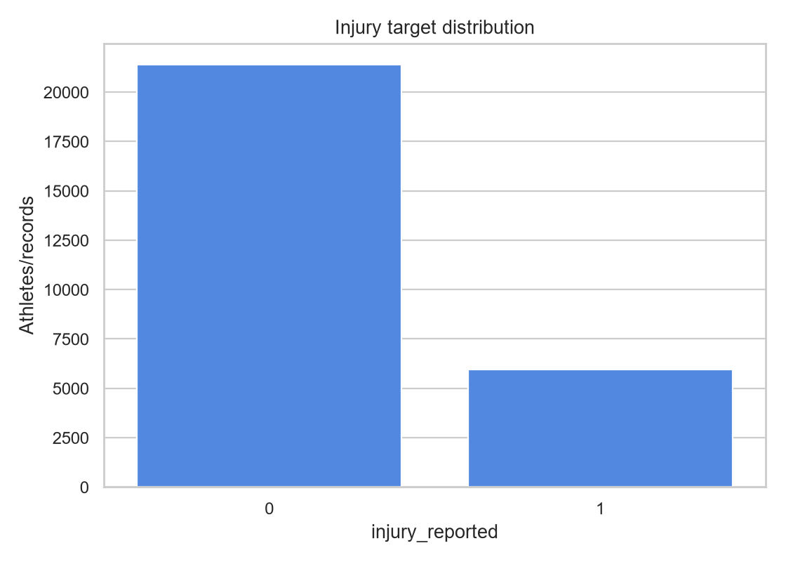
Figure 2. Reported distribution of the NFL injury target.
The plotted target has substantially more non-injury than injury records (approximately 78% versus 22%). Accuracy alone can therefore be misleading, making recall, precision, F1, and ROC-AUC useful comparison metrics. The injury-history features show stronger descriptive association with injury-report status than most workload measures in the reported correlation analysis.
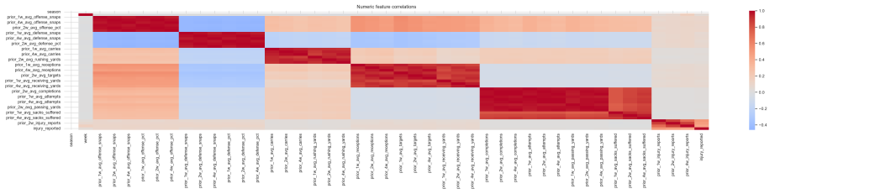
Figure 3. Correlation heatmap of selected engineered features.
Prior snap counts and offensive workload measures such as carries and receptions show relatively weak associations with injury-report status. These are observational correlations, not evidence that a particular workload causes an injury. Correlations among workload variables may also reflect overlapping measures of playing time.

5. Clustering analysis
K-Means was used to explore athlete workload profiles without using the injury outcome to define the groups. The team selected two clusters after considering silhouette scores and interpretability. The distinguishing-feature heatmap highlights prior passing attempts, completions, passing yards, and other workload variables as major differences between clusters.
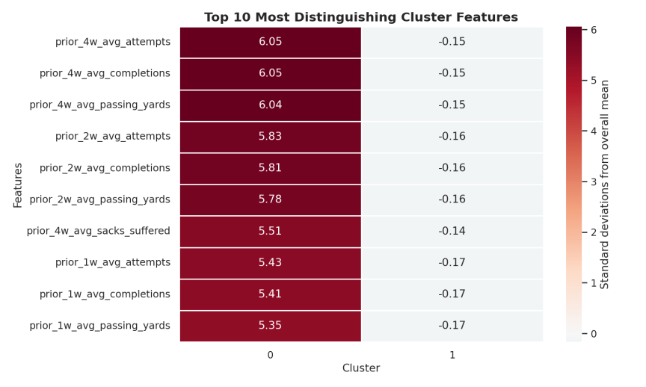
Figure 4. Most distinguishing features between the two reported K-Means clusters.
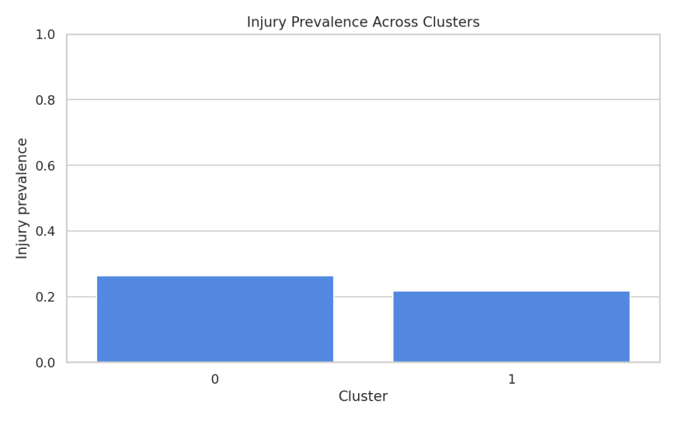
Figure 5. Reported injury prevalence by cluster.
Cluster 0 shows approximately 26% injury prevalence, compared with approximately 22% in Cluster 1. The feature chart indicates that Cluster 0 has larger values for several prior workload measures, especially passing-related statistics. These findings suggest that workload-defined groups differ somewhat in injury-report frequency, but the gap is modest and may reflect player roles or exposure rather than a causal effect. The clusters should be interpreted as exploratory player profiles, not independently validated injury-risk categories.

6. Challenges and decisions
NBA target validation: The attempted NBA modeling run did not identify positive cases in candidate injury columns. The team should inspect the injury-data join, date alignment, missing values, and target definition before reporting NBA classifier performance. NFL-only results are used for the present comparison rather than implying the NBA results were validated.
Class imbalance: Roughly one-fifth of reported NFL observations are positive injury cases. Multiple metrics are reported so that accuracy is not the only measure of performance.
Leakage and data matching: NFL player identifiers and week-level joins require careful checks. The pipeline uses prior-period features and reports matching/data-quality summaries; train/test splitting must occur before fitting any preprocessing transformations.
Interpretation: Workload, injury history, and playing position or role can be related. Model scores and cluster differences are predictive/descriptive associations, not proof of causation.

7. Remaining work
• Confirm the NBA injury target and investigate why candidate columns contained no positive cases.
• Re-run and save reproducible NFL model evaluations, including split strategy, hyperparameters, and output artifacts.
• Validate the reported model metrics and clustering figures against the latest merged repository code.
• Evaluate whether adding NBA results is feasible after fixing the target; otherwise clearly scope final conclusions to NFL.
• Document dataset provenance, target definition, data limitations, and feature importance or model interpretation.
• Prepare final presentation/notebook narrative and compare models on a consistent evaluation split.

8. Team contributions
Member | Contribution
Zachary Marseglia | NFL data ingestion, cleaning, joins, leakage-safe feature engineering, and data-quality checks.
Edwin Bucio | NBA data collection and cleaning; midpoint report setup and dataset description.
Christian Iverson | Supervised model experiments, model comparison, and hyperparameter exploration.
Hunter Dang | K-Means clustering, clustering visualizations, and exploratory cluster comparisons.
Status note: This document consolidates the team’s reported progress and figures. It does not independently verify execution of the latest code or resolve the NBA injury-label issue.

