# CS 255 System Design Document Template

## UML Diagrams

### UML Use Case Diagram

### UML Activity Diagrams

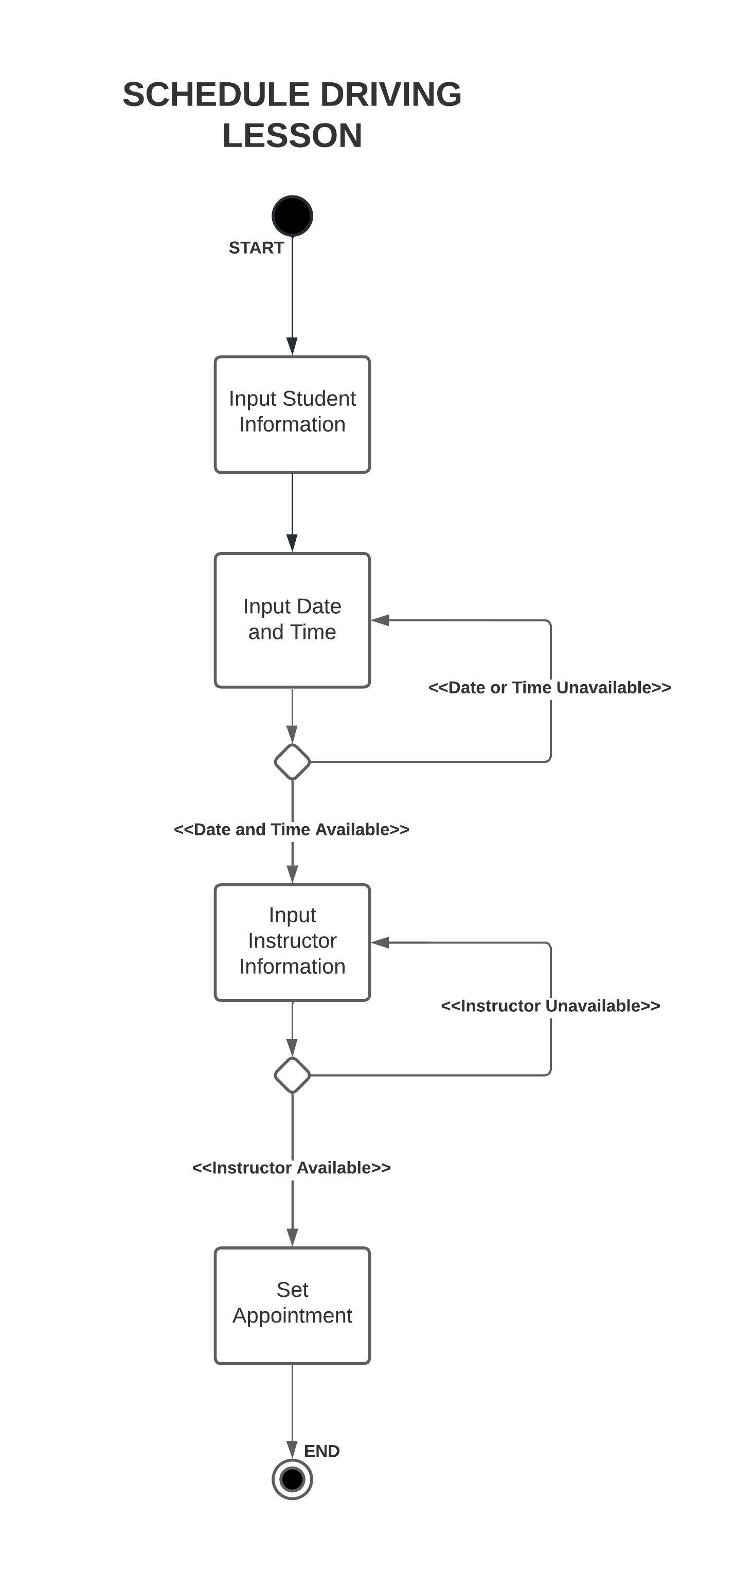

### Diagram, engineering drawing Description automatically generatedUML Sequence Diagram

### UML Class Diagram

## Technical Requirements

**Hardware requirements**

Each user of the system will need to connect to the system via their own computer or mobile device. Each user will require network connection capability.

**Software requirements**

Each user will require a web browser (with applicable plugins) to access the system.

**Tool requirements**

The IT officer will require a development platform as well as a implementation platform to make changes to the system.

**Infrastructure requirements**

The DriverPass online platform will require a dedicated server host. This host will have to have enough memory to handle online traffic as well as storage of customer data.