# Objective

This Project objective is to create a one-page responsive layout and how they can be tied with the backend service.

# Scenario

Merchants need to develop Employee Management System. Merchants have decided to build this entire application in phases. In 1st Phase, we must create a single-page web application that will render all employee lists and allow users to add a new employee to the master.

# Architecture Diagram

## 1.1 Final Architecture Overview

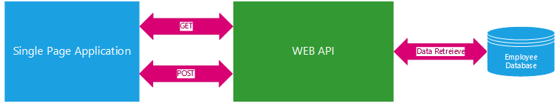

## 1.1 Phase I - Architecture

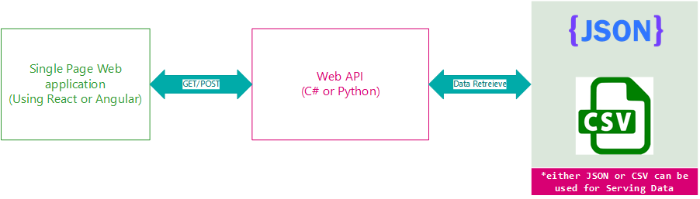

# Phase I – Feature

* On Launch of the Employee portal, the portal should load the Employee Name, Date of Joining, and Sex in a List format. API serves this information to the frontend application.
* User should be able to add New Employees to the list. This list should be stored back in either JSON or CSV documents.

# Development Language

* You Can use either Python or C# to develop the API
* You can use either React or Angular to develop the frontend application

# Attachments

* Employee Master in JSON
* Employee Master in CSV