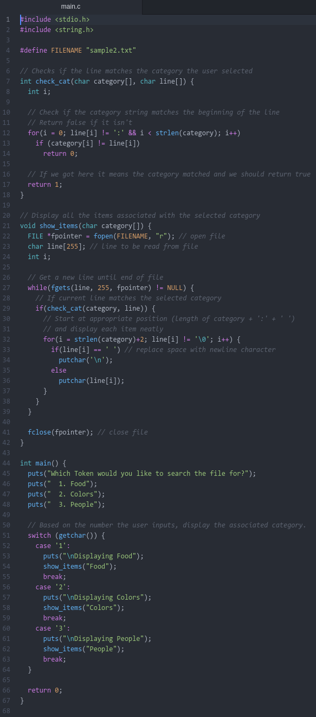
Zachary Thompson

Code:

Output with FILENAME set to sample1.txt:

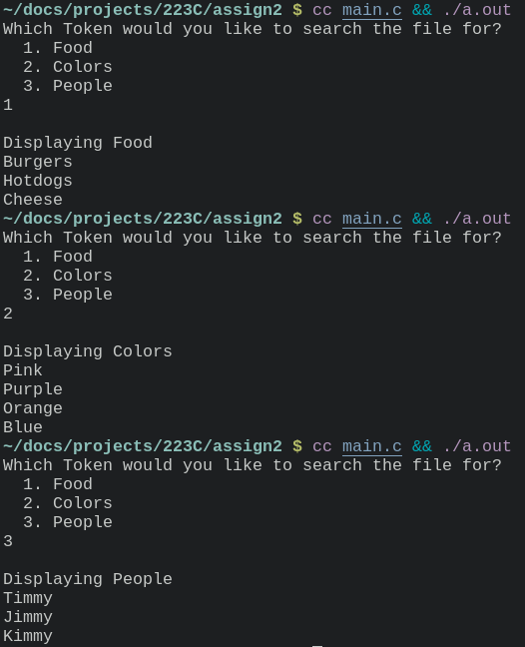
Output with FILENAME set to sample2.txt:
