Zachary Thompson

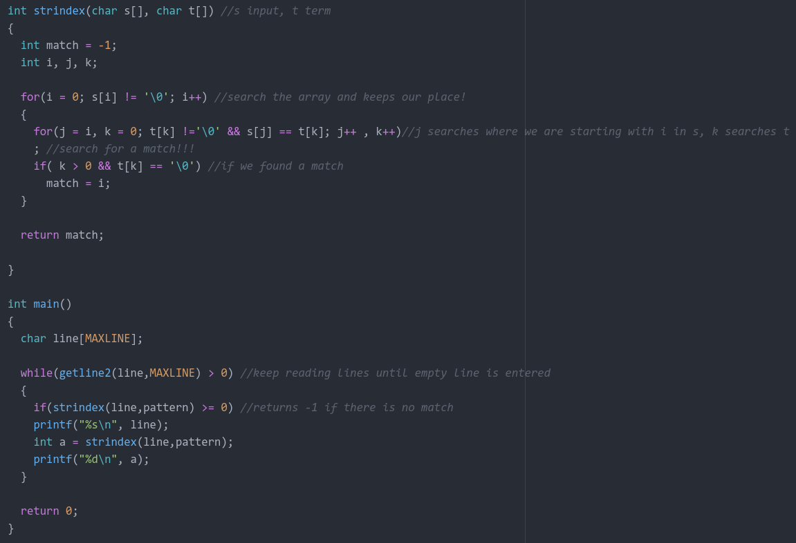

I made main print out the index it recieves from strindex.
“ould” was the search term.

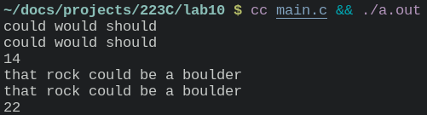

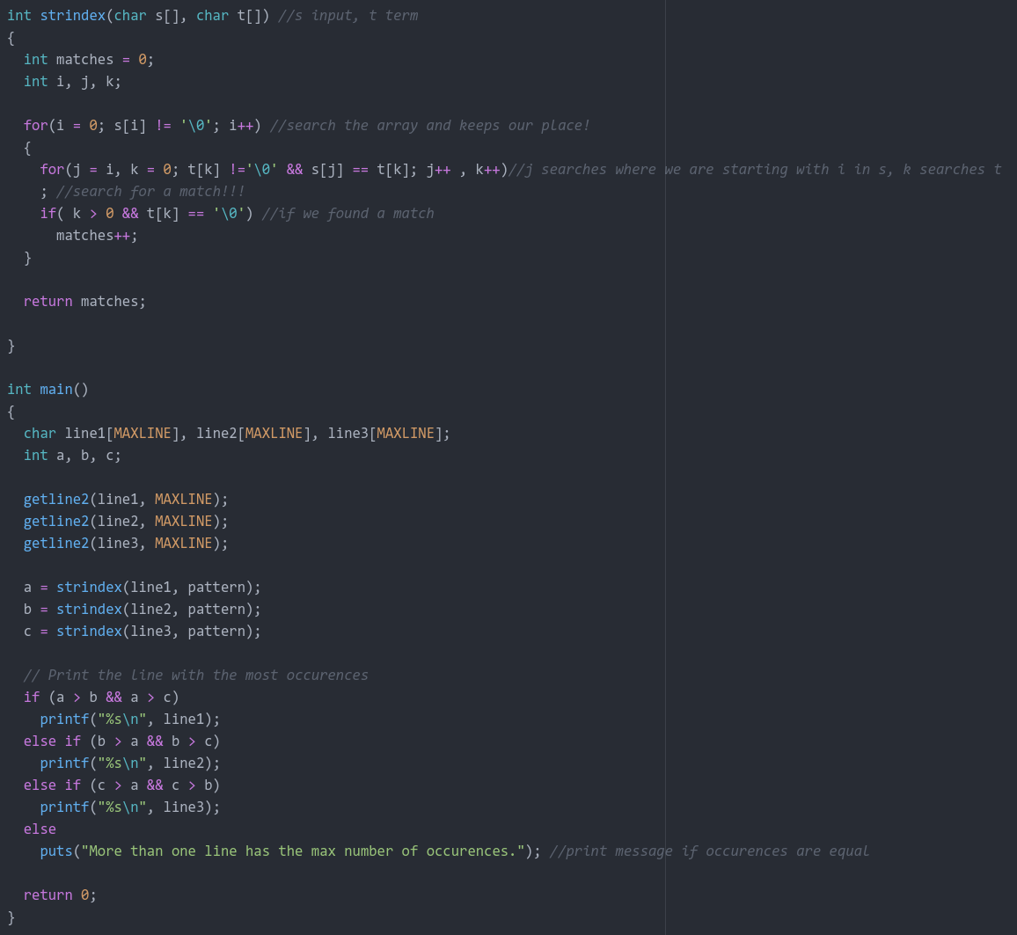
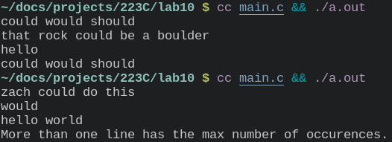
“ould” was the search term.

