Zachary Thompson

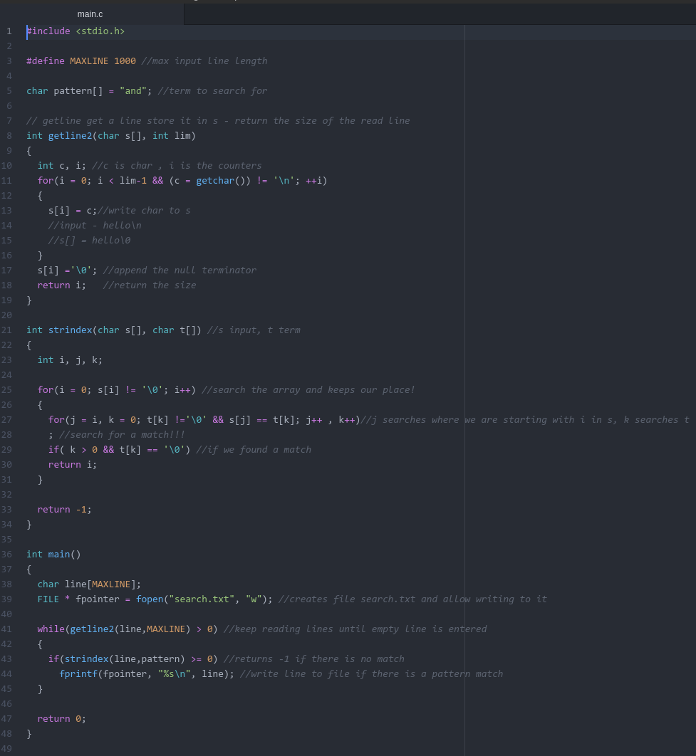
Code:
Sample Output:
